Online Resource: Supplementary Information
Soil Moisture and Evapotranspiration Responses to Precipitation Uncertainty Using Noah-MP Land Surface Model
Stochastic Environmental Research and Risk Assessment
Seulchan Lee¹, Jongmin Park², Jaehwan Jeong³, and Minha Choi^{1,4,}*
¹ Department of Water Resources, Graduate School of Water Resources, Sungkyunkwan University, Suwon 16419, Republic of Korea
² Division of Environmental Engineering, Korea National University of Transportation, Chungju 27469, Republic of Korea
³ Agriculture-Forestry Bioresources Convergence Center, Seoul National University, Seoul 08826, Republic of Korea
⁴ School of Civil, Architectural Engineering & Landscape Architecture, Sungkyunkwan University, Suwon 16419, Republic of Korea
Text S1. Performance metrics
To evaluate the precipitation products and simulated variables, we used Pearson’s correlation coefficient (R), root mean square error (RMSE), and bias, defined as:

$R=\frac{\sum_{t=1}^{n}{(S_{t}-\overline{S})(O_{t}-\overline{O})}}{\sqrt{\sum_{t=1}^{n}{{(S_{t}-\overline{S})}^{2}}}\sqrt{\sum_{t=1}^{n}{{(O_{t}-\overline{O})}^{2}}}}$ (S1)
$RMSE=\sqrt{\frac{1}{n}\sum_{t=1}^{n}{{(S_{t}-O_{t})}^{2}}}$ (S2)
$Bias=\frac{1}{n}\sum_{t=1}^{n}{(S_{t}-O_{t})}$ (S3)

where $O_{t}$ and $S_{t}$ represent reference values (APHRODITE precipitation or APHRODITE-driven simulation) and simulated values (other forcings), respectively, at time step $t$. $\overline{O}$ and $\overline{S}$ are the corresponding means. Two comprehensive metrics, the Kling-Gupta efficiency coefficient (KGE; Kling et al., 2012) and the Nash-Sutcliffe efficiency coefficient (NSE; Nash and Sutcliffe, 1970), were also used to assess the overall performance of the precipitation products and simulated variables. The KGE is defined as:

$KGE=1-\sqrt{{(R-1)}^{2}+{(β-1)}^{2}+{(γ-1)}^{2}}$ (S4)
$β=\overline{S}/\overline{O}$ (S5)
$γ={CV}_{S}/{CV}_{O}$ (S6)

where $β$ is the bias ratio, $γ$ is the variability ratio, and ${CV}_{S}$, ${CV}_{O}$ are the coefficients of variation for the simulated and observed values, respectively. Ranging from negative infinity to 1, A KGE value of 1 indicates perfect agreement between simulated and observed values, while lower values indicate increasing levels of deviation. NSE quantifies the predictive skill of a model by comparing simulation errors to the variability in observations:

$NSE=1-\frac{\sum{{(S_{t}-O_{t})}^{2}}}{\sum{{(O_{t}-\overline{O})}^{2}}}$ (S7)

An NSE value of 1 indicates perfect model performance, whereas an NSE of 0 indicates that the model performs no better than the mean of the observations. Negative NSE values suggest that the model is less effective than simply using the observed mean as a predictor.
Additionally, hit-and-miss statistics are used to evaluate the precipitation products, in terms of capturing the occurrence of the precipitation events. This includes the probability of detection (POD), false alarm ratio (FAR), and critical success index (CSI), as below:

$POD=\frac{Hits}{Hits+Misses}$ (S8)
$FAR=\frac{False Alarms}{Hits+False Alarms}$ (S9)
$CSI=\frac{Hits}{Hits+False Alarms+Misses}$ (S10)

Here, the threshold to determine precipitation event was set to be 1.0 mm/day, following Kim et al. (2017). For the definitions of the components in Eqs. (S8–S10), readers are referred to Kim et al. (2017) and Cui et al. (2020).
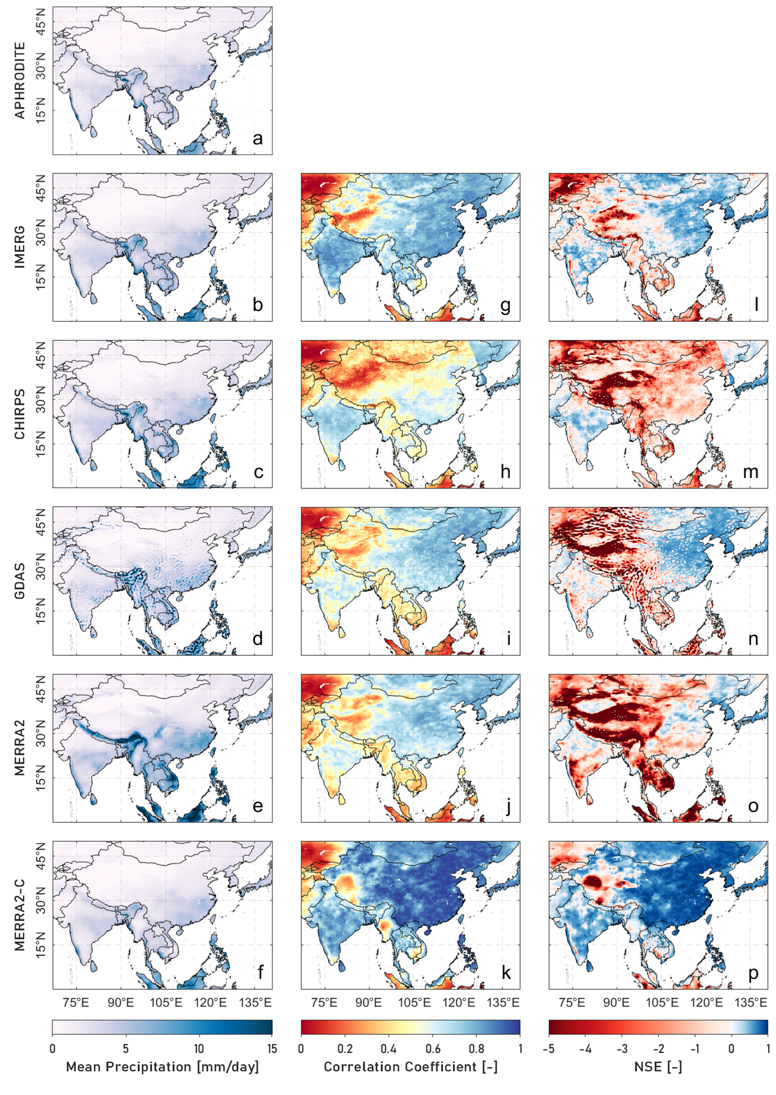
Fig. S1. (a-f) Mean precipitation from 2011 to 2015, (g-k) correlation coefficient, and (l-p) Nash-Sutcliffe model efficiency coefficient (NSE) of the precipitation products compared to APHRODITE from 2011 to 2015.
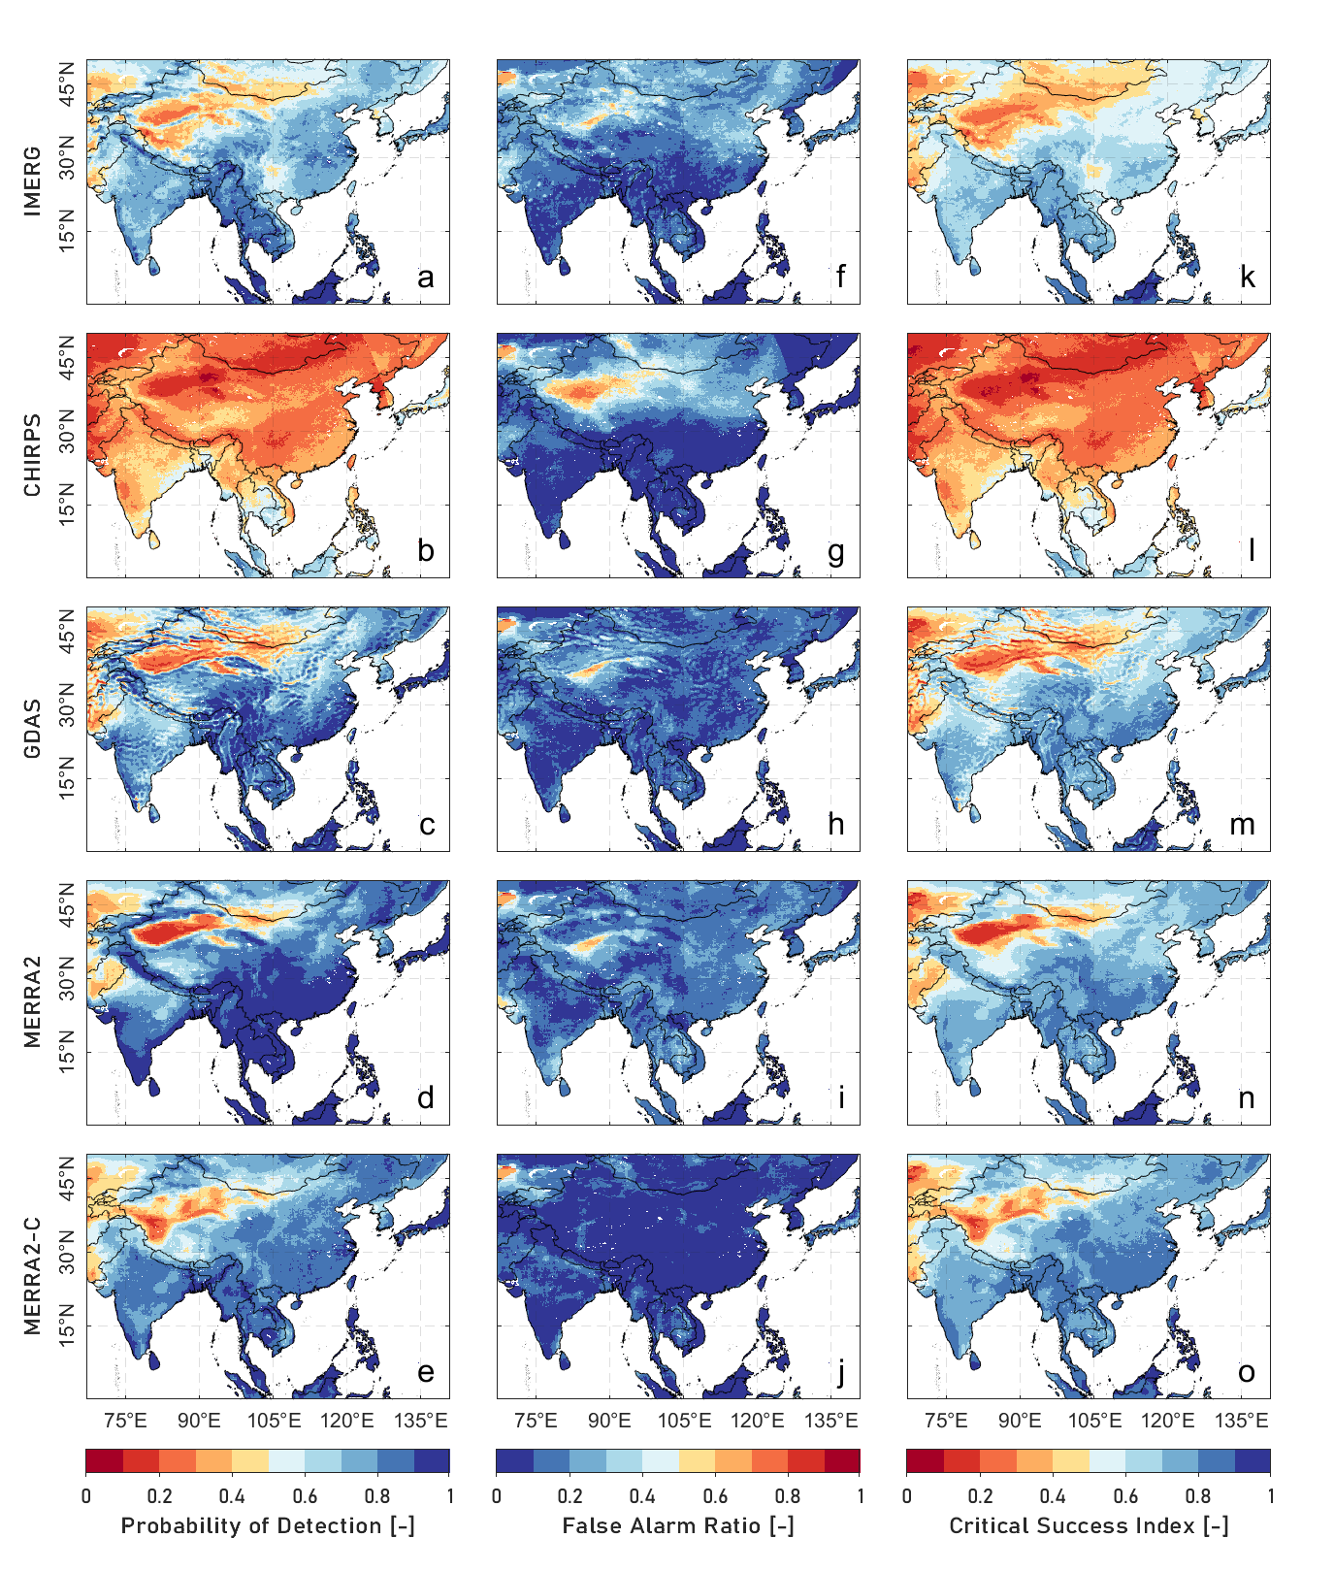
Fig. S2. (a-e) Probability of detection (POD), (f-j) false alarm ratio (FAR), and (l-p) critical success index (CSI) of the precipitation products compared to APHRODITE from 2011 to 2015.

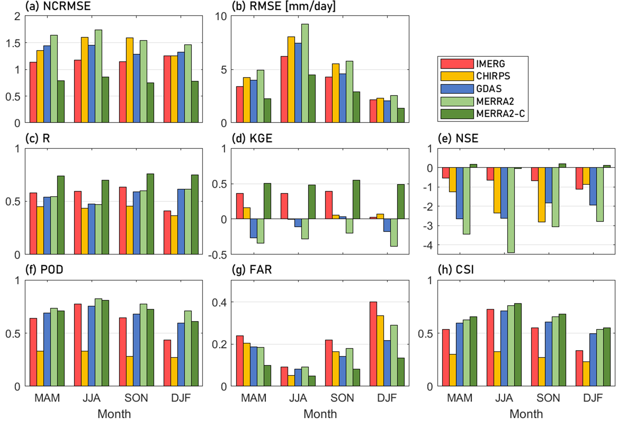
Fig. S3. Seasonal variations in statistical metrics for the five precipitation products compared to APHRODITE. The metrics include (a) NCRMSE, (b) RMSE, (c) R, (d) KGE, (e) NSE, (f) POD, (g) FAR, and (h) CSI.

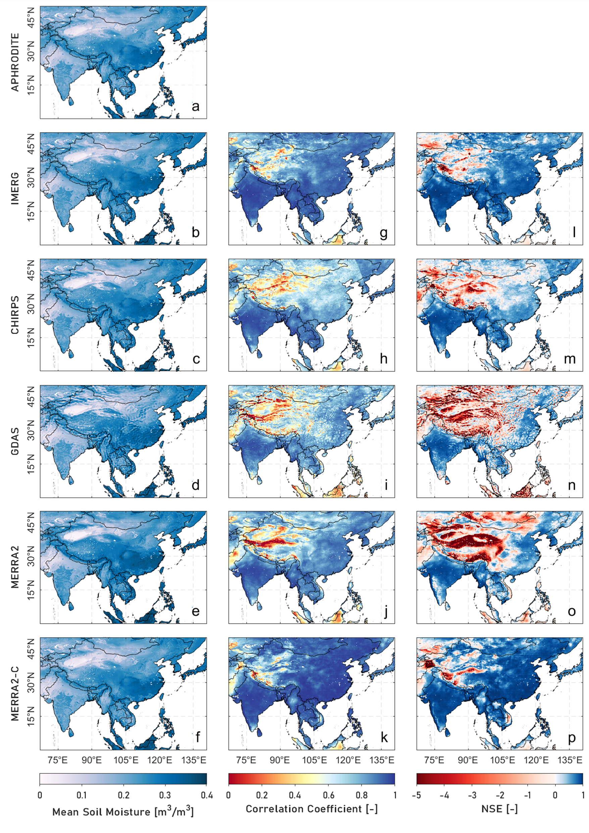
Fig. S4. (a-f) Mean soil moisture (SM) from the simulated datasets, (g-k) correlation coefficient, and (l-p) NSE of the simulated SM compared to APHRODITE-simulated SM from 2011 to 2015.
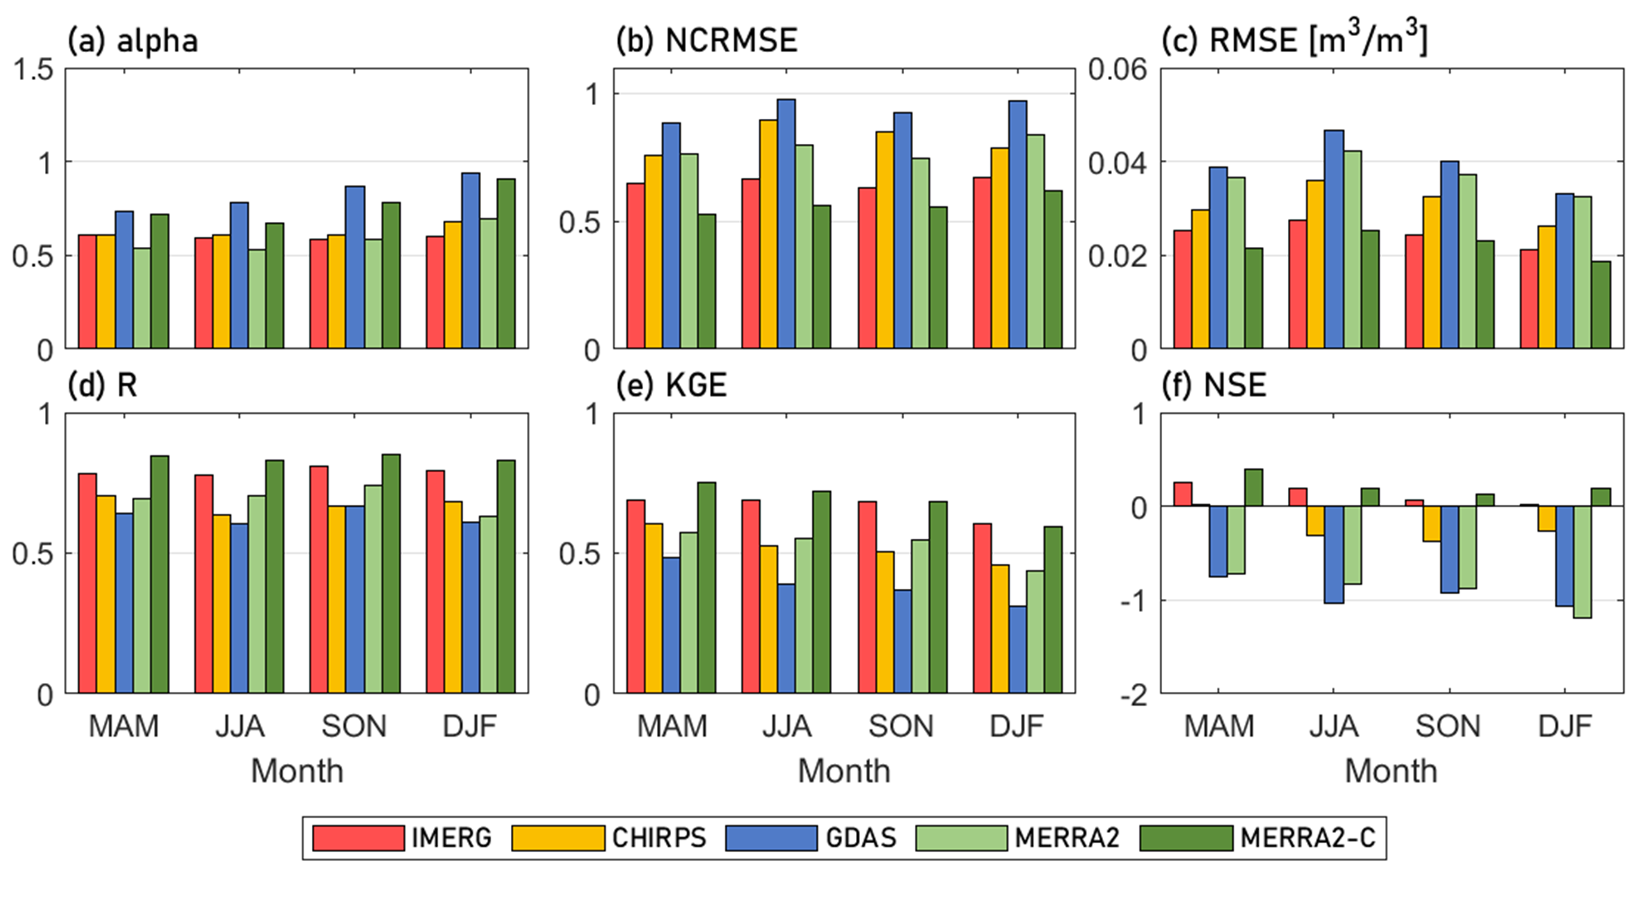
Fig. S5. Seasonal variations in statistical metrics for simulated SM compared to APHRODITE-derived SM. The metrics include (a) $α_{SM}$, (b) NCRMSE, (c) RMSE, (d) R, (e) KGE, and (f) NSE.

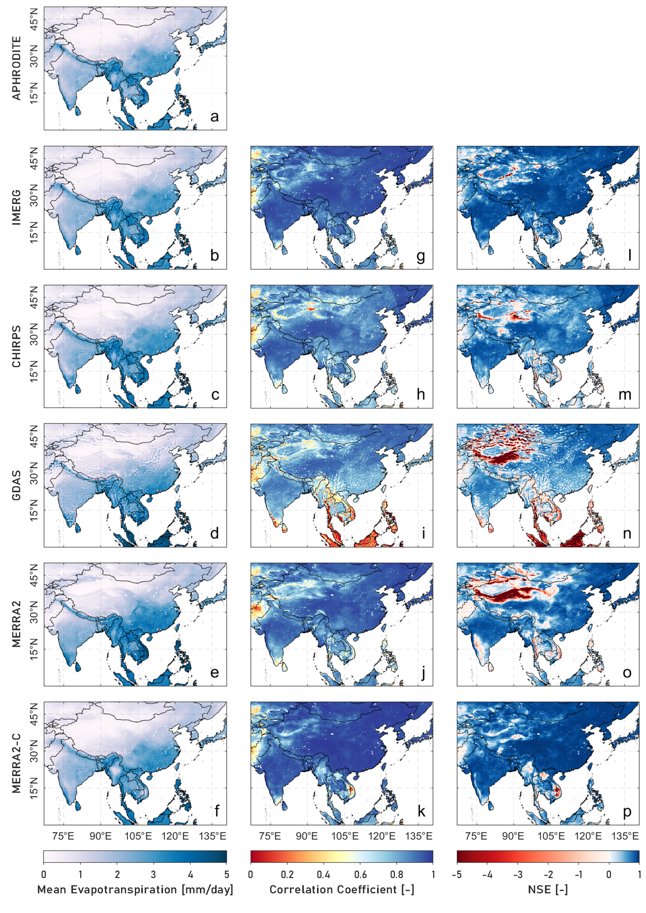
Fig. S6. (a-f) Mean evapotranspiration (ET) from the simulated datasets, (g-k) correlation coefficient, and (l-p) NSE of the simulated ET compared to APHRODITE-simulated ET from 2011 to 2015.
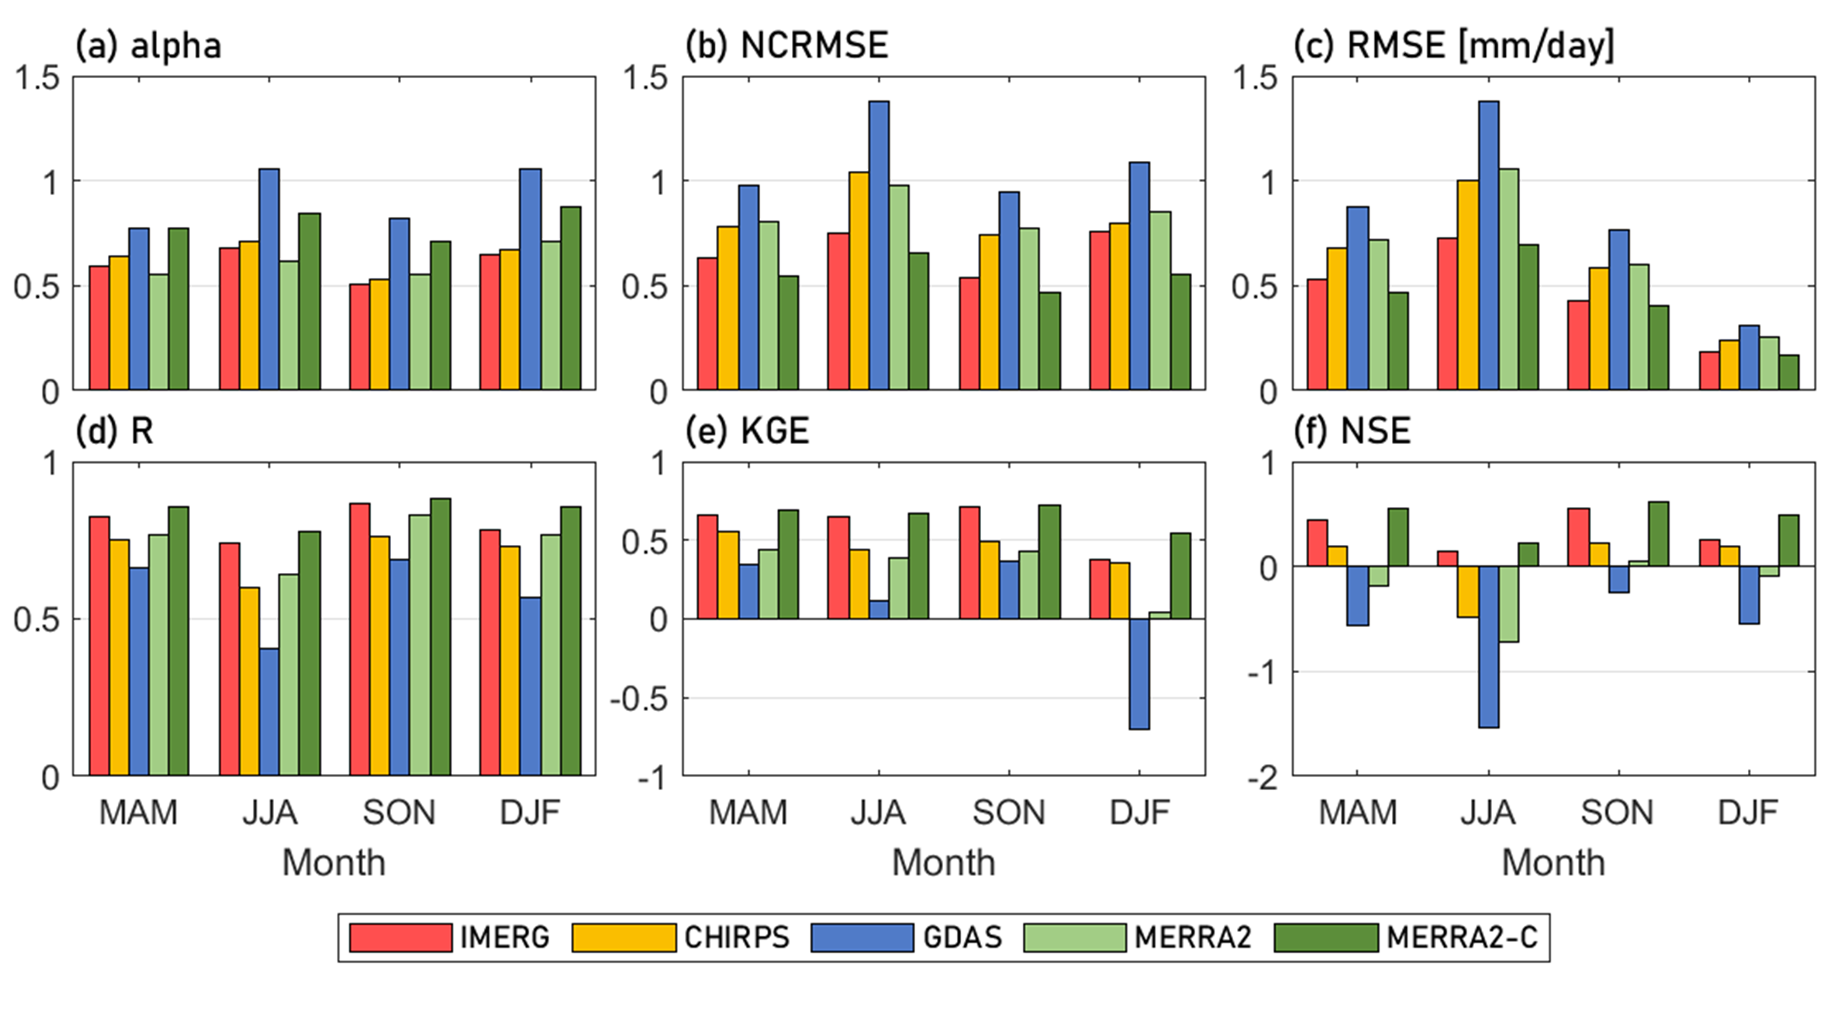
Fig. S7. Seasonal variations in statistical metrics for simulated ET compared to APHRODITE-derived ET.

* Corresponding Author Professor Minha Choi, Department of Water Resources, Graduate School of Water Resources, Sungkyunkwan University, Suwon 16419, Republic of Korea T) 82-31-290-7527 F) 82-31-290-7549 Email) mhchoi@skku.edu
Kling, H., Fuchs, M., & Paulin, M. (2012). Runoff conditions in the upper Danube basin under an ensemble of climate change scenarios. Journal of hydrology, 424, 264-277.
Nash, J. E., & Sutcliffe, J. V. (1970). River flow forecasting through conceptual models part I—A discussion of principles. Journal of hydrology, 10(3), 282-290.
Kim, K., Park, J., Baik, J., Choi, M., 2017. Evaluation of topographical and seasonal feature using GPM IMERG and TRMM 3B42 over Far-East Asia. Atmospheric Research, 187: 95-105. https://doi.org/10.1016/j.atmosres.2016.12.007
Cui, W., Dong, X., Xi, B., Feng, Z., Fan, J., 2020. Can the GPM IMERG final product accurately represent MCSs’ precipitation characteristics over the central and eastern United States? Journal of Hydrometeorology, 21(1): 39-57. https://doi.org/10.1175/jhm-d-19-0123.1

