Supplementary Material
Table S1. List of localities where the occurrence of EVD outbreaks (events of zoonotic transmission of EVD to humans) has been confirmed, in chronological order, and bibliographic references. M-Year: Meteorological year from December to November. Quarter: Meteorological quarter. Q1: December-February. Q2: March-May. Q3: June-August. Q4: September-November. F: Biogeographical favourability for the Ebola virus. H: High favourability. I: Intermediate favourability. DRC: Democratic Republic of the Congo; ROC: Republic of Congo. Virus: Ebolavirus species.
 | M-Year | Quarter | F | Country | Locality name | Virus | References*
1 | 1976 | Q3 | I | Sudan | Nzara | Sudan | 1
2 | 1976 | Q4 | H | DRC | Yambuku | Zaire | 2
3 | 1977 | Q3 | I | DRC | Tandala (Bonduni) | Zaire | 3
4 | 1979 | Q3 | I | Sudan | Nzara | Sudan | 4
5 | 1994 | Q4 | H | Ivory Coast | Täi National Park | Tai forest | 5,6
6 | 1995 | Q1 | H | Gabon | Andock | Zaire | 7,8
7 | 1995 | Q1 | H | Gabon | Minkebé | Zaire | 8,9
8 | 1995 | Q1 | H | Gabon | Mékouka | Zaire | 7,8,10
9 | 1995 | Q1 | I | DRC | Mwembe (Kikwit) | Zaire | 11,12
10 | 1996 | Q1 | H | Gabon | Mayibout | Zaire | 7,8,10
11 | 1996 | Q3 | H | Gabon | Booué (logging camp) | Zaire | 7,10
12 | 1996 | Q3 | H | Gabon | Societé de la Haute Mondah | Zaire | 7,8,13
13 | 2000 | Q3 | I | Uganda | Rwot-Obilo (Gulu) | Sudan | 14,15,16
14 | 2001 | Q4 | H | Gabon | Mendemba (Kikwit) | Zaire | 8,17,18,19
15 | 2001 | Q4 | H | Gabon | Ekata | Zaire | 18
16 | 2002 | Q1 | H | Gabon | Ekata | Zaire | 18
17 | 2002 | Q1 | I | ROC | Olloba | Zaire | 18
18 | 2002 | Q1 | H | Gabon | Etakangaye | Zaire | 18
19 | 2002 | Q1 | H | ROC | Abolo | Zaire | 17
20 | 2002 | Q1 | H | ROC | Ambomi | Zaire | 17
21 | 2002 | Q1 | H | ROC | Entsiami | Zaire | 8,17,18
22 | 2002 | Q2 | H | Gabon | Grand Etoumbi | Zaire | 8,17,18
23 | 2002 | Q2 | I | ROC | Olloba | Zaire | 8,20
24 | 2003 | Q1 | H | ROC | Kéllé | Zaire | 21,22
25 | 2003 | Q1 | H | ROC | Mbomo | Zaire | 21,22
26 | 2003 | Q1 | H | ROC | Yembelengoye | Zaire | 17,18
27 | 2003 | Q1 | H | ROC | Mvoula | Zaire | 17,18
28 | 2003 | Q4 | H | ROC | Mbanza | Zaire | 8,17,18,20,23,24,25
29 | 2003 | Q4 | H | ROC | Mbomo | Zaire | 20,26
30 | 2004 | Q2 | I | Sudan | Yambio | Sudan | 17,27,28
31 | 2005 | Q2 | H | ROC | Etoumbi | Zaire | 8,23
32 | 2007 | Q2 | H | DRC | Luebo | Zaire | 29,30
33 | 2007 | Q4 | I | Uganda | Budinbugyo | Bundibugyo | 31,32
34 | 2009 | Q1 | I | DRC | Mweka | Zaire | 33,34
35 | 2011 | Q2 | I | Uganda | Nakisamata | Sudan | 35
36 | 2012 | Q3 | H | DRC | Isiro | Bundibugyo | 36
37 | 2012 | Q3 | I | Uganda | Kibaale | Sudan | 36
38 | 2012 | Q4 | I | Uganda | Luwero | Sudan | 36
39 | 2014 | Q1 | I | Guinea | Guéckédou | Zaire | 37,38
40 | 2014 | Q3 | H | DRC | Isaka (Ikanamongo) | Zaire | 30,39
41 | 2017 | Q2 | H | DRC | Bas Uélé (Likati) | Zaire | 40
42 | 2018 | Q2 | H | DRC | Ikoko-Ipenge (Bikoro) | Zaire | 41
43 | 2018 | Q3 | H | DRC | Mangina | Zaire | 42
44 | 2020 | Q2 | H | DRC | Mbandaka/Bikoro (Quateur) | Zaire | 43
45 | 2021 | Q1 | I | Guinea | Gouck (Nzrkor) | Zaire | 44
46 | 2022 | Q2 | I | DRC | Mbandaka (Quateur) | Zaire | 45
47 | 2022 | Q4 | I | Uganda | Ngabano (Mubende) | Sudan | 46
48 | 2025 | Q1 | I | Uganda | Wakiso | Sudan | 47
49 | 2025 | Q3 | I | DRC | Bulape | Zaire | 48
References:
1. Anonymous. 1978. Ebola haemorrhagic fever in Sudan,1976. Bull World Health Organ. 56, 247-270.
2. Anonymous. 1978. Ebola haemorrhagic fever in Zaire, 1976. Bull World Health Organ. 56, 271-293.
3. Heymann FL, Weisfeld JS, Webb PA, Johnson KM, Cairns T, Berquist H. 1980. Ebola hemorrhagic fever: Tandala, Zaire, 1977-1978. J. Infect. Dis. 142, 372-376. doi: 10.1093/infdis/142.3.372.
4. Baron RC, McCormick JB, Zuibeir OA. 1983. Ebola virus disease in southern Sudan: hospital dissemination and intrafamilial spread. Bull World Health Organ. 61, 997-1003.
5. Le Guenno B. 1995. Isolation and partial characterisation of a new strain of Ebola virus. Lancet 345, 1271-1274. doi: 10.1086/514296.
6. Formenty P, Boesch C, Wyers M, Steiner C, Donati F, Dind F, Walker F, Le Guenno B. 1999. Ebola virus outbreak among wild chimpanzees living in a rain forest of Côte d'Ivoire. J. Infect. Dis. 179, 120-126.
7. Georges A-J, Leroy EM, Renaut AA, Benissan CT, Nabias RJ, Ngoc MT, et al. 1999. Ebola hemorrhagic fever outbreaks in Gabon, 1994-1997: Epidemiologic and health control issues. J. Infect. Dis. 179, 65-75. doi: 10.1086/514290.
8. Lahm SA, Kombila M, Swanepoel R, Barnes RFW. 2007. Morbidity and mortality of wild animals in relation to outbreaks of Ebola haemorrhagic fever in Gabon, 1994-2003. Trans. R. Soc. Trop. Med. Hyg. 101, 64-78.
9. Amblard J, Obiand P, Edzand S, Prehaud C, Bouloy M, Le Guenno B. 1997. Identification of the Ebola virus in Gabon in 1994. Lancet 349, 181-182.
10. Georges-Courbot A-J, Sánchez A, Lu C-Y, Baize S, Leroy E, Lansout-Soukate J, Tévi-Bénissan C, et al. 1997. Isolation and phylogenetic characterization of Ebola viruses causing different outbreaks in Gabon. Emerg. Infect. Dis. 3, 59-62. doi: 10.3201/eid0301.970107.
11. Khan AS, Tshioko FK, Heymann DL, Le Guenno B, Nabeth P, Kerstiëns B, et al. 1999. The reemergence of Ebola hemorrhagic fever, Democratic Republic of the Congo, 1995. J. Infect. Dis. 179, 76-86. doi: 10.1086/514306.
12. Muyembe T, Kipasa M, on behalf of International Scientific and Technical Committee and WHO Collaborating Centre for Haemorrhagic Fevers. 1995. Ebola haemorrhagic fever in Kikwit, Zaire. Lancet 345, 1448.
13. Kuhn J. 2008. History of filoviral disease outbreaks. In: Filoviruses. A compendium of 40 years of epidemiology, clinical and laboratory studies (Calisher CH, ed.). Springer-Verlag, Vienna. pp. 59-97.
14. Lamunu M, Lutwama JJ, Kamugisha J, Opio A, Nambooze J, Ndayimirije N, Okware S. 2004. Containing a haemorrhagic fever epidemic: the Ebola experience in Uganda (October 2000 - January 2001). Int. J. Infect. Dis. 8, 27-37. doi: 10.1016/j.ijid.2003.04.001.
15. Okware SI, Omaswa FG, Zaramba S, Opio A, Lutwama JJ, Kamugisha J, et al. 2002. An outbreak of Ebola in Uganda. Trop. Med. Int. Health.7, 1068-1075. doi:10.1046/j.1365-3156.2002.00944.x.
16. Anonymous. 2001. Outbreak of Ebola haemorrhagic fever, Uganda, August 2000 - January 2001. Wkly Epidemiol. Rec.76, 41-46.
17. Pourrut X, Kumulungui B, Wittmann T, Moussavou G, Délicat A, Yaba P, et al. 2005. The natural history of Ebola virus in Africa. Microbes Infect.7, 1005-1014. doi: 10.1016/j.micinf.2005.04.006.
18. Leroy EM, Rouquet P, Formenty P, Souquière S, Kilbourne A, Froment J-M, et al. 2004. Multiple Ebola virus transmission events and rapid decline of Central African wildlife. Science 303, 387-390. doi: 10.1126/science.1092528.
19. Anonymous. 2003). Outbreak(s) of Ebola haemorrhagic fever, Congo and Gabon, October 2001 - July 2002. Wkly Epidemiol. Rec. 78, 223-228.
20. Rouquet P, Froment J-M, Bermejo M, Kilbourn A, Karesh W, Reed P, Kumulungui B, et al. 2005. Wild animal mortality monitoring and human Ebola outbreaks, Gabon and Republic of Congo, 2001-2003 Emerg. Infect. Dis. 11, 283-290. doi: 10.3201/eid1102.040533.
21. Anonymous. 2003. Outbreak(s) of Ebola haemorrhagic fever in the Republic of the Congo, January-April 2003. Wkly Epidemiol. Rec. 78: 285-289.
22. Formenty P, Libama F, Epelboin A, Allarangar Y, Leroy E, Moudzeo H, et al. 2003. L’epidemie de fievre hemorragique a virus Ebola en Republique du Congo, 2003: Une nouvelle estrategie? Médecine Tropicale: Revue du Corps de Santé Colonial.;63: 291-295.
23. Nkoghe D, Kone ML, Yada A, Leroy E. 2011. A limited outbreak of Ebola haemorrhagic fever in Etoumbi, Republic of Congo, 2005. Trans. R. Soc. Trop. Med. Hyg. 105, 466-472. doi: 10.1016/j.trstmh.2011.04.011.
24. Anonymous. 2003. Republic of Congo: Ebola epidemic. International Federation of Red Cross and Red Crescent Societies. Information Bulletin 2, 3.
25. Lucht A, Formenty P, Feldmann H, Götz M, Leroy E, Bataboukila P, et al. 2007. Development of an immunofiltration-based antigen-detection assay for rapid diagnosis of Ebola virus infection. J. Infect. Dis.196, S184-192. doi: 10.1086/520593.
26. Pourrut X, Souris M, Towner JS, Rollin PE, Nichol ST, Gonzalez JP, Leroy E. 2009. Large serological survey showing cocirculation of Ebola and Marburg viruses in Gabonese bat populations, and a high seroprevalence of both viruses in Rousettus aegyptiacus. BMC Infect. Dis. 9, 159-169. doi: 10.1186/1471-2334-9-159.
27. Onyango CO, Opoka ML, Ksiazek TG, Formenty P, Ahmed A, Tukei PM, et al. 2007. Laboratory diagnosis of Ebola hemorrhagic fever during an outbreak in Yambio, Sudan. 2004. J Infect Dis. 196, 193-198. doi: 10.1086/520609.
28. Anonymous. 2005. Outbreak(s) of Ebola haemorrhagic fever in Yambio, South Sudan, April-June 2004. Wkly Epidemiol. Rec. 80, 370-375.
29. Leroy EM, Epelboin A, Mondonge V, Pourrut X, Gonzalez J-P, Muyembe-Tamfum J-J, Pierre F. 2009. Human Ebola outbreak resulting from direct exposure to fruit bats in Luebo, Democratic Republic of Congo, 2007. Vector Borne Zoobiotic Dis. 9, 723-728. doi: 10.1089/vbz.2008.0167.
30. Rosello A, Mossoko M, Flasche S, Van Hoek AJ, Mbala P, Camacho A, et al. 2015. Ebola virus disease in the Democratic Republic of the Congo, 1976-2014. Elife. 4, e09015. doi: 10.7554/eLife.09015.
31. Towner JS, Sealy TK, Khristova ML, Albariño CG, Conlan S, Reeder SA, et al. 2008. Newly discovered Ebola virus associated with hemorrhagic fever outbreak in Uganda. PLoS Pathog 4, e1000212. doi: 10.1371/journal.ppat.1000212.
32. MacNeil A, Farnon EC, Wamala J, Olware S, Cannon DL, Reed Z, et al. 2010. Proportion of deaths and clinical features in Bundibugyo Ebola virus infection, Uganda. Emerg Infect Dis.16, 1969-1972. doi: 10.3201/eid1612.100627.
33. Anonymous. 2009. Ebola Hemorrhagic Fever, Information Packet. Special Pathogens Branch Division of High-Consequence Pathogens and Pathology. National Center for Emerging Zoonotic Infectious Diseases, Center for Disease Control and Prevention, U.S. Department of Health and Human Services, Atlanta, USA. https://health.mo.gov/living/lpha/toolkit/pdf/ebola-information-packet.pdf.
34. Anonymous. 2009. End of Ebola outbreak in the Democratic Republic of the Congo. World Health Organization http://www.who.int/csr/don/2009_02_17/en/ (accessed 24/11/2015).
35. Shoemaker T, MacNeil A, Balinandi S, Campbell S, Wamala JF, McMullan LK, et al. 2012. Reemerging Sudan Ebola virus disease in Uganda, 2011. Emerg. Infect. Dis. 18, 1480-1483. doi: 10.3201/eid1809.111536.
36. Albariño CG, Shoemaker T, Khristova ML, Wamala JF, Muyembe JJ, Balinandi S, et al. 2013. Genomic analysis of filoviruses associated with four viral hemorrhagic fever outbreaks in Uganda and the Democratic Republic of the Congo in 2012. Virology 442, 97-100. doi: 10.1016/j.virol.2013.04.014.
37. Bausch DG, Schward L. 2014. Outbreak of Ebola Virus Disease in Guinea: Where ecology meets economy. PLoS Negl. Trop. Dis. 8, e3056. doi: 10.1371/journal.pntd.0003056.
38. Baize S, Pannetier D, Oestereich L, Rieger T, Koivogui L, Magassouba N’F, et al. 2014. Emergence of Zaire Ebola virus disease in Guinea. N. Engl J. Med. 371, 418-25. doi: 10.1056/NEJMoa1404505.
39. Maganga GD, Kapetshi J, Berthet N, Benoît Kebela Ilunga, Kabange F, Mbala Kingebeni P. et al (2014) Ebola Virus Disease in the Democratic Republic of Congo. N Engl J Med 371, 2083-91. https://www.nejm.org/doi/full/10.1056/nejmoa1411099.
40. Anonymous. 2017. Ebola virus disease - Democratic Republic of Congo. Weekly Bulletin on Outbreaks and Other Emergencies. Week 19: 06 - 12 May 2017. https://iris.who.int/bitstream/handle/10665/255407/OEW19-61252017.pdf?sequence=1.
41. Anonymous. 2018. Ebola virus disease - Democratic Republic of Congo. Weekly Bulletin on Outbreaks and Other Emergencies. Week. 19: 5-11 May 2018. https://iris.who.int/bitstream/handle/10665/272519/OEW19-511042018.pdf.
42. Ebola virus disease - Democratic Republic of Congo. Weekly Bulletin on Outbreaks and Other Emergencies. Week. 31: 28 July-3 August 2018. https://iris.who.int/bitstream/handle/10665/273631/OEW31-2873082018.pdf.
43. Anonymous. 2020. Ebola virus disease (EVD) in Equateur Province, Democratic Republic of the Congo. Weekly Bulletin on Outbreaks and Other Emergencies. Week 23: 1 - 7 June 2020. https://apps.who.int/iris/bitstream/handle/10665/332302/OEW23-0107062020.pdf.
44. Anonymous. 2021. Ebola virus disease in Guinea. Weekly Bulletin on Outbreaks and Other Emergencies. Week 7: 8 - 14 February 2021. https://apps.who.int/iris/bitstream/handle/10665/339701/OEW07-0814022021.pdf.
45. Anonymous. 2022. Ebola virus disease in the Democratic Republic of the Congo. Weekly Bulletin on Outbreaks and Other Emergencies. Week 17: 18 - 24 April 2022. https://apps.who.int/iris/bitstream/handle/10665/353573/OEW17-1824042022.pdf.
46. Anonymous. 2022. Ebola virus disease caused by Sudan virus in Uganda. Weekly Bulletin on Outbreaks and Other Emergencies. Week 40: 26 September - 2 October 2022. https://apps.who.int/iris/bitstream/handle/10665/363400/OEW40-260902102022.pdf.
47. WHO 2025. Disease Outbreak News. Sudan virus disease – Uganda https://www.who.int/emergencies/disease-outbreak-news/item/2025-DON556#
48. WHO 2025. Disease Outbreak News. Ebola virus disease - Democratic Republic of the Congo https://www.who.int/emergencies/disease-outbreak-news/item/2025-DON580

Table S2. Climatic oscillation indices used to assess possible links with EBOD outbreaks.
Index | Name
AMM | Atlantic Meridional Mode
AMO | Atlantic multidecadal Oscillation
AO | Artic Oscillation Index
CAR | Caribbean SST Index
DMI | Dipole Mode Index
EA | East Atlantic Pattern
EA/WR | East Atlantic/West Russia Pattern
EP/NP | East Pacific/North Pacific Pattern
GMT | Global Mean Lan/Ocean Temperature
MEI | Multivariate ENSO Index
NAO | North Atlantic Oscillation
NIÑO_1+2 | Extreme Eastern Tropical Pacific SST
NIÑO_34 | East Central Tropical Pacific SST
NIÑO_4 | Central Tropical Pacific SST
NTA | North Tropical Atlantic SST Index
ONI | Oceanic Nino Index
PDO | Pacific Decadal Oscillation Index
PNA | Pacific/North American Pattern
POL | Polar/Eurasia Pattern
QBO | Quasi-Biennial Oscillation
SCA | Scandinavia Pattern
SOI | Southern Oscillation Index
TNA | Tropical Northern Atlantic Index
TSA | Tropical Southern Atlantic Index
WHWP | Western Hemisphere warm pool
WP | West Pacific Pattern
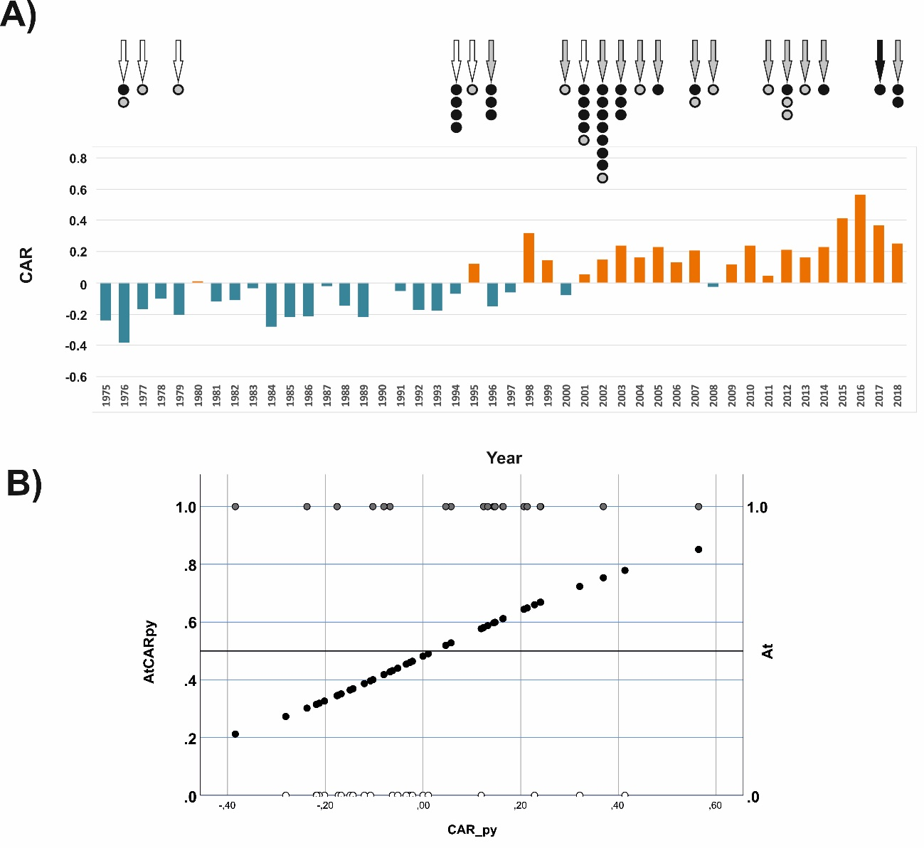Figure S1. A) Variation of the Caribbean Sea Surface Temperature Index (CAR) during the meteorological years (December to November) covered by this study, meteorological years with EBOD outbreaks (arrows), and occurrence of EBOD outbreaks (each circle is a different outbreak). Colours of the arrows: climatic favourability for EBOD outbreaks according to the model AtCARpy (White: F<0.5; Grey: 0.5≤F<0.8; Black: F≥0.8). Circle colours: biogeographical favourability for the presence of the Ebola-virus at the location of the outbreaks (Grey: 0.2≤F<0.8; Black: F≥0.8). B) Relationship between climatic favourability for the occurrence of EBOD outbreaks during a meteorological year according to the model AtCARpy and the CAR of the previous year. CAR_py: Mean CAR in the previous meteorological year. Grey circles at the top: meteorological years with EBOD outbreaks. White circles at the bottom: meteorological years without EBOD outbreaks. Logit of the climatic favourability model AtCARpy in Table 1.
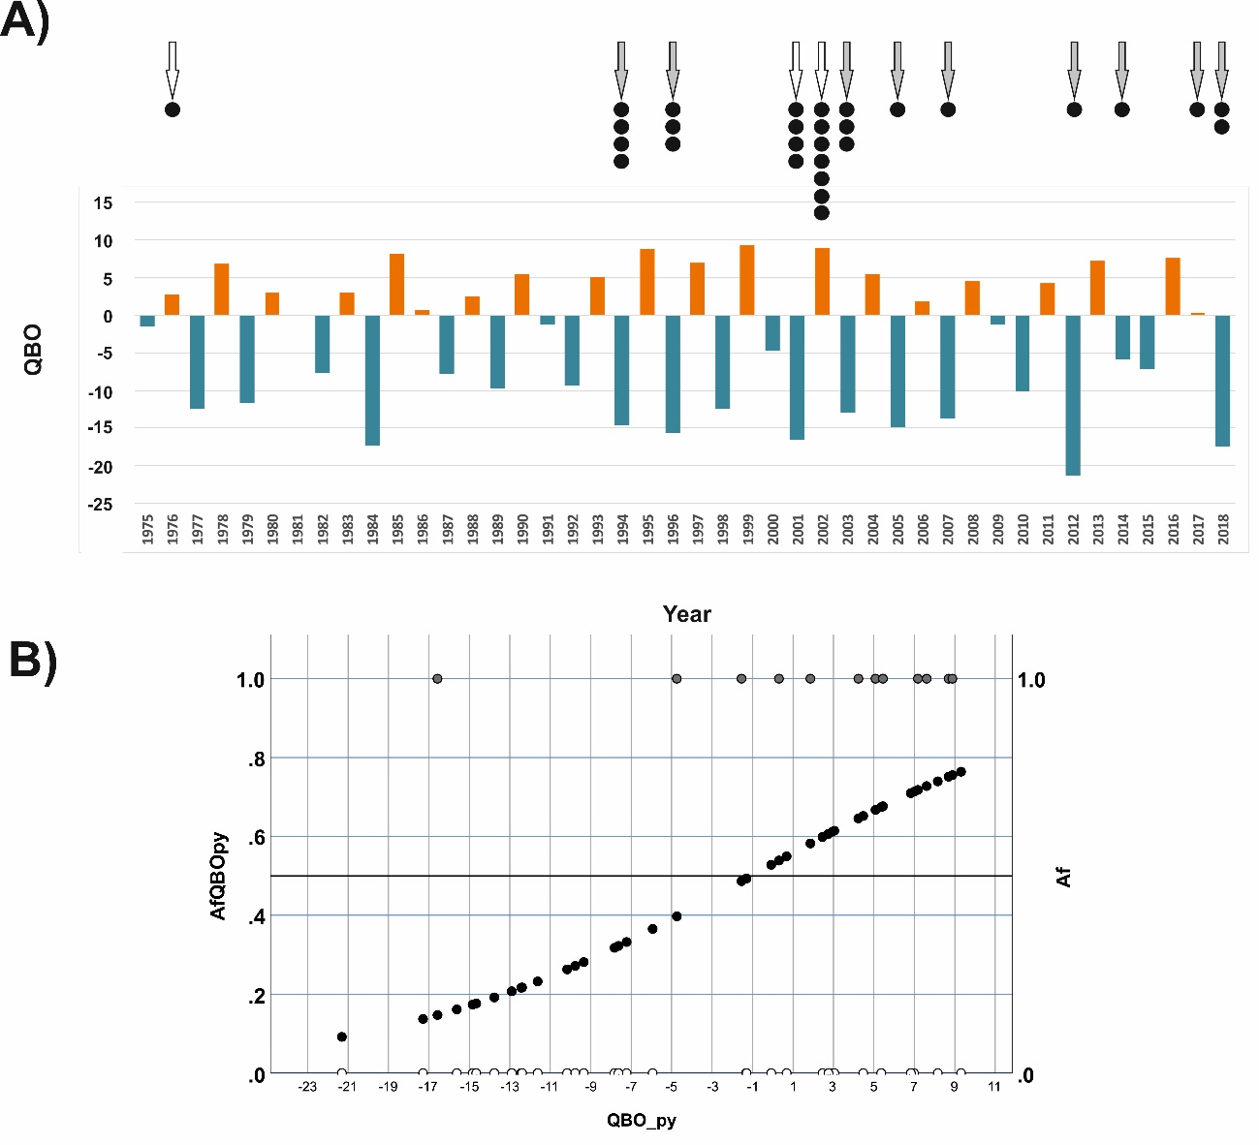Figure S2. A) Variation of the Quasi-Biennial Oscillation (QBO) during the meteorological years (December to November) covered by this study, meteorological years with EBOD outbreaks (arrows), and occurrence of EBOD outbreaks in the areas of high biogeographical favourability for the presence of the Ebola-virus (each circle is a different outbreak). Colours of the arrows: climatic favourability for EBOD outbreaks according to the model AfQBOpy (White: F<0.5; Grey: 0.5≤F<0.8). Black circles: biogeographical favourability for the presence of the Ebola-virus at the location of the outbreaks (F≥0.8) B) Relationship between climatic favourability for the occurrence of EBOD outbreaks in the areas of high biogeographical favourability for the presence of the Ebola-virus during a meteorological year according to the model AfQBOpy and the QBO of the previous year. QBO_py: Mean QBO in the previous meteorological year. Grey circles at the top: meteorological years with EBOD outbreaks in the areas of high biogeographical favourability for the presence of the Ebola-virus. White circles at the bottom: meteorological years without EBOD outbreaks in the areas of high biogeographical favourability for the presence of the Ebola-virus. Logit of the climatic favourability model AfQBOpy in Table 1.
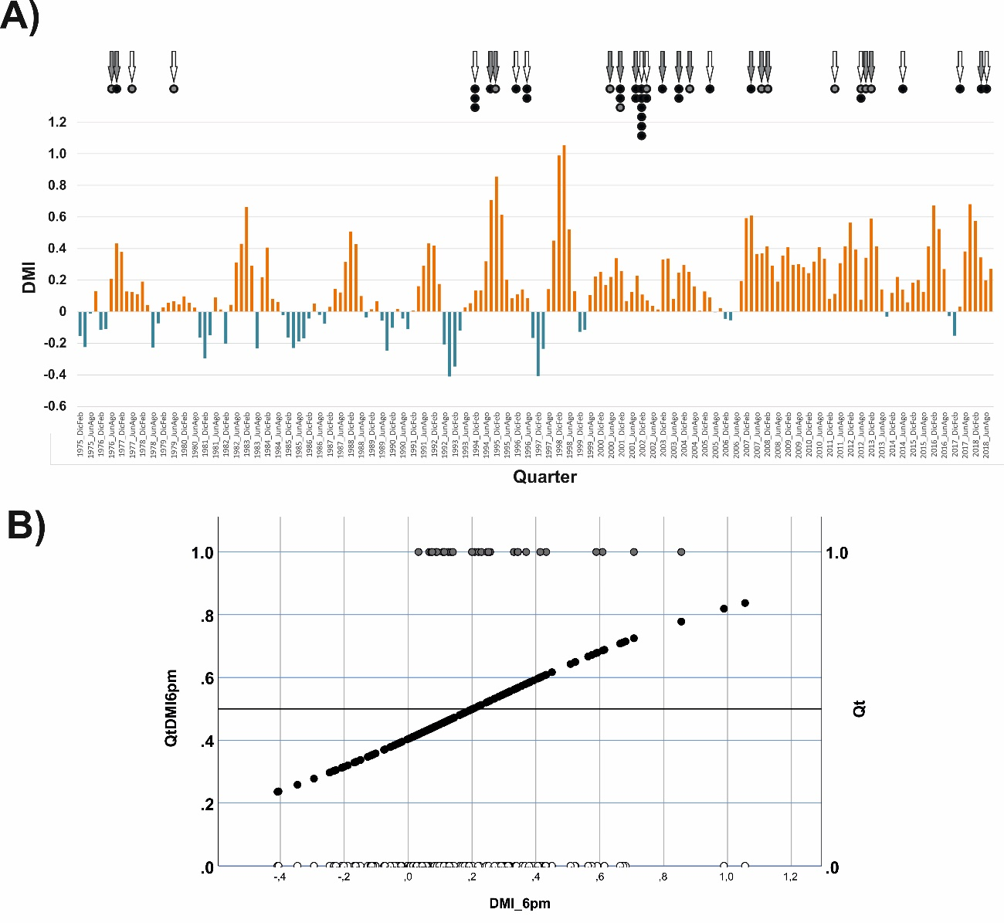Figure S3. A) Variation of the Dipole Mode Index (DMI) during the meteorological quarters (December to November) covered by this study, meteorological quarters with EBOD outbreaks (arrows), and occurrence of EBOD outbreaks (circles). Colours of the arrows: climatic favourability for EBOD outbreaks according to the model QtDMI6pm (White: F<0,5; Grey: 0,5≤F<0,8). Circle colours: biogeographical favourability for the presence of the Ebola-virus at the location of the outbreaks (Grey: 0,2≤F<0,8; Black: F≥0,8). B) Relationship between climatic favourability for the occurrence of EBOD outbreaks in the areas of high biogeographical favourability for the presence of the Ebola-virus during a meteorological year according to the model QtDMI6pm and the DMI of the previous year. DMI_6pm: Mean DMI in the previous six months. Grey circles at the top: meteorological quarters with EBOD outbreaks. White circles at the bottom: meteorological quarters without EBOD outbreaks. Logit of the climatic favourability model QtDMI6pm in Table 2.
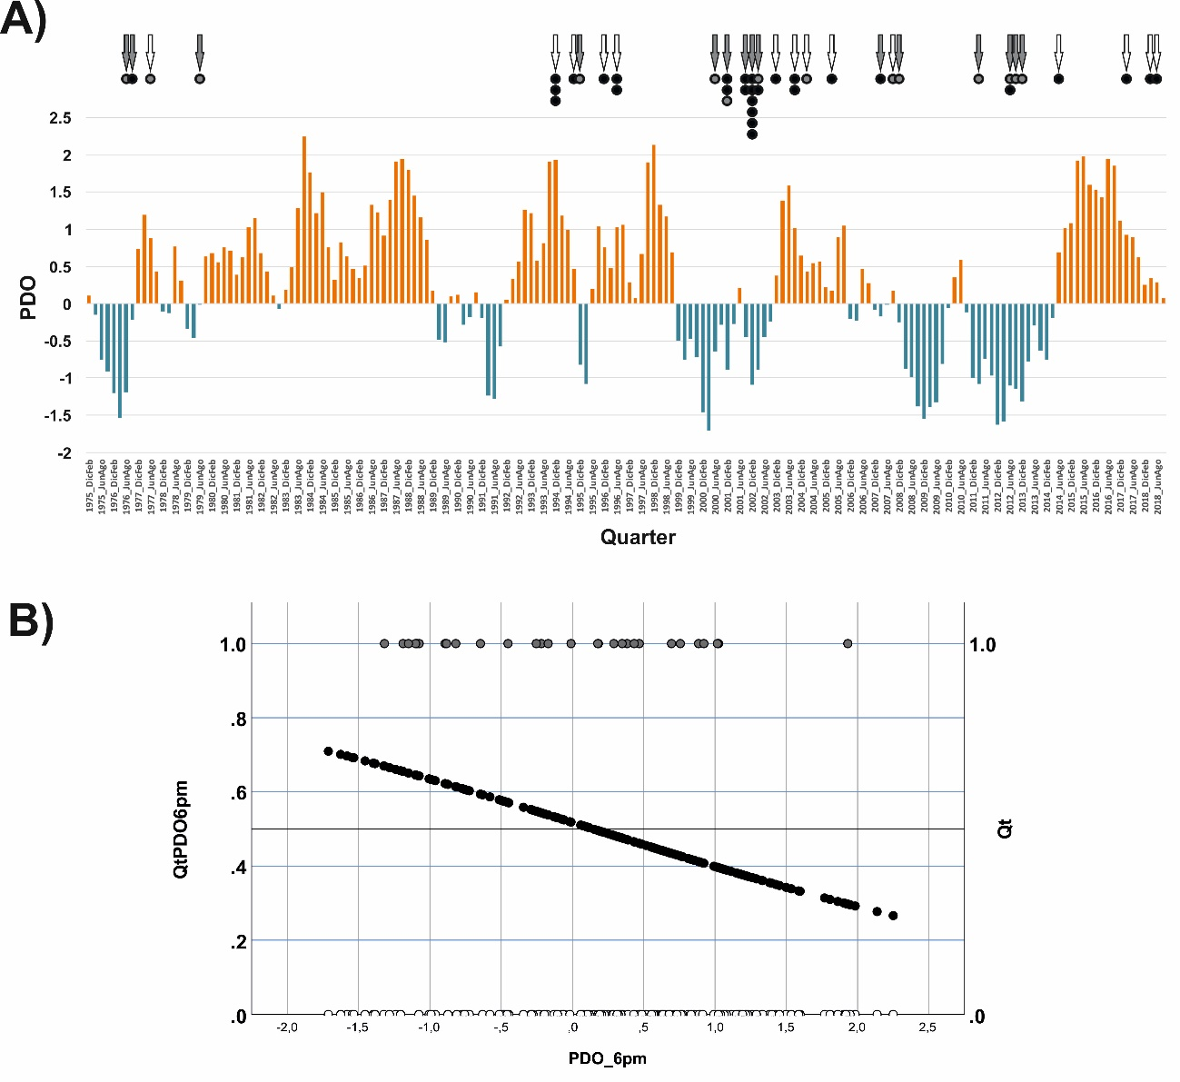Figure S4. A) Variation of the Pacific Decadal Oscillation Index (PDO) during the meteorological quarters (December to November) covered by this study, meteorological quarters with EBOD outbreaks (arrows), and occurrence of EBOD outbreaks (circles). Colours of the arrows: climatic favourability for EBOD outbreaks according to the model QtPDO6pm (White: F<0,5; Grey: 0,5≤F<0,8). Circle colours: biogeographical favourability for the presence of the Ebola-virus at the location of the outbreaks (Grey: 0,2≤F<0,8; Black: F≥0,8). B) Relationship between climatic favourability for the occurrence of EBOD outbreaks in the areas of high biogeographical favourability for the presence of the Ebola-virus during a meteorological year according to the model QtPDO6pm and the PDO of the previous year. PDO_6pm: Mean PDO in the previous six months. Grey circles at the top: meteorological quarters with EBOD outbreaks. White circles at the bottom: meteorological quarters without EBOD outbreaks. Logit of the climatic favourability model QtPDO6pm in Table 2.
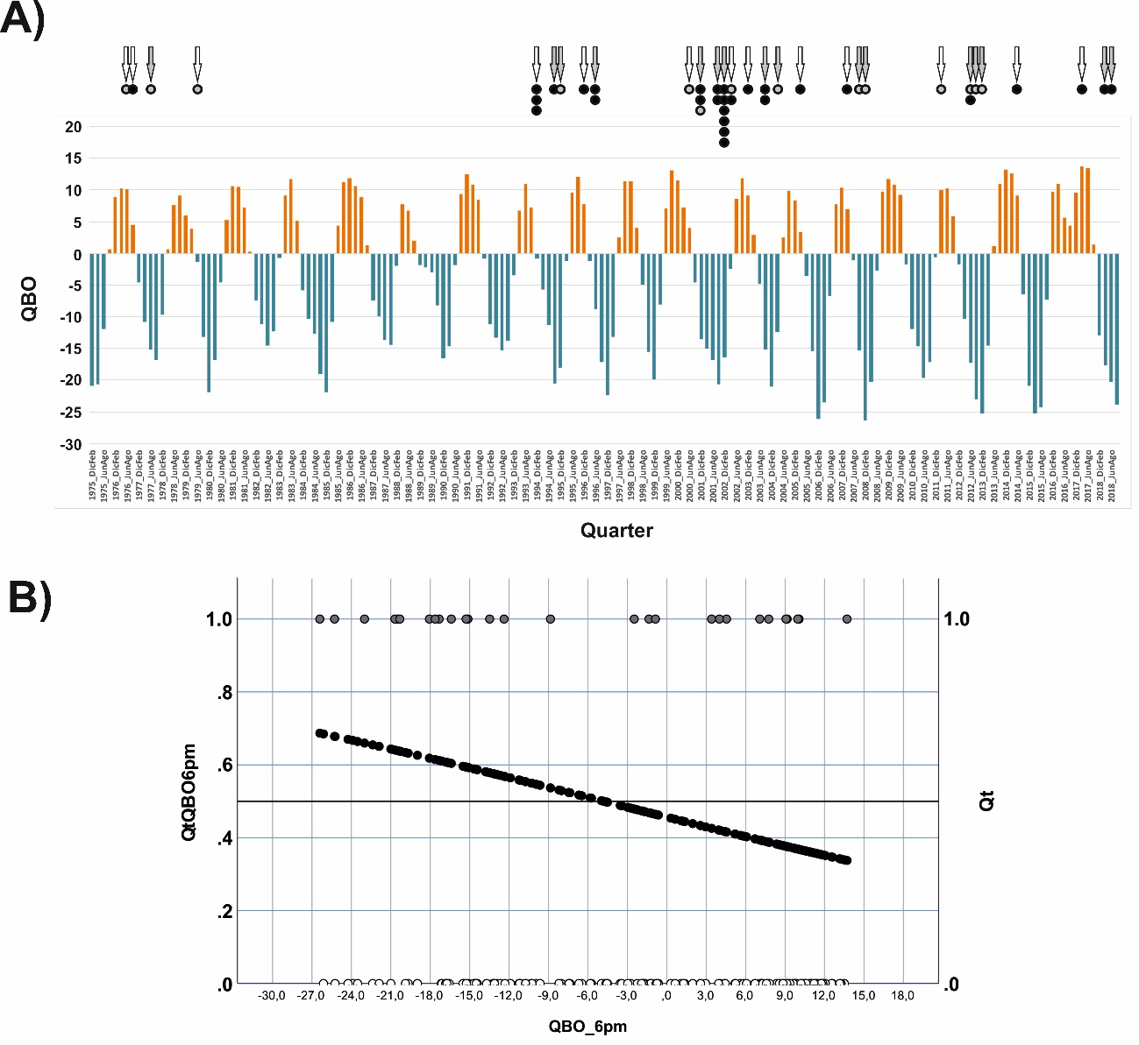Figure S5. A) Variation of the Quasi-Biennial Oscillation (QBO) during the meteorological quarters (December to November) covered by this study, meteorological quarters with EBOD outbreaks (arrows), and occurrence of EBOD outbreaks (circles). Colours of the arrows: climatic favourability for EBOD outbreaks according to the model QtQBO6pm (White: F<0,5; Grey: 0,5≤F<0,8). Circle colours: biogeographical favourability for the presence of the Ebola-virus at the location of the outbreaks (Grey: 0.2≤F<0.8; Black: F≥0.8). B) Relationship between climatic favourability for the occurrence of EBOD outbreaks in the whole study area during a meteorological year according to the model QtQBO6pm and the QBO of the previous 6 months. QBO_6pm: Mean QBO in the previous six months. Grey circles at the top: meteorological quarters with EBOD outbreaks. White circles at the bottom: meteorological quarters without EBOD outbreaks. Logit of the climatic favourability model QtQBO6pm in Table 2.
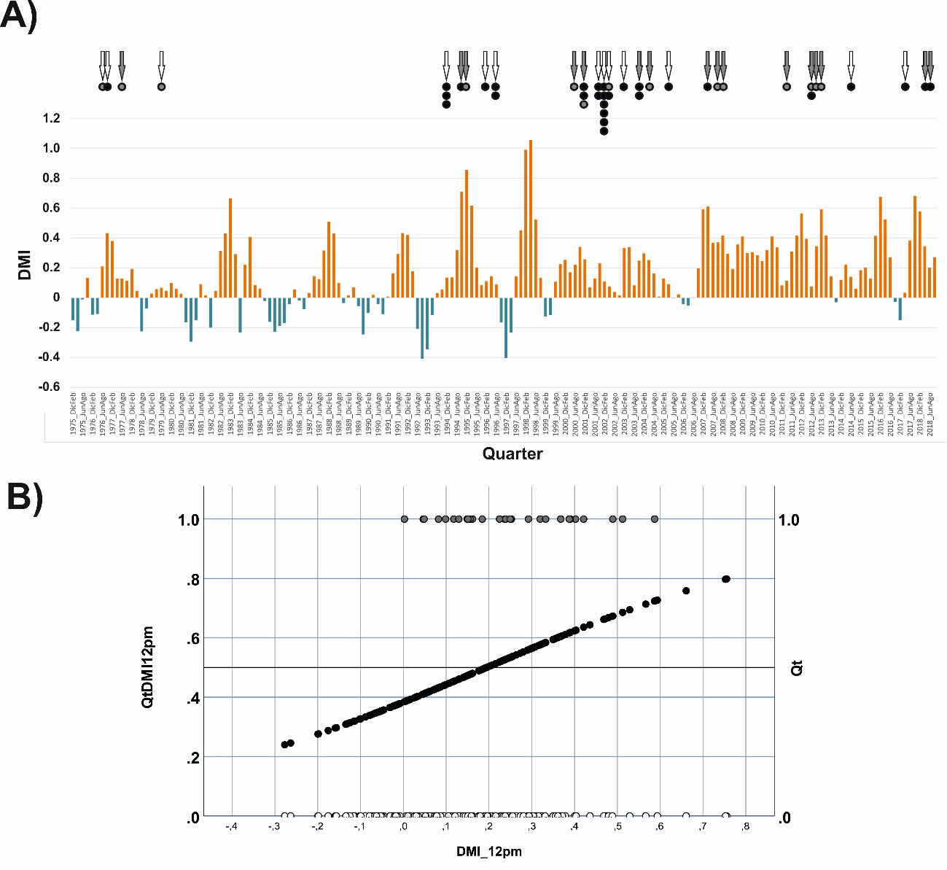Figure S6. A) Variation of the Dipole Mode Index (DMI) during the meteorological quarters (December to November) covered by this study, meteorological quarters with EBOD outbreaks (arrows), and occurrence of EBOD outbreaks (circles). Colours of the arrows: climatic favourability for EBOD outbreaks according to the model QtDMI6pm (White: F<0,5; Grey: 0,5≤F<0,8). Circle colours: biogeographical favourability for the presence of the Ebola-virus at the location of the outbreaks (Grey: 0,2≤F<0,8; Black: F≥0,8). B) Relationship between climatic favourability for the occurrence of EBOD outbreaks in the areas of high biogeographical favourability for the presence of the Ebola-virus during a meteorological year according to the model QtDMI6pm and the DMI of the previous year. DMI_6pm: Mean DMI in the previous six months. Grey circles at the top: meteorological quarters with EBOD outbreaks. White circles at the bottom: meteorological quarters without EBOD outbreaks. Logit of the climatic favourability model QtDMI6pm in Table 2.
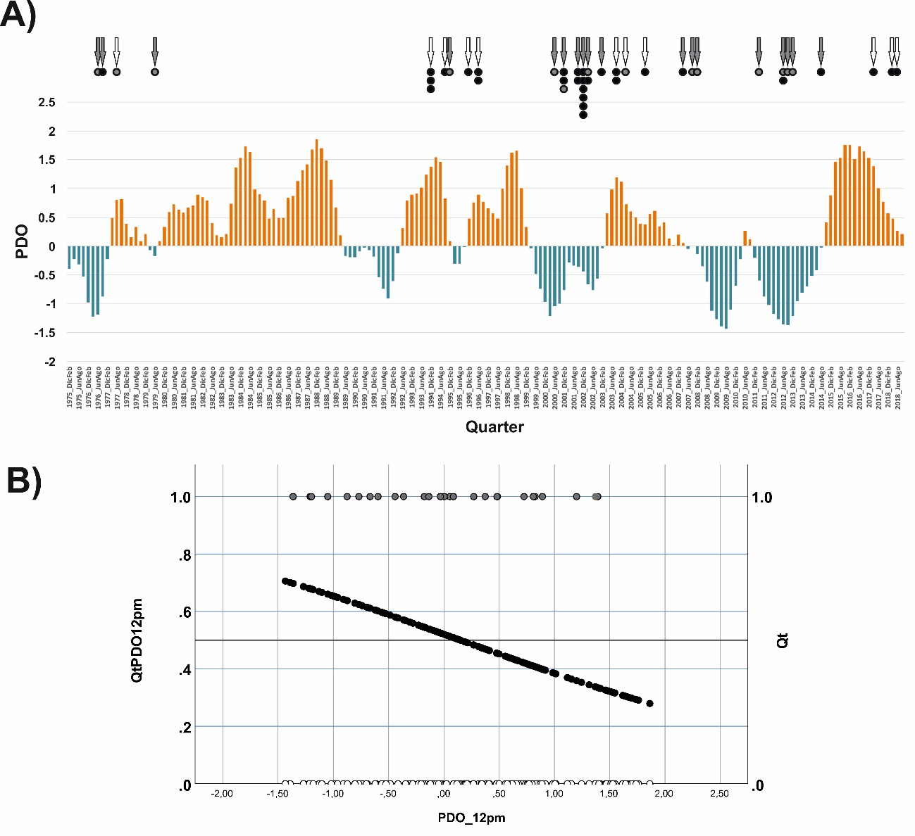Figure S7. A) Variation of the Pacific Decadal Oscillation (PDO) during the meteorological quarters (December to November) covered by this study, meteorological quarters with EBOD outbreaks (arrows), and occurrence of EBOD outbreaks (circles). Colours of the arrows: climatic favourability for EBOD outbreaks according to the model QtPDO12pm (White: F<0,5; Grey: 0,5≤F<0,8). Circle colours: biogeographical favourability for the presence of the Ebola-virus at the location of the outbreaks (Grey: 0,2≤F<0,8; Black: F≥0,8). B) Relationship between climatic favourability for the occurrence of EBOD outbreaks in the whole study area during a meteorological year according to the model QtPDO12pm and the PDO of the previous 12 months. PDO_12pm: Mean PDO in the previous 12 months. Grey circles at the top: meteorological quarters with EBOD outbreaks. White circles at the bottom: meteorological quarters without EBOD outbreaks. Logit of the climatic favourability model QtPDO12pm in Table 2.

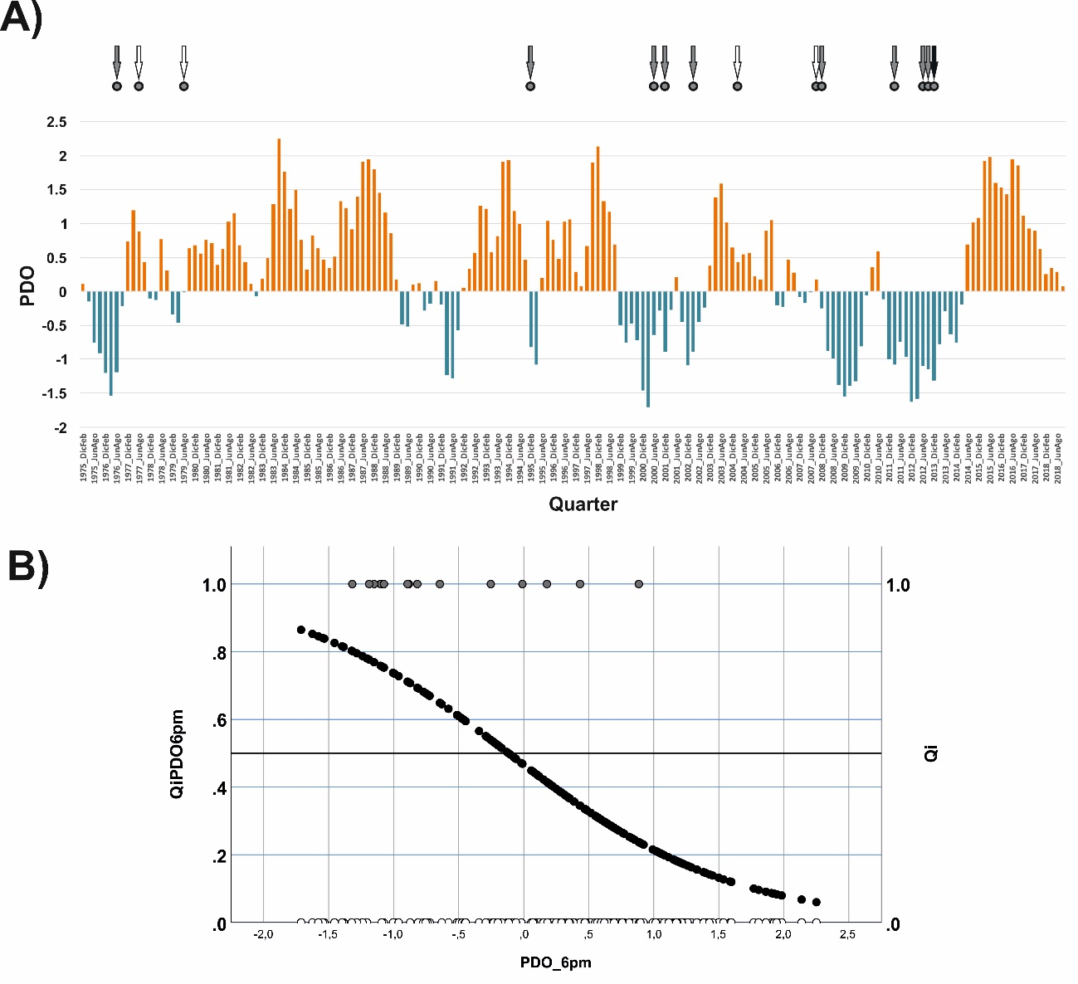 Figure S8. A) Variation of the Pacific Decadal Oscillation (PDO) during the meteorological quarters (December to November) covered by this study, meteorological quarters with EBOD outbreaks (arrows), and occurrence of EBOD outbreaks in the areas of intermediate biogeographical favourability for the presence of the Ebola-virus (circles). Colours of the arrows: climatic favourability for EBOD outbreaks according to the model QiPDO6pm (White: F<0,5; Grey: 0,5≤F<0,8; Black: F≥0,8). B) Relationship between climatic favourability for the occurrence of EBOD outbreaks in the areas of intermediate biogeographical favourability for the presence of the Ebola-virus during a meteorological year according to the model QiPDO6pm and the PDO of the previous six months. PDO_6pm: Mean PDO in the previous six months. Grey circles at the top: meteorological quarters with EBOD outbreaks. White circles at the bottom: meteorological quarters without EBOD outbreaks. Logit of the climatic favourability model QiPDO6pm in Table 2.

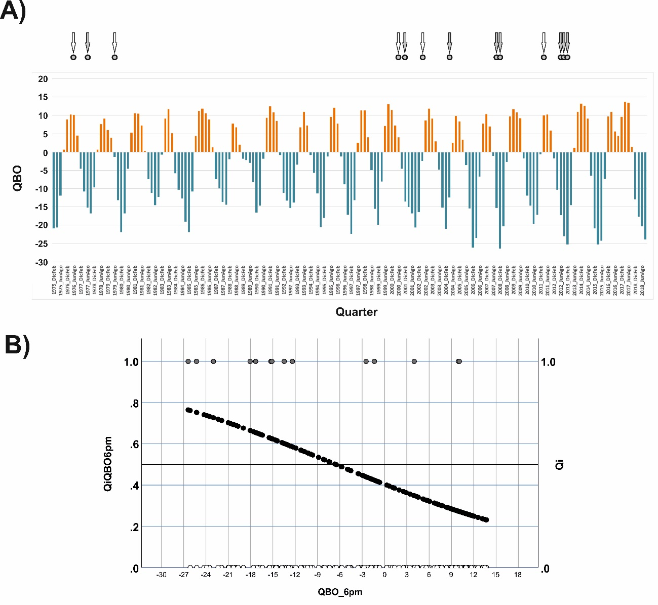
Figure S9. A) Variation of the Quasi-Biennial Oscillation (QBO) during the meteorological quarters (December to November) covered by this study, meteorological quarters with EBOD outbreaks (arrows), and occurrence of EBOD outbreaks in the areas of intermediate biogeographical favourability for the presence of the Ebola-virus (circles). Colours of the arrows: climatic favourability for EBOD outbreaks according to the model QiQBO6pm (White: F<0,5; Grey: 0,5≤F<0,8). B) Relationship between climatic favourability for the occurrence of EBOD outbreaks in the areas of intermediate biogeographical favourability for the presence of the Ebola-virus during a meteorological year according to the model QiQBO6pm and the QBO of the previous six months. QBO_6pm: Mean QBO in the previous six months. Grey circles at the top: meteorological quarters with EBOD outbreaks. White circles at the bottom: meteorological quarters without EBOD outbreaks. Logit of the climatic favourability model QiQBO6pm in Table 2.

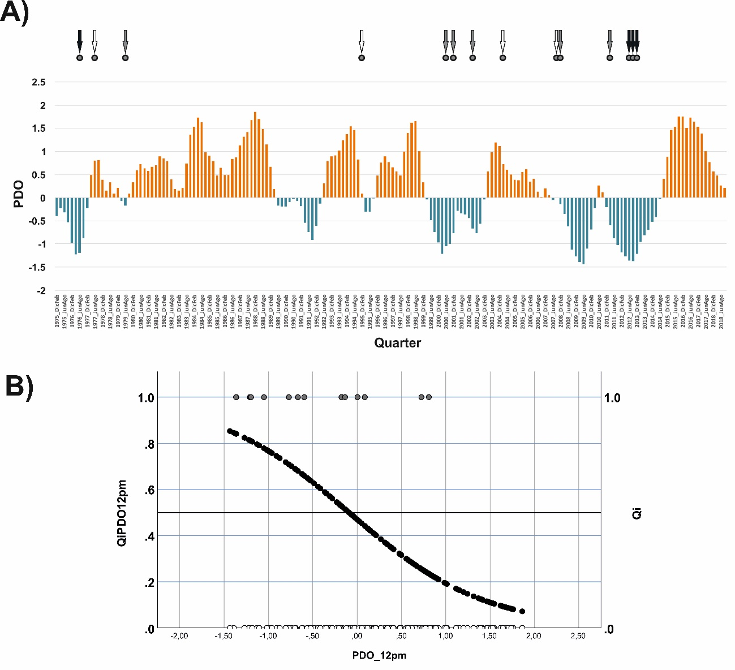Figure S10. A) Variation of the Pacific Decadal Oscillation (PDO) during the meteorological quarters (December to November) covered by this study, meteorological quarters with EBOD outbreaks (arrows), and occurrence of EBOD outbreaks in the areas of intermediate biogeographical favourability for the presence of the Ebola-virus (circles). Colours of the arrows: climatic favourability for EBOD outbreaks according to the model QiPDO12pm (White: F<0,5; Grey: 0,5≤F<0,8; Black: F≥0,8). B) Relationship between climatic favourability for the occurrence of EBOD outbreaks in the areas of intermediate biogeographical favourability for the presence of the Ebola-virus during a meteorological year according to the model QiPDO12pm and the PDO of the previous 12 months. PDO_12pm: Mean PDO in the previous 12 months. Grey circles at the top: meteorological quarters with EBOD outbreaks. White circles at the bottom: meteorological quarters without EBOD outbreaks. Logit of the climatic favourability model QiPDO12pm in Table 2.

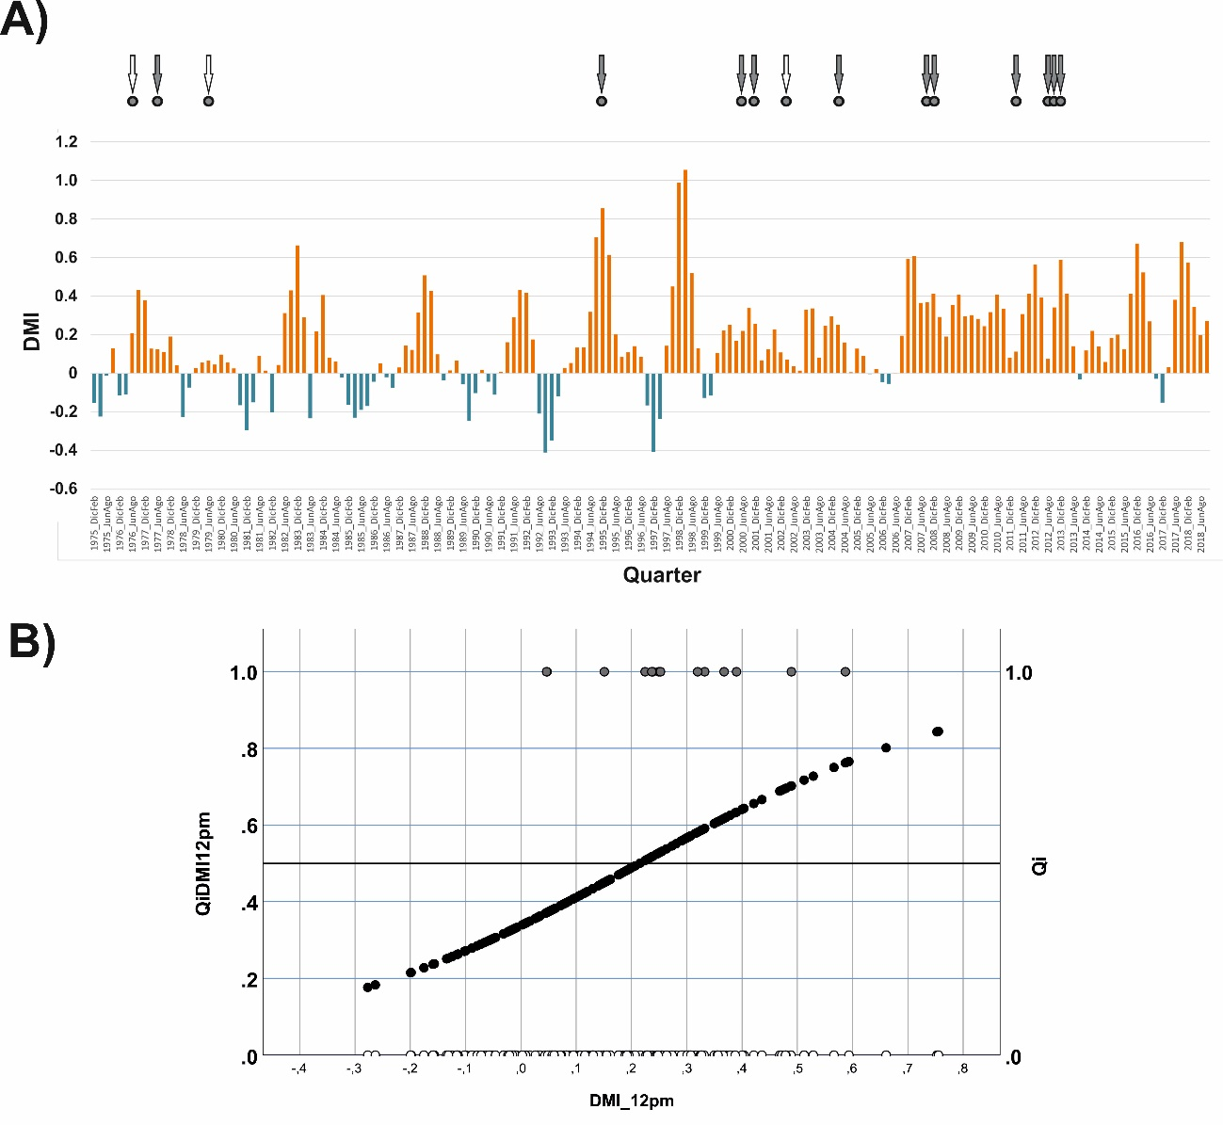Figure S11. A) Variation of the Dipole Mode Index (DMI) during the meteorological quarters (December to November) covered by this study, meteorological quarters with EBOD outbreaks (arrows), and occurrence of EBOD outbreaks in the areas of intermediate biogeographical favourability for the presence of the Ebola-virus (circles). Colours of the arrows: climatic favourability for EBOD outbreaks according to the model QiDMI12pm (White: F<0,5; Grey: 0,5≤F<0,8). B) Relationship between climatic favourability for the occurrence of EBOD outbreaks in the areas of intermediate biogeographical favourability for the presence of the Ebola-virus during a meteorological year according to the model QiDMI12pm and the DMI of the previous 12 months. DMI_12pm: Mean DMI in the previous 12 months. Grey circles at the top: meteorological quarters with EBOD outbreaks. White circles at the bottom: meteorological quarters without EBOD outbreaks. Logit of the climatic favourability model QiDMI12pm in Table 2.

