Supplementary figures and tables

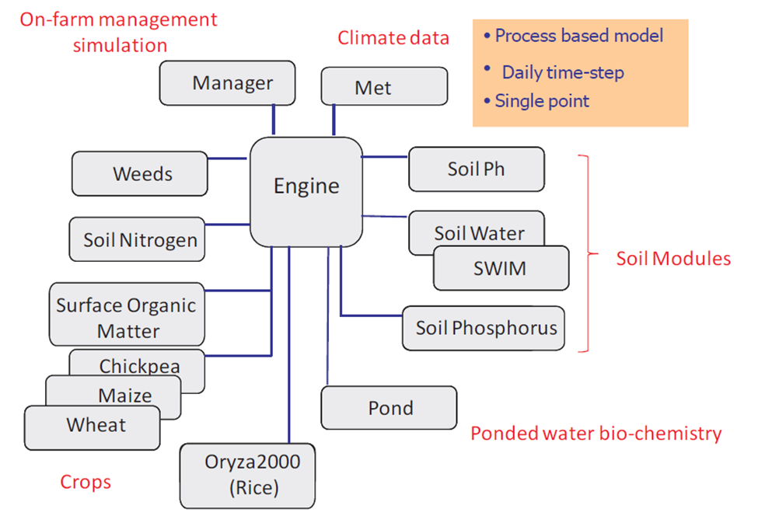
Figure 1: Modular structure of APSIM adapted from Gaydon (2014)

Table 1: Key genetic coefficients of PBA Hattrick and the Ideotype used by the APSIM-Chickpea model
Genetic coefficient | PBA Hattrick | Ideotype
Rate of HI increase (no unit) | 0.01 | 0.0110
From emergence to end of juvenile phase (DD) | 515.0 | 515.0
Estimated days from emergence to floral initiation (days) | 83 | 83
End of juvenile (DD) | 446.0 | 400.0
From froral initiation to flowering (DD) | 33.0 | 33.0
From flowering to start grain fill (DD) | 410 | 450.0
Start of grain fill units (DD) | 690 | 690
End of grain fill units (DD) | 60 | 60
DD means degree days

Table 2: Wald statistic, correlations and decision used to construct ideotype
Parameter | Wald statistic | Correlation | Decisions
Early ground cover (%) | 14.2** | 0.10 | H – LSD
Days to first flower | 31.66*** | -0.18 | L + LSD
Days to 50% flowering | 18.63*** | -0.23 | L + LSD
Days to last flower | 24.69*** | -0.36* | L + LSD
Flower duration (days) | 24.62*** | 0.12 | H – LSD
NDVI at early podding | 58.92*** | 0.55 | H – LSD
NDVI at late podding | 8.32* | -0.52* | L + LSD
Plant height at late flowering (cm) | 20.72*** | 0.10 | L + LSD
Plant height at late podding (cm) | 29.84*** | 0.04 | L + LSD
Chlorophyll content at mid podding (SU) | 5.38* | 0.02 | H – LSD
Chlorophyll content at late podding (SU) | 9.61** | -0.35* | L + LSD
No of leaflets per leaf | 13.42** | -0.10 | AV ± LSD
Single leaf area (cm²) | 25.64*** | -0.04 | AV ± LSD
Single leaflet area (cm²) | 35.79*** | -0.03 | AV ± LSD
Leaflet length (cm²) | 28.16*** | 0.02 | AV ± LSD
No of pods per plant | 11.43** | -0.18 | AV ± LSD
Pod biomass per plant (g) | 19.11*** | -0.31 | L + LSD
Pod Harvest index | 9.6** | 0.10 | AV ± LSD
Shoot biomass | 25.85*** | -0.41* | L + LSD
Shoot Harvest index | 47.88*** | 0.24 | AV ± LSD
1000 seed weight (g) | 9.05** | -0.39 | L + LSD
Wald statistic is from the multiple linear regression Wald tests for dropping terms. Significant terms at various levels of confidence were picked. * = P<0.05, ** = P<0.01, *** = P<0.001. Correlations are between the considered traits and yield. Decision on ideotype optimization based on trait ranges and relationship with yield and other traits. L = low, H = high, AV = average, LSD = least significant difference at 5%, cm = centimetre, g = grams and SU = SPAD Units. Parameters in bold can be simulated using APSIM.

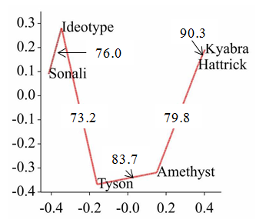
PC 1
PC 2

Figure 2: Minimum spanning tree for genotype similarity. Genotypes close to each other along the line are more similar than those further away in the tree. The numbers inside the figure indicate per cent similarity between two adjacent genotypes. The X-axis is principal component 1 (PC1) and the Y-axis is principal component 2 (PC2) of the output.

Table 3: Multiple linear regression of various growth stages in relation to yield
Summary of analysis
Source | d.f. | s.s. | m.s. | v.r. | F pr.
Regression | 2 | 22550219 | 11275109 | 619.05 | <.001
Residual | 47 | 856032 | 18213
Total | 49 | 23406251 | 477679
Wald tests for dropping terms
Term | Wald statistic | d.f. | F statistic | F pr.
swdSGF | 493.6 | 1 | 493.64 | <0.001
swdEGF | 10.8 | 1 | 10.8 | 0.002
Where swdSGF is soil water deficit at the start of grain filling and swdEGF is soil water deficit at the end of grain filling.

