Supplementary materials 2
Magnitude of air temperature anomalies in June 2019
In June 2019 more than 20 hot days were recorded (Fig. S2A). Very hot days occurred all over Poland with different frequency (from 1 to 15 days). The fewest (<5) were along the Gulf of Gdańsk and the most frequent (over 10 days) in central-western Poland (Fig. S2B). In western Poland, there were also 1-2 extremely hot days. Warm and tropical nights were relatively frequent and distributed all over Poland (Fig. S2C, S2D). Two heatwaves appeared in June. The first of them, with different lengths at individual stations (3-7 days), occurred between 10 and 16 June, covering most of Poland (Fig. S2E). The second 3-day heat wave, with record temperature of up to 38°C, between June 25 and 27 covered Central and Western Poland (Fig. S2F).
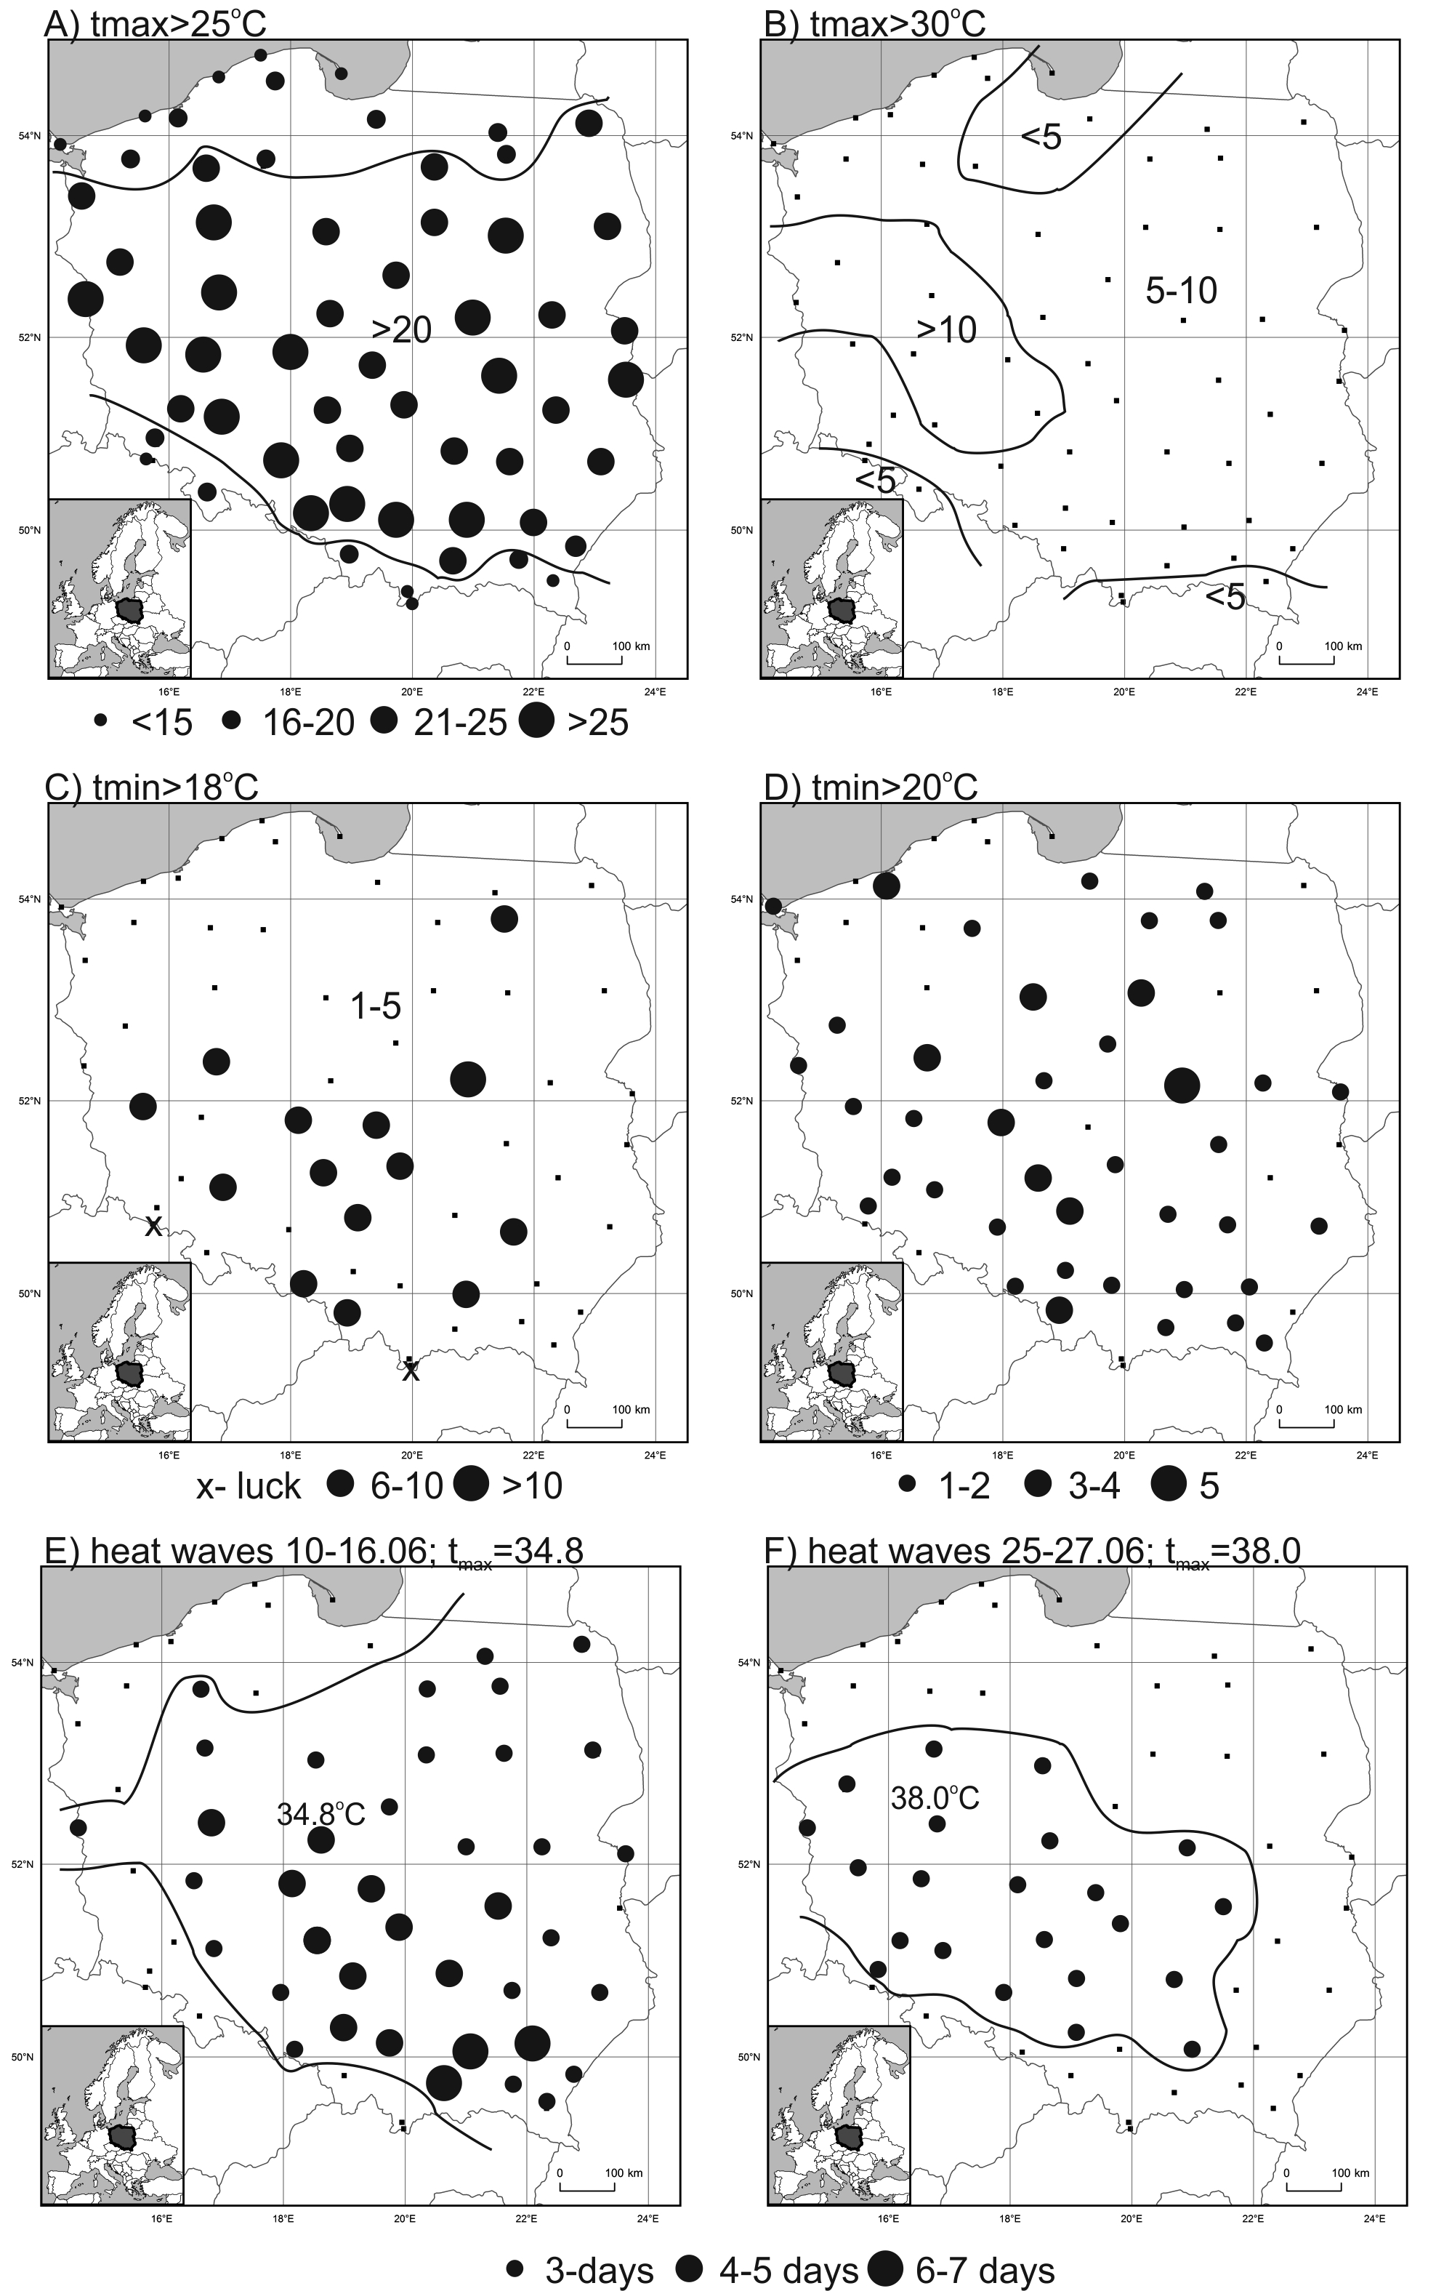
Fig. S2. Number of hot (tmax>25°C, A) and very hot (tmax>30°C, B), warm (tmin>18°C, C) and tropical (tmin>20°C, D) as well as length of heatwaves (E, F) in June 2019
Source: author’s own elaboration

