Analysis of Spatial Variability of the Summer Thermal Comfort Indices in İstanbul – Supplementary Material
Table S.1. Specifications of TSMS stations observing meteorological variables in İstanbul between 2013-2017 and missing value rates
 | Stations/District | Coordinates | Altitude (m) | Climatic features | Corine Land Cover Type | Observed variables and % of missing values
1 | Adalar (Buoy)/ Adalar | 40.9328  28.9489 | 0 | South, coastal | Sea and ocean | T_{a} (39%)  RH (43%)  WS (38%)
2 | Arnavutköy/ Arnavutköy | 41.2203  28.7075 | 140 | Inland, rural | Discontunious Urban Fabric | T_{a} (26%)  RH (29%)  WS (26%)
3 | Florya/Bakırköy | 40.9758  28.7865 | 37 | South, coastal, urban | Green Urban Areas | T_{a} (2%)  RH (9%)  WS (1%)
4 | Atatürk Havalimanı/ Bakırköy | 40.9819  28.8208 | 33 | South, coastal, urban | Airports | T_{a} (2%)  RH (2%)  WS (4%)  C (2%)
5 | Beykoz/Beykoz | 41.1417  29.0739 | 5 | Bosphorus,coastal, urban | Industrial or Commercial Units | T_{a} (24%)  RH (25%)  WS (26%)
6 | Beykoz Anadolu Feneri/Beykoz | 41.2233  29.1658 | 58 | North, coastal, forest | Broad Leaved Forest | T_{a} (33%)  RH (33%)  WS (32%)
7 | Büyükçekmece/ Büyükçekmece | 41.0453  28.5900 | 20 | South, coastal, urban | Industrial or Commercial Units | T_{a} (2%)  RH (7%)  WS (3%)
8 | Çatalca Radar Sahası/Çatalca | 41.3409  28.3568 | 381 | Inland, forest | Broad Leaved Forest | T_{a} (3%)  RH (19%)  WS (3%)
9 | Çekmeköy/ Çekmeköy | 41.0783  29.3256 | 80 | Inland, forest | Discontunious Urban Fabric | T_{a} (23%)  RH (29%)  WS (25%)
10 | Eyüp/Eyüp | 41.1028  28.9242 | 54 | Inland, urban | Pastures | T_{a} (3%)  RH (4%)  WS (3%)
11 | Kumkapı Fener/ Fatih | 41.0042  28.9547 | 12 | South, coastal, urban | Discontunious Urban Fabric | T_{a} (21%)  RH (23%)  WS (25%)
12 | Fatih/Fatih | 41.0155  28.9601 | 10 | Inland, urban | Discontunious Urban Fabric | T_{a} (1%)  RH (8%)  WS (1%)
13 | Davutpaşa Marmara/ Güngören | 41.0266  28.8853 | 68 | Inland, urban | Sport and Leisure Facilities | T_{a} (23%)  RH (25%)  WS (21%)
14 | Göztepe/Kadıköy | 40.9890  29.0532 | 41 | South, inland, urban | Industrial or Commercial Units | T_{a} (35%)  RH (35%)  WS (33%)
15 | Kadıköy Rıhtım/ Kadıköy | 40.9883  29.0190 | 5 | South, coastal, urban | Green Urban Areas | T_{a} (3%)  RH (4%)  WS (2%)

 | Stations/District | Coordinates | Altitude (m) | Climatic features | Corine Land Cover Type | Observed variables and % of missing values
16 | İstanbul Bölge/ Kartal | 40.9113  29.1558 | 18 | South, coastal, urban | Industrial or Commercial Units | T_{a} (0.4%)  RH (1%)  WS (2%)  C (23%)
17 | Sabiha Gökçen Havalimanı/ Pendik | 40.8977  29.3033 | 99 | Inland, urban | Airports | T_{a} (0.8%)  RH (0.8%)  WS (2%)  C (0.5%)
18 | Sancaktepe/ Sancaktepe | 41.0086  29.2822 | 110 | Inland, urban | Industrial or Commercial Units | T_{a} (23%)  RH (30%)  WS (24%)
19 | Samandıra Havalimanı/ Sancaktepe | 40.9866  29.2135 | 123 | Inland, urban | Airports | T_{a} (4%)  RH (7%)  WS (3%)
20 | Sarıyer/Sarıyer | 41.1464  29.0502 | 59 | Bosphorus,coastal, urban | Green Urban Areas | T_{a} (0.1%)  RH (1%)  WS (0.2%)  C (18%)
21 | Kumköy-Kilyos/ Sarıyer | 41.2505  29.0384 | 38 | North, coastal, forest | Discontunious Urban Fabric | T_{a} (0.4%)  RH (0.9%)  WS (0.8%)  C (42%)
22 | Silivri/Silivri | 41.1856  28.1575 | 195 | Inland, rural | Broad Leaved Forest | T_{a} (27%)  RH (28%)  WS (28%)
23 | Silivri Fener/ Silivri | 41.0731  28.2394 | 9 | South, coastal, sub-urban | Port Areas | T_{a} (9%)  RH (12%)  WS (8%)
24 | Şile/Şile | 41.1688  29.6007 | 83 | North, coastal, sub-urban | Discontunious Urban Fabric | T_{a} (2%)  RH (3%)  WS (2%)
25 | Şişli/Şişli | 41.0547  28.9683 | 60 | Inland, urban | Road and Rail Networks and Associated Land | T_{a} (28%)  RH (28%)  WS (29%)
26 | Tuzla İTÜ/Tuzla | 40.8128  29.2978 | 13 | South, coastal, urban | Port Areas | T_{a} (7%)  RH (10%)  WS (7%)
27 | Tuzla Aydınlı/ Tuzla | 40.8514  29.2717 | 8 | South, coastal, urban | Port Areas | T_{a} (6%)  RH (9%)  WS (6%)
28 | Tuzla/Tuzla | 40.8278  29.2931 | 3 | South, coastal, urban | Industrial or Commercial Units | T_{a} (2%)  RH (2%)  WS (3%)
29 | Ümraniye/ Ümraniye | 41.0294  29.1383 | 191 | Inland, urban | Coniferous Forest | T_{a} (26%)  RH (26%)  WS (26%)
30 | Üsküdar/Üsküdar | 41.0328  29.0464 | 75 | Bosphorus,coastal, urban | Discontunious Urban Fabric | T_{a} (28%)  RH (27%)  WS (26%)
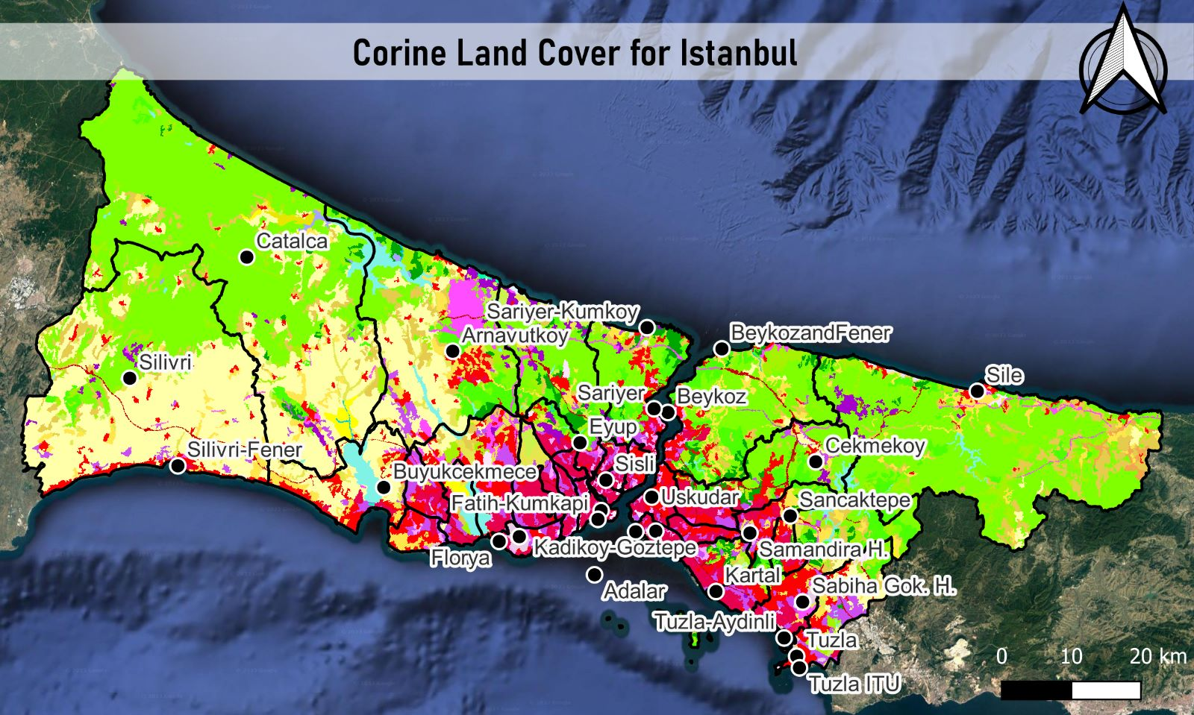
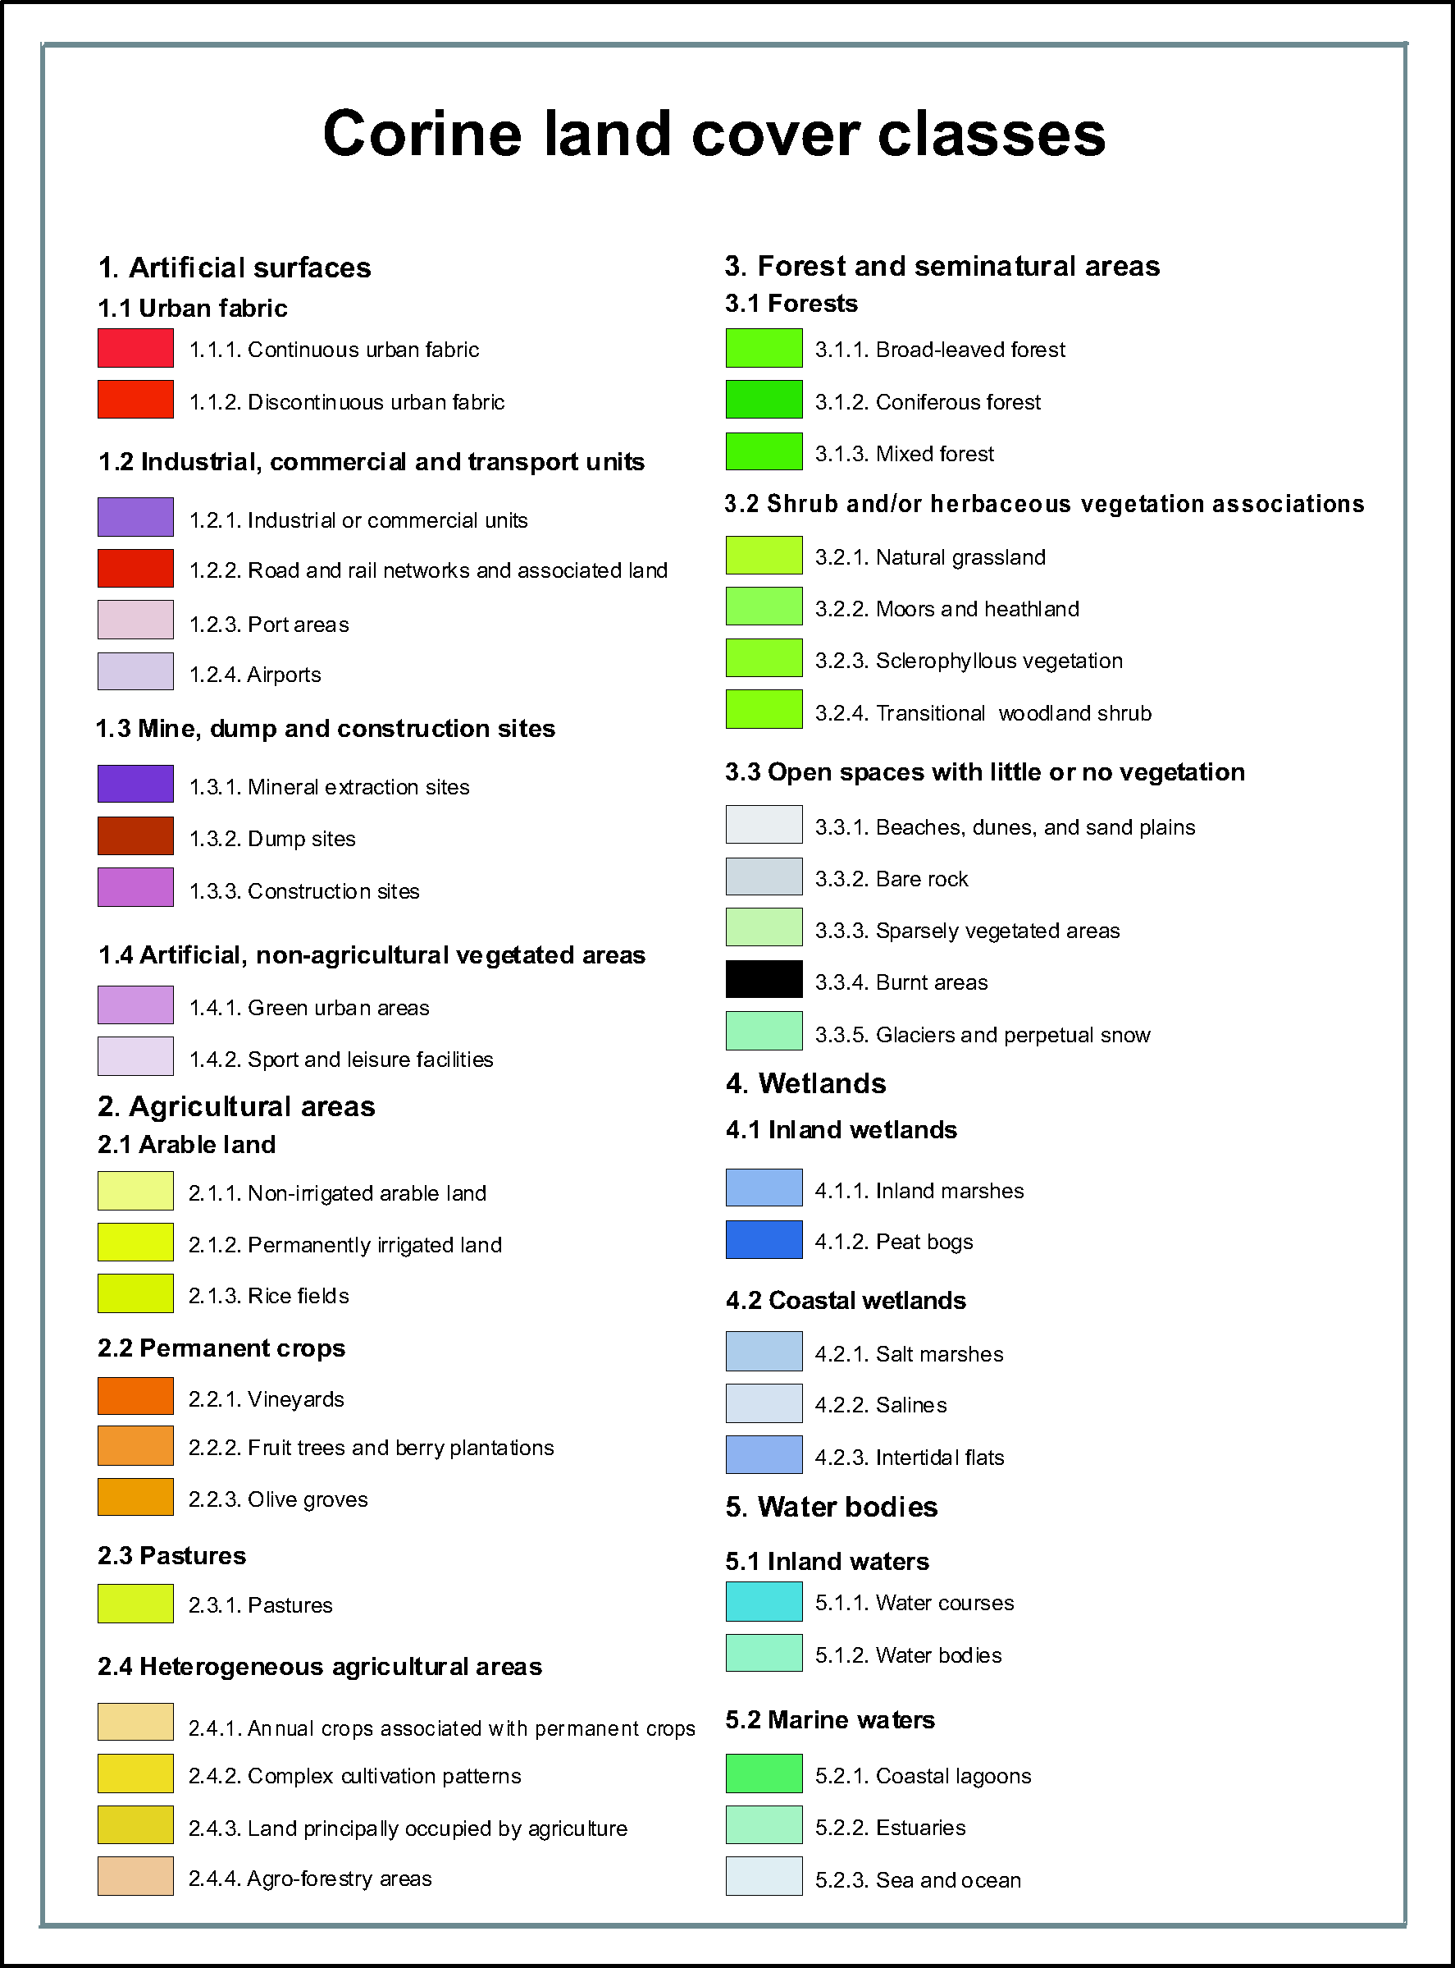
Figure S.1. CORINE Land Cover for İstanbul
AT Calculation Approaches by Steadman (1994)
- Temperature and vapor pressure dependent approach:
AT_{p} = 0,89 T + 0,38 P_{vap} – 2,56
AT_{p} : Apparent temperature (°C), T : Temperature (°C), P_{vap} : Vapor pressure (hPa)
- Temperature, vapor pressure and wind speed dependent approach:
AT_{pv} = T + 0,33 P_{vap} – 0,7 ν₁₀ – 4,00
AT_{pv} : Apparent temperature (°C), ν₁₀ : Wind speed measured at 10 m height (m/s)
- Temperature, vapor pressure, wind speed and radiation dependent approach:
AT_{pvg} = T + 0,35 P_{vap} – 0,7 ν₁₀ + 0,7 Q_{g} / (ν₁₀ + 10) – 4,25
AT_{pvg} : Apparent temperature (°C), Q_{g} : Absorbed radiation per unit body surface (W/m²)

Assessment Tables of Thermal Indexes
Table S.2. Assesment table of HI (NWS, 2021)
HI (°C) | Category | Possible heat disorders for people in high risk groups
27-32 | Caution | Fatigue possible with prolonged exposure and/or physical activity.
33-41 | Extreme Caution | Sunstroke, muscle cramps, and/or heat exhaustion possible with prolonged exposure and/or physical activity.
42-54 | Danger | Sunstroke, muscle cramps, and/or heat exhaustion likely. Heatstroke possible with prolonged exposure and/or physical activity.
>54 | Extreme Danger | Heat stroke or sunstroke likely.

Table S.3. Assessment table of WBGT (ABM, 2021b)
WBGT (°C) | Recommended outdoor activities
<18 | Unlimited
18 – 23 | Keep alert for possible increases in the index and for symptoms of heat stress
23 – 28 | Active exercise for unacclimatized persons should be curtailed
28 – 30 | Active exercise for all but the well-acclimated should be curtailed
>30 | All training should be stopped

PET is derived by based on Munich Energy-Balance Model for Individuals (MEMI):
M + W + R + C + E_{D} + E_{Re} + E_{Sw} + S = 0
M: Metabolic rate, W: Physical work output, R: Net radiation of the body, C: Convective heat flow, E_{D}: Latent heat flow by diffusion through skin, E_{Re}: Latent heat flux due to respiration, E_{Sw}: Latent heat flux by evaporation of sweat, S: Storage heat flow
Table S.4. Assessment table of PET (Matzarakis et al., 1999)
PET (°C) | Thermal perception | Grade of physiological stress
>41 | Very hot | Extreme heat stress
35-41 | Hot | Strong heat stress
29-35 | Warm | Moderate heat stress
23-29 | Slightly warm | Slight heat stress
18-23 | Comfortable | No thermal stress
13-18 | Slightly cool | Slight cold stress
8-13 | Cool | Moderate cold stress
4-8 | Cold | Strong cold stress
≤4 | Very cold | Extreme cold stress

UTCI is derived by based on UTCI-Fiala model:
M + W + C + K + E + Q + Res ± S = 0
M: Metabolic production, W: Mechanical power, C: Convection, K: Conduction, E: Evaporation, Q: Radiation, Res: Respiration, S: Storage (change in heat content of the body)
Table S.5. Assessment table of UTCI (Blazejczyk et al., 2013)
UTCI (°C) | Stress Category
≥ 46 | Extreme heat stress
38 – 46 | Very strong heat stress
32 – 38 | Strong heat stress
26 – 32 | Moderate heat stress
9 – 26 | No thermal stress
0 – 9 | Slight cold stress
-13 – 0 | Moderate cold stress
-27 – -13 | Strong cold stress
-40 – -27 | Very strong cold stress
< -40 | Extreme cold stress

PT is derived by based on Klima-Michel model:
M - W = (C + R + E_{sk}) + (C_{res} + E_{res}) + S_{sk} + S_{cr}
M: Metabolic heat production, W: Mechanical work, S_{sk}: Heat storage in the skin, S_{cr}: Heat storage in the core, C: Convective loss of sensible heat, R: Radiative loss of sensible heat, E_{sk}: Evaporative loss from the skin, C_{res}: Loss of sensible heat by respiration, E_{res}: Loss of latent heat by respiration
Table S.6. Assessment table of PT (Staiger et al., 2012)
PT (°C) | Thermal perception | Thermo-physiological stress
≥ 38 | Very hot | Extreme heat stress
32 - 38 | Hot | Great heat stress
26 - 32 | Warm | Moderate heat stress
20 - 26 | Slightly warm | Slight heat stress
0 - 20 | Comfortable | Comfort possible
-13 - 0 | Slightly cool | Slight cold stress
-26 - -13 | Cool | Moderate cold stress
-39 - -26 | Cold | Great cold stress
< -39 | Very cold | Extreme cold stress

Table S.7. The conditions of sultriness and windchill cases based on Steadman’s tables
Sultriness case | Windchill case
20°C ≤ T_{a} < 23°C and RH > 70% | T_{a} < 29°C and WS > 3 m/s
23°C ≤ T_{a} < 26°C and RH > 60% | 29°C ≤ T_{a} < 33°C and WS > 4 m/s
26°C ≤ T_{a} < 28°C and RH > 50% | 33°C ≤ T_{a} < 34°C and WS > 8 m/s
28°C ≤ T_{a} < 32°C and RH > 40%
32°C ≤ T_{a} < 36°C and RH > 30%
36°C ≤ T_{a} < 43°C and RH > 25%
43°C ≤ T_{a} and RH > 20%

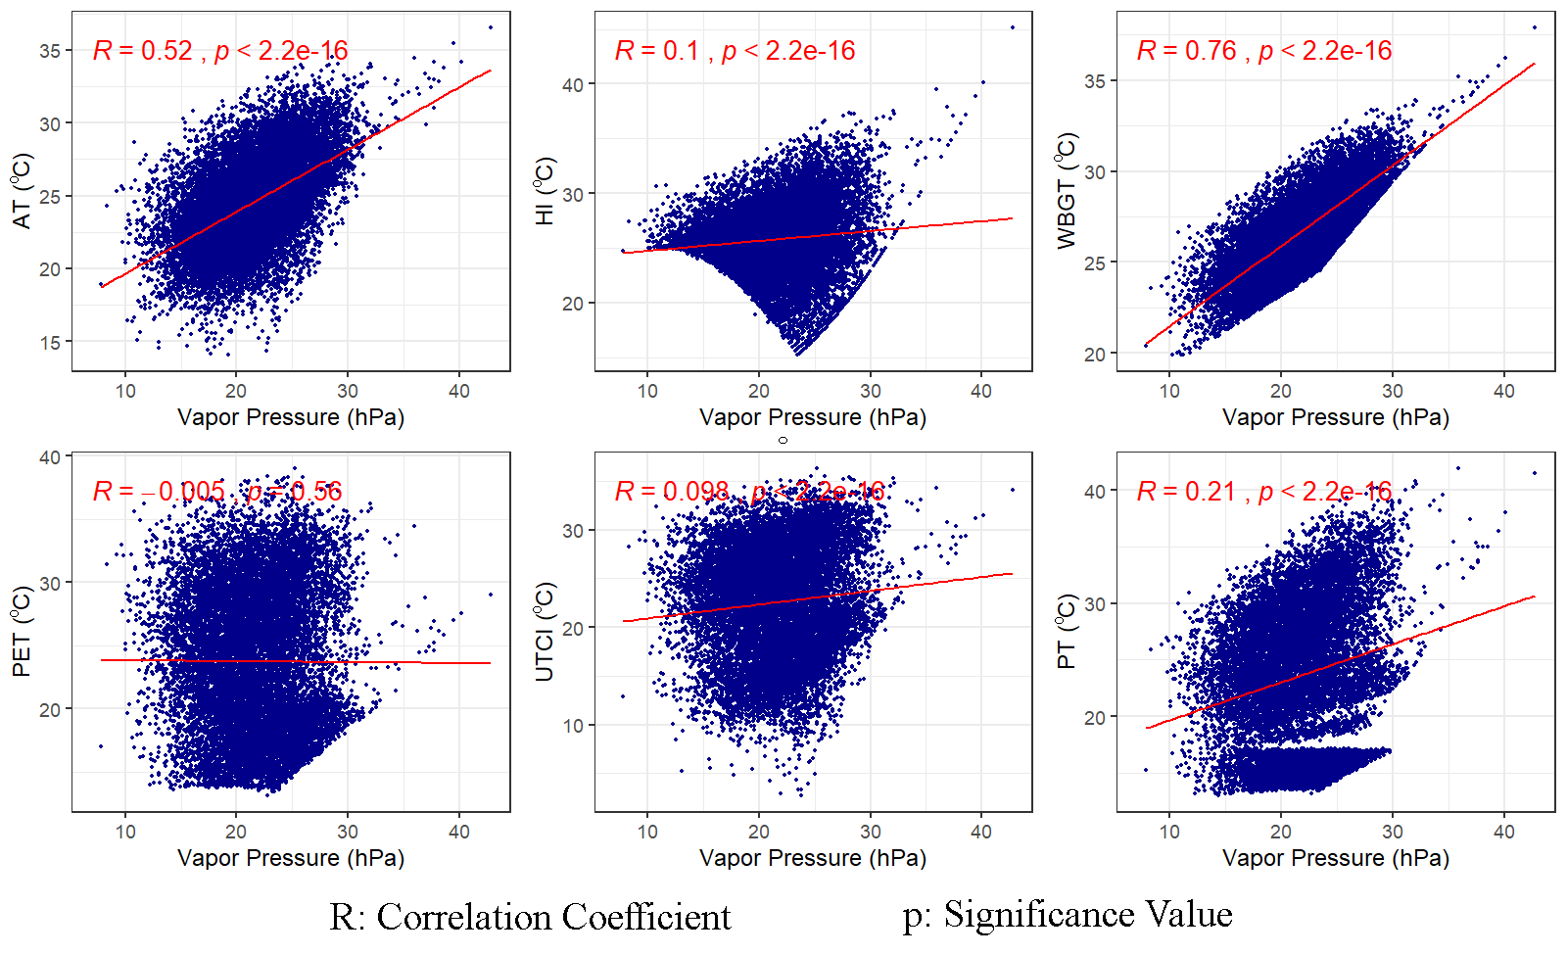
Figure S.2. Scatterplot and correlation analysis of vapor pressure and thermal indices

Results of homogeneity tests for air temperature variable

Results of Hypothesis Test
--------------------------
Null Hypothesis: Ratio of each pair of variances = 1
Alternative Hypothesis: At least one variance differs
Test Name: Levene's Test for
Homogenity of Variance

Estimated Parameter(s):

Adalar = 6.077783
Arnavutköy = 11.737584
Atatürk Hav. = 11.485790
Beykoz = 13.556342
Beykoz/Ana.Fen. = 9.362033
Büyükçekmece = 18.320192
Çatalca = 10.426970
Çekmeköy = 19.234941
Eyüp = 17.888819
Fatih/Den.Bil. = 14.321280
Fatih/Kumkapı = 8.386869
Florya = 13.802360
Güngören = 12.954484
Kadıköy/Göztepe = 14.007684
Kadıköy/Rıhtım = 12.858479
Kartal = 14.184884
Sab.Gökçen Hav. = 15.218471
Samandıra Hav. = 15.665257
Sancaktepe = 18.209165
Sarıyer = 12.564923
Sarıyer/Kumköy = 14.060686
Silivri = 14.989507
Silivri Fen. = 10.751463
Şile = 14.052138
Şişli = 12.180845
Tuzla = 16.011360
Tuzla/Ayd.Fen. = 8.405260
Tuzla/İTÜ Fen. = 9.009931
Ümraniye = 16.820532
Üsküdar = 12.352540

Data: sicaklik_yaz1
Grouping Variable: Columns

Sample Sizes:
Adalar = 6923
Arnavutköy = 8599
Atatürk Hav. = 11006
Beykoz = 8552
Beykoz/Ana.Fen. = 8272
Büyükçekmece = 10780
Çatalca = 10979
Çekmeköy = 8561
Eyüp = 10442
Fatih/Den.Bil. = 10922
Fatih/Kumkapı = 8782
Florya = 10881
Güngören = 8635
Kadıköy/Göztepe = 7689
Kadıköy/Rıhtım = 10919
Kartal = 10887
Sab.Gökçen Hav. = 10976
Samandıra Hav. = 10594
Sancaktepe = 8157
Sarıyer = 11029
Sarıyer/Kumköy = 11011
Silivri = 8123
Silivri Fen. = 10211
Şile = 10926
Şişli = 8554
Tuzla = 10901
Tuzla/Ayd.Fen. = 10717
Tuzla/İTÜ Fen. = 10485
Ümraniye = 8650
Üsküdar = 8387
Number NA/NaN/Inf's:
Adalar = 4117
Arnavutköy = 2441
Atatürk Hav. = 34
Beykoz = 2488
Beykoz/Ana.Fen. = 2768
Büyükçekmece = 260
Çatalca = 61
Çekmeköy = 2479
Eyüp = 598
Fatih/Den.Bil. = 118
Fatih/Kumkapı = 2258
Florya = 159
Güngören = 2405
Kadıköy/Göztepe = 3351
Kadıköy/Rıhtım = 121
Kartal = 153
Sab.Gökçen Hav. = 64
Samandıra Hav. = 446
Sancaktepe = 2883
Sarıyer = 11
Sarıyer/Kumköy = 29
Silivri = 2917
Silivri Fen. = 829
Şile = 114
Şişli = 2486
Tuzla = 139
Tuzla/Ayd.Fen. = 323
Tuzla/İTÜ Fen. = 555
Ümraniye = 2390
Üsküdar = 2653

Test Statistic: F = 304.1327
Test Statistic Parameters: num df = 29
denom df = 291520
P-value: 0

Results of Hypothesis Test
--------------------------
Null Hypothesis: Ratio of each pair of variances = 1
Alternative Hypothesis: At least one variance differs
Test Name: Bartlett's Test for Homogenity of Variance (With Correction Factor)
Estimated Parameter(s):

Adalar = 6.077783
Arnavutköy = 11.737584
Atatürk Hav. = 11.485790
Beykoz = 13.556342
Beykoz/Ana.Fen. = 9.362033
Büyükçekmece = 18.320192
Çatalca = 10.426970
Çekmeköy = 19.234941
Eyüp = 17.888819
Fatih/Den.Bil. = 14.321280
Fatih/Kumkapı = 8.386869
Florya = 13.802360
Güngören = 12.954484
Kadıköy/Göztepe = 14.007684
Kadıköy/Rıhtım = 12.858479
Kartal = 14.184884
Sab.Gökçen Hav. = 15.218471
Samandıra Hav. = 15.665257
Sancaktepe = 18.209165
Sarıyer = 12.564923
Sarıyer/Kumköy = 14.060686
Silivri = 14.989507
Silivri Fen. = 10.751463
Şile = 14.052138
Şişli = 12.180845
Tuzla = 16.011360
Tuzla/Ayd.Fen. = 8.405260
Tuzla/İTÜ Fen. = 9.009931
Ümraniye = 16.820532
Üsküdar = 12.352540
Data: sicaklik_yaz1
Grouping Variable: Columns

Sample Sizes:
Adalar = 6923
Arnavutköy = 8599
Atatürk Hav. = 11006
Beykoz = 8552
Beykoz/Ana.Fen. = 8272
Büyükçekmece = 10780
Çatalca = 10979
Çekmeköy = 8561
Eyüp = 10442
Fatih/Den.Bil. = 10922
Fatih/Kumkapı = 8782
Florya = 10881
Güngören = 8635
Kadıköy/Göztepe = 7689
Kadıköy/Rıhtım = 10919
Kartal = 10887
Sab.Gökçen Hav. = 10976
Samandıra Hav. = 10594
Sancaktepe = 8157
Sarıyer = 11029
Sarıyer/Kumköy = 11011
Silivri = 8123
Silivri Fen. = 10211
Şile = 10926
Şişli = 8554
Tuzla = 10901
Tuzla/Ayd.Fen. = 10717
Tuzla/İTÜ Fen. = 10485
Ümraniye = 8650
Üsküdar = 8387

Number NA/NaN/Inf's:
Adalar = 4117
Arnavutköy = 2441
Atatürk Hav. = 34
Beykoz = 2488
Beykoz/Ana.Fen. = 2768
Büyükçekmece = 260
Çatalca = 61
Çekmeköy = 2479
Eyüp = 598
Fatih/Den.Bil. = 118
Fatih/Kumkapı = 2258
Florya = 159
Güngören = 2405
Kadıköy/Göztepe = 3351
Kadıköy/Rıhtım = 121
Kartal = 153
Sab.Gökçen Hav. = 64
Samandıra Hav. = 446
Sancaktepe = 2883
Sarıyer = 11
Sarıyer/Kumköy = 29
Silivri = 2917
Silivri Fen. = 829
Şile = 114
Şişli = 2486
Tuzla = 139
Tuzla/Ayd.Fen. = 323
Tuzla/İTÜ Fen. = 555
Ümraniye = 2390
Üsküdar = 2653

Test Statistic: Chisq = 8482.646
Test Statistic Parameter: df = 29
P-value: 0

