Appendix 1
A literature search was conducted on the PubMed, Scopus, Web of Science, and J-STAGE databases. The keywords included in the search terms in Chapter 2, which are related to sweating response and various individual characteristics, are summarized in Table A1. Flow charts of the literature search for Chapter 3 on (1) sweat distribution, (2) local effect and (3) thermosensitivity are summarized in Fig. A1, A2 and A3, respectively.

Table A1 Search terms used for literature search described in Chapter 2
Topic | Search terms
Sweating response | Sweat, sweating, sweating response, sweat rate, sweat production
Individual characteristics | Age, aging, old, elderly
Individual characteristics | Acclimation, acclimatization, adaption, tolerance
Individual characteristics | Sex, gender, female, women
Individual characteristics | Body surface to mass ratio, body surface area, body size, morphology
Individual characteristics | Aerobic fitness, physical training, maximum oxygen consumption, endurance training, exercise

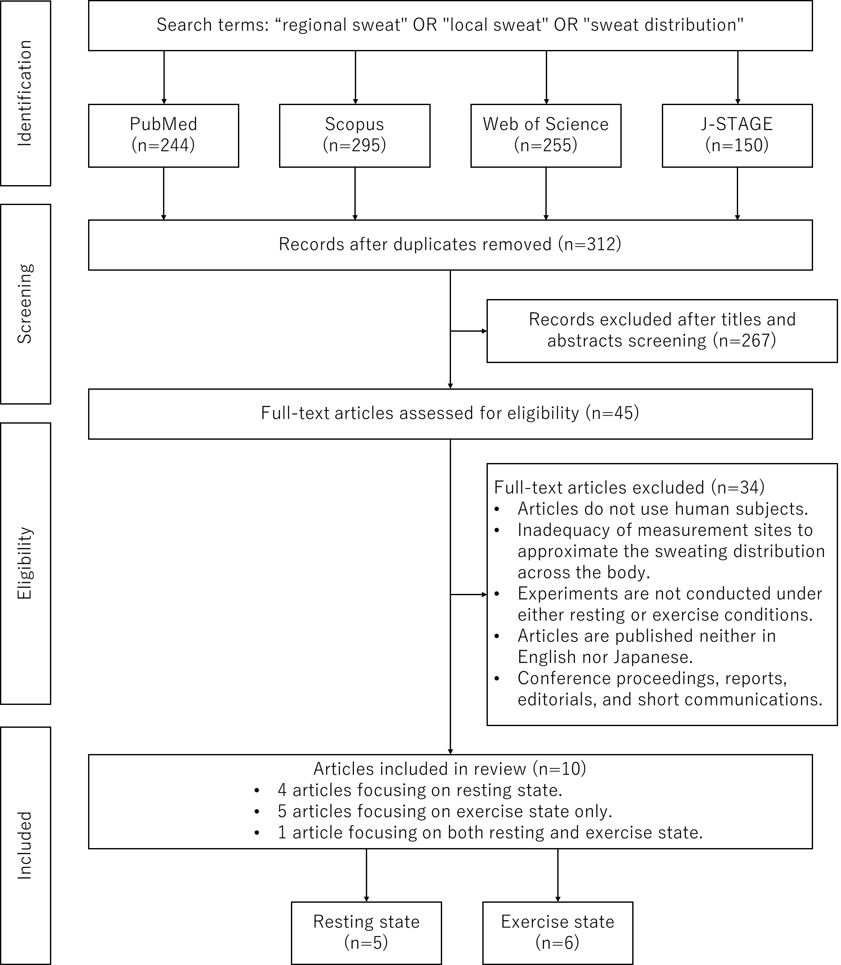
Fig. A1 Flow chart of literature search on sweat distribution

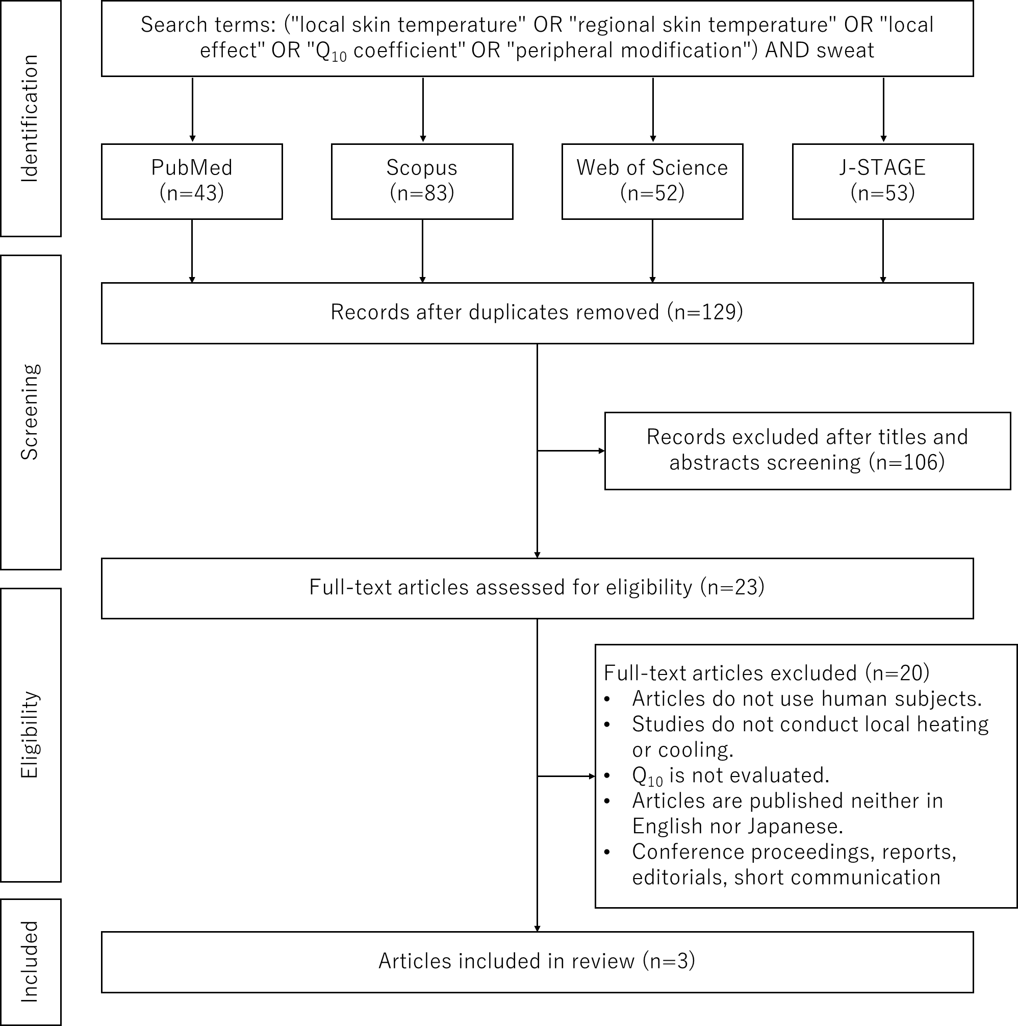
Fig. A2 Flow chart of literature search on local effect

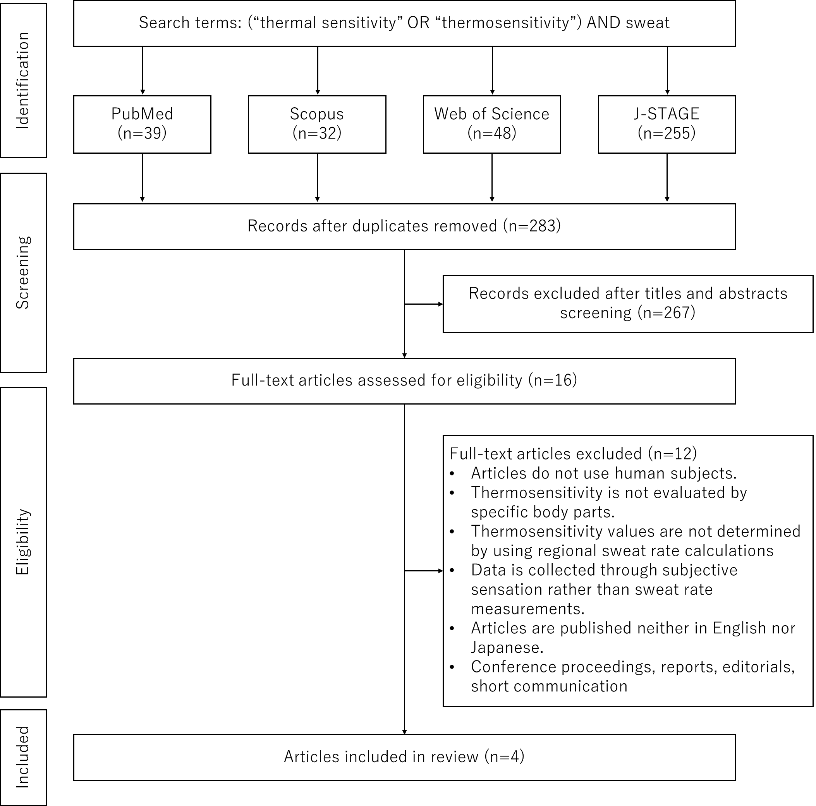
Fig. A3 Flow chart of literature search on thermosensitivity

Appendix 2
To analyze sweat distribution during exercise, we calculated the metabolic rate and metabolic heat production based on the information provided in each study.
The calculation of metabolic rate [W.m⁻²] employed the following equation (Nishi, 1981), except for Weiner (1945):

$$M=\frac{{\dot{V}}_{O_{2}}}{60}×\frac{e_{c}\left(R-R_{f}\right)+e_{f}\left(R_{c}-R\right)}{R_{c}-R_{f}}×\frac{1}{BSA}$$ | (A1)

Where ${\dot{V}}_{O_{2}}$ is oxygen consumption [L.min⁻¹]; R is respiratory quotient; R_{c} is the respiratory quotient when consuming carbohydrates only (=1.0); R_{f} is the respiratory quotient when consuming fats only (=0.7); e_{c} is the heat production per liter of oxygen consumed during carbohydrate oxidation (= 21,130) [J.L⁻¹]; e_{f} is the heat production per liter of oxygen consumed during fat oxidation (= 19,690) [J.L⁻¹]; and BSA is body surface area [m²].
The values of the respiratory quotient R used in this study are presented in Table A1. The respiratory quotient concerning Cotter et al. (1995) and Patterson et al. (2000) was set based on Parsons (2003). Smith and Havenith (2011, 2012) set the respiratory quotient values in their study.

Table A1 Respiratory quotient ratio of exercise conditions
Author | Respiratory quotient
Cotter et al. (1995) | 0.85
Patterson et al. (2000) | 0.85
Smith & Havenith (2012) | 0.85 for 60%VO₂ _{max} and 1 for 75%VO₂ _{max}
Smith & Havenith (2011) | 0.85 for 55%VO₂ _{max} and 1 for 75%VO₂ _{max}

The metabolic heat production H_{prod} [W.m⁻²] of the participants is as follows:

$$H_{prod}=M-W$$ | (A2)

where W is the absolute external work rate [W.m⁻²].
Cotter et al. (1995) and Patterson et al. (2000) provided peak power instead of VO₂ _{max}. Therefore, the following equation (Hawley and Noakes 1992) was used to calculate VO₂ _{max} [L.min⁻¹]:

$${\dot{V}}_{O_{2}max}=0.01141×W_{peak}+0.435$$ | (A3)

where W_{peak} is the peak power [W].
Additionally, because Patterson et al. (2000) did not provide participant height data, a height of 180 cm was assumed, and the body surface area [m²] was calculated using the DuBois formula (DuBois and DuBois 1916):

$$BSA=0.007184×{Weight}^{0.425}×{Height}^{0.725}$$ | (A4)

where Weight and Height are the participant’s weight [kg] and height [cm], respectively.
Weiner (1945) provided no information on exercise intensity. Therefore, considering the heat generated by muscles during the step exercise against gravity, the metabolic heat production of the participants was calculated using the following formula (Tanabe et al. 1995):

$$H_{prod}=\frac{Weight×g×h×N_{step}}{η×T×BSA}+M_{rest}$$ | (A5)

Where g represents the gravity acceleration [m.s⁻²]; h is the vertical distance moved per step (= the height of the step) [m.step⁻¹]; N_{step} is the total number of steps ascended during the exercise period [step]; η is muscle work efficiency (= 0.15); T is the total time of the exercise and non-exercise periods [s]; and M_{rest} is the metabolic rate under non-exercise conditions (assumed to be 58.15 W.m⁻² in this study).

