Supplementary Material S2
Figures
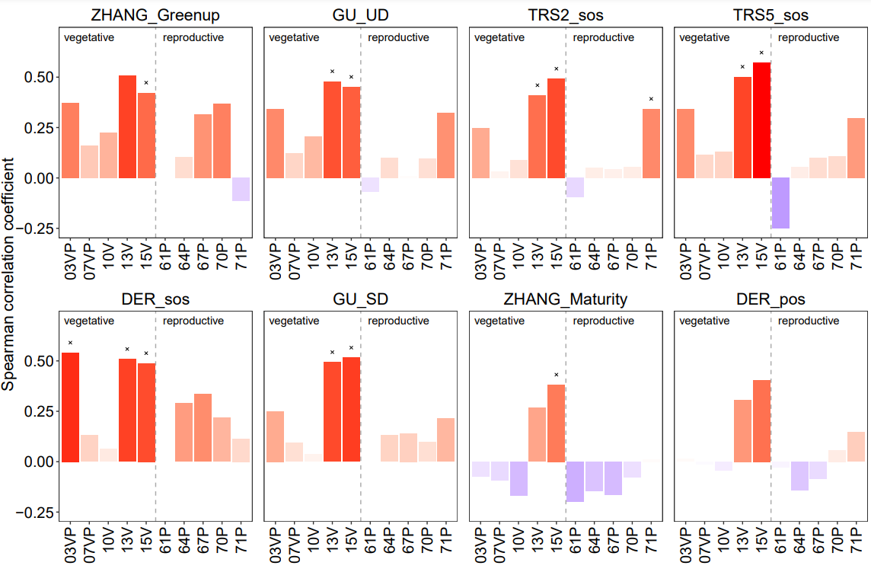
Fig. S1 Spearman coefficient correlation coefficients between phenological ground observations (BBCH code, x-axis) and remotely sensed phenometrics in pixels with more than 75% of hazelnut coverage (orchards ID02, ID06, ID10, ID11, ID14, ID16, ID18, ID19, ID20). Positive correlations are highlighted in blue, negative correlations in red with darker color indicate higher correlation strength. The cross indicates significance at p = 0.05.

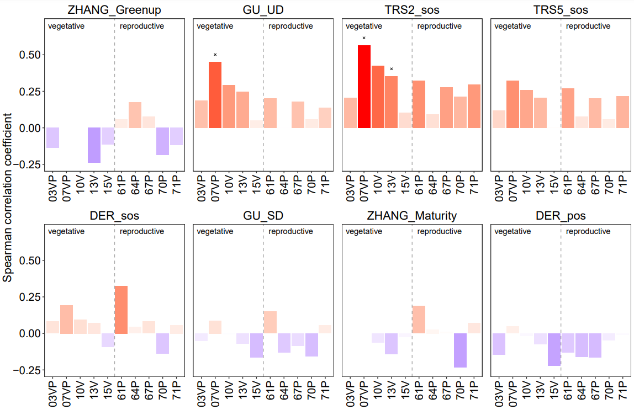
Fig. S2 Spearman coefficient correlation coefficients between phenological ground observations (BBCH code, x-axis) and remotely sensed phenometrics in pixels with less than 75% of hazelnut coverage (orchards (ID01, ID03, ID04, ID05, ID07, ID08, ID09, ID12, ID13, ID15, ID17). Positive correlations are highlighted in blue, negative correlations in red with darker color indicate higher correlation strength. The cross indicates significance at p = 0.05.

