Supplementary file contents
Supplementary Table 1 Summary statistics of the city-specific characteristics for the 7 prefecture-level regions in Tibet Autonomous Region, China. 3
Supplementary Table 2 Combined effect of air pollution mixtures and meteorological factors on the number of tuberculosis cases in the WQS model 4
Supplementary Table 3 PIPs of air pollution mixtures and meteorological factors for the number of tuberculosis cases in BKMR model. 5
Supplementary Table 4 Combined effect of air pollution mixtures and meteorological factors on the number of tuberculosis cases in the WQS model *(Sex) 6
Supplementary Table 5 Combined effect of air pollution mixtures and meteorological factors on the number of tuberculosis cases in the WQS model *(Work) 7
Supplementary Table 6 Combined effect of air pollution mixtures and meteorological factors on the number of tuberculosis cases in the WQS model *(Year) 8
Supplementary Table 7 PIPs of air pollution mixtures and meteorological factors for the number of tuberculosis cases in BKMR model. 9
Supplementary Figure 1 Correlation between daily air pollutant concentrations and meteorological variables 10
Supplementary Figure 2 The WQS model weights of air pollution mixtures and meteorological factors on the number of tuberculosis cases in positive direction. The model was adjusted for all covariates. 11
Supplementary Figure 3 The BKMR model for joint effect analysis of meteorological factors on the number of tuberculosis cases. The model adjusted for all covariates. 12
Supplementary Figure 4 The BKMR model for joint effect analysis of air pollutants on the number of tuberculosis cases. The model adjusted for all covariates. 13
Supplementary Figure 5 The WQS model weights of the effects of air pollution mixture and meteorological factors on the number of tuberculosis cases in the male subgroup are positive. The model A and B were adjusted for all covariates and the model C was not adjusted for covariates. 14
Supplementary Figure 6 The WQS model weights of the effects of air pollution mixture and meteorological factors on the number of tuberculosis cases in the female subgroup are positive. The model A and B were adjusted for all covariates and the model C was not adjusted for covariates. 15
Supplementary Figure 7 The WQS model weights of the effects of air pollution mixture and meteorological factors on the number of tuberculosis cases in the nomad subgroup are positive. The model A and B were adjusted for all covariates and the model C was not adjusted for covariates. 16
Supplementary Figure 8 The WQS model weights of the effects of air pollution mixture and meteorological factors on the number of tuberculosis cases in the student subgroup are positive. The model A and B were adjusted for all covariates and the model C was not adjusted for covariates. 17
Supplementary Figure 9 The WQS model weights of the effects of air pollution mixture and meteorological factors on the number of tuberculosis cases in the other occupations subgroup are positive. The model A and B were adjusted for all covariates and the model C was not adjusted for covariates. 18
Supplementary Figure 10 The WQS model weights of the effects of air pollution mixture and meteorological factors on the number of tuberculosis cases between year of 2019 and 2021 subgroup are positive. The model A and B were adjusted for all covariates and the model C was not adjusted for covariates. 19
Supplementary Figure 11 The WQS model weights of the effects of air pollution mixture and meteorological factors on the number of tuberculosis cases between year of 2022 and 2023 subgroup are positive. The model A and B were adjusted for all covariates and the model C was not adjusted for covariates. 20
Supplementary Figure 12 The WQS model weights of the effects of air pollution mixture and meteorological factors on the number of tuberculosis cases by monthly. The model A and B were adjusted for all covariates and the model C was not adjusted for covariates. 21
Supplementary Figure 13 The WQS model weights of the effects of air pollution mixture and meteorological factors on the number of tuberculosis cases when adjusting for time trends. The model A and B were adjusted for all covariates and the model C was just adjusted for time trends. 22
Supplementary Figure 14 The WQS model weights of air pollution mixtures and meteorological factors on the number of tuberculosis cases in positive direction (With different regions) 23
Supplementary Figure 15 The BKMR model for joint effect analysis of air pollutants on the number of tuberculosis cases in the male subgroup. The model was not adjusted for covariates. 24
Supplementary Figure 16 The BKMR model for joint effect analysis of air pollutants on the number of tuberculosis cases in the female subgroup. The model was not adjusted for covariates. 25
Supplementary Figure 17 The BKMR model for joint effect analysis of air pollutants on the number of tuberculosis cases in the nomad subgroup. The model was not adjusted for covariates. 26
Supplementary Figure 18 The BKMR model for joint effect analysis of air pollutants on the number of tuberculosis cases in the student subgroup. The model was not adjusted for covariates. 27
Supplementary Figure 19 The BKMR model for joint effect analysis of air pollutants on the number of tuberculosis cases in the other occupation subgroup. The model was not adjusted for covariates. 28
Supplementary Figure 20 The BKMR model for joint effect analysis of air pollutants on the number of tuberculosis cases between the year of 2019 to 2021. The model was not adjusted for covariates. 29
Supplementary Figure 21 The BKMR model for joint effect analysis of air pollutants on the number of tuberculosis cases between the year of 2022 to 2023. The model was not adjusted for covariates. 30
Supplementary Figure 22 The BKMR model for joint effect analysis of air pollutants on the number of tuberculosis cases by monthly. 31
Supplementary Figure 23 The BKMR model for joint effect analysis of air pollutants on the number of tuberculosis cases when adjusting for time trends. 32
Supplementary Figure 24 Overall effect of environment mixtures on the number of tuberculosis cases in BKMR model (With different regions). 33

Supplementary Table 1 Summary statistics of the city-specific characteristics for the 7 prefecture-level regions in Tibet Autonomous Region, China.
Regions | TB cases, N (%) | Air pollutants indicators, Mean ± SD |  |  |  |  |  | Meteorological factors, Mean ± SD
Regions | TB cases, N (%) | PM₁₀ | PM_{2.5} | SO₂ | NO₂ | CO | O₃ | Tavg | Tmax | Tmin | Wspd | Prcp
Total | 18347 (100.00) | 21.62 ± 8.85 | 10.59 ± 4.54 | 7.26 ± 1.15 | 11.01 ± 4.53 | 0.55 ± 0.14 | 74.94 ± 18.10 | 11.17 ± 6.63 | 18.19 ± 5.93 | 4.23 ± 7.69 | 7.48 ± 1.28 | 3.01 ± 3.65
Lhasa | 1453 (7.92) | 19.61 ± 13.35 | 8.24 ± 5.63 | 6.08 ± 2.79 | 9.71 ± 4.61 | 0.43 ± 0.12 | 78.00 ± 21.49 | 8.19 ± 7.00 | 15.62 ± 6.38 | 1.20 ± 7.99 | 8.38 ± 1.72 | 2.05 ± 3.37
Shigatse | 3772 (20.56) | 13.00 ± 6.97 | 6.24 ± 2.91 | 9.46 ± 4.10 | 10.72 ± 6.28 | 0.43 ± 0.14 | 90.79 ± 26.53 | 13.64 ± 6.13 | 20.19 ± 5.25 | 6.70 ± 7.44 | 7.32 ± 1.52 | 3.48 ± 5.35
Shannan | 1558 (8.49) | 12.79 ± 7.36 | 7.52 ± 4.49 | 7.70 ± 2.19 | 9.71 ± 4.61 | 0.48 ± 0.18 | 67.42 ± 22.06 | 15.30 ± 5.87 | 21.74 ± 4.85 | 8.39 ± 7.23 | 6.51 ± 1.37 | 4.24 ± 5.85
Nyingchi | 1360 (7.41) | 23.24 ± 13.94 | 10.42 ± 7.16 | 4.61 ± 1.73 | 11.15 ± 6.66 | 0.56 ± 0.20 | 80.31 ± 24.90 | 14.75 ± 5.59 | 20.98 ± 5.11 | 8.70 ± 6.57 | 6.68 ± 1.40 | 4.88 ± 7.48
Chamdo | 6704 (36.54) | 20.84 ± 13.23 | 10.63 ± 6.67 | 8.33 ± 2.79 | 11.59 ± 7.56 | 0.44 ± 0.21 | 62.35 ± 20.61 | 8.31 ± 6.86 | 16.68 ± 6.53 | 1.23 ± 7.83 | 6.41 ± 1.13 | 2.22 ± 3.07
Nagqu | 3044 (16.59) | 41.80 ± 20.87 | 23.02 ± 13.55 | 7.64 ± 3.05 | 10.95 ± 5.48 | 0.85 ± 0.39 | 66.60 ± 21.89 | 4.81 ± 8.03 | 12.30 ± 7.48 | -2.56 ± 9.12 | 10.16 ± 2.54 | 1.94 ± 2.85
Ngari | 455 (2.48) | 6.25 ± 2.91 | 21.40 ± 13.29 | 7.07 ± 2.08 | 17.71 ± 9.74 | 0.44 ± 0.21 | 78.62 ± 24.05 | 13.17 ± 7.70 | 19.86 ± 7.11 | 5.95 ± 8.29 | 6.90 ± 1.49 | 2.23 ± 3.80
Tavg: Average temperature; Tmax: Max temperature; Tmin: Mini temperature; Wspd: Wind speed; Prcp: Precipitation;
Note: Units – Temperature: °C; Wind speed: m/s; Precipitation: mm;
Air pollutants: PM₁₀, PM₂.₅, SO₂, NO₂, O₃ in μg/m³; CO in mg/m³.

Supplementary Table 2 Combined effect of air pollution mixtures and meteorological factors on the number of tuberculosis cases in the WQS model
Outcome | OR | 95% CI | P-value
Mix model | 0.94 | 0.91-0.97 | < 0.001
Air pollutant mixtures
Crude model I | 0.94 | 0.91-0.97 | < 0.001
Model I | 1.00 | 0.96-1.05 | 0.86
Meteorological factors
Crude model II | 1.03 | 1.00-1.06 | 0.09
Model II | 1.19 | 1.13-1.27 | < 0.001
WQS: weighted quantile sum; OR: odds ratio; CI: confidence interval; Crude model adjusted for none, while Model I adjusted for all meteorological factor and Model II adjusted for all air pollution factors.

Supplementary Table 3 PIPs of air pollution mixtures and meteorological factors for the number of tuberculosis cases in BKMR model.
 | PIP ª | PIP ^{b}
Air pollutant mixtures
PM₁₀ (μg/m3) | 1.00 | 1.00
NO₂ (μg/m3) | 1.00 | 1.00
SO₂ (μg/m3) | 1.00 | 1.00
O₃ (μg/m3) | 1.00 | 0.91
Meteorological factors
Average temperature (°C) | 1.00 | 1.00
Wind speed (m/s) | 1.00 | 1.00
Precipitation (mm) | 0.96 | 1.00
ª Exposure to air pollution mixtures alone or exposure to meteorological factors alone；This model adjusted for the covariates.
^{b} Mixed exposure to air pollution mixtures and meteorological factors; The model was not adjusted for covariates.

Supplementary Table 4 Combined effect of air pollution mixtures and meteorological factors on the number of tuberculosis cases in the WQS model *(Sex)
Outcome | OR | 95% CI | P-value
Male
Mix model | 1.67 | 1.51-1.85 | < 0.001
Air pollutants indicators
Crude model I | 1.24 | 1.17-1.32 | < 0.001
Model I | 1.18 | 1.11-1.26 | < 0.001
Meteorological factors
Crude model II | 1.21 | 1.15-1.27 | < 0.001
Model II | 1.27 | 1.18-1.36 | < 0.001
Female
Mix model | 1.53 | 1.40-1.66 | < 0.001
Air pollutants indicators
Crude model I | 1.20 | 1.15-1.26 | < 0.001
Model I | 1.17 | 1.11-1.24 | < 0.001
Meteorological factors
Crude model II | 1.20 | 1.15-1.26 | < 0.001
Model II | 1.16 | 1.10-1.22 | < 0.001
WQS: weighted quantile sum; OR: odds ratio; CI: confidence interval; Crude model adjusted for none, while Model I adjusted for all meteorological factor and Model II adjusted for all air pollution factors.
Tavg: Average temperature; Tmax: Maximum temperature; Tmin: Minimum temperature; Wspd: Wind speed; Prcp: Precipitation

Supplementary Table 5 Combined effect of air pollution mixtures and meteorological factors on the number of tuberculosis cases in the WQS model *(Work)
Outcome | OR | 95% CI | P-value
Nomads
Mix model | 1.53 | 1.40-1.61 | < 0.001
Air pollutants indicators
Crude model I | 1.19 | 1.13-1.26 | < 0.001
Model I | 1.18 | 1.12-1.25 | < 0.001
Meteorological factors
Crude model II | 1.20 | 1.14-1.25 | < 0.001
Model II | 1.15 | 1.09-1.21 | < 0.001
Students
Mix model | 1.86 | 1.64-2.11 | < 0.001
Air pollutants indicators
Crude model I | 1.32 | 1.22-1.42 | < 0.001
Model I | 1.31 | 1.21-1.41 | < 0.001
Meteorological factors
Crude model II | 1.21 | 1.14-1.29 | < 0.001
Model II | 1.38 | 1.25-1.51 | < 0.001
Other
Mix model | 1.48 | 1.27-1.73 | < 0.001
Air pollutants indicators
Crude model I | 1.26 | 1.14-1.39 | < 0.001
Model I | 1.16 | 1.02-1.31 | < 0.001
Meteorological factors
Crude model II | 1.18 | 1.09-1.28 | < 0.001
Model II | 1.19 | 1.08-1.31 | < 0.001
WQS: weighted quantile sum; OR: odds ratio; CI: confidence interval; Crude model adjusted for none, while Model I adjusted for all meteorological factor and Model II adjusted for all air pollution factors.
Tavg: Average temperature; Tmax: Maximum temperature; Tmin: Minimum temperature; Wspd: Wind speed; Prcp: Precipitation

Supplementary Table 6 Combined effect of air pollution mixtures and meteorological factors on the number of tuberculosis cases in the WQS model *(Year)
Outcome | OR | 95% CI | P-value
2019-2021
Mix model | 1.32 | 1.17-1.48 | < 0.001
Air pollutants indicators
Crude model I | 1.16 | 1.08-1.24 | < 0.001
Model I | 1.15 | 1.07-1.25 | < 0.001
Meteorological factors
Crude model II | 1.10 | 1.05-1.16 | < 0.001
Model II | 1.05 | 1.00-1.10 | 0.06
2022-2023
Mix model | 1.50 | 1.38-1.63 | < 0.001
Air pollutants indicators
Crude model I | 1.37 | 1.27-1.48 | < 0.001
Model I | 1.31 | 1.18-1.45 | < 0.001
Meteorological factors
Crude model II | 1.22 | 1.14-1.30 | < 0.001
Model II | 1.15 | 1.03-1.28 | < 0.001
WQS: weighted quantile sum; OR: odds ratio; CI: confidence interval; Crude model adjusted for none, while Model I adjusted for all meteorological factor and Model II adjusted for all air pollution factors.
Tavg: Average temperature; Tmax: Maximum temperature; Tmin: Minimum temperature; Wspd: Wind speed; Prcp: Precipitation

Supplementary Table 7 PIPs of air pollution mixtures and meteorological factors for the number of tuberculosis cases in BKMR model.
 | PIP ª | PIP ^{b}
Air pollutant mixtures
PM₁₀ (μg/m3) | 1.00 | 1.00
NO₂ (μg/m3) | 1.00 | 1.00
SO₂ (μg/m3) | 1.00 | 1.00
O₃ (μg/m3) | 1.00 | 0.91
Meteorological factors
Average temperature (°C) | 1.00 | 1.00
Wind speed (m/s) | 1.00 | 1.00
Precipitation (mm) | 0.96 | 1.00
ª Exposure to air pollution mixtures alone or exposure to meteorological factors alone；This model adjusted for the covariates.
^{b} Mixed exposure to air pollution mixtures and meteorological factors; The model was not adjusted for covariates.

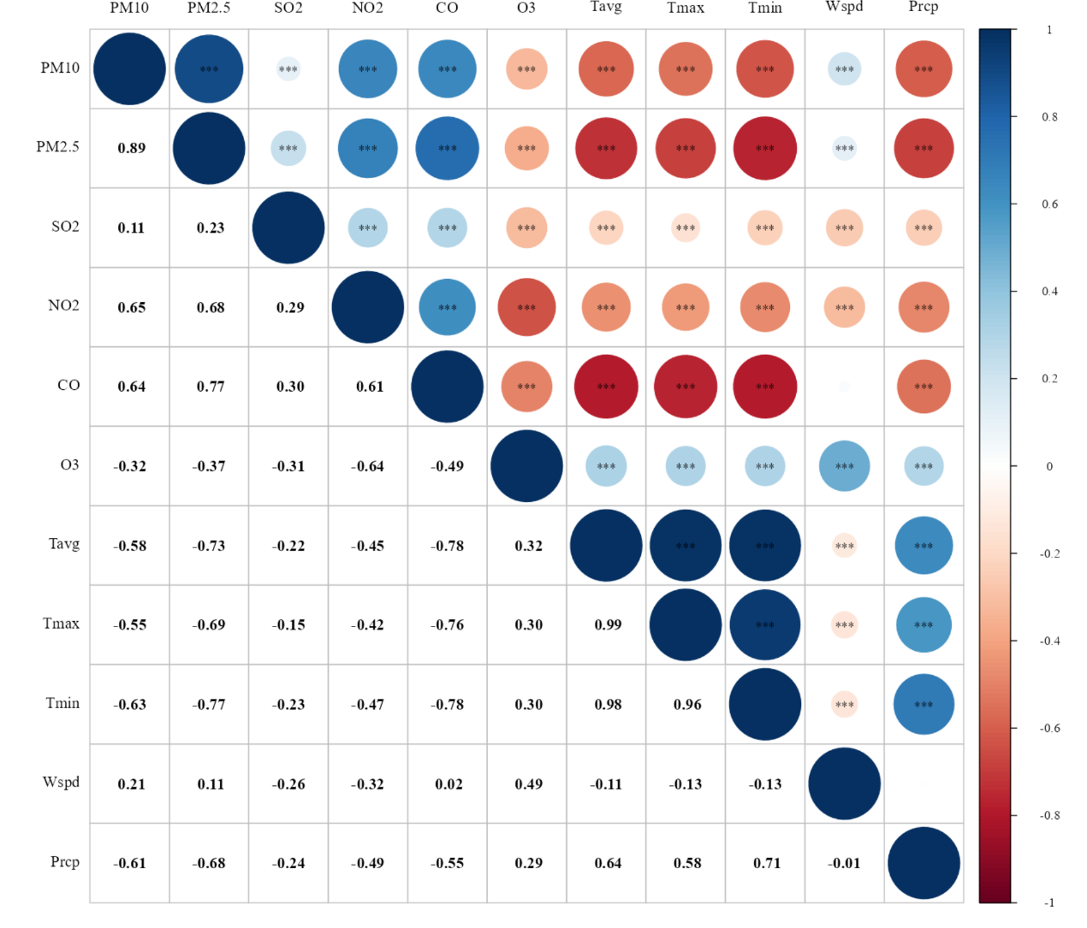

Supplementary Figure 1 Correlation between daily air pollutant concentrations and meteorological variables

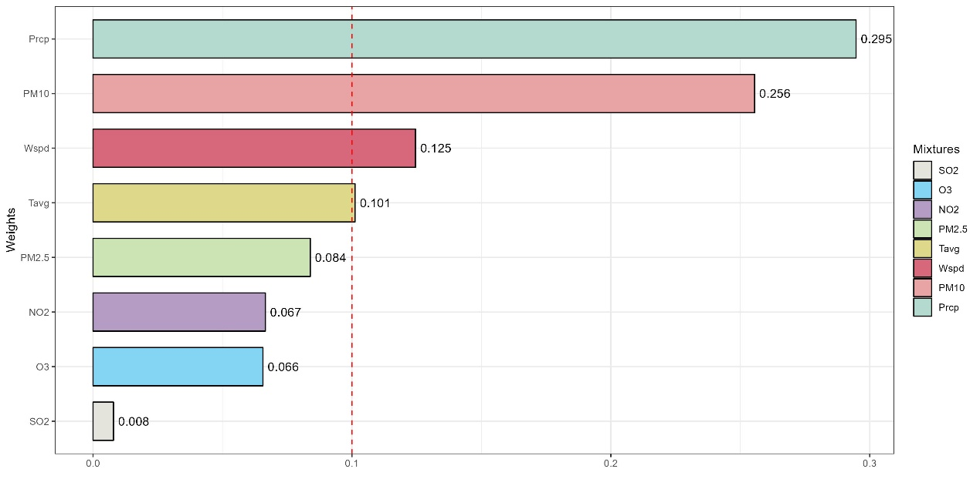

Supplementary Figure 2 The WQS model weights of air pollution mixtures and meteorological factors on the number of tuberculosis cases in positive direction. The model was adjusted for all covariates.

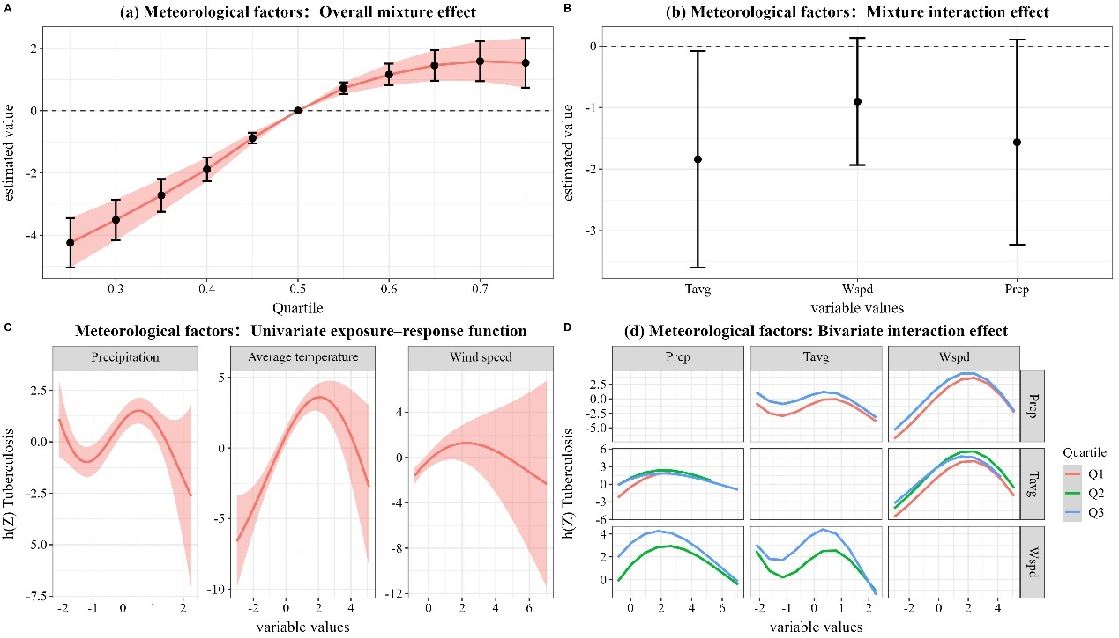

Supplementary Figure 3 The BKMR model for joint effect analysis of meteorological factors on the number of tuberculosis cases. The model adjusted for all covariates.

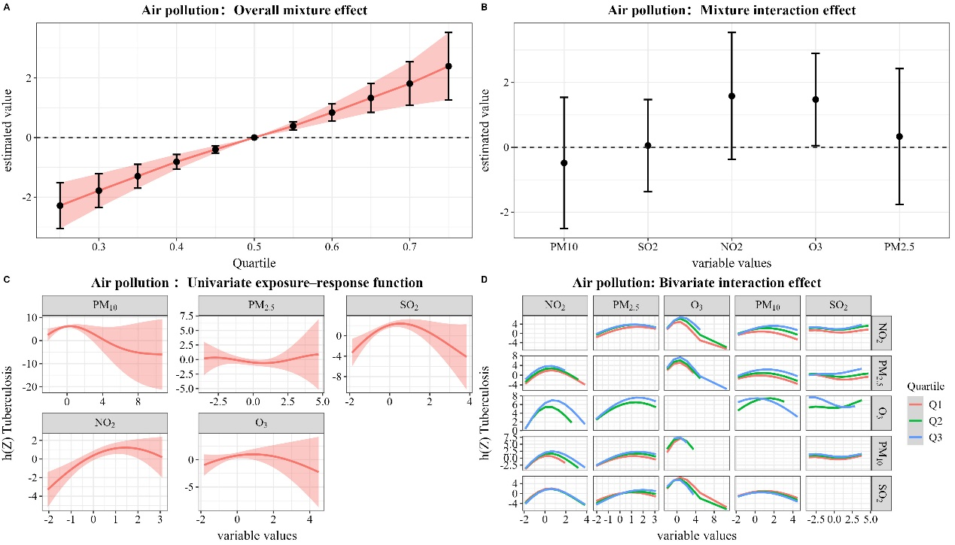

Supplementary Figure 4 The BKMR model for joint effect analysis of air pollutants on the number of tuberculosis cases. The model adjusted for all covariates.

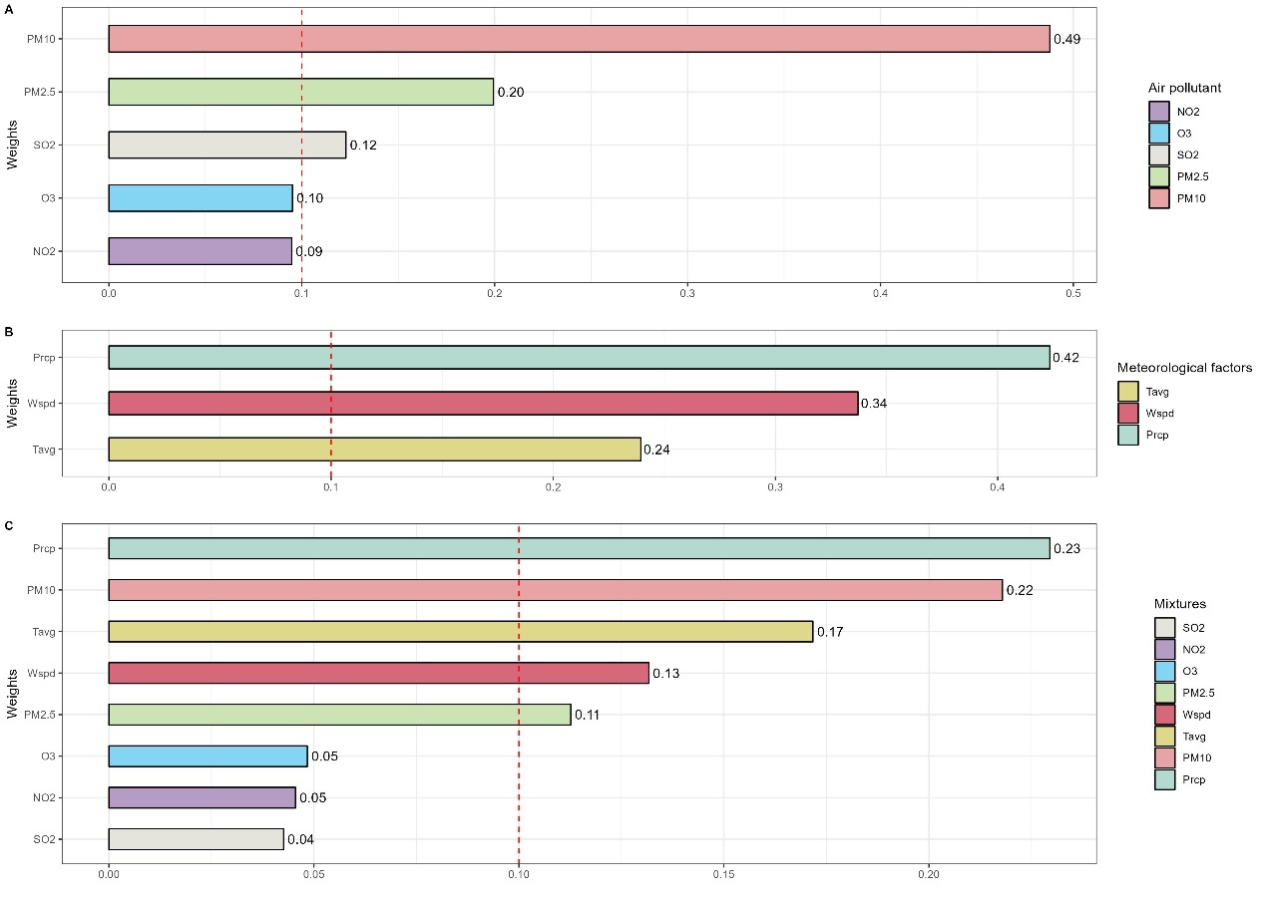

Supplementary Figure 5 The WQS model weights of the effects of air pollution mixture and meteorological factors on the number of tuberculosis cases in the male subgroup are positive. The model A and B were adjusted for all covariates and the model C was not adjusted for covariates.

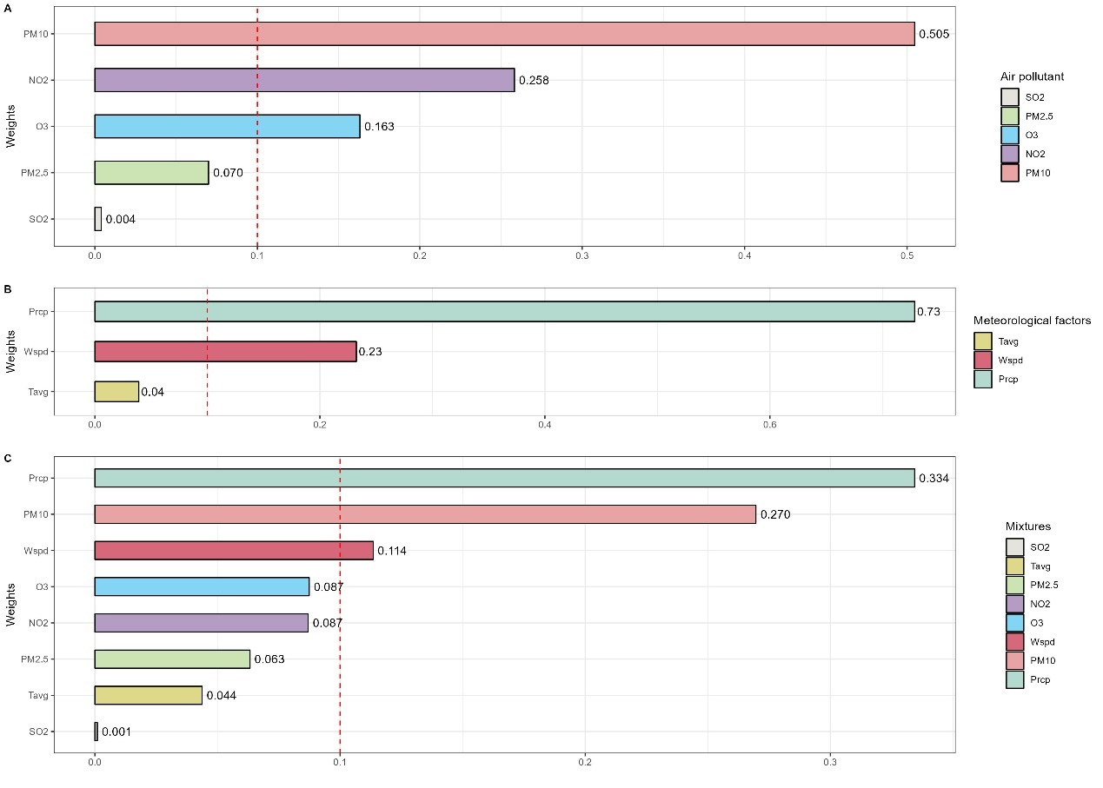

Supplementary Figure 6 The WQS model weights of the effects of air pollution mixture and meteorological factors on the number of tuberculosis cases in the female subgroup are positive. The model A and B were adjusted for all covariates and the model C was not adjusted for covariates.

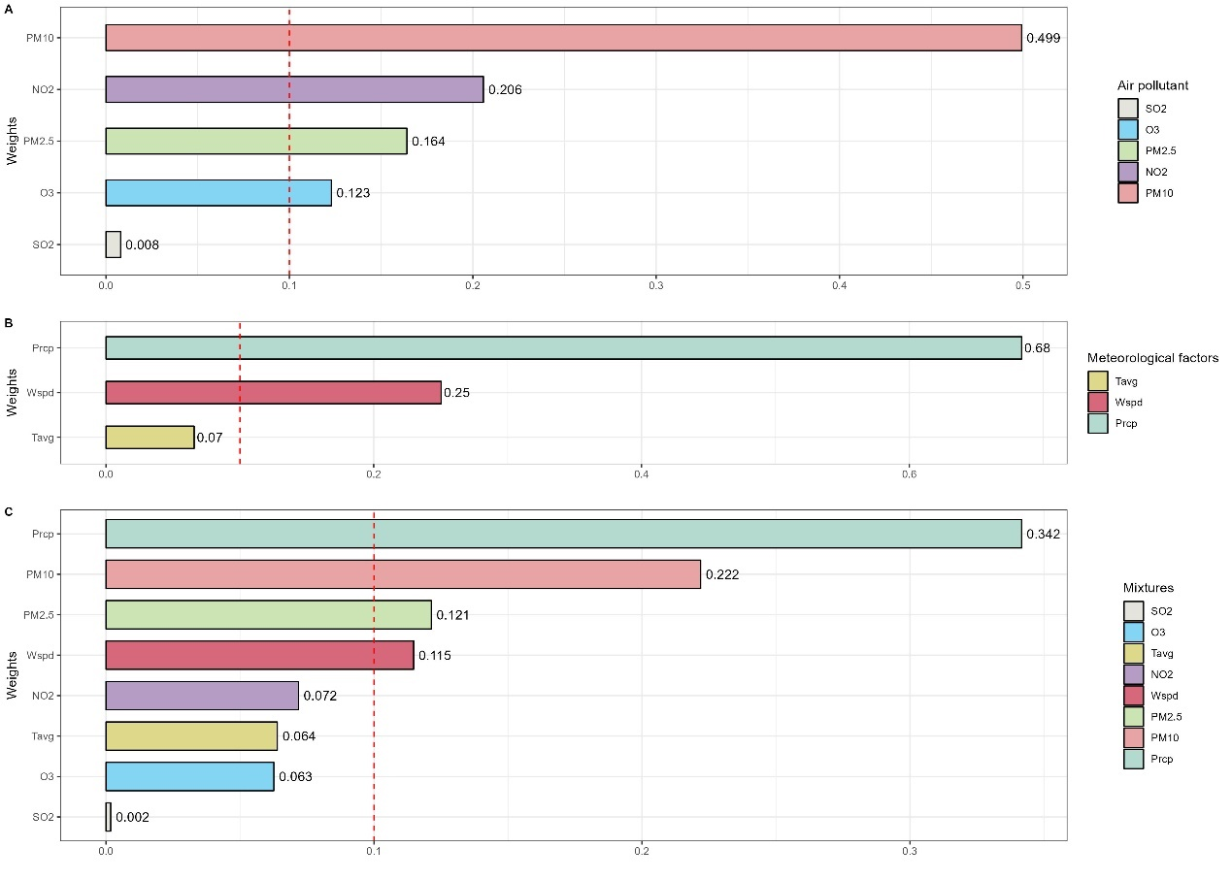

Supplementary Figure 7 The WQS model weights of the effects of air pollution mixture and meteorological factors on the number of tuberculosis cases in the nomad subgroup are positive. The model A and B were adjusted for all covariates and the model C was not adjusted for covariates.

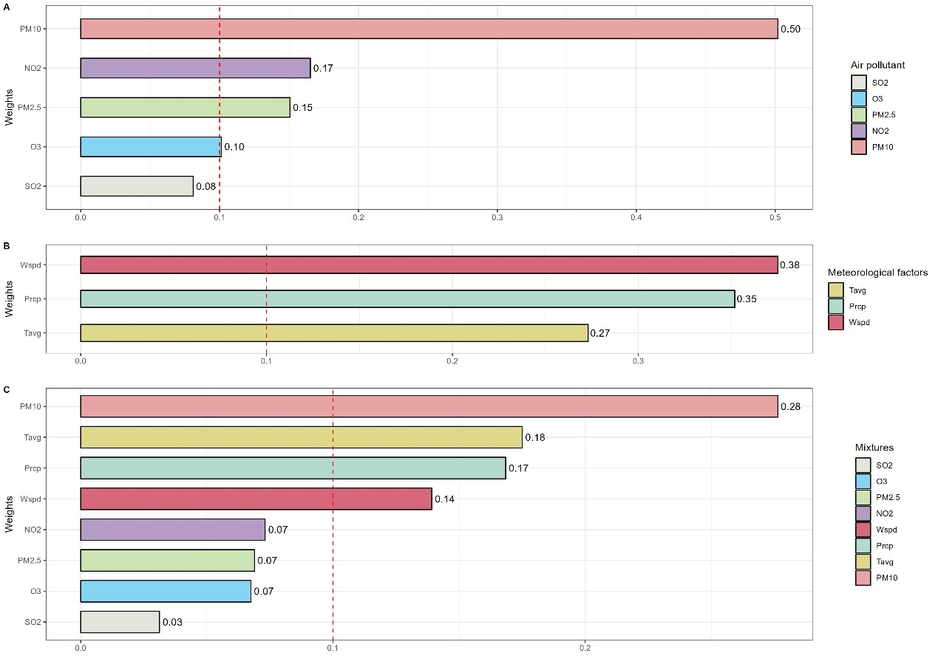

Supplementary Figure 8 The WQS model weights of the effects of air pollution mixture and meteorological factors on the number of tuberculosis cases in the student subgroup are positive. The model A and B were adjusted for all covariates and the model C was not adjusted for covariates.

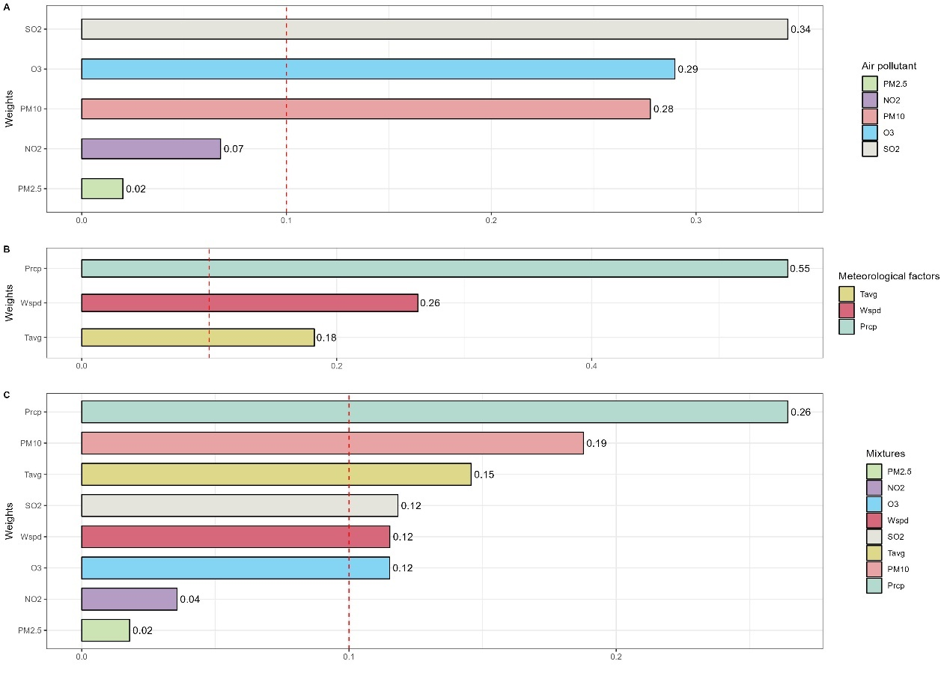

Supplementary Figure 9 The WQS model weights of the effects of air pollution mixture and meteorological factors on the number of tuberculosis cases in the other occupations subgroup are positive. The model A and B were adjusted for all covariates and the model C was not adjusted for covariates.

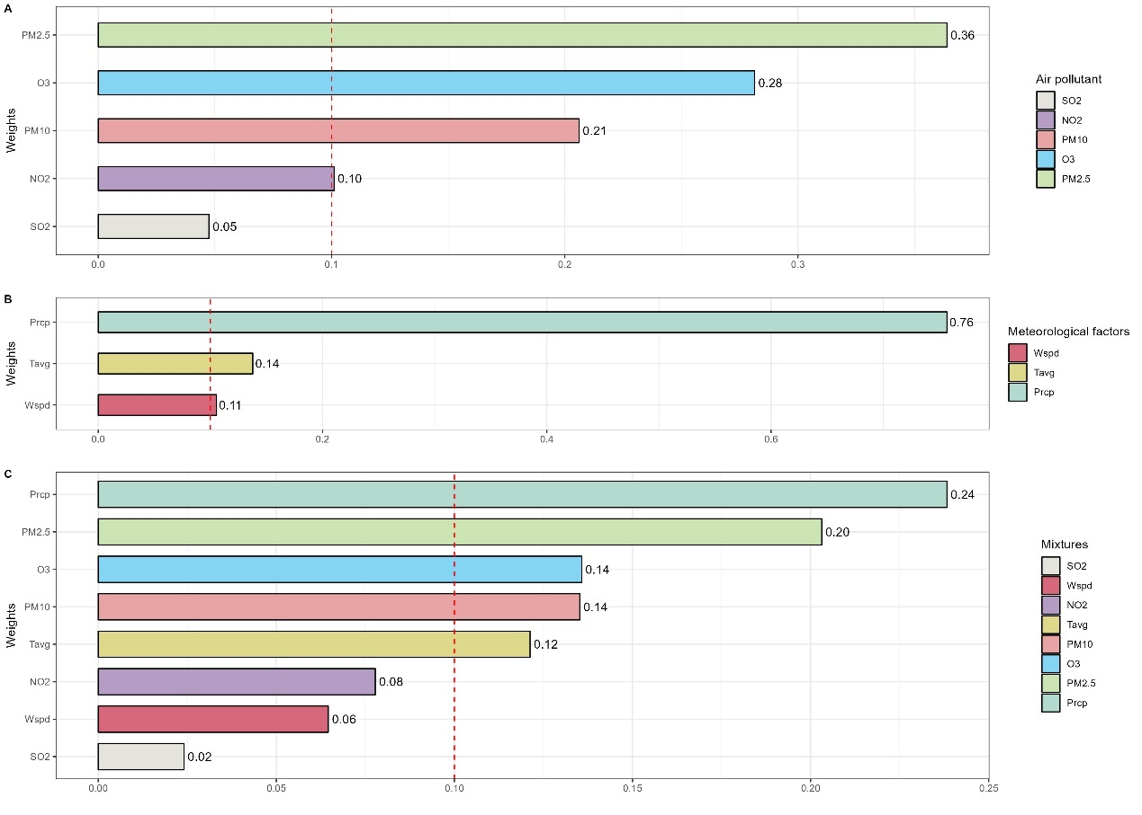

Supplementary Figure 10 The WQS model weights of the effects of air pollution mixture and meteorological factors on the number of tuberculosis cases between year of 2019 and 2021 subgroup are positive. The model A and B were adjusted for all covariates and the model C was not adjusted for covariates.

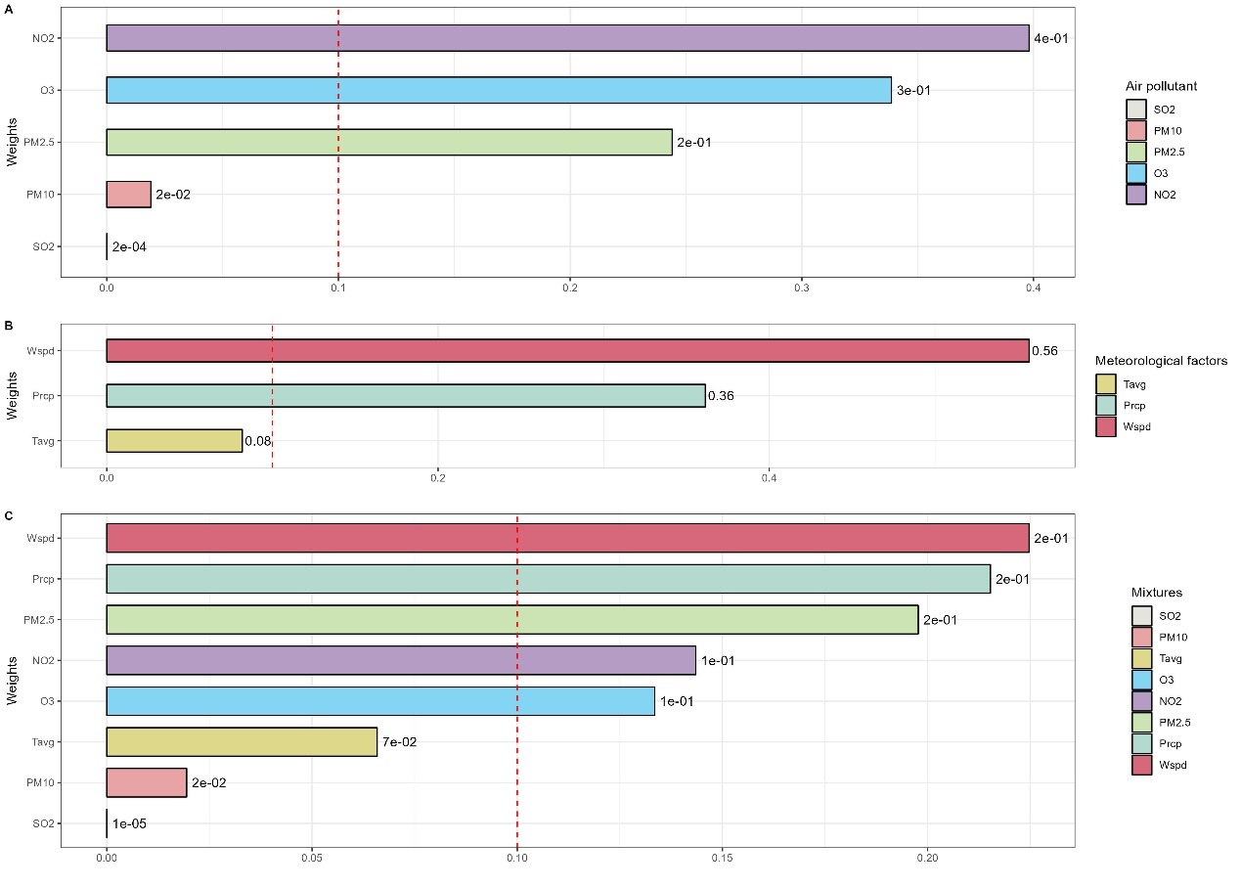

Supplementary Figure 11 The WQS model weights of the effects of air pollution mixture and meteorological factors on the number of tuberculosis cases between year of 2022 and 2023 subgroup are positive. The model A and B were adjusted for all covariates and the model C was not adjusted for covariates.

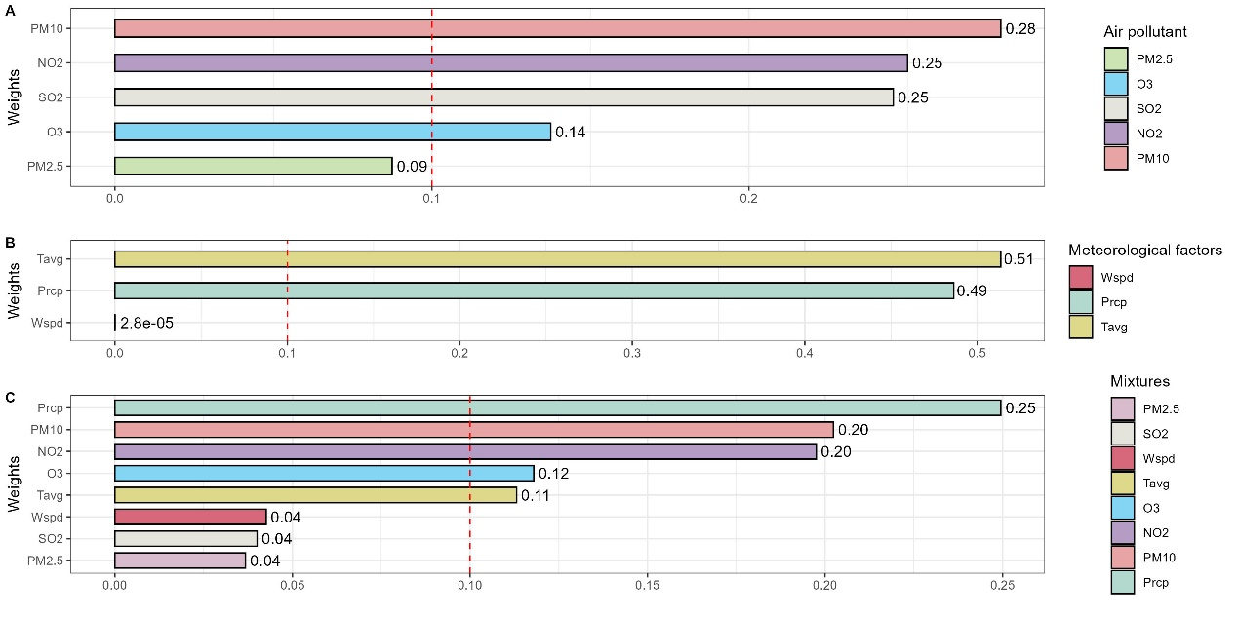

Supplementary Figure 12 The WQS model weights of the effects of air pollution mixture and meteorological factors on the number of tuberculosis cases by monthly. The model A and B were adjusted for all covariates and the model C was not adjusted for covariates.

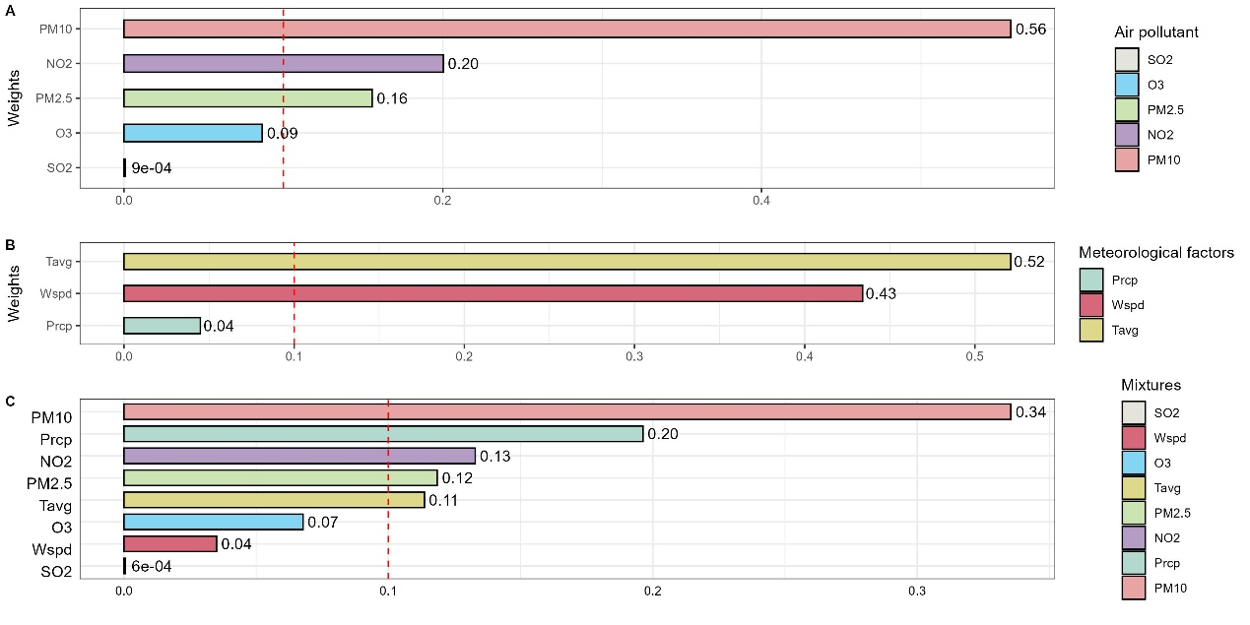

Supplementary Figure 13 The WQS model weights of the effects of air pollution mixture and meteorological factors on the number of tuberculosis cases when adjusting for time trends. The model A and B were adjusted for all covariates and the model C was just adjusted for time trends.

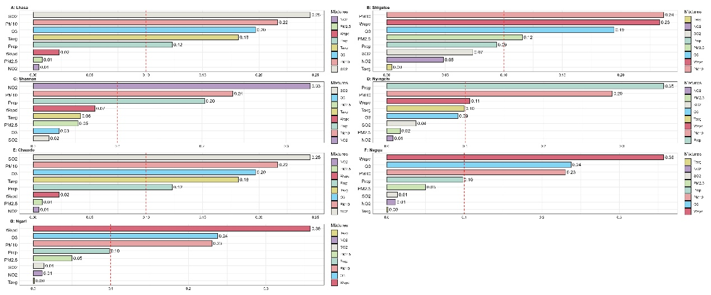

Supplementary Figure 14 The WQS model weights of air pollution mixtures and meteorological factors on the number of tuberculosis cases in positive direction (With different regions)

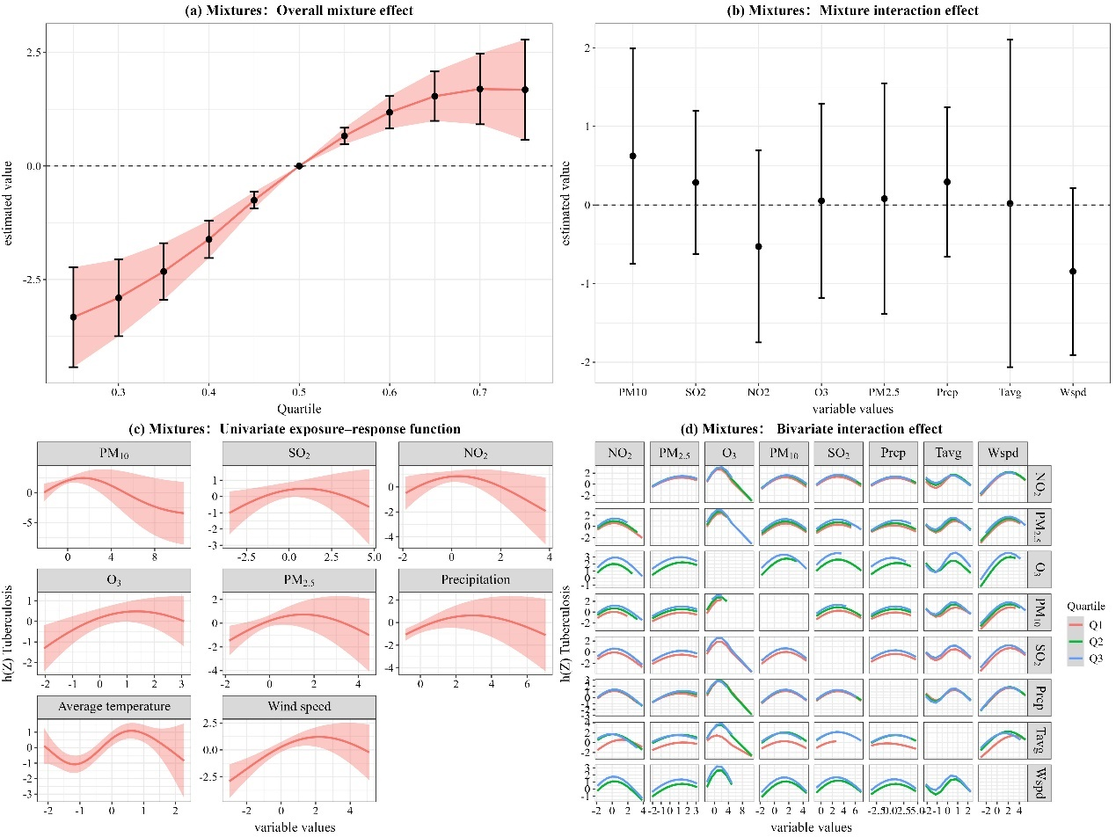

Supplementary Figure 15 The BKMR model for joint effect analysis of air pollutants on the number of tuberculosis cases in the male subgroup. The model was not adjusted for covariates.

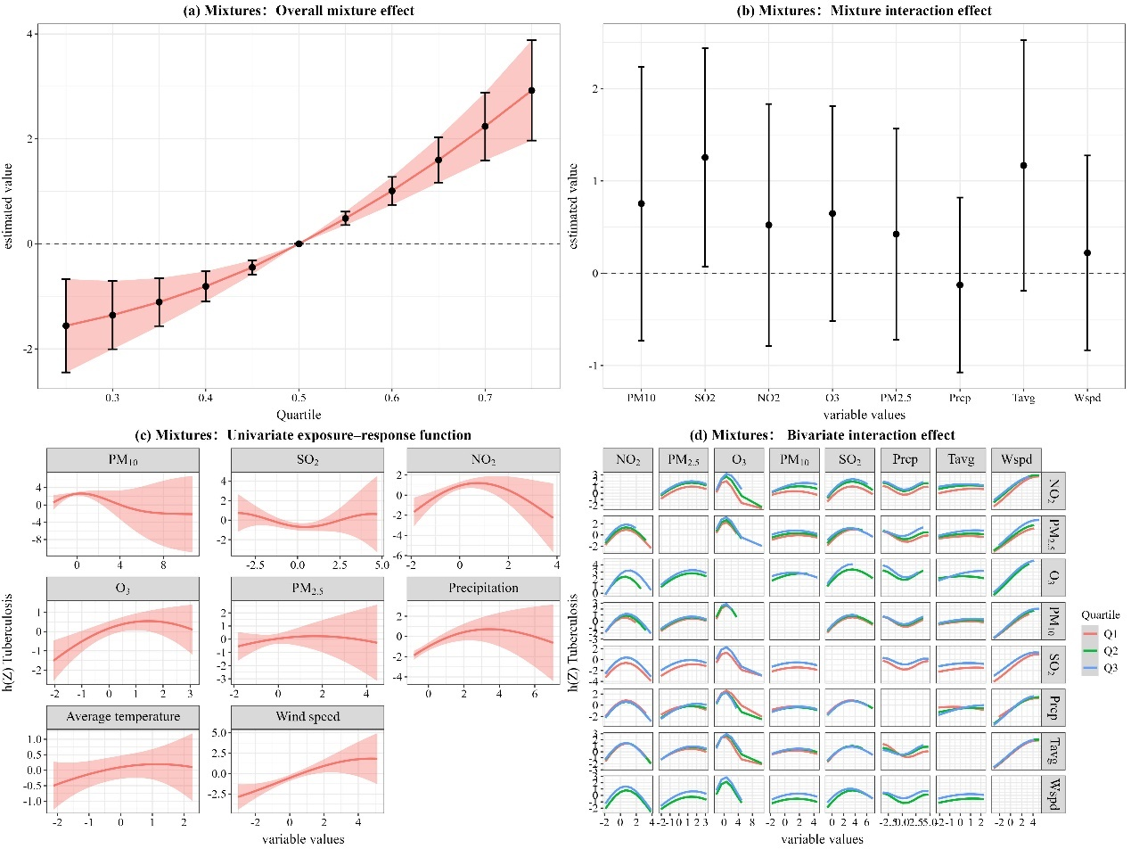

Supplementary Figure 16 The BKMR model for joint effect analysis of air pollutants on the number of tuberculosis cases in the female subgroup. The model was not adjusted for covariates.

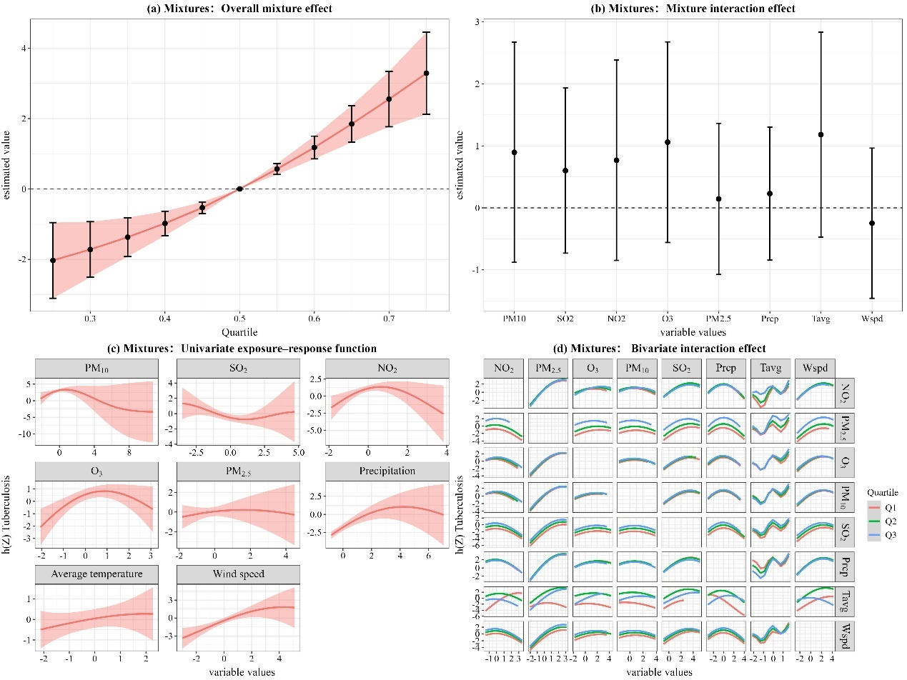

Supplementary Figure 17 The BKMR model for joint effect analysis of air pollutants on the number of tuberculosis cases in the nomad subgroup. The model was not adjusted for covariates.

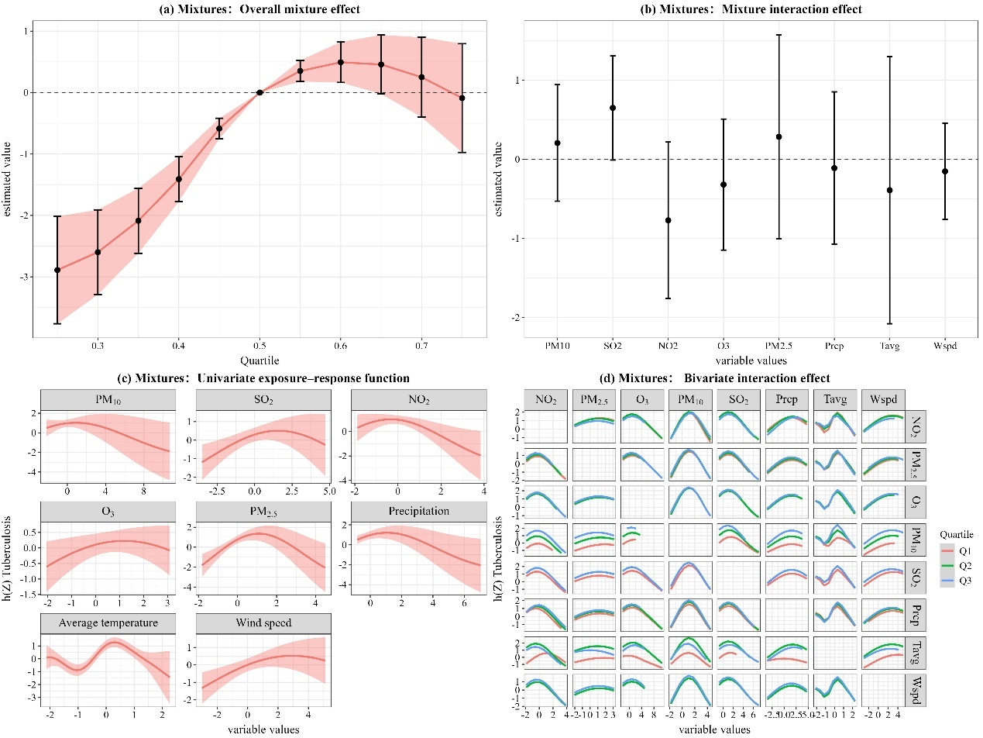

Supplementary Figure 18 The BKMR model for joint effect analysis of air pollutants on the number of tuberculosis cases in the student subgroup. The model was not adjusted for covariates.

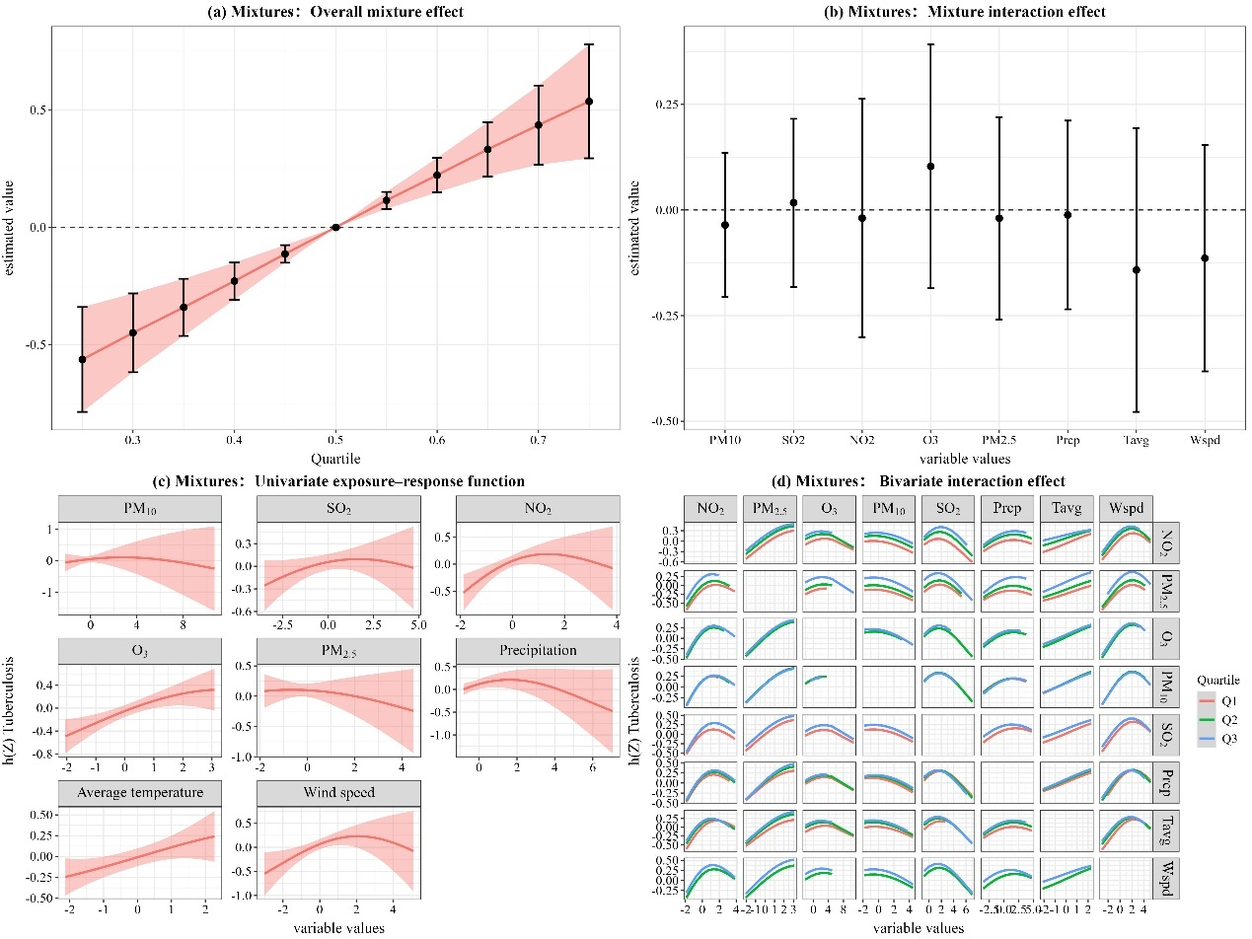

Supplementary Figure 19 The BKMR model for joint effect analysis of air pollutants on the number of tuberculosis cases in the other occupation subgroup. The model was not adjusted for covariates.

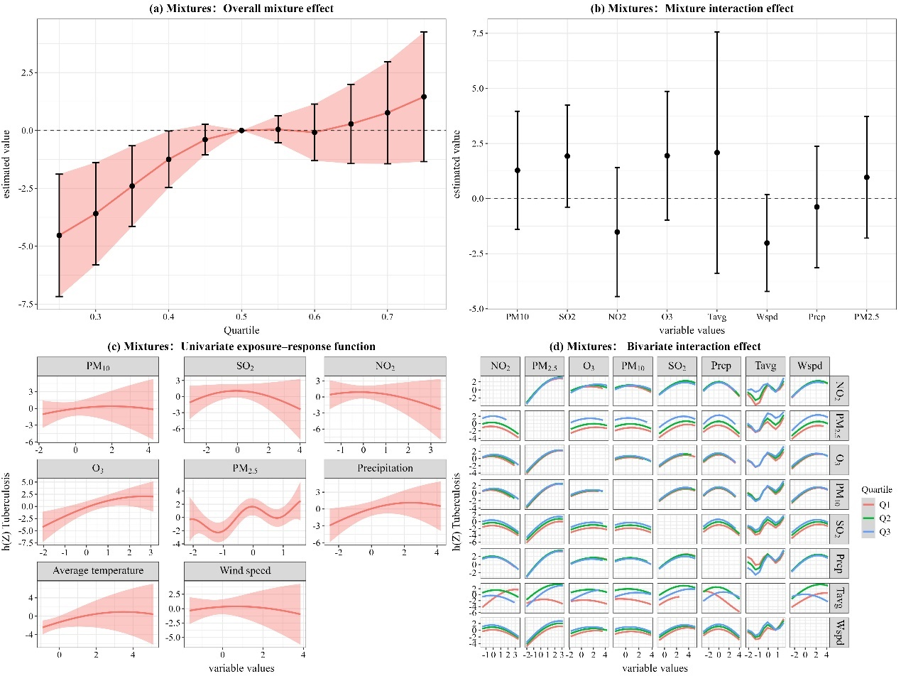

Supplementary Figure 20 The BKMR model for joint effect analysis of air pollutants on the number of tuberculosis cases between the year of 2019 to 2021. The model was not adjusted for covariates.

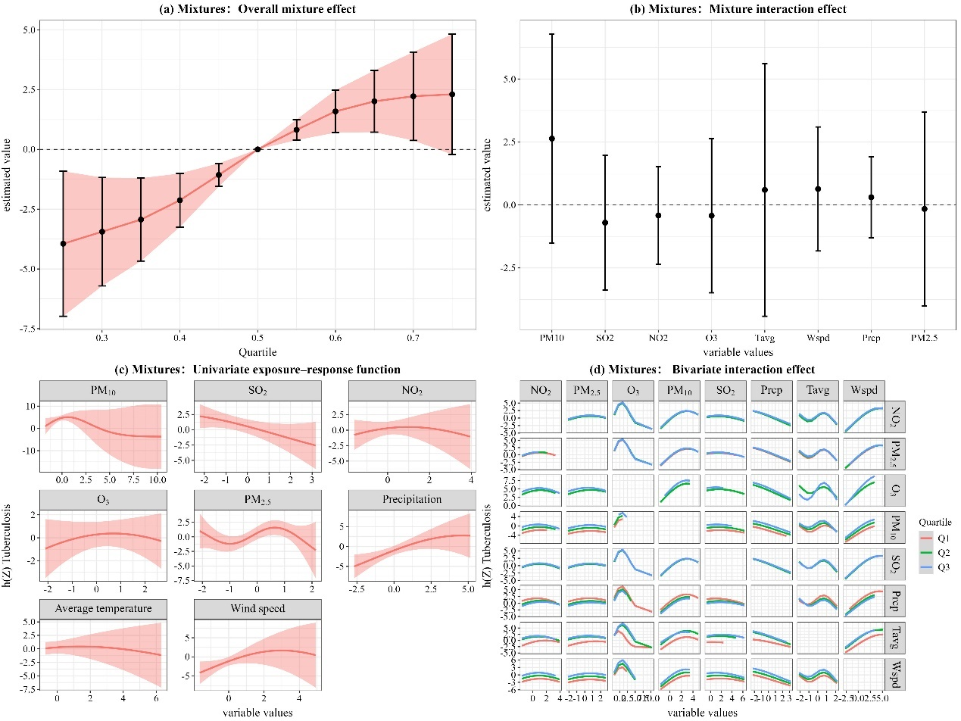

Supplementary Figure 21 The BKMR model for joint effect analysis of air pollutants on the number of tuberculosis cases between the year of 2022 to 2023. The model was not adjusted for covariates.

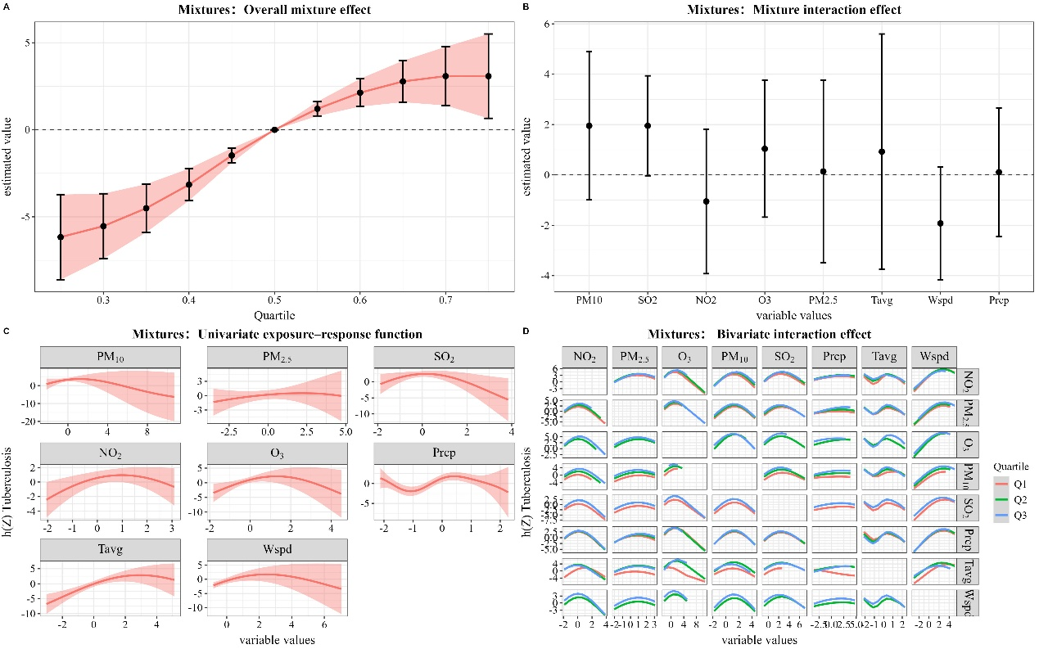

Supplementary Figure 22 The BKMR model for joint effect analysis of air pollutants on the number of tuberculosis cases by monthly.

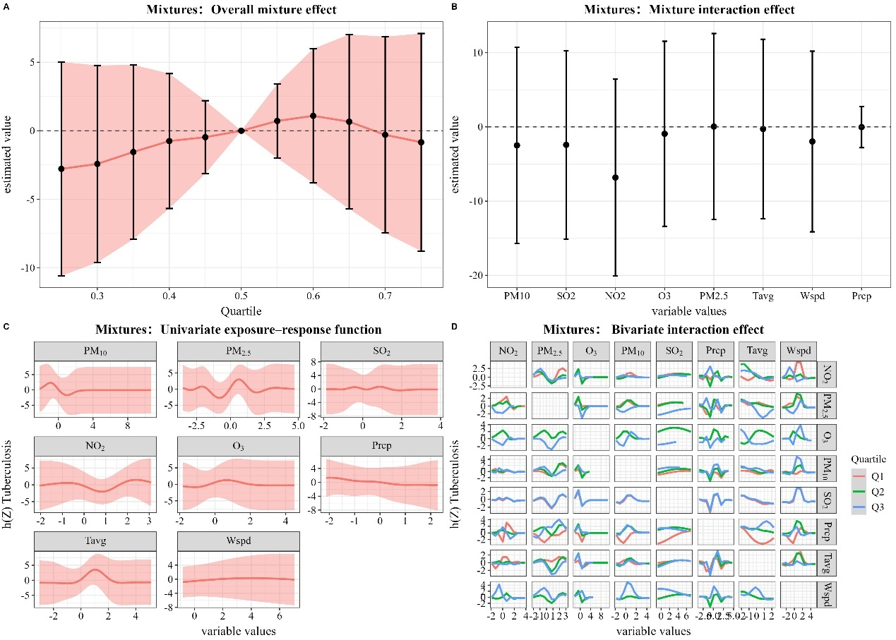

Supplementary Figure 23 The BKMR model for joint effect analysis of air pollutants on the number of tuberculosis cases when adjusting for time trends.

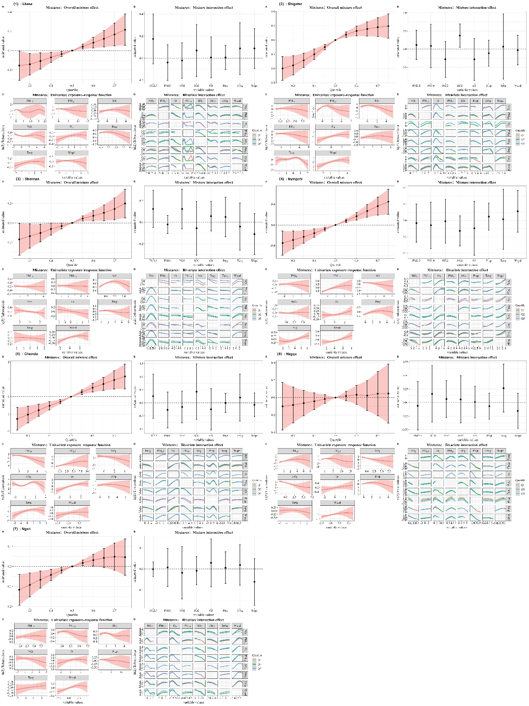

Supplementary Figure 24 Overall effect of environment mixtures on the number of tuberculosis cases in BKMR model (With different regions).

