Supplementary material

CMIP6 Climate Models

The five CMIP6 models selected for this study were CanESM5-r4, CMCC-CM2-SR5, GFDL-ESM4-r1, MPI-ESM1-2-HR-r1 and CNRM- CM6-1-r3. These models were selected so that the simulated future changes in average temperature and precipitation in Finland would at least be reasonably representative of the changes produced by the larger set of 28 CMIP6 models. All models have scored quite well in previous assessments of the quality of the models. From the bias-corrected climate models, we used daily average temperature values from the time period 1 January 1970 until 31 December 2099 for the forcing scenarios SSP2-4.5 and SSP5-8.5. The grid spacing from these models are 0.5°× 0.5°, which is approximately at the 60th latitude 56*28 km.

Minimum mortality temperatures, missing data on all-age mortality and total population in the Finnish wellbeing service counties

Table SM1 Minimum mortality temperatures, missing data on all-age mortality and total population in the Finnish wellbeing service counties. Counties with percentage missing data above 50% were excluded from some analyses.
Wellbeing service county | Minimum mortality temperature (MMT) | Missing data on all-age mortality.  (2000-2017) and (%) | Total Population  (in 2017)
Central Finland | 15 | 196 (2.98%) | 276570
Central Ostrobothnia | 15 | 4992 (75.9%) | 69440
Central Uusimaa | 16 | 2396 (36.4%) | 197458
East Uusimaa | 16 | 3916 (59.6%) | 98082
Helsinki |  | 2 (0.03%) | 648268
  16
Kainuu | 14 | 3471 (52.8%) | 74952
Kanta-Häme | 15 | 925 (14.1%) | 174542
Kymenlaakso | 15 | 481 (7.32%) | 170850
Lapland | 14 | 762 (11.6%) | 181313
North Karelia | 15 | 661 (10.1%) | 168520
North Ostrobothnia | 14 | 66 (1.00%) | 415154
North Savo | 15 | 112 (1.7%) | 254508
Ostrobothnia | 15 | 1169 (17.8%) | 178030
Päijät-Häme | 15 | 464 (7.06%) | 210378
Pirkanmaa | 15 | 2 (0.03%) | 519138
Satakunta | 15 | 208 (3.16%) | 223181
South Karelia | 15 | 1345 (20.5%) | 131497
South Ostrobothnia | 15 | 460 (7.00%) | 197755
South Savo | 15 | 799 (12.2%) | 140796
Southwest Finland | 16 | 1 (0.02%) | 482586
Vantaa and Kerava | 16 | 1963 (29.9%) | 260203
West  Uusimaa | 16 | 163 (2.48%) | 463542
Åland | 16 | 6342 (96.5%) | 29720

Root Mean Square Error (RMSE) and relative RMSE for fixed knot model and qAIC knot alternative model under lag 21

Table SM2 Fixed knots model and qAIC knots model RMSE and relative RMSE model for deaths estimates. The relative RMSE is normalized by mean of all deaths.
Counties | RMSE  fixed kntos  model | Relative  RMSE  Fixed knots  model* | % | RMSE  qAIC model | Relative  RMSE  qAIC  model* | %
Central Finland | 2,756 | 0,400 | 40,0 | 2,752 | 0,399 | 39,9
Central Ostrobothnia | 1,091 | 0,340 | 34,0 | 1,087 | 0,339 | 33,9
Central Uusimaa | 1,460 | 0,371 | 37,1 | 1,458 | 0,371 | 37,1
East Uusimaa | 1,195 | 0,363 | 36,3 | 1,192 | 0,362 | 36,2
Helsinki | 3,836 | 0,289 | 28,9 | 3,851 | 0,290 | 29,0
Kainuu | 1,325 | 0,374 | 37,4 | 1,324 | 0,374 | 37,4
Kanta-Häme | 2,157 | 0,433 | 43,3 | 2,155 | 0,433 | 43,3
Kymenlaakso | 2,322 | 0,417 | 41,7 | 2,322 | 0,417 | 41,7
Lapland | 2,227 | 0,436 | 43,6 | 2,228 | 0,436 | 43,6
North Karelia | 2,222 | 0,424 | 42,4 | 2,224 | 0,424 | 42,4
North Ostrobothnia | 3,046 | 0,383 | 38,3 | 3,045 | 0,383 | 38,3
North Savo | 2,850 | 0,391 | 39,1 | 2,850 | 0,391 | 39,1
Ostrobothnia | 1,853 | 0,388 | 38,8 | 1,853 | 0,388 | 38,8
Päijät-Häme | 2,424 | 0,417 | 41,7 | 2,423 | 0,417 | 41,7
Pirkanmaa | 3,655 | 0,306 | 30,6 | 3,652 | 0,306 | 30,6
Satakunta | 2,696 | 0,403 | 40,3 | 2,696 | 0,403 | 40,3
South Karelia | 1,845 | 0,406 | 40,6 | 1,851 | 0,407 | 40,7
South Ostrobothnia | 2,468 | 0,434 | 43,4 | 2,467 | 0,434 | 43,4
South Savo | 2,174 | 0,422 | 42,2 | 2,174 | 0,421 | 42,1
Southwest Finland | 3,586 | 0,300 | 30,0 | 3,581 | 0,299 | 29,9
Vantaa and Kerava | 1,698 | 0,411 | 41,1 | 1,697 | 0,410 | 41,0
West Uusimaa | 2,829 | 0,405 | 40,5 | 2,829 | 0,405 | 40,5

Temperature-mortality relationship and temperature histogram in Finnish wellbeing service counties with fixed knots and qAIC based knots for the lag 21 (lag 14, and 7 available on request)

Temperature-mortality relationships for fixed knots model
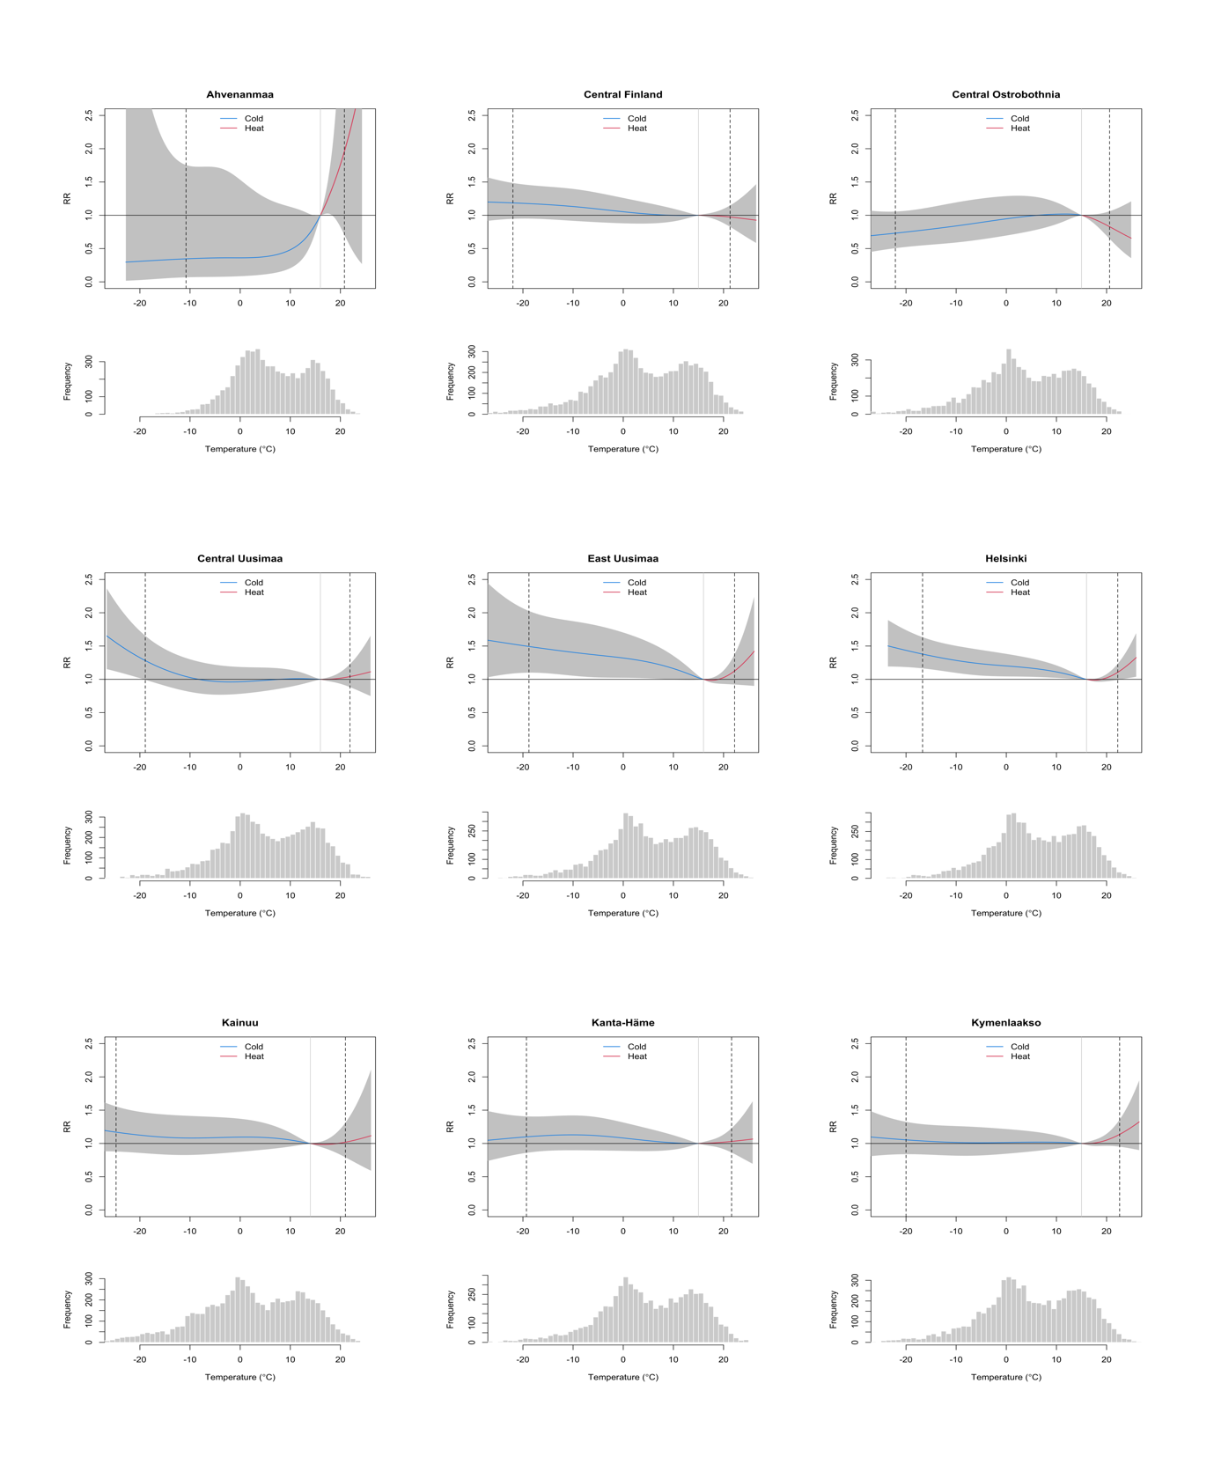

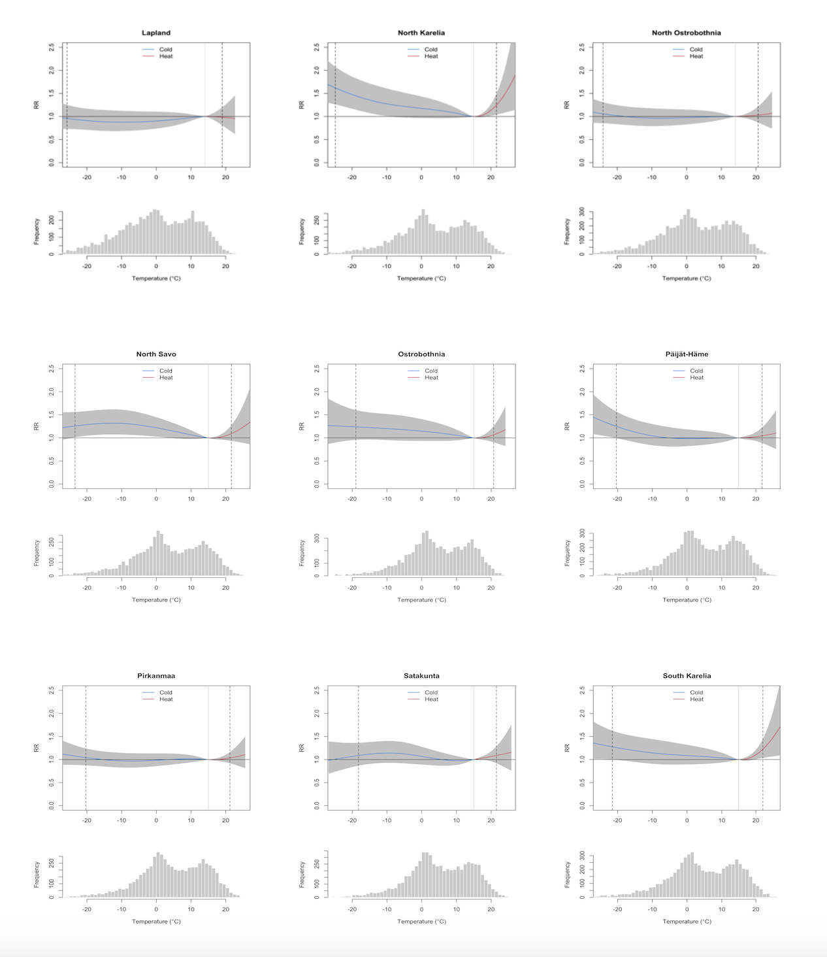

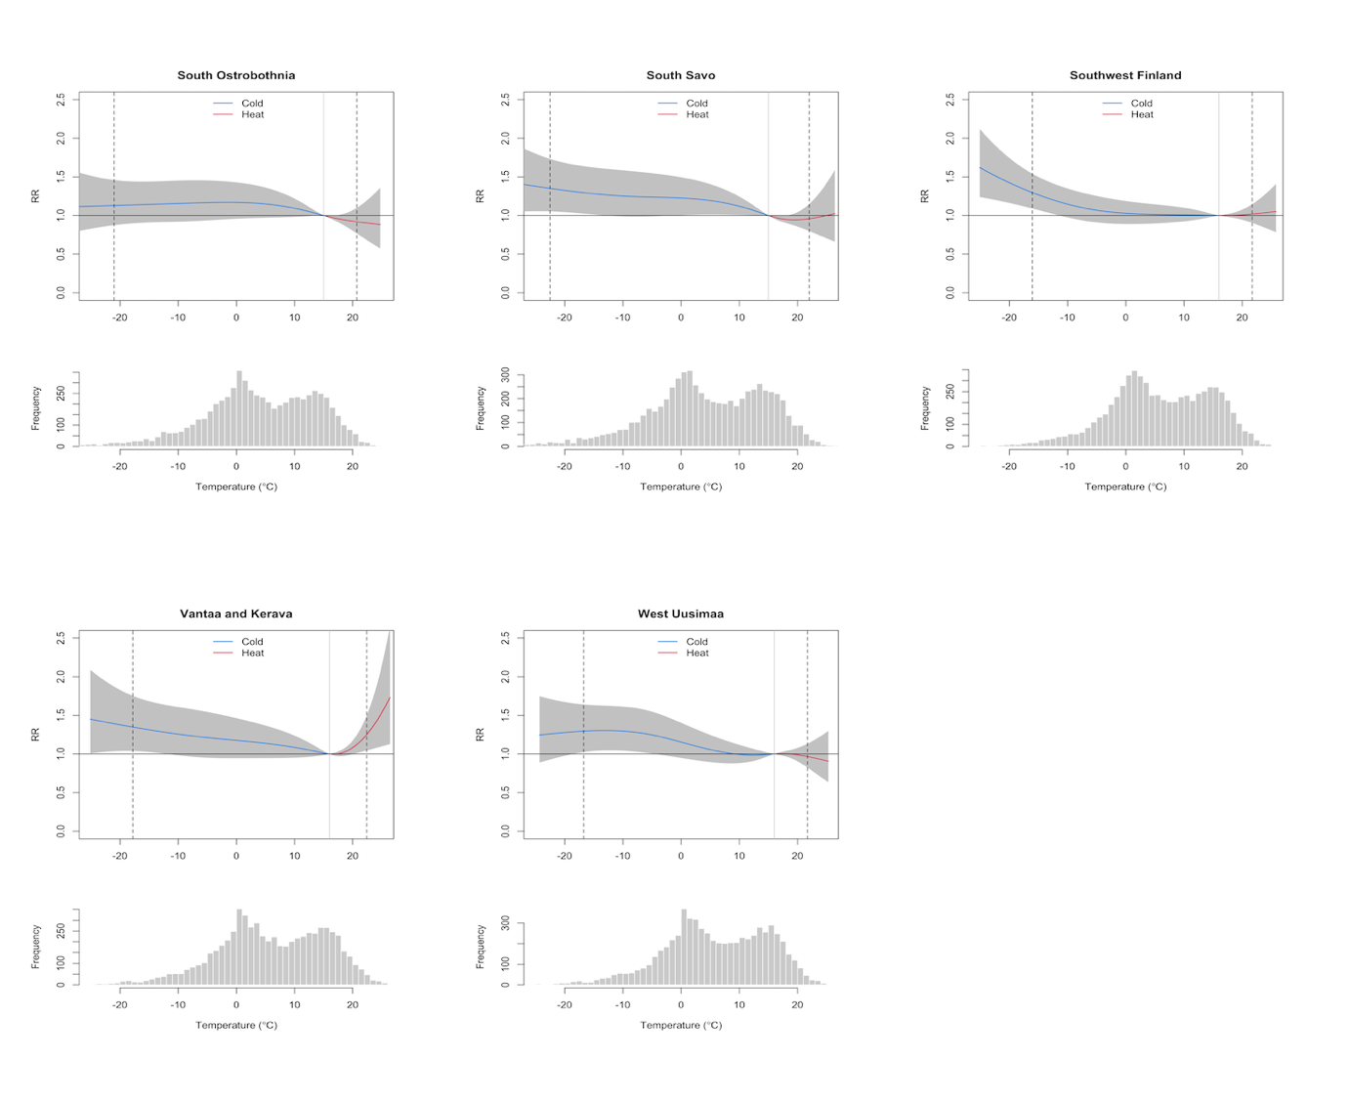

Fig. SM1 Overall cumulative relative risks (RR) of temperature-related mortality and daily mean temperature distributions in Finnish wellbeing service counties in 2000-2017. The upper graphs the grey area illustrates the 95%-CI (confidence interval) of the modelled relationship. The dashed vertical lines present 1st and 99th percentiles and MMT is presented as solid vertical line. The lower graphs present the frequency distribution of the daily mean temperature. The results are presented for fixed knots model under the lag 21.

Temperature-mortality realtionships for qAIC based knot model

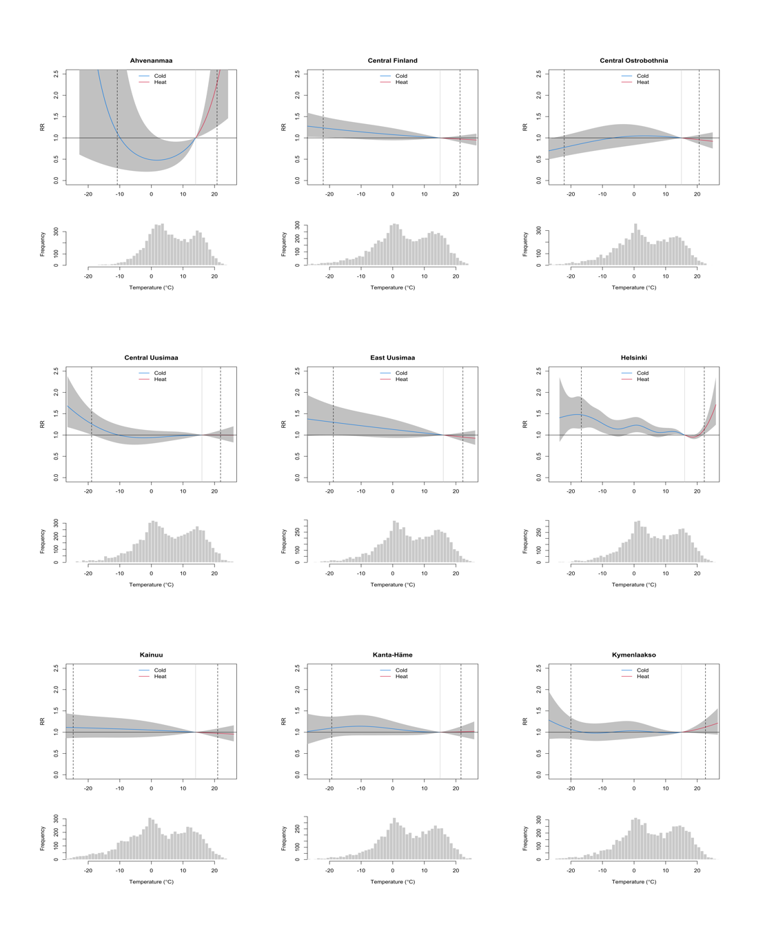
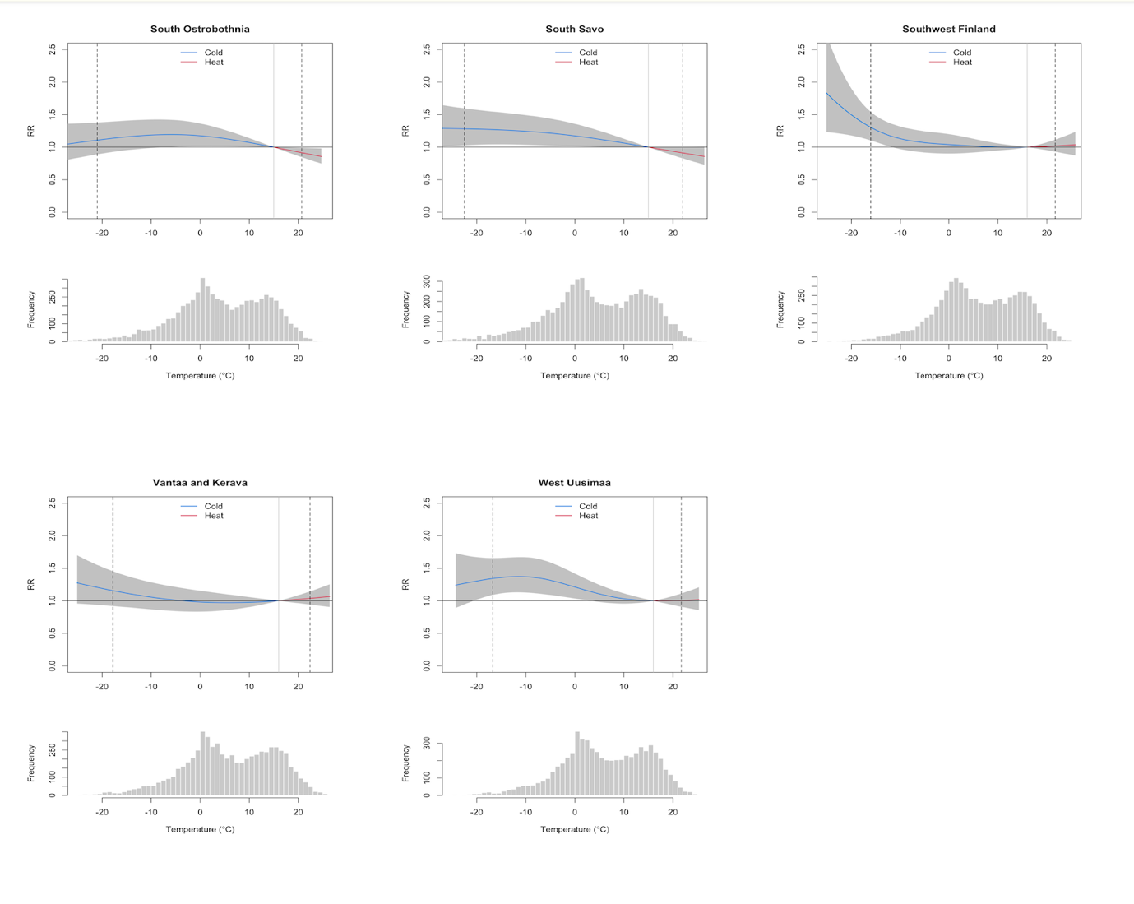

Fig. SM2 Overall cumulative relative risks (RR) of temperature-related mortality and daily mean temperature distributions in Finnish wellbeing service counties in 2000-2017. The upper graphs the grey area illustrates the 95%-CI (confidence interval) of the modelled relationship. The dashed vertical lines present 1st and 99th percentiles and MMT is presented as solid vertical line. The lower graphs present the frequency distribution of the daily mean temperature. The results are presented for the QAIC based knots under the lag 21.

Quasi-Akaike Information Criterion (qAIC) for the best knot selection for the DLNM modelling for 21, 14 and 7 days lag

Table SM3 Quasi-Akaike Information Criterion (qAIC) for the best knot selection for the DLNM modelling
Wellbeing service county | Best knot for the variable (temperature) | Best knot for the lag
Central Finland | 1 | 1
Central Ostrobothnia | 1 | 1
Central Uusimaa | 2 | 2
East Uusimaa | 1 | 1
Helsinki  Ahvenanmaa/Åland | 7  1 | 2  4
Kainuu | 1 | 2
Kanta-Häme | 2 | 1
Kymenlaakso | 3 | 2
Lapland | 1 | 2
North Karelia | 8 | 1
North Ostrobothnia | 2 | 1
North Savo | 3 | 2
Ostrobothnia | 1 | 2
Päijät-Häme | 2 | 1
Pirkanmaa | 4 | 1
Satakunta | 2 | 5
South Karelia | 7 | 2
South Ostrobothnia | 1 | 2
South Savo | 1 | 1
Southwest Finland | 3 | 1
Vantaa_Kerava | 1 | 1
West Uusimaa | 2 | 1

Table SM4 Quasi-Akaike Information Criterion (qAIC) for the best knot selection for the DLNM modelling for 14 days lag
Wellbeing service county | Best knot for the variable (temperature) | Best knot for the lag
Central Finland | 1 | 1
Central Ostrobothnia | 1 | 1
Central Uusimaa | 3 | 1
East Uusimaa | 1 | 1
Helsinki | 7 | 1
Kainuu | 1 | 1
Kanta-Häme | 2 | 2
Kymenlaakso | 3 | 3
Lapland | 1 | 1
North Karelia | 8 | 1
North Ostrobothnia | 1 | 1
North Savo | 3 | 1
Ostrobothnia | 1 | 1
Päijät-Häme | 1 | 5
Pirkanmaa | 4 | 1
Satakunta | 2 | 1
South Karelia | 7 | 2
South Ostrobothnia | 1 | 1
South Savo | 1 | 1
Southwest Finland | 8 | 3
Vantaa_Kerava | 1 | 1
West Uusimaa | 2 | 1

Table SM5 Quasi-Akaike Information Criterion (qAIC) for the best knot selection for the DLNM modelling for 7 days lag
Wellbeing service county | Best knot for the variable (temperature) | Best knot for the lag
Central Finland | 5 | 1
Central Ostrobothnia | 1 | 1
Central Uusimaa | 1 | 1
East Uusimaa | 1 | 4
Helsinki | 7 | 1
Kainuu | 1 | 1
Kanta-Häme | 2 | 1
Kymenlaakso | 3 | 2
Lapland | 1 | 2
North Karelia | 4 | 1
North Ostrobothnia | 1 | 1
North Savo | 3 | 1
Ostrobothnia | 1 | 1
Päijät-Häme | 1 | 1
Pirkanmaa | 4 | 1
Satakunta | 2 | 3
South Karelia | 3 | 1
South Ostrobothnia | 5 | 1
South Savo | 1 | 2
Southwest Finland | 3 | 1
Vantaa_Kerava | 1 | 2
West Uusimaa | 2 | 1

All-age excess heat- and cold related attributable number of deaths (AN)

Table SM6 All-age excess heat related attributable number of deaths (AN) for wellbeing service counties in Finland with 95% confidence interval (CI) with results based on best qAIC knot values under the lag 21. The results include model projections for 2010-2019, 2050-2059 and 2090-2099 under both SSP2-4.5 and SSP5-8.5.
 |  | AN Heat under SSP2-4.5 |  |  | AN heat under SSP5-8.5
Wellbeing service  county | 2010-2019 SSP2-4.5 | 2050-2059 SSP2-4.5 | 2090-2099 SSP2-4.5.5 | 2010-2019 SSP5-8.5 | 2050-2059 SSP5-8.5 | 2090-2099 SSP5-8.5
Central Finland | -48  (-187;84) | -76  (-323;166) | -109  (-484;200) | -52  (-204;90) | -96  (-428;171) | -205  (-898;361)
Central Uusimaa | 2  ( -100;95) | 2  (-183;155) | 2  (-275;254) | 2  (-109;107) | 2  (-243;221) | -1  (-558;484)
Helsinki | -66  (-387; 222) | 200  (-338;897) | 502  (-324;1687) | -26  (-359;301) | 483  (-225;1485) | 2183  (244;5078)
Kanta-Häme | 8  (-154;156) | 15  (-256;266) | 23  (-362;389) | 9  (-162;171) | 21  (-329;342) | 53  (-685;723)
Kymenlaakso | 153  (-67; 357) | 240  (-94;614) | 133  (-196; 501) | 159  (-71;380) | 299  (-114;790) | 628  (-225;1567)
Lapland | 34  (-30;107) | 56  (-53;197) | 90  (-84;323) | 38  (-34;120) | 76  (-70;266) | 181  (-167;582)
North Karelia | 86  (-120;277) | 228  (-100;590) | 435  (-64;1082) | 108  (-101;304) | 382  (-30;898) | 1313  (288;2491)
North Ostrobothnia | 11  (-176;187) | 15  (-295;307) | 21  (-430;450) | 11  ( -102;300) | 18  (-382;391) | 35  (-823;802)
North Savo | 130  (-85;335) | 215  (-116;592) | 326  (-152;915) | 142  (-87;362) | 292  (-137;805) | 692  (-235;1698)
Ostrobothnia | -20  (-116;73) | -34  (-225;133) | -50  (-348;200) | -22  (-133;81) | -43  (-293;170) | -92  (-627;362)
Päijät-Häme | 62  (-86;213) | 97  (-133;350) | 133  (-186;501) | 85  (-89;223) | 121  (-167;444) | 250  (-332;875)
Pirkanmaa | 92  (-200;383) | 172  (-331;731) | 259  (-469;1101) | 101  (-210;421) | 235  (-427;997) | 579  (-919;2203)
Päijät-Häme | 82  (-86;253) | 141  (-137;464) | 201  (-187;668) | 89  (-89;275) | 176  (-167;610) | 392  (-363;1227)
South Karelia | 253  (50;452) | 371  (68;710) | 493  (55;1017) | 260  (50;458) | 444  (52;914) | 825  (-351;1813)
South Ostrobothnia | -114  (-243;-8) | -195  (-465;-15) | -287  (-716;-22) | -124  (-264;-10) | -253  (-640;-20) | -566  (-1354;-41)
South Savo | -140  (-305;4) | -215  (-508;6) | -297  (-746;9) | -147  (-319;4) | -268  (-678;8) | -548  (-1344;18)
Southwest Finland | 43  (-196;278) | 79  (-365;536) | 116  (-547;831) | 47  (-217;303) | 103  (-474;699) | 245  (-1090;1584)
Vantaa and Kerava | 35  (-60; 134) | 59  (-101;236) | 82  (-147; 350) | 38  (-64;147) | 74  (-127;305) | 162  (-282;634)
West  Uusimaa | 2  (-161; 154) | 8  (-293;297) | 16  (-435;450) | 3  (-176;175) | 14  (-379;389) | 54  (-840;884)

Table SM7 All-age excess cold related attributable number of deaths (AN) for wellbeing service counties in Finland with 95% confidence interval (CI) with results based on best qAIC knot values under the lag 21. The results include model projections for 2010-2019, 2050-2059 and 2090-2099 under both SSP2-4.5 and SSP5-8.5.
Wellbeing service  county | 2010-2019 SSP2-4.5 |  |  | 2050-2059 SSP2-4.5 |  |  | 2090-2099  SSP2-4.5 |  |  | 2010-2019  SSP5-8.5 |  |  | 2050-2059  SSP5-8.5 |  |  | 2090-2099  SSP5-8.5
Central Finland |  | 1434  (-821;3220) |  |  | 1249  (-811;3082) |  |  | 1151  (-774;2876) |  |  | 1453  (-793;3345) |  |  | 1187  (-792;2982) |  |  | 876  (-733;2331)
Central Uusimaa |  |  | -341  ( -1945;1113) |  |  | -370  (-1806;956) |  |  | -359  (-1702;887) |  |  | -307  (-1907;1144) |  |  | -359  (-1740;922) |  |  | -314  (-1419;707)
Helsinki |  |  | 5186  (1063; 8666) |  |  | 4620  (818;7977) |  |  | 4286  (741;7445) |  |  | 5214  (1132; 8679) |  |  | 4415  (690;7669) |  |  | 3402  (275; 6223)
Kanta-Häme |  | 839  (-866;2393) |  |  | 727  (-826;2146) |  |  | 668  (-761;2019) |  |  | 838  (-853;2397) |  |  | 686  (-803;2059) |  |  | 481  (-681;1618)
Kymenlaakso |  |  | 154  (-2186; 2212) |  |  | 139  (-1978;2034) |  |  | 126  (-1865;1885) |  |  | 159  (-72;380) |  |  | 132  (-1910;1949) |  |  | 96  (-1501;1557)
Lapland |  | -1137  (-4075;1247) |  |  | -1089  (-3861:1142) |  |  | -1029  (-3613;1056) |  |  | -1126  (-5051;1241) |  |  | -1054  (-3716;1092) |  |  | -911  (-3090;875)
North  Karelia |  | 2207  (-307;4179) |  |  | 1985  (-296;3851) |  |  | 1834  (-332;3626) |  |  | 2227  (-216;4190) |  |  | 1882  (-336;3718) |  |  | 1467  (-387;3050)
North Ostrobothnia |  | -687  (-3488;1919) |  |  | -663  (-3260;1753) |  |  | -624  (-3024;1636) |  |  | -666  ( -3460;1941) |  |  | -629  (-3121;1689) |  |  | -510  (-2502;1365)
North  Savo |  | 3726  (1301;5931) |  |  | 3402  (1136;5489) |  |  | 3168  (1043;5123) |  |  | 3694  (1283;5885) |  |  | 3255  (1077;5302) |  |  | 2560  (731;4330)
Ostrobothnia |  | 679  (-1107;2187) |  |  | 580  (-1066;1973) |  |  | 527  (-999;1805) |  |  | 689  (-1097;2168) |  |  | 547  (-1044;1900) |  |  | 395  (-860;1473)
Päijät-Häme |  | 42  (-1990;1790) |  |  | -79  (-1953;1555) |  |  | -100  (-1844;1443) |  |  | 78  (-1951;1796) |  |  | -95  (-1889;1484) |  |  | -199  (-1656;1065)
Pirkanmaa |  | 515  (-3558;4130) |  |  | 543  (-3130;3941) |  |  | 513  (-2914;3670) |  |  | 533  (-3540;4155) |  |  | 549  (-2986;3813) |  |  | 594  (-2257;3292s)
Satakunta |  | 672  (-1479;2638) |  |  | 520  (-1414; 2316) |  |  | 459  (-1335;2143) |  |  | 677  (-1468;2664) |  |  | 472  (-1391;2210) |  |  | 234  (-1226;1648)
South  Karelia |  | 1201  (-867;2896) |  |  | 1075  (-831;2692) |  |  | 993  (-782;2494) |  |  | 1198  (-871;2879) |  |  | 1032  (-819;2495) |  |  | 783  (-689;2069)
South Ostrobothnia |  | 2071  (123;3737) |  |  | 1938  (128;3496) |  |  | 1808  (118;3256) |  |  | 2056  (107;3698) |  |  | 1865  (134;3389) |  |  | 1536  (126;2795)
South Savo |  | 1945  (246;3413) |  |  | 1752  (194;3134) |  |  | 1635  (168;2924) |  |  | 1952  (253;3378) |  |  | 1682  (180;3041) |  |  | 1316  (106;2425)
Southwest Finland |  | 1303  (-2260;4629) |  |  | 971  (-2354;4042) |  |  | 856  (-2224;3745) |  |  | 1387  (-2198;4688) |  |  | 911  (-2778;3894) |  |  | 532  (-2039;2972)
Vantaa and Kerava | -93  (-1777; 1312) |  |  | -156  (-1700;1224) |  |  | -161  (-1606;1077) |  |  | -70  (-1753;1327) |  |  | -161  (-1656;1187) |  |  | -199  (-1399;818)
West  Uusimaa | 2671  (508; 4681) |  |  | 2286  (280;4367) |  |  | 2096  (218;3926) |  |  | 2684  (525;4702) |  |  | 2163  (209;4030) |  |  | 1520  (-76;3084)

Table SM8 All-age excess cold related attributable number of deaths (AN) for wellbeing service counties in Finland with 95% confidence interval (CI) with results based on fixed knots values under the lag 21. The results include model projections for 2010-2019, 2050-2059 and 2090-2099 under both SSP2-4.5 and SSP5-8.5.

Wellbeing service  county | 2010-2019 SSP2-4.5 |  |  | 2050-2059 SSP2-4.5 |  |  | 2090-2099  SSP2-4.5 |  |  | 2010-2019  SSP5-8.5 |  |  | 2050-2059  SSP5-8.5 |  |  | 2090-2099  SSP5-8.5
Central Finland |  | 1039  (-2232;3653) |  |  | 862  (-2159;3335) |  |  | 782  (-2044;3113) |  |  | 1055  (-2178;3646) |  |  | 805  (-2121;3235) |  |  | 516  (-1941;2576)
Central Uusimaa |  |  | -72  ( -2183;1712) |  |  | -118  (-2053;1537) |  |  | -121  (-1954;1439) |  |  | -38  (-2147;1735) |  |  | -115  (-1990;1496) |  |  | -109  (-1653;1228)
Helsinki |  |  | 5720  (1856;9254) |  |  | 5167  (1575;8527) |  |  | 4819  (1422;8014) |  |  | 5762  (1970; 9276) |  |  | 4978  (1502;4242) |  |  | 4013  (1070;6805)
Kanta-Häme |  | 841  (-1580;2754) |  |  | 734  (-1508;2532) |  |  | 676  (-1413;2374) |  |  | 840  (-1565;2677) |  |  | 695  (-1467;2425) |  |  | 498  (-1257;1951)
Kymenlaakso |  |  | 276  (-2656; 2580) |  |  | 252  (-2463;2397) |  |  | 238  (-2310;2272) |  |  | 279  (-2644;2579) |  |  | 247  (-2376;2316) |  |  | 219  (-1908;1936)
Lapland |  | -1571  (-5368;1333) |  |  | -1492  (-5077:1207) |  |  | -1401  (-4718;1151) |  |  | -1556  (-5348;1316) |  |  | -1437  (-4900;1187) |  |  | -1211  (-4062;1003)
North  Karelia |  | 2315  (-187;4275) |  |  | 2048  (-287;3922) |  |  | 1909  (-308;3669) |  |  | 2338  (-154;1289) |  |  | 1968  (-296;3799) |  |  | 1520  (-378;3110)
North Ostrobothnia |  | -434  (-4400;2741) |  |  | -431  (-4157;2549) |  |  | -408  (-3861;2383) |  |  | -415  ( -4382;2745) |  |  | -408  (-3998;2462) |  |  | -337  (-3301;2059)
North  Savo |  | 3395  (450;5773) |  |  | 3095  (345;5357) |  |  | 2890  (303;5014) |  |  | 3384  (451;5721) |  |  | 2968  (305;5187) |  |  | 2346  (102;4286)
Ostrobothnia |  | 1528  (-742;3474) |  |  | 1375  (-730;3206) |  |  | 1269  (-691;2976) |  |  | 1533  (-723;3460) |  |  | 1341  (-712;3195) |  |  | 1030  (-670;2514)
Päijät-Häme |  | 85  (-2766;2337) |  |  | -13  (-2665;2092) |  |  | -31  (-2520;1972) |  |  | 124  (-2714;2371) |  |  | -21  (-2593;2034) |  |  | -87  (-2162;1622)
Pirkanmaa |  | -217  (-4720;3499) |  |  | -174  (-4350;3286) |  |  | -154  (-4045;3098) |  |  | -132  (-4550;3593) |  |  | 36  (-4174;3522) |  |  | 502  (-3823;1448)
Satakunta |  | 781  (-2126;3287) |  |  | 607  (-2066;2966) |  |  | 534  (-1960;2746) |  |  | 782  (-2105;3273) |  |  | 551  (-2040;2842) |  |  | 616  (-632;1931)
South  Karelia |  | 989  (-1165;2713) |  |  | 855  (-1137;2487) |  |  | 791  (-1104;2304) |  |  | 1003  (-1146;2719) |  |  | 818  (-1120;2390) |  |  | 783  (-689;2069)
South Ostrobothnia |  | 2086  (-728;4273) |  |  | 1975  (-607;4060) |  |  | 1852  (-569;3795) |  |  | 2075  (-721;4256) |  |  | 1913  (-576;3943) |  |  | 1626  (-434;3324)
South Savo |  | 2440  (109;4241) |  |  | 2248  (92;3974) |  |  | 2113  (89;3751) |  |  | 2445  (121;4265) |  |  | 2176  (87;3866) |  |  | 1802  (77;3220)
Southwest Finland |  | 1237  (-2894;4946) |  |  | 902  (-2935;4413) |  |  | 799  (-2799;4116) |  |  | 1326  (-2820;5011) |  |  | 848  (-2871;4255) |  |  | 494  (-2622;3348)
Vantaa and Kerava | 1544  (-449;3199) |  |  | 1378  (-472;2964) |  |  | 1279  (-445;2764) |  |  | 1553  (-403;3207) |  |  | 1323  (-456;2845) |  |  | 1043  (-416;2339)
West  Uusimaa | 1885  (-1290;4473) |  |  | 1578  (-1453;3981) |  |  | 1390  (-1431;3699) |  |  | 1903  (-1278;4469) |  |  | 1436  (-1467;3837) |  |  | 891  (-1557;2940)

Wellbeing service counties of Finland
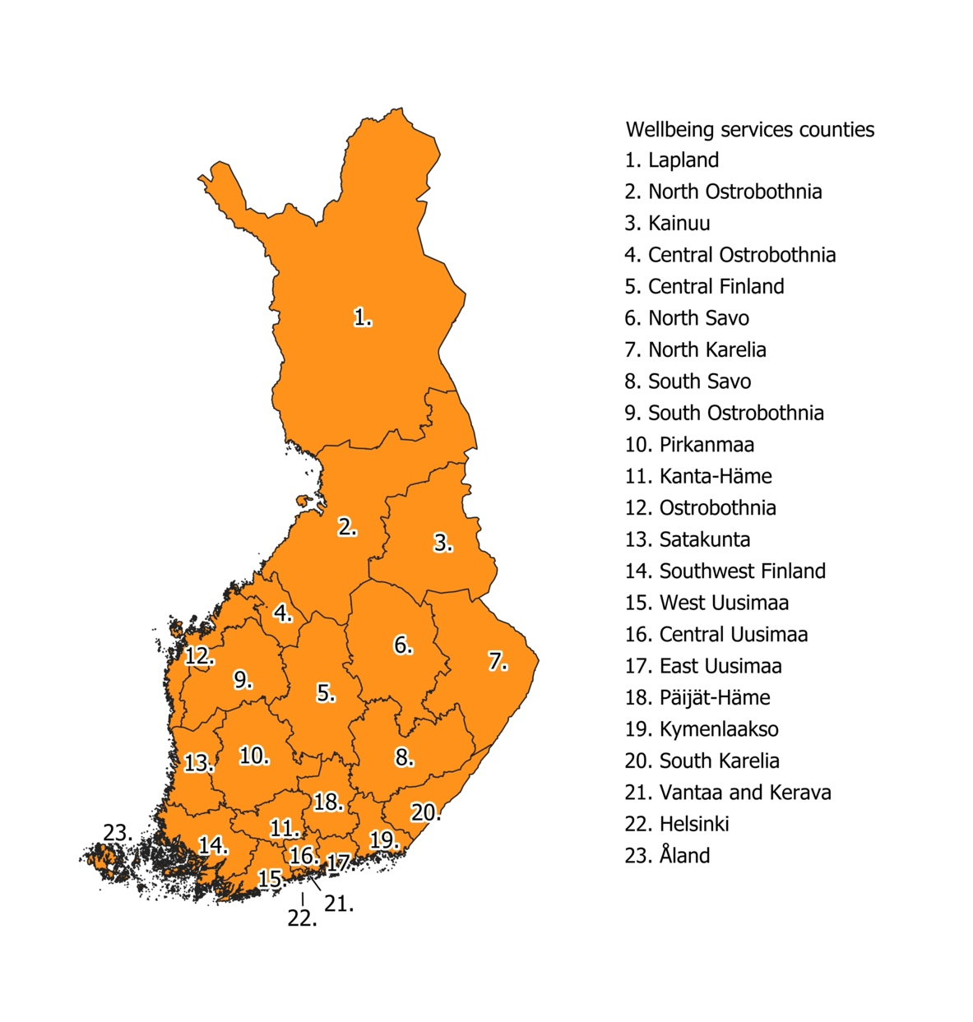
Fig. SM3 Wellbeing service counties of Finland

