Supplementary materials

Figure 1: Climate data for São Carlos – Clima Tool output for 868450_TMYx.2009-2023.

Figure 2: Linear regression of simulated and measured temperature.

Figure 3: Courtyard shading profile.

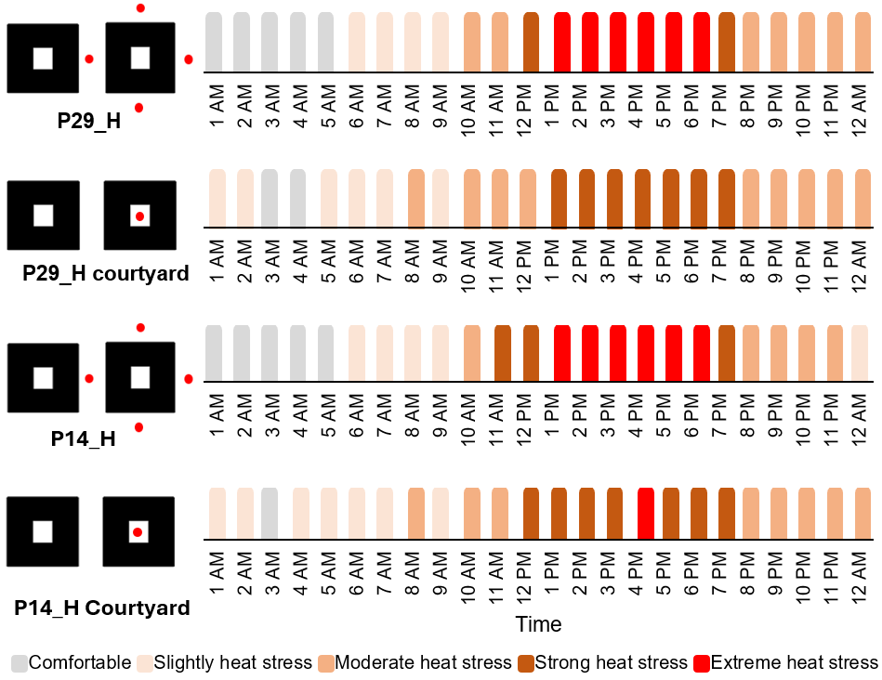
Figure 4: Heat stress levels inside and outside the courtyards during the heatwave.
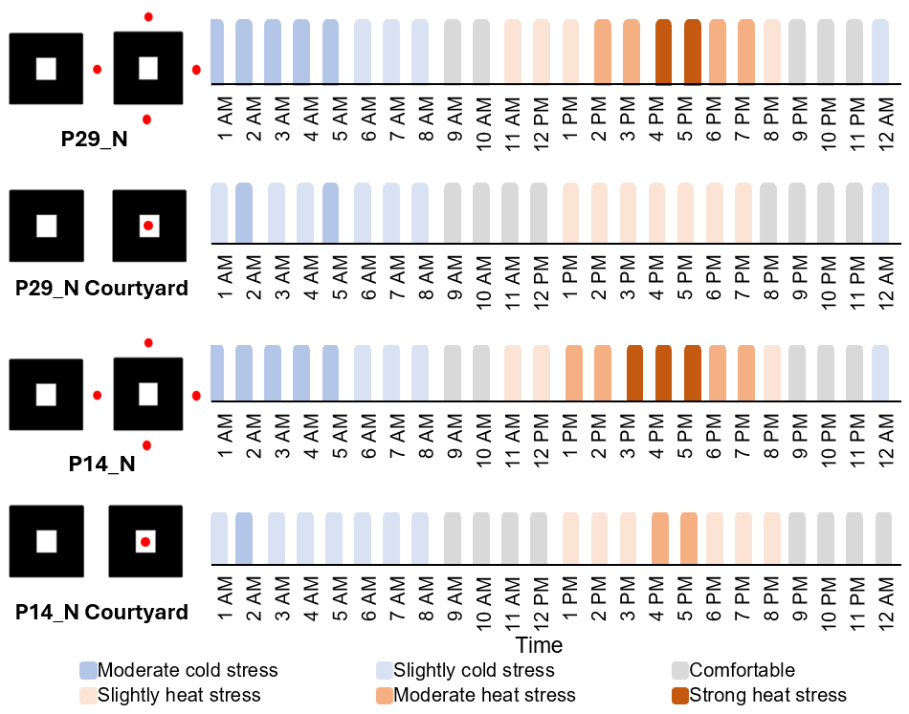
Figure 5: Heat stress levels inside and outside the courtyards outside the heatwave.
Figure 6: Vertical profile of air velocity in scenario P29_H, at 2 am.

