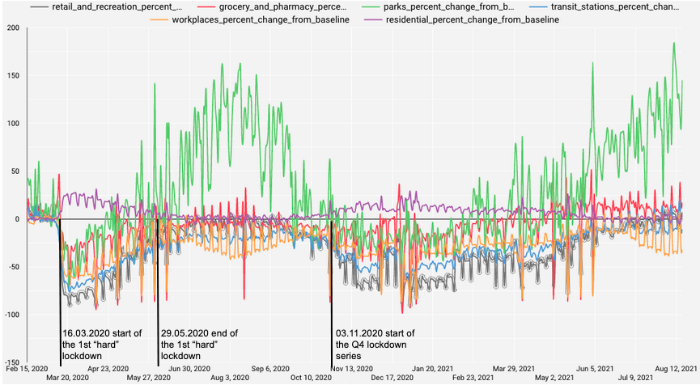
Supplementary Figure 1: COVID-19 Google Mobility Report on Austria. Displayed is a %-change in movement of users of Google products relative to a baseline (28). The baseline day is the median value from the 5‑week period Jan 3 – Feb 6, 2020 by the company. Clearly visible is a marked drop in all registered mobilities but “residential” on March 16th, the date of the first lockdown in Austria. Similarly, the lockdown series in Q4 2020 entailed a lasting reduction in workplace, retail, and transit mobility.

