Supplemental material

A comparison of breast cancer incidence and cancer stages before and after the introduction of the Austrian national breast cancer screening program in the federal state of Salzburg: real-world data from the Tumor Registry Salzburg.

Ein Vergleich von Brustkrebsinzidenz und Tumorstadien vor und nach Einführung des nationalen Brustkrebsfrüherkennungsprogramms in Österreich im Bundesland Salzburg: Real-world Daten aus dem Salzburger Tumorregister.

Simon Peter Gampenrieder^{1,2}, Marc Vaisband^{1,3}, Gabriel Rinnerthaler^{1,2,4}, Lukas Weiss^{1,2,6}, Bernhard Jaud^{1,6}, Martin Sprenger⁵, Richard Greil^{1,2,6}

Running header: Influence of the Austrian national breast cancer screening on breast cancer stage

¹ Department of Internal Medicine III with Haematology, Medical Oncology, Haemostaseology, Infectiology and Rheumatology, Oncologic Center, Salzburg Cancer Research Institute - Laboratory for Immunological and Molecular Cancer Research (SCRI-LIMCR), Paracelsus Medical University Salzburg, Salzburg, Austria;
² Cancer Cluster Salzburg, Salzburg, Austria;
³ University of Bonn, Bonn, Germany;
⁴ Division of Oncology, Department of Internal Medicine, Medical University of Graz, Austria;
⁵ Institute of Social Medicine and Epidemiology, Medical University of Graz, Graz, Austria;
⁶ Tumor Registry Salzburg, Salzburg, Austria;

Appendix 1: Statistical details

1.1 Poisson rate parameter approximation

For the equality testing of incidence rates in the Poisson model, we followed (28) in calculated the age-standardized incidence rate as

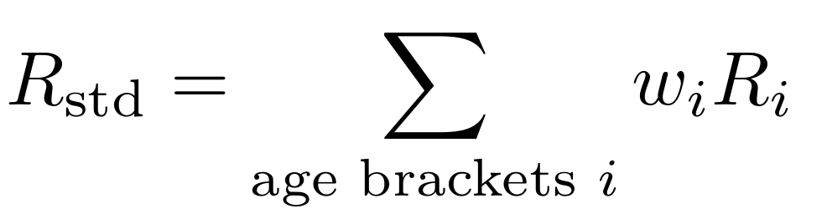

with the standard error estimate

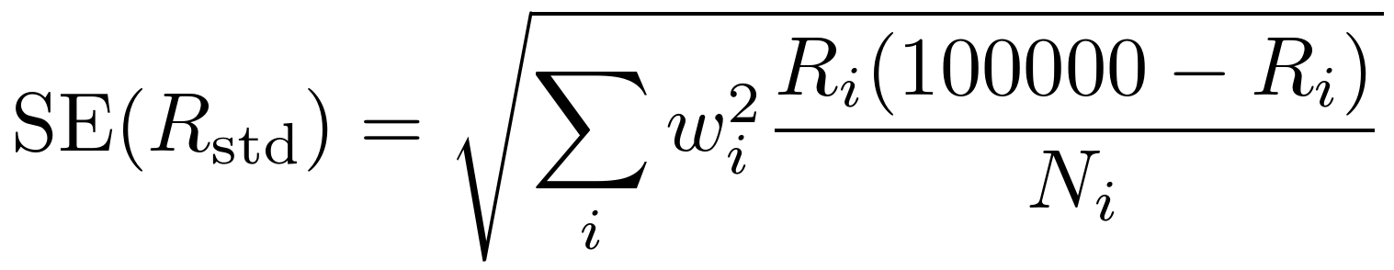

where the $w_{i}$ are the respective weights of the i-th age in the standard population, $N_{i}$are the raw case counts, and $R_{i}$ are the empirical incidence rates per 100,000 population for each age bracket. These rate estimates were then compared between the baseline and reference observation periods using the z-test, using the canonical test statistic:

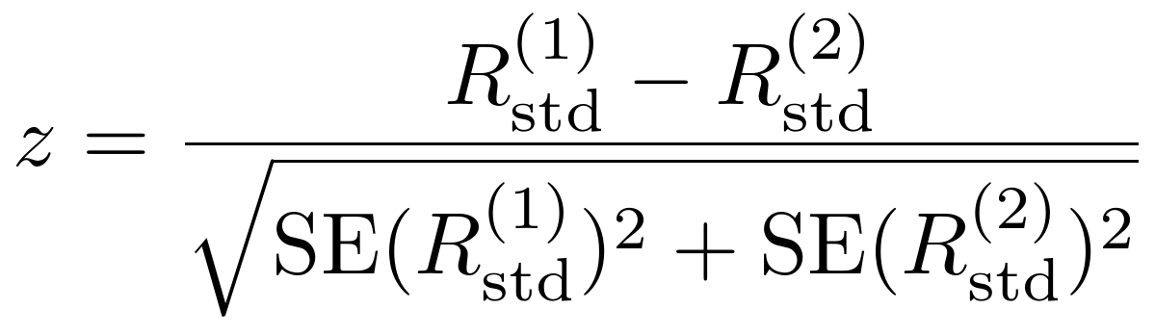

In order to estimate the power of this procedure, we additionallz calculated the minimal effect size which would have been necessary for a nominally significant test under equal standard error estimates. The results are reported in Table S5 of the supplement.

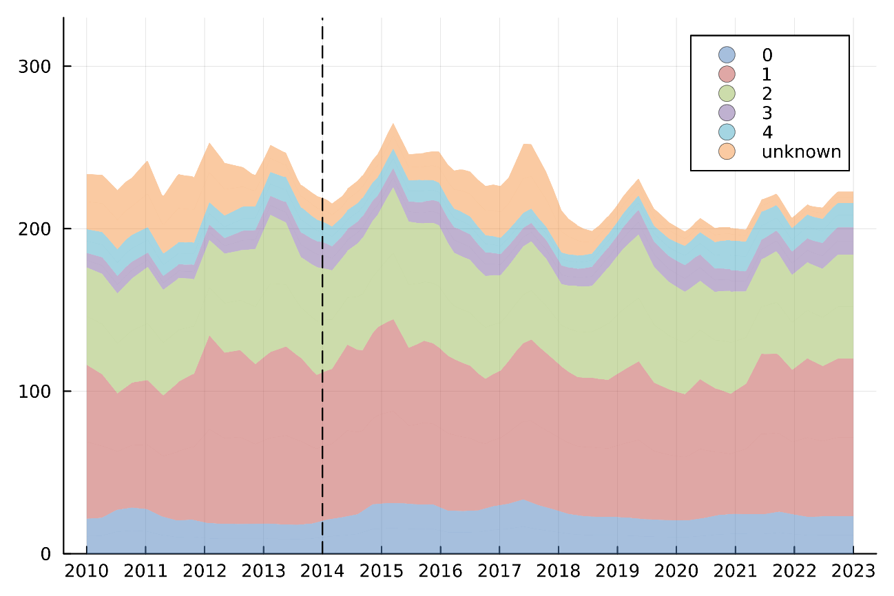
Figure S1. Graphical representation of the estimated breast cancer instantaneous incidence rate (per 100.000 women; not age-standardized) in the Primary Study Population (age 45-69; n = 2,310), obtained using non-parametric Bayesian intensity function estimation, over time in the federal state of Salzburg between 2010 and 2023, including the different stages at diagnosis.

Figure S2. Age-standardized incidence rate per year per 100,000 standard population (all stages) including the 95% confidence intervals in the Primary Study Population (age 45-69; n = 2,310).
* z-test comparing the incidence rates between 2010-2013 and 2016-2019.

Figure S3. Age-standardized incidence rate per year per 100,000 standard population including the 95% confidence intervals according to stage 0-I vs. II-IV in the Primary Study Population (age 45-69; n = 2,310).

Figure S4. Age-standardized incidence rate per year per 100,000 standard population according to stage 0-I vs. II-IV in the Primary Study Population (age 45-69; n = 2,310).

Figure S5. Age-standardized incidence rate per year per 100,000 standard population including the 95% confidence intervals according to nodal status (without stage IV) in the Primary Study Population (age 45-69; n = 2,310).

Figure S6. Percentage of breast cancer subtypes in the Primary Study Population (age 45-69; n = 2,310).

Table S1. Proportional distribution of the age-standardized incidence rate per year per 100,000 standard population according to stage in the Primary Study Population.
n = 2.310 | 2010-2022 | 2010-2013 | 2014-2015 | 2016-2019 | 2020-2022 | p*
Stage 0 | 12.6% | 12.2% | 13.0% | 13.4% | 11.6% | 0.380
Stage I | 45.5% | 44.1% | 47.9% | 46.2% | 44.3% | 0.380
Stage II | 28.3% | 28.2% | 27.5% | 29.0% | 28.0% | 0.380
Stage III | 6.7% | 6.1% | 6.1% | 6.9% | 8.0% | 0.380
Stage IV | 6.9% | 9.4% | 5.5% | 4.5% | 8.1% | 0.380
Stage 0-I | 58.1% | 56.3% | 60.9% | 59.6% | 55.9% | 0.524
Stage II-IV | 41.9% | 43.7% | 39.1% | 40.4% | 44.1% | 0.524
N0 | 69.5% | 64.8% | 73.6% | 73.2% | 66.7% | 0.538
N+ | 23.5% | 25.8% | 20.6% | 22.2% | 25.1% | 0.538
* Logistic regression including time period (2010-2013 vs. 2016-2019), age (45-54 vs. 55-64 and 45-54 vs. 65-74), interaction of age and time period and residence (rural vs. urban)

Table S2. Binary logistic regression for stage 0-I vs. II-IV in the Primary Study Population with diagnosis 2010-2013 or 2016-2019.
n = 1,364 | Coefficient | 95% CI | Standard deviation | z | p
Time period  2010-2013* vs. 2016-2019 | -0.123 | -0.503 - 0.256 | 0.194 | -0.638 | 0.524
Age  45-52* vs. 53-60 | 0.152 | -0.257 - 0.560 | 0.208 | 0.728 | 0.467
45-52* vs. 61-69 | -0.122 | -0.496 - 0.253 | 0.191 | -0.635 | 0.525
Interaction age / time period**  45-52* vs. 53-60 /  2010-2013* vs. 2016-2019 | -0.175 | -0.731 - 0.380 | 0.283 | -0.619 | 0.536
45-52* vs. 61-69 /  2010-2013* vs. 2016-2019 | 0.095 | -0.418 - 0.608 | 0.262 | 0.364 | 0.716
Residence  rural* vs. urban | -0.037 | -0.253 - 0.179 | 0.110 | -0.333 | 0.739
* reference
** included to correct for a potential change in age distribution between the different time periods

Table S3. Binary logistic regression for nodal status (N0 vs. N+) without stage IV in the Primary Study Population with diagnosis 2010-2013 or 2016-2019.
n = 1,277 | Coefficient | 95% CI | Standard deviation | z | p
Time period  2010-2013* vs. 2016-2019 | -0.136 | -0.568 - 0.296 | 0.220 | -0.615 | 0.538
Age  45-52* vs. 53-60 | 0.184 | -0.277 - 0.646 | 0.236 | 0.782 | 0.434
45-52* vs. 61-69 | -0.123 | -0.557 - 0.311 | 0.222 | -0.555 | 0.579
Interaction age / time period**  45-52* vs. 53-60 /  2010-2013* vs. 2016-2019 | -0.408 | -1.049 - 0.234 | 0.327 | -1.246 | 0.213
45-52* vs. 61-69 /  2010-2013* vs. 2016-2019 | -0.036 | -0.633 - 0.561 | 0.305 | -0.117 | 0.907
Residence  rural* vs. urban | -0.028 | -0.281 - 0.224 | 0.129 | -0.220 | 0.826
* reference
** included to correct for a potential change in the distribution between the different time periods

Table S4. Ordinal logistic regression for stage 0-IV in the Primary Study Population after data imputation (Mx M0 if stage I or II).
n = 1,550 | Coefficient | 95% CI | Standard deviation | z | p
Time period  2010-2013* vs. 2016-2019 | -0.146 | -0.468 - 0.176 | 0.164 | -0.888 | 0.374
Age  45-52* vs. 53-60 | 0.068 | -0.273 - 0.409 | 0.174 | 0.392 | 0.695
45-52* vs. 61-69 | -0.015 | -0.322 - 0.293 | 0.157 | -0.095 | 0.925
Interaction age / time period**  45-52* vs. 53-60 /  2010-2013* vs. 2016-2019 | 0.003 | -0.473 - 0.479 | 0.243 | 0.012 | 0.991
45-52* vs. 61-69 /  2010-2013* vs. 2016-2019 | 0.004 | -0.432 - 0.441 | 0.223 | 0.019 | 0.985
Residence  rural* vs. urban | -0.024 | -0.209 - 0.161 | 0.094 | -0.252 | 0.801
* reference
** included to correct for a potential change in the distribution between the different time periods

Table S5 Calculation of the minimum difference size for nominally significant test for a ceteris-paribus comparison of age-standardized incidence rates between 2010-2013 and 2016-2019.
 | 2010-2013 | 95%CI | 2016-2019 | 95%CI | p | Difference in incidence rate  2010-2013 vs. 2016-2019 | Minimum difference size for nominally significant test with unchanged standard errors
All stages* | 176.0 | 149.3-206.0 | 193.9 | 167.0-224.0 | 0.371 | 17.9 | 39.4
Stage 0 | 21.5 | 12.9-33.6 | 26.1 | 16.8-38.5 | 0.525 | 4.6 | 14.1
Stage I | 77.6 | 60.3-98.4 | 89.6 | 71.5-110.7 | 0.376 | 12.0 | 26.5
Stage II | 49.6 | 35.8-66.2 | 56.2 | 41.9-73.1 | 0.539 | 6.6 | 21.0
Stage III | 10.8 | 5.0-20.2 | 13.5 | 7.2-23.1 | 0.602 | 2.7 | 10.1
Stage IV | 16.5 | 8.9-27.2 | 8.7 | 3.6-16.6 | 0.141 | 7.8 | 10.4
N0 | 114.1 | 92.9-138.7 | 142.0 | 118.8-167.7 | 0.095 | 27.9 | 32.7
N+ | 45.4 | 32.2-61.5 | 43.0 | 30.6-30.6 | 0.807 | 2.4 | 19.2
Nodal status unknown | 0.0 | 0.0-0.0 | 0.3 | -0.82-1.39 | 0.617 | 0.3 | 1.1
* Stages according to AJCC version 8

