Supplementary Figure S1. Overview of the study design of the SMART-trial
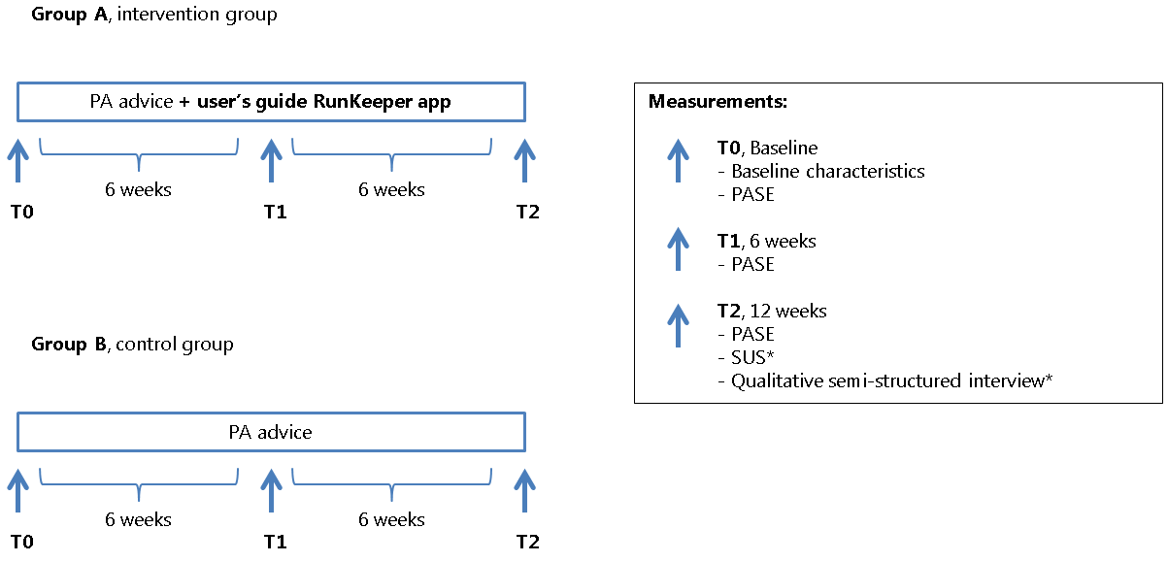
*Group A only
Abbreviations: PA, physical activity; PASE, Physical Activity Scale for the Elderly; SUS, System Usability Scale

