Supplementary Data to “Cancer-related fatigue in patients treated with mistletoe extracts: A systematic review and meta-analysis”

Florian Pelzer ^{1,2}, Martin Loef ³, David D. Martin¹, Stephan Baumgartner^{1,2}
¹ Institute of Integrative Medicine, Witten/Herdecke University, Witten, Germany
² Society for Cancer Research, Arlesheim, Switzerland
³ CHS Institut, Berlin, Germany

Corresponding author
Florian Pelzer, M.Sc.
E-mail: florian.pelzer@uni-wh.de
ORCID-Nr.: 0000-0002-8169-4539

- Supplementary details to statistical procedures
We imputed missing means and standard deviations according to Higgins et al. (2019, chapter 6.5.2.8 ff). Standard deviations of the change from baseline were estimated with the formula:

$${SD}_{E, change}=\sqrt{{SD}_{E, baseline}^{2}+{SD}_{E,final}^{2}-\left(2×Corr×{SD}_{E, baseline}×{SD}_{E, final}\right)}$$

The correlation coefficient (Corr) was estimated using the maximum number of studies with sufficient data and examined for consistency. The mean correlation coefficient was estimated as Corr=0.6.

For the combination of groups we imputed missing means with:

$$M_{1,2}=\frac{N_{1}M_{1}+N_{2}M_{2}}{N_{1}+N_{2}}$$

Missing standard deviations for combined groups were calculated with:

$${SD}_{1,2}=\sqrt{\frac{\left(N_{1}-1\right){SD}_{1}^{2}+\left(N_{2}-1\right){SD}_{2}^{2}+\frac{N_{1}N_{2}}{N_{1}+N_{2}}\left(M_{1}^{2}+M_{2}^{2}-2M_{1}M_{2}\right)}{N_{1}+N_{2}-1}}$$

- Additional calculations
  - Meta-Regression
We conducted meta-regressions regarding the impact of the intervention duration and baseline fatigue level on the effect size. Those were neither significantly associated with baseline fatigue (ES -0.01 95% CI -0.03 to 0.06; p=0.52; 10 studies) nor with the intervention duration (ES -0.04 95% CI -0.08 to 0.002; p=0.06, 12 studies).
  - Effect sizes
SMD can be re-expressed as mean differences (MD) and OR can be re-expressed as relative risks (RR) according to [1].
Meta-analysis of RCT by pooling the MD instead of the SMD: Mistletoe extracts reduced CRF in studies using questionnaires scaled from 100 to 0 (EORTC-QLQ-C30 and GLQ-8) with MD=8.5 (95% CI -14.99 to -2) (Fig. S1). This can be interpreted as clinically meaningful [2]. Two studies [3, 4] which were double-blinded and applied GLQ8 for measuring CRF, had a pooled effect estimate of MD=-17.5 (95% CI -32.09 to -2.92; p=0.02) in contrast to MD=-6.28 (95% CI -13.23 to 0.68; p=0.08) for the open-label studies using the EORTC-QLQ-C30.

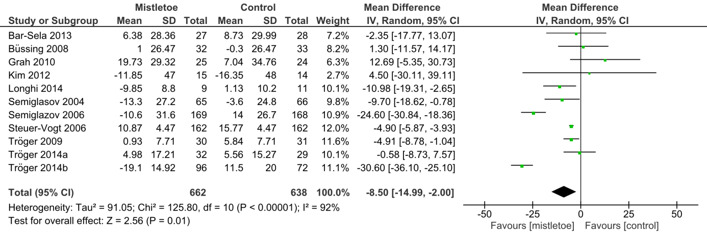
Figure S1. Random-Effect meta-analysis pooling mean differences from RCT regarding the effect of mistletoe vs. control on cancer-related fatigue

Meta-analysis of retrospective NRSI by pooling the RR instead of the OR: Mistletoe extracts reduced the risk of suffering from CRF by 46%, with RR=0.54 (95% CI 0.34-0.84; p=0.007) (Fig. S2). This magnitude is also comparable with a reported effect estimate of regular physical exercise on CRF [5].

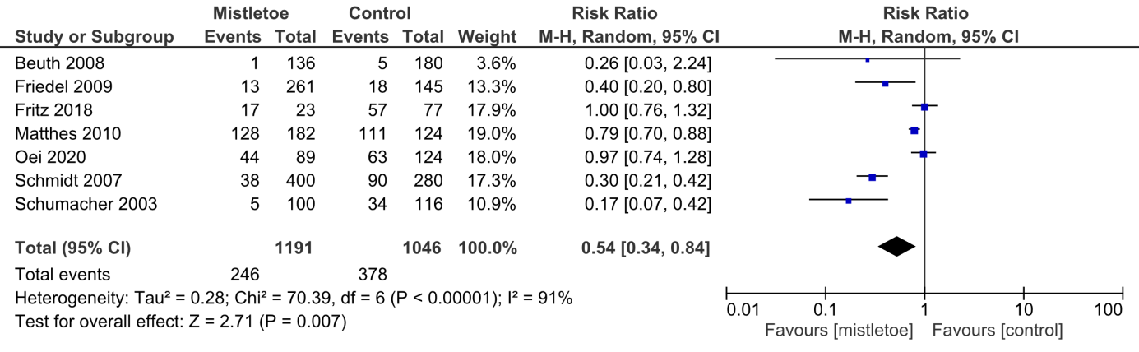
Figure S2. Random-Effect meta-analysis pooling relative risks from retrospective NRSI regarding the effect of mistletoe vs. control on cancer-related fatigue

- Supplementary figures to risk of bias evaluation

Figure S3: Summary of risk of bias assessment of RCT in percentage according to Cochrane RoB 2 tool (intention-to-treat)

- Supplementary figures to publication bias evaluation

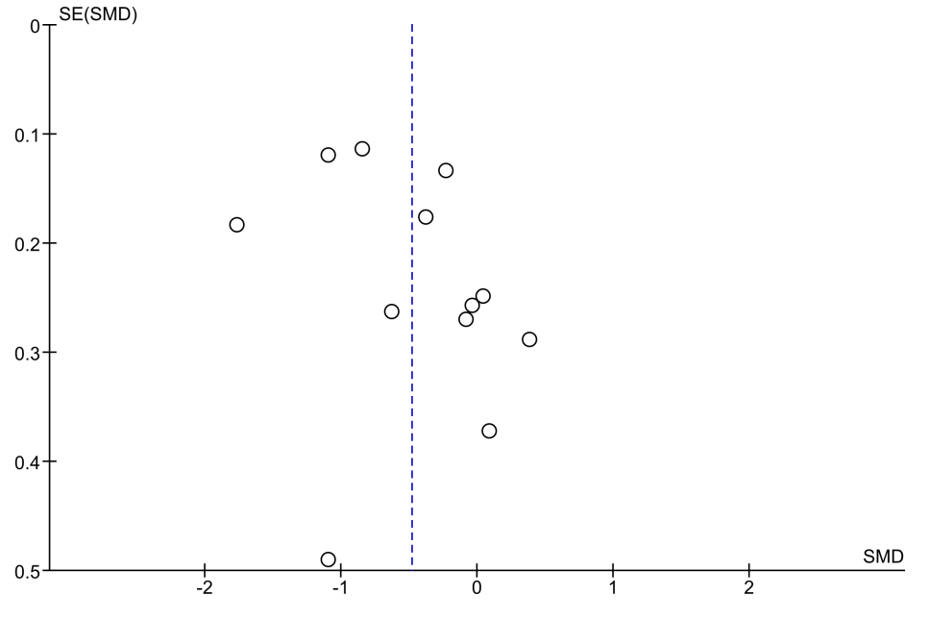

Figure S4. Funnel plot to meta-analysis in Figure 2

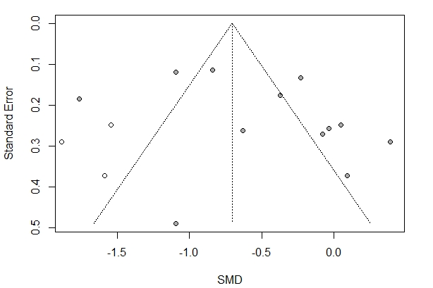

Figure S5. Visualization of the Duval & Tweedie’s trim-and-fill procedure for the RCT

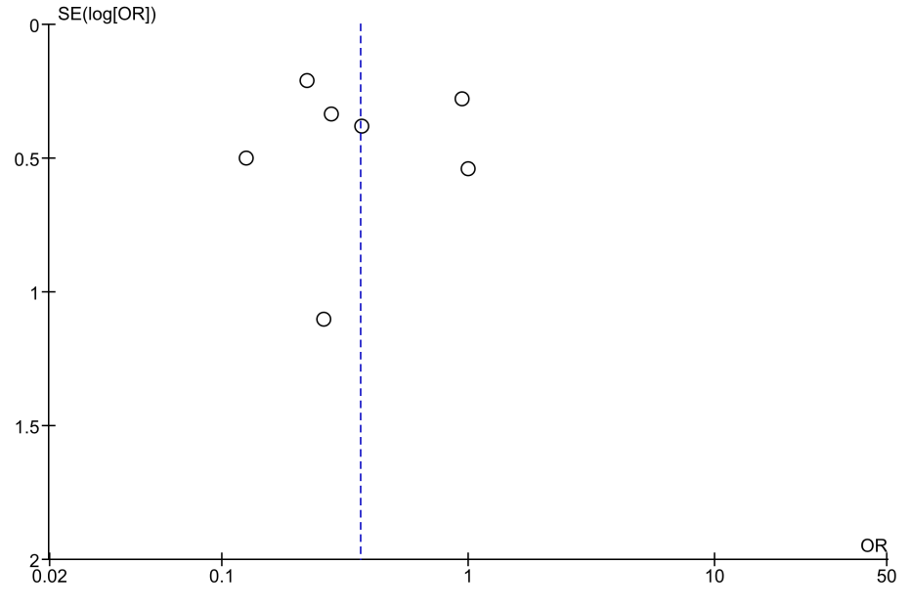

Figure S6. Funnel plot to meta-analysis in Figure 4

- Supplementary tables
Table S1. Literature search algorithms

Europe PMC (https://europepmc.org)
("quality of life" OR "HRQL" OR "QOL" OR "well being" OR "Fatigue" OR "cancer related fatigue" OR "CRF" OR "asthenia" OR "müdigkeit")
AND
("krebs" OR "cancer" OR "neoplasm" OR "tumor")
AND
("mistletoe" OR "viscum" OR "iscador" OR "iscucin" OR "abnobaviscum" OR "helixor" OR "lektinol" OR "isorel" OR "vysorel" OR "plenosol" OR "cefalektin")
CENTRAL (https://www.cochranelibrary.com)
mistletoe OR Viscum
AND
cancer OR neoplasm OR tumour
AND
quality of life OR fatigue OR QOL
Embase (https://www.embase.com/)
(‘quality of life’ OR ‘fatigue’ OR ‘qol’ OR ‘hrqol’ OR (‘hrql’ OR ‘patient satisfaction’ OR ‘cancer related fatigue’ OR ‘asthenia’ OR ‘müdigkeit’ OR ‘crf’)
AND
(mistletoe’ OR ‘viscum’ OR ‘mistel’ OR ‘iscador’ OR ‘abnobaviscum’ OR ‘abnoba’ OR ‘helixor’ OR ‘isorel’ OR ‘eurixor’ OR ‘iscucin’ OR ‘lektinol’)
AND
(‘cancer’ OR ‘neoplasm’ OR ‘krebs’ OR ‘tumor’ OR ‘tumour’ OR ‘carcin’)
Clinicaltrials.gov (https://clinicaltrials.gov/)
(mistletoe OR viscum OR Iscador OR helixor OR abnoba OR lektinol)
AND
(cancer OR neoplasm OR tumor OR tumour OR quality of life)
Verein für Krebsforschung (www.vfk.ch/informationen/literatursuche/)
Sequentially searched for ‘Fatigue’, ‘Müdigkeit’, ‘Erschöpfung’
Opengrey (http://opengrey.org/)
mistletoe OR viscum
Content experts consulted:
Dr. Marcus Reif (Gesellschaft für Klinische Forschung); Dr. Wilfried Tröger (Verein für Krebsforschung)

Table S2. ‘Near-misses’ and reasons for exclusion

Auerbach, 2005; [6] | EORTC QLQ-C30 data not published, author did not respond request.
Bock, 2014; [7] | Secondary publication of already included study
Büssing, 2008b; [8] | HLQ-questionnaire is not validated for CRF
Friedel, 2012; [9] | Secondary publication of already included study
Grah, 2019; [10] | Verum group received mistletoe extracts and non-pharmacological interventions additionally to the intervention of the control group.
Heiny, 1997; [11] | Reported questionnaire (FACT Version 3.0) has no fatigue dimension
Kröz, 2011; [12] | No effect sizes estimable.
Lewicka, 2012; [13] | EORTC QLQ-C30 data not published, author did not respond to request.
Thronicke, 2017; [14] | Verum group received mistletoe extracts and non-pharmacological interventions additionally to the intervention of the control group.

Table S3. Supplementary study characteristics

Reference |  | Application form | Therapy duration (weeks) | Baseline fatigue score | Outcome  classification of the cancer-related  fatigue measure | Primary outcome (if other than cancer-related fatigue measure) | Source of funding
RCT | Bar-Sela 2013 | subcutaneous | 6 | 52.1 | Primary outcome |  | Rambam Health Care Campus
RCT | Büssing 2008 | intravenous | 10 | 34.5 | Secondary outcome | Immunosuppression measure | Verein für Krebsforschung (VfK)
RCT | Grah 2010 | subcutaneous | 44 | 44.6 | Secondary outcome | Overall survival | VfK
RCT | Kim 2012 | subcutaneous | 23 | 46.6 | Primary outcome |  | Abnoba GmbH
RCT | Longhi 2014 | subcutaneous | 52 | 26.9 | Secondary outcome | Disease free survival | VfK
RCT | Piao 2004 | subcutaneous | 8 | n/a | Primary outcome |  | Helixor Heilmittel GmbH
RCT | Semiglasov 2004 | subcutaneous | 15 | 33.6 | Primary outcome |  | Madaus AG
RCT | Semiglazov 2006 | subcutaneous | 15 | n/a | Secondary outcome | Qual. of life (FACT-G) | Madaus AG
RCT | Steuer-Vogt 2006 | subcutaneous | 60 | 14 | Secondary outcome | Disease free survival | Ministry for Education and Research (Germany); biosyn GmbH
RCT | Tröger 2009 | subcutaneous | 24 | 24.2 | Primary outcome |  | VfK
RCT | Tröger 2014a | subcutaneous | 24 | 25.6 | Primary outcome |  | Helixor Heilmittel GmbH
RCT | Tröger 2014b | subcutaneous | 52 | 47.4 | Secondary outcome | Overall survival | VfK
NRSI | Beuth 2008 | subcutaneous | 156 | n/a | Primary outcome |  | Helixor Heilmittel GmbH
NRSI | Friedel 2009 | subcutaneous | 208 | n/a | Secondary outcome | Adverse drug react. by chemo-/radiother. | VfK
NRSI | Fritz 2018 | subcutaneous | n/a | n/a | Unknown |  | R. Bosch Foundation, S. Dörges Stiftung
NRSI | Loewe-Mesch 2008 | subcutaneous | 11 | n/a | Unknown |  | VfK
NRSI | Matthes 2010 | subcutaneous | 60 | n/a | Secondary outcome | Adverse drug react. by chemo-/radiother. | VfK
NRSI | Oei 2020 | subcutaneous  intravenous | 56 | n/a | Primary outcome |  | Abnoba GmbH; Helixor Heilmittel GmbH; Iscador AG
NRSI | Schmidt 2007 | subcutaneous | 208 | n/a | Secondary outcome | Adverse drug react. by chemo-/radiother. | VfK
NRSI | Schumacher 2003 | subcutaneous | 39 | n/a | Primary outcome |  | biosyn GmbH

Table S4. Subgroup analyses of the meta-analysis pooling effect estimates from RCT of mistletoe vs. control on cancer-related fatigue
Moderator | N studies | SMDª | 95% CI |  | Heterogeneity I² | z-score | p-value
Blinding
Yes | 2 | –0.62 | –1.08 | –0.17 | 80% | 2.68 | 0.007
No | 10 | –0.45 | –0.89 | 0 | 91% | 1.96 | 0.05
Cancer type
Breast cancer | 5 | –0.39 | –0.76 | –0.03 | 77% | 2.13 | 0.03
Other | 7 | –0.55 | –1.12 | 0.02 | 93% | 1.88 | 0.06
Product type
Iscador | 6 | –0.52 | –1.27 | 0.24 | 92% | 1.33 | 0.18
Other | 6 | –0.47 | –0.83 | –0.10 | 87% | 2.51 | 0.01
Additional treatment
Chemotherapy | 9 | –0.23 | –0.51 | 0.05 | 76% | 1.60 | 0.11
Other | 3 | –1.35 | –1.88 | –0.82 | 79% | 4.99 | < 0.00001
Controls
Active | 4 | –0.55 | –0.93 | –0.17 | 79% | 2.86 | 0.004
No Active | 8 | –0.41 | –0.95 | 0.13 | 92% | 1.48 | 0.14
Country
Germany | 3 | –0.24 | –1.24 | 0.76 | 94% | 0.48 | 0.63
Serbia | 3 | –0.82 | –1.89 | 0.25 | 94% | 1.50 | 0.13
Other | 6 | –0.41 | –0.74 | –0.08 | 75% | 2.42 | 0.02
Type of measurement
EORTC | 9 | –0.47 | –0.98 | 0.04 | 91% | 1.82 | 0.07
Other | 3 | –0.49 | –0.89 | –0.08 | 85% | 2.35 | 0.02
Baseline fatigue score
< 30 | 4 | –0.70 | –1.24 | –0.15 | 80% | 2.50 | 0.01
≥ 30 | 6 | –0.30 | –1.00 | 0.40 | 93% | 0.84 | 0.40
Intervention duration
< 6 months | 8 | –0.30 | –0.57 | –0.03 | 73% | 2.17 | 0.03
≥ 6 months | 4 | –0.90 | –1.69 | –0.12 | 92% | 2.25 | 0.02
Risk of Bias
≤ 2 domains with at least some concern | 7 | –0.53 | –1.07 | 0 | 90% | 1.96 | 0.05
> 2 domains with at least some concern | 5 | –0.40 | –0.89 | 0.08 | 89% | 1.62 | 0.11
Study size
≤ 120 patients in both arms | 7 | –0.13 | –0.44 | 0.18 | 49% | 0.82 | 0.41
> 120 patients in both arms | 5 | –0.85 | –1.32 | –0.39 | 93% | 3.59 | 0.0003
a: random-effect meta-analysis

Table S5. Subgroup analyses of the meta-analysis pooling effect estimates from NRSI of mistletoe vs. control on cancer-related fatigue
Moderator | N studies | ORª | 95% CI |  | Heterogeneity I2 | z-score | p-value
Cancer type
Breast cancer | 5 | 0.38 | 0.16 | 0.94 | 84% | 2.10 | 0.04
other | 2 | 0.31 | 0.19 | 0.51 | 0% | 4.66 | <0.00001
Product type
Iscador | 3 | 0.26 | 0.19 | 0.35 | 0% | 8.38 | <0.00001
other | 4 | 0.46 | 0.15 | 1.39 | 79% | 1.38 | 0.17
Type of measurement
EORTC | 2 | 0.96 | 0.59 | 1.55 | 0% | 0.18 | 0.86
symptom status (yes/no) | 5 | 0.24 | 0.18 | 0.32 | 0% | 9.46 | <0.00001
Risk of Bias
≤ 2 domains with serious concern | 5 | 0.37 | 0.19 | 0.71 | 78% | 2.98 | 0.003
> 2 domains with serious concern | 2 | 0.35 | 0.05 | 2.69 | 87% | 1.01 | 0.31
a: random-effect meta-analysis if I²>0%, otherwise fixed-effect

Table S6. Sensitivity analyses of the meta-analysis in Figure 2 regarding the small-study effect (# 1), the inclusion of a prospective NRSI (# 2,4) and the handling of data multiplicity (# 3-6)

# | Moderator | N studies | SMD | 95% CI |  | Heterogeneity I² | z-score | p-value
1 | mean post outcome [15-17], fixed-effect | 12 | -0.65 | -0.76 | -0.55 | 89% | 12.21 | < 0.00001
2 | mean post outcome [15-17], + [18], random-effect | 13 | -0.46 | -0.78 | -0.13 | 89% | 2.76 | 0.006
3 | single time post outcome (max duration) [15-17], mean of 3 analyses [15], random-effect | 12 | -0.54 | -0.96 | -0.13 | 92% | 2.56 | 0.01
4 | single post outcome (max duration) [15-17], + [18], mean of 3 analyses [15], random-effect | 13 | -0.52 | -0.91 | -0.12 | 92% | 2.56 | 0.01
5 | single post outcome (max duration) [15-17], death/ drop-out as worst case analysis [15], random-effect | 12 | -0.58 | -0.98 | -0.17 | 92% | 2.78 | 0.005
6 | single post outcome (max duration) [15-17], MAR analysis [15], random-effect | 12 | -0.48 | -0.93 | -0.03 | 93% | 2.09 | 0.04

Table S7. Sensitivity analyses of the RCT subgroup analyses regarding a small-study effect by applying a fixed-effect meta-analysis

Moderator | N studies | SMDª | 95% CI |  | Heterogeneity I² | z-score | p-value
Blinding
Yes | 2 | –0.70 | –0.89 | –0.51 | 80% | 7.34 | < 0.00001
No | 10 | –0.63 | –0.76 | –0.51 | 91% | 9.77 | < 0.00001
Cancer type
Breast cancer | 5 | –0.55 | –0.71 | –0.39 | 77% | 6.87 | < 0.00001
other | 7 | –0.74 | –0.88 | –0.60 | 93% | 10.24 | < 0.00001
Product type
Iscador | 6 | –0.68 | –0.89 | –0.48 | 92% | 6.48 | < 0.00001
other | 6 | –0.64 | –0.77 | –0.52 | 87% | 10.35 | < 0.00001
Additional treatment
chemotherapy | 9 | –0.39 | –0.51 | –0.26 | 76% | 6.02 | < 0.00001
other | 3 | –1.28 | –1.48 | –1.09 | 79% | 13.10 | < 0.00001
Controls
Active | 4 | –0.56 | –0.71 | –0.40 | 79% | 7.23 | < 0.00001
No Active | 8 | –0.75 | –0.89 | –0.60 | 92% | 10.00 | < 0.00001
Country
Germany | 3 | –0.73 | –0.92 | –0.53 | 94% | 7.20 | < 0.00001
Serbia | 3 | –1.04 | –1.30 | –0.79 | 94% | 8.03 | < 0.00001
other | 6 | –0.50 | –0.64 | –0.35 | 75% | 6.85 | < 0.00001
Type of measurement
EORTC | 9 | –0.76 | –0.90 | –0.61 | 91% | 10.22 | < 0.00001
other | 3 | –0.54 | –0.69 | –0.39 | 85% | 6.96 | < 0.00001
Baseline fatigue score
< 30 | 4 | –0.87 | –1.07 | –0.68 | 80% | 8.93 | < 0.00001
≥ 30 | 6 | –0.53 | –0.72 | –0.35 | 93% | 5.61 | < 0.00001
Intervention duration
< 6 months | 8 | –0.43 | –0.55 | –0.30 | 73% | 6.48 | < 0.00001
≥ 6 months | 4 | –1.11 | –1.29 | –0.93 | 92% | 11.97 | < 0.00001
Risk of Bias
≤ 2 domains with at least some concern | 7 | –0.73 | –0.88 | –0.59 | 90% | 9.74 | < 0.00001
> 2 domains with at least some concern | 5 | –0.57 | –0.72 | –0.42 | 89% | 7.51 | < 0.00001
Study size
≤ 120 patients in both treatment arms | 7 | –0.11 | –0.33 | 0.10 | 49% | 1.01 | 0.31
> 120 patients in both treatment arms | 5 | –0.82 | –0.94 | –0.70 | 93% | 13.43 | < 0.00001
a: fixed-effect meta-analysis

Table S8. Sensitivity analyses of the meta-analysis in Figure 5 regarding an alternative analysis model (#1), the exclusion of one study with a high risk of bias in four domains (#2), the handling of data multiplicity (#3-4), and the inclusion of a prospective NRSI (#5)

# | Moderator | N studies | OR | 95% CI |  | Heterogeneity I2 | z-score | p-value
1 | fixed effect model | 7 | 0.34 | 0.27 | 0.44 | 77% | 8.51 | <0.00001
2 | - [19], random effect model | 6 | 0.32 | 0.17 | 0.59 | 77% | 3.66 | 0.0003
3 | Ctx vs Ctx+mistletoe extracts, mean of 3 time points [20], random effect model | 7 | 0.36 | 0.21 | 0.63 | 67% | 3.56 | 0.0004
4 | Ctx vs Ctx+mistletoe extracts, single time post outcome (max duration) [20], random effect model | 7 | 0.36 | 0.20 | 0.63 | 66% | 3.56 | 0.0004
5 | + [18], random effect model | 8 | 0.40 | 0.23 | 0.69 | 75% | 3.28 | 0.001

References (for supplementary data)

1. Andrade, C. (2015) Understanding relative risk, odds ratio, and related terms: as simple as it can get. J Clin Psychiatry 76: 857-861. https://doi.org/10.4088/JCP.15f10150
2. Musoro, J., et al. (2019) Minimally important differences for interpreting EORTC QLQ-C30 scores in patients with advanced breast cancer. JNCI Cancer Spectr 3: https://doi.org/10.1093/jncics/pkz037
3. Semiglasov, V., et al. (2004) The standardised mistletoe extract PS76A2 improves QoL in patients with breast cancer receiving adjuvant CMF chemotherapy: a randomised, placebo-controlled, double-blind, multicentre clinical trial. Anticancer Res 24: 1293-1302.
4. Semiglazov, V., et al. (2006) Quality of life is improved in breast cancer patients by Standardised Mistletoe Extract PS76A2 during chemotherapy and follow-up: a randomised, placebo-controlled, double-blind, multicentre clinical trial. Anticancer Res 26: 1519-1529.
5. Park, W., et al. (2015) Factors associated with fatigue in Korean gastric cancer survivors. Korean J Fam Med 36: https://doi.org/10.4082/kjfm.2015.36.6.328
6. Auerbach, L., et al. (2005) Signifikant höherer Anteil aktivierter NK-Zellen durch additive Misteltherapie bei chemotherapierten Mamma-Ca-Patientinnen in einer prospektiv-randomisierten doppelblinden Studie, In R. Scheer, et al.(ed) Fortschritte in der Misteltherapie, Aktueller Stand der Forschung und klinische Anwendung., KVC Verlag, Essen, p. 543-554
7. Bock, P., et al. (2014) Targeting inflammation in cancer-related-fatigue: a rationale for mistletoe therapy as supportive care in colorectal cancer patients. Inflamm Allergy Drug Targets 13: 105-111. https://doi.org/10.2174/1871528113666140428103332
8. Büssing, A., et al. (2008b) Local reactions to treatments with VISCUM ALBUM L. extracts and their association with T-lymphocyte subsets and quality of life. Anticancer Res 28: 1893-1897.
9. Friedel, W., et al. Improved quality of life and survival prolongation by long-term supportive treatment with fermented mistletoe (VISCUM ALBUM L.) extract in primary non-metastatic colorectal cancer. in Poster European Congress Integrative Medicine 2012. 2012.
10. Grah, C., et al. (2019) Viscum album L. therapy effects in the context of the ACCEPT program – Companion-Study of quality of life and therapy adherence during multimodal therapy for lung cancer. Phytomedicine 61: 1. https://doi.org/10.1016/j.phymed.2019.09.078
11. Heiny, B. and V. Albrecht (1997) Komplementäre Therapie mit Mistellektin-1- normiertem Extrakt; Lebensqualitätstabilisierung beim fortgeschrittenen kolorektalen Karzinom. Med Welt 48: 419-423.
12. Kröz, M., et al. (2011) Mistletoe and chemotherapy responsiveness of different scales in oncological patients undergoing chemotherapy. Phytomedicine 18: 16. https://doi.org/10.1016/j.phymed.2011.09.039
13. Lewicka, S., et al. (2012) Attempt to assess usefulness of the salivary cortisol determination as an objective parameter to follow effects of adjuvant and palliative therapy with VISCUM ALBUM (mistletoe preparation) in women with breast cancer Endocr Rev 33:
14. Thronicke, A., et al. Health related quality of life of non-metastasized breast cancer patients receiving multimodal integrative concepts (poster) in Quality of Cancer Care. 2017. Berlin, Germany.
15. Grah, C. (2010) Misteltherapie bei nichtkleinzelligem Bronchialkarzinom. Dissertation, Charité - Universitätsmedizin Berlin
16. Kim, K., et al. (2012) Quality of life, immunomodulation and safety of adjuvant mistletoe treatment in patients with gastric carcinoma - a randomized, controlled pilot study. BMC Complement Altern Med 12: https://doi.org/10.1186/1472-6882-12-172
17. Steuer-Vogt, M., et al. (2006) Influence of ML-1 standardized mistletoe extract on the quality of life in head and neck cancer patients. HNO 54: 277-286. https://doi.org/10.1007/s00106-005-1318-y
18. Loewe-Mesch, A., et al. (2008) Adjuvante simultane Mistel-/Chemotherapie bei Mammakarzinom–Einfluss auf Immunparameter, Lebensqualität und Verträglichkeit. Complement Med Res 15: 22-30. https://doi.org/10.1159/000112860
19. Fritz, P., et al. (2018) Is Mistletoe Treatment Beneficial in Invasive Breast Cancer? A New Approach to an Unresolved Problem. Anticancer Res 38: 1585-1593. https://doi.org/10.21873/anticanres.12388
20. Oei, S., et al. (2020) Impact of Oncological Therapy and Viscum album L Treatment on Cancer-Related Fatigue and Internal Coherence in Nonmetastasized Breast Cancer Patients. Integr Cancer Ther 19: https://doi.org/10.1177/1534735420917211

