Ballet after breast cancer: Investigating the feasibility and acceptability of a novel 16-week classical ballet intervention for breast cancer survivors
Eliza R. Macdonald, Dr Briana K. Clifford, A/Prof. David Simar, and Dr Rachel E. Ward.

Online resource 1
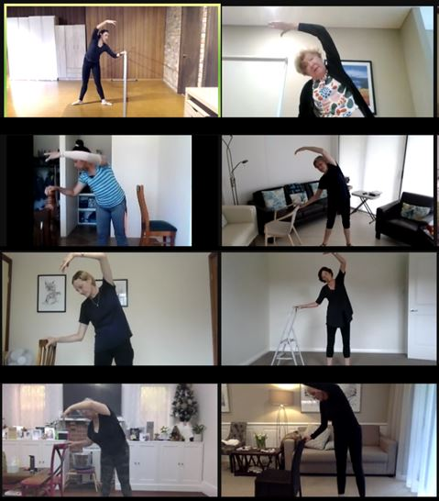
Online resource 1, Fig. 1. Online ballet classes: “Port de bras” (“carriage of the arms”) performed at the barre, requiring large shoulder ROM.

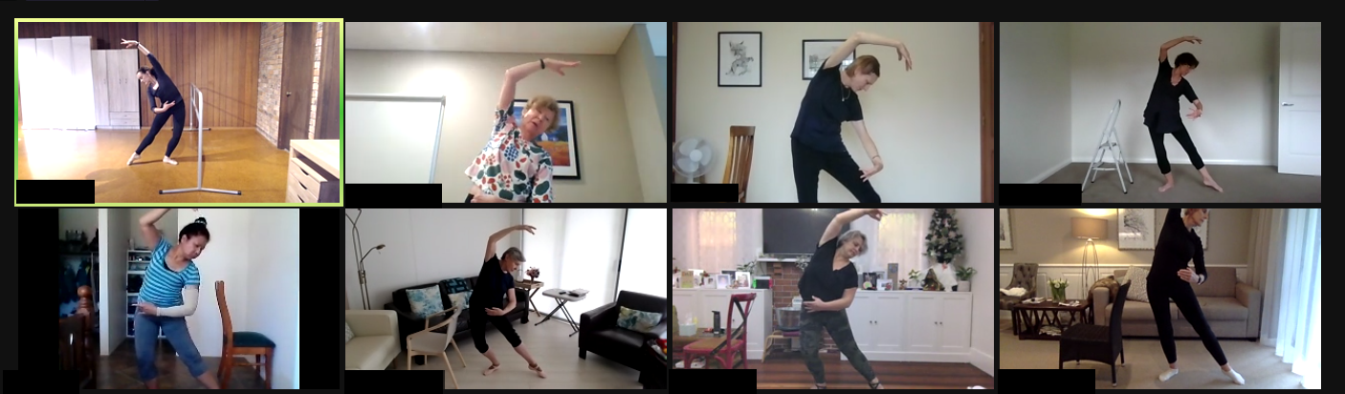
Online resource 1, Fig. 2 . Online ballet classes: “Port de bras” progression performed away from the barre, requiring increased balance and large shoulder ROM

