Ballet after breast cancer: Investigating the feasibility and acceptability of a novel 16-week classical ballet intervention for breast cancer survivors
Eliza R. Macdonald, Dr Briana K. Clifford, A/Prof. David Simar, and Dr Rachel E. Ward.
Online resource 2

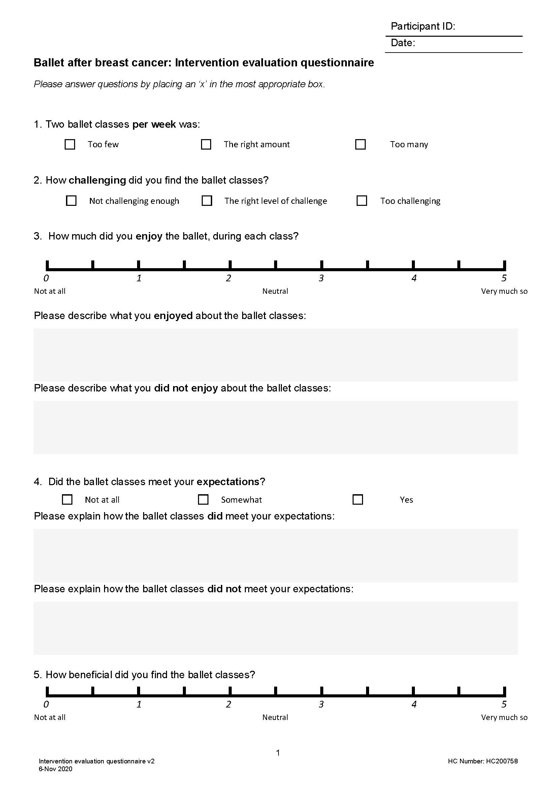
Online resource 2, Supplementary file 1.
Ballet after breast cancer: Intervention evaluation questionnaire

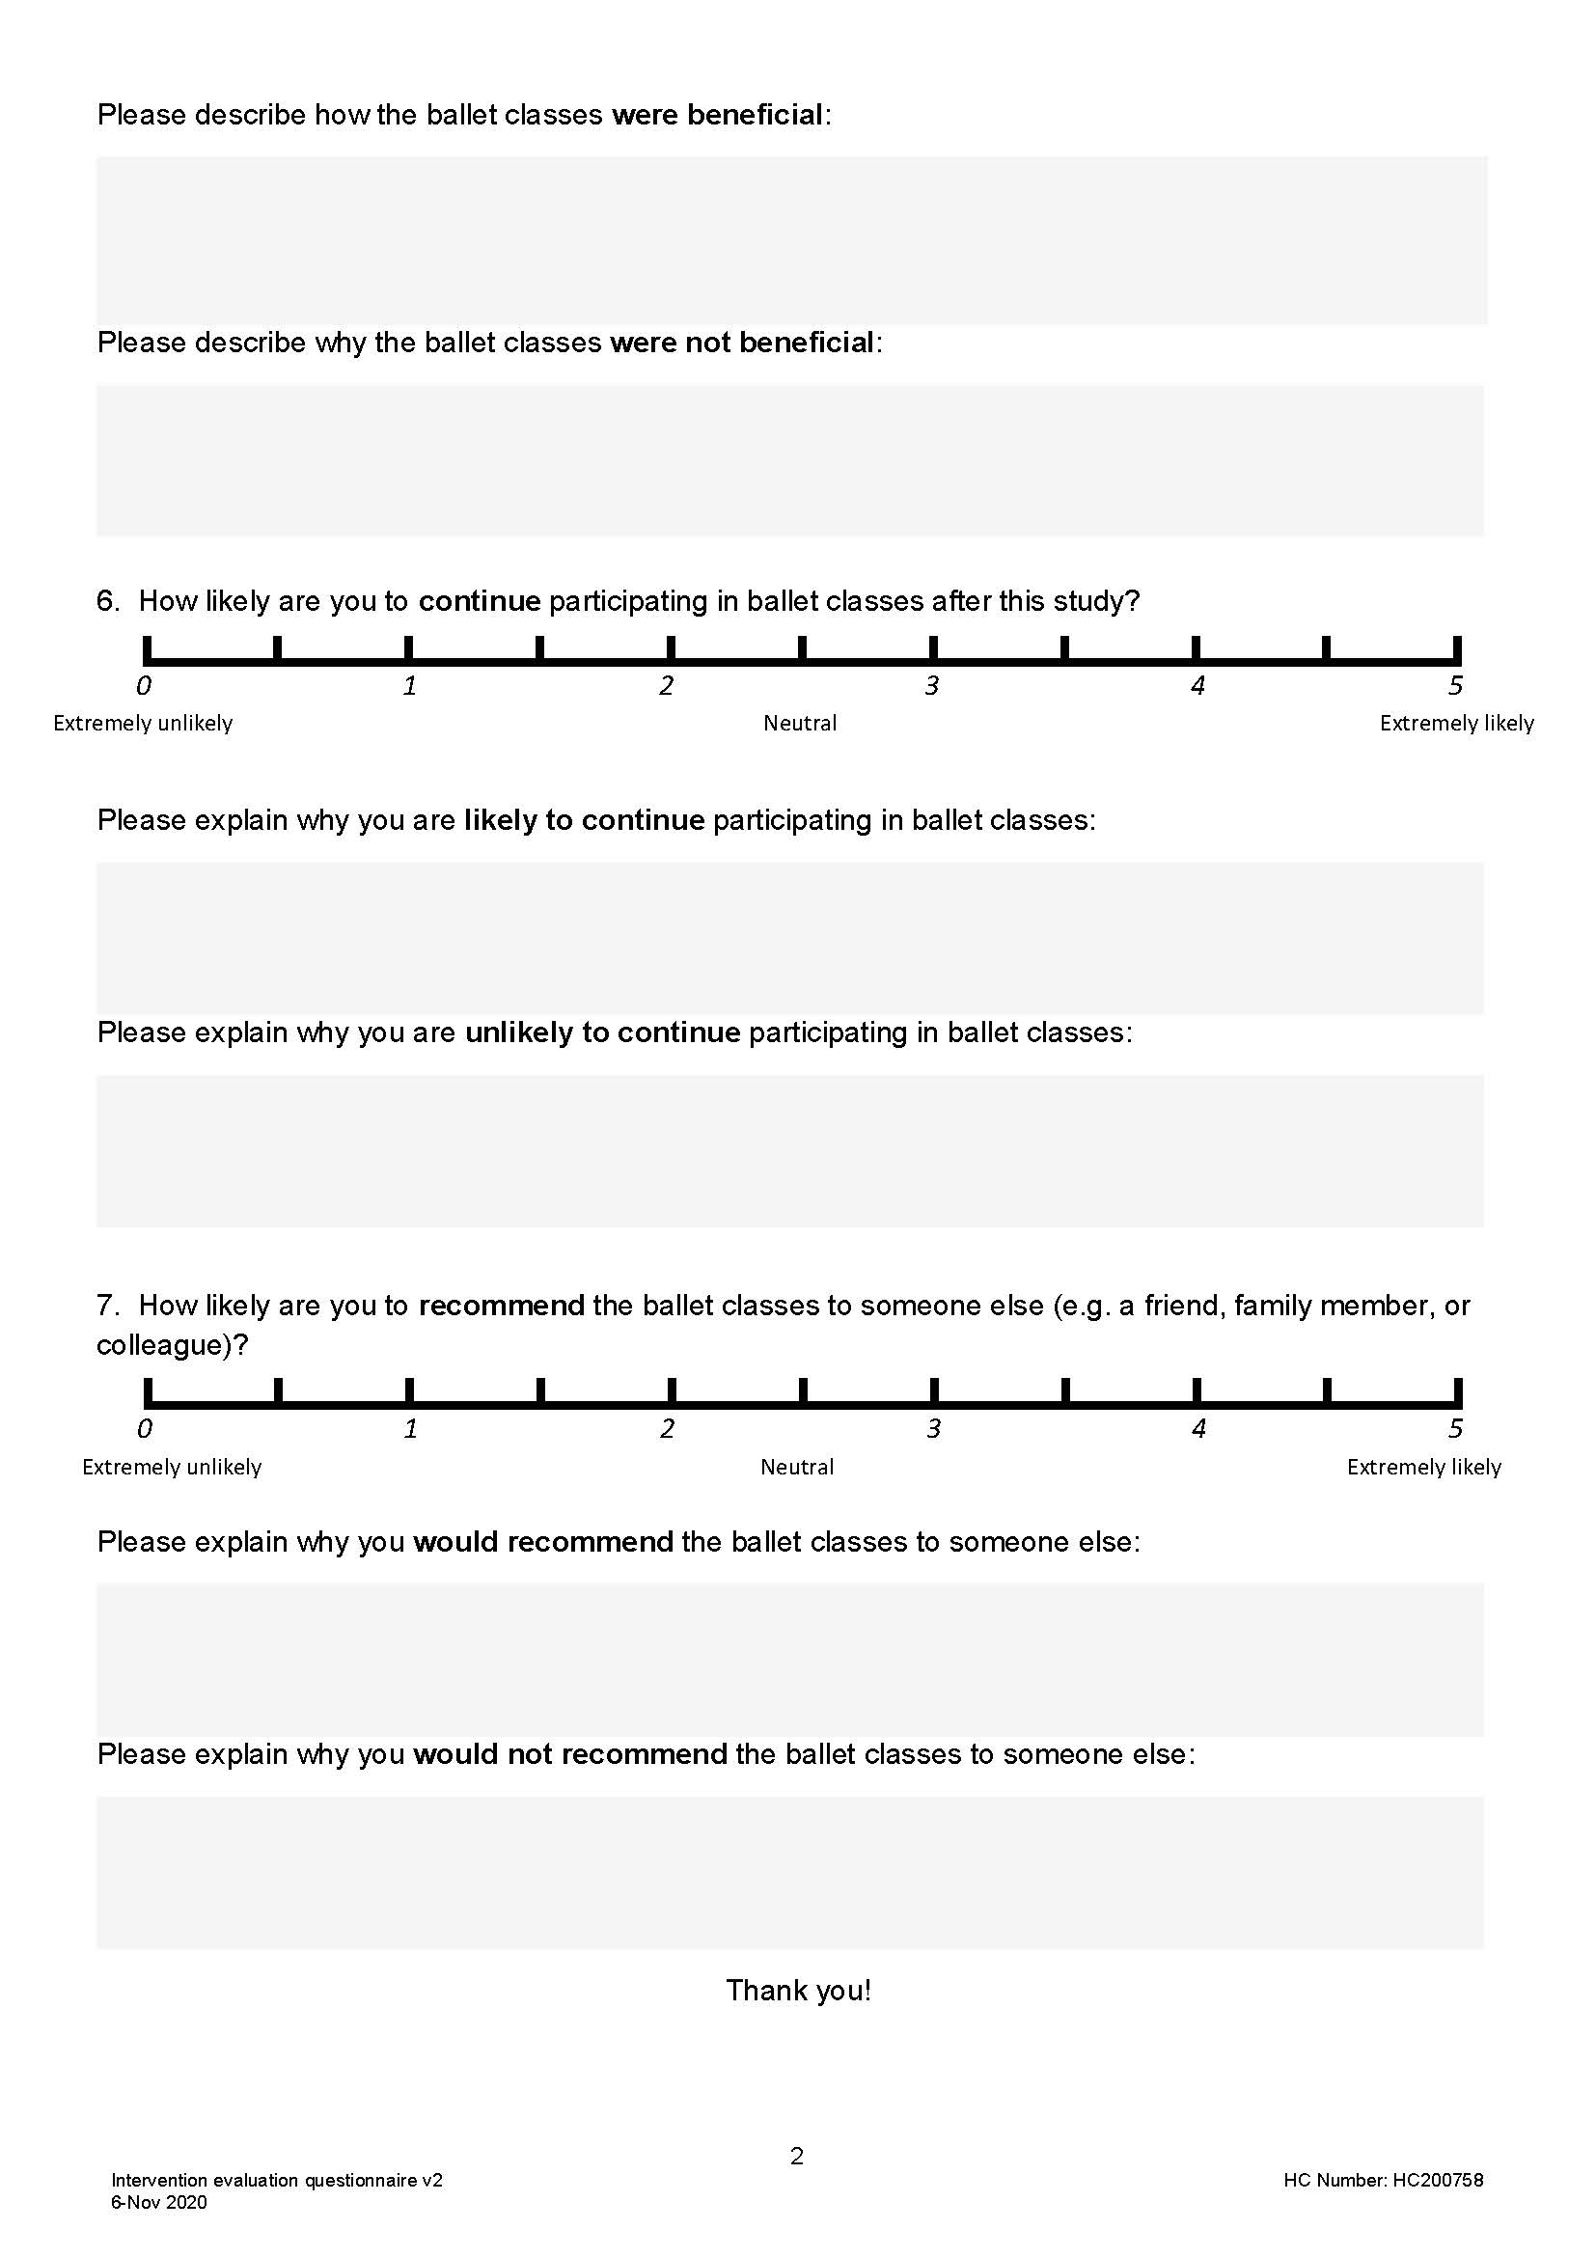

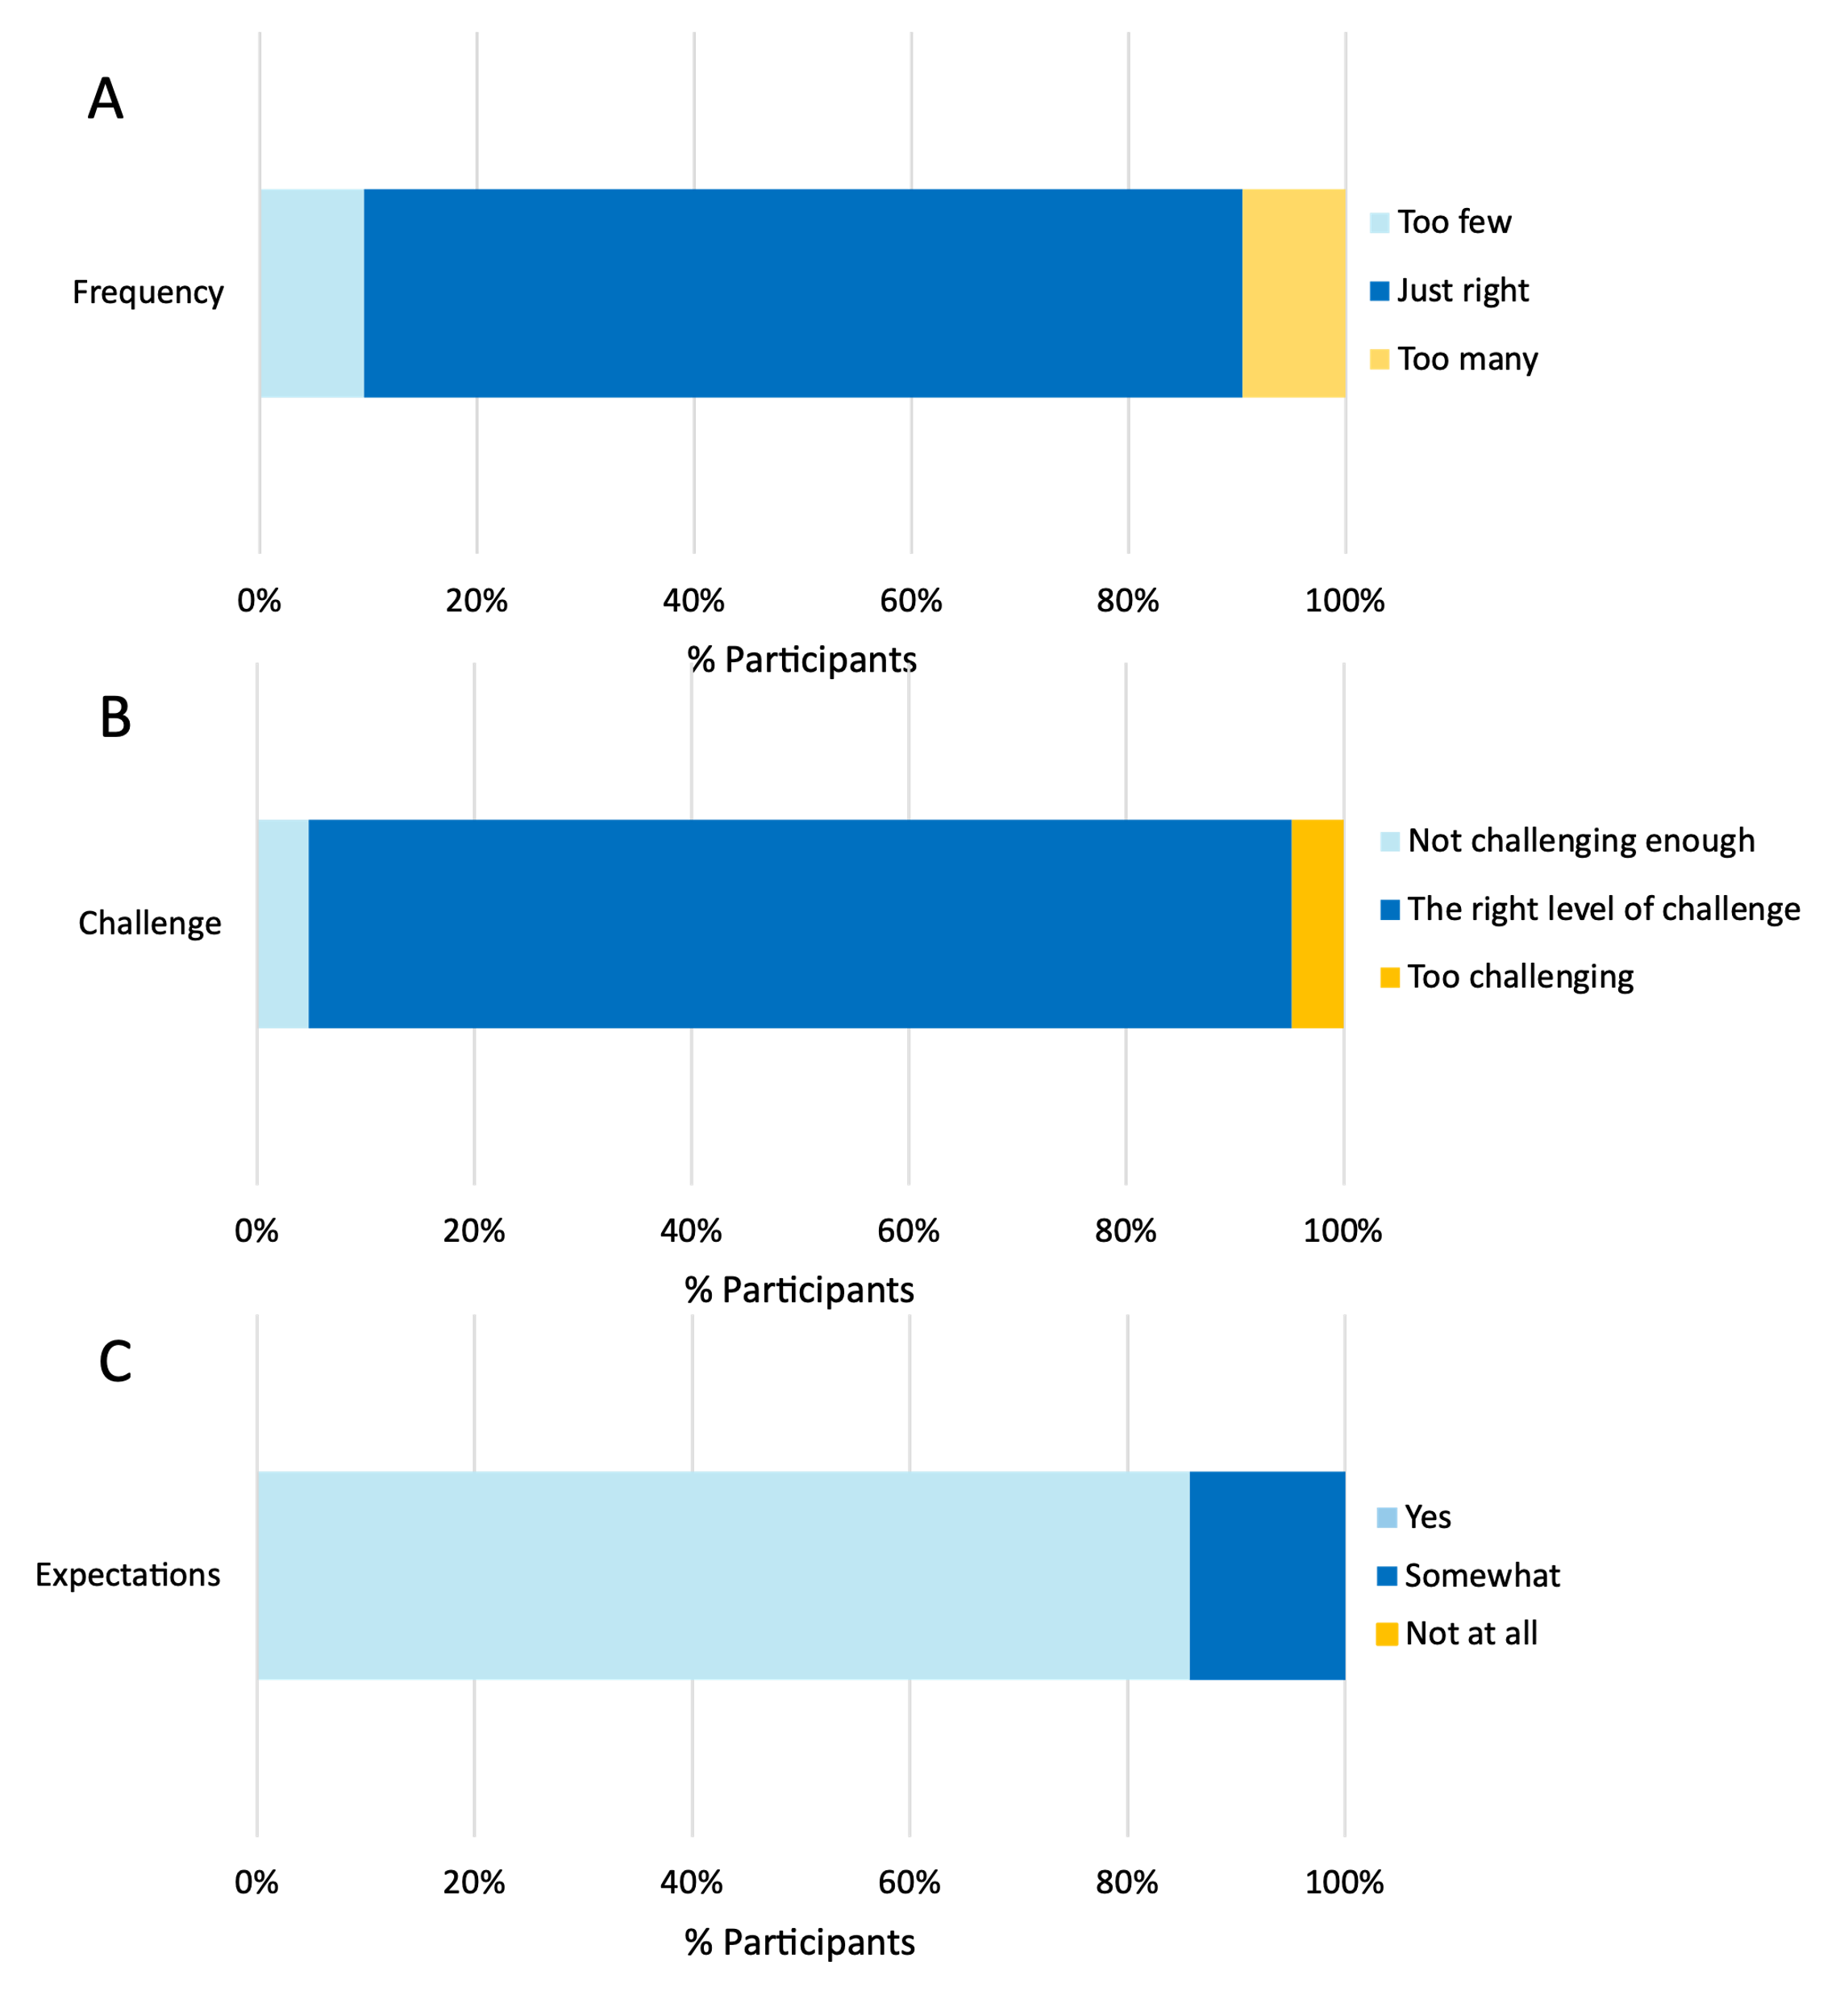
Online resource 2, Fig. 1. Participant evaluation responses regarding the A) suitability of class frequency; B) suitability of the level of challenge of the ballet exercises; C) extent to which ballet classes met expectations.
The right amount

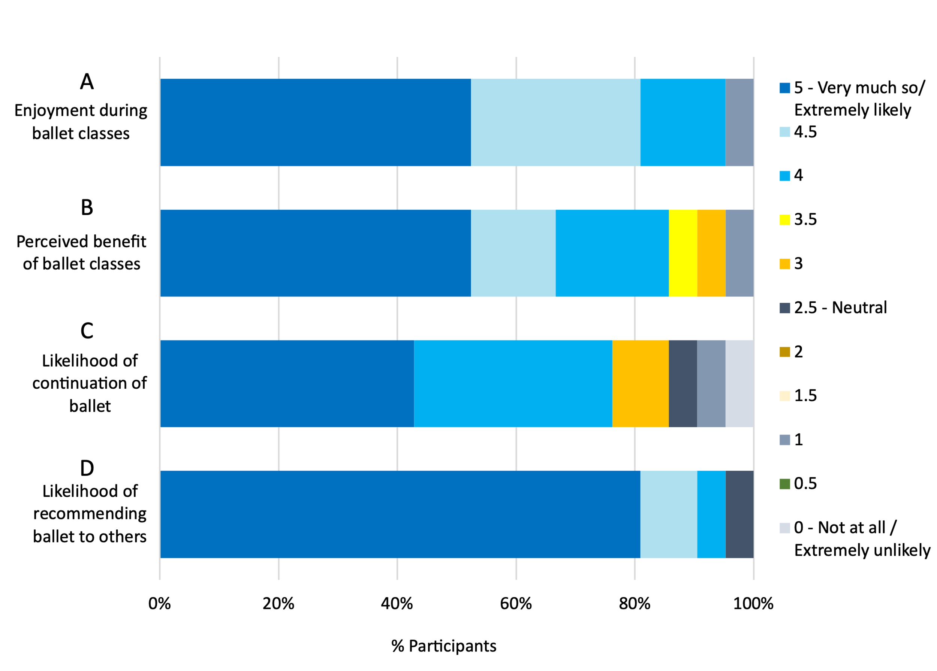
Online resource 2, Fig. 3. Participant evaluation responses regarding their A) Enjoyment of the ballet classes; B) Perceived benefit from the ballet classes; C) Likelihood of continuation of ballet classes; D) Likelihood of recommending ballet to others.

