Overestimation of the effect of (fos)aprepitant on intravenous dexamethasone pharmacokinetics requires adaptation of the guidelines for children with chemotherapy induced nausea and vomiting
A. Laura Nijstad, Evelien de Vos-Kerkhof, Catherine F. Enters-Weijnen, Marianne D. van de Wetering, Wim J.E. Tissing, Matthijs M. Tibben, Hilde Rosing, Arief Lalmohamed, Alwin D.R. Huitema, C. Michel Zwaan
Supportive Care in Cancer

Corresponding author
Prof. dr. C. Michel Zwaan
Princess Máxima Center for Pediatric Oncology, Postbus 113, 3720 AC Bilthoven, The Netherlands
c.m.zwaan@prinsesmaximacentrum.nl

Supplementary material

Supplementary Table S1 CYP3A4 substrates and/or –inhibitors. Patients using these CYP3A4 substrates and/or -inhibitors within seven days or CYP3A4 inducers within 30 days before the start of antiemetic therapy were excluded
CYP3A inhibitor (strong) | CYP3A inducer (strong)
Boceprevir  Clarithromycin  Conivaptan  Grapefruit juice  Indinavir  Itraconazole  Ketoconazole  Lopinavir  Mibefradil  Nefazodone  Nelfinavir  Posaconazole  Ritonavir  Saquinavir  Telaprevir  Telithromycin  Voriconazole | Avasimibe  Carbamazepine  Phenytoin  Rifampin  St John’s wort

Supplementary Table S2 Sample scheme
Time after first dexamethasone/ (fos)aprepitant administration | t=0 | t=0.5h | t=1-2h | t=4h | t=6h | t=12h | t=24h
Sample | X | X | X | X | X | X | X

Sample scheme:
Sample 1 (1 ml): t = 0 hour after first administration/end of infusion of dexamethasone and (fos)aprepitant
Sample 2 (1 ml): t = 0.5 hour after first administration/end of infusion of dexamethasone and (fos)aprepitant
Sample 3 (1 ml): t = 1-2 hours after first administration/end of infusion of dexamethasone and (fos)aprepitant
Sample 4 (1 ml): t = 4 hours after first administration/end of infusion of dexamethasone and (fos)aprepitant
Sample 5 (1 ml): t = 6 hours, just before the second administration of dexamethasone
Sample 6 (1 ml): t = 12 hours, just before the third administration of dexamethasone
Sample 7 (1 ml): t = 24 hours, just before the fifth administration of dexamethasone and second administration of (fos)aprepitant

Supplementary Table S3 Dexamethasone area under the curve (AUC_{t0-∞}) in mg/L*h in simulated patients stratified for dose and aprepitant use
 | With aprepitant |  | Without aprepitant
 | Median | Range | Median | Range
Dexamethasone 6 mg/m² | 0.768 | 0.135 – 3.311 | 0.498 | 0.117 – 2.090
Dexamethasone 4 mg/m² | 0.512 | 0.090 – 2.207 | NA
Dexamethasone 3 mg/m² | 0.384 | 0.068 – 1.656 | NA
NA not applicable

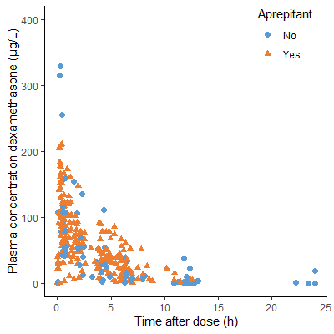
Supplementary Figure S1 Dexamethasone plasma concentrations versus time after dose

Supplementary Figure S2 Graphical representation of the final integrated dexamethasone and aprepitant model

Supplementary Figure S3 Goodness-of-fit plots dexamethasone

Supplementary Figure S4 Prediction-corrected visual predictive check. Black lines depict the observed median (solid) and 2.5% and 97.5% percentile (dashed) concentrations. Dark- and light-grey areas represent 95% prediction intervals of the simulated mean and the 2.5 and 97.5% percentiles, respectively. Round dots represent observations.

