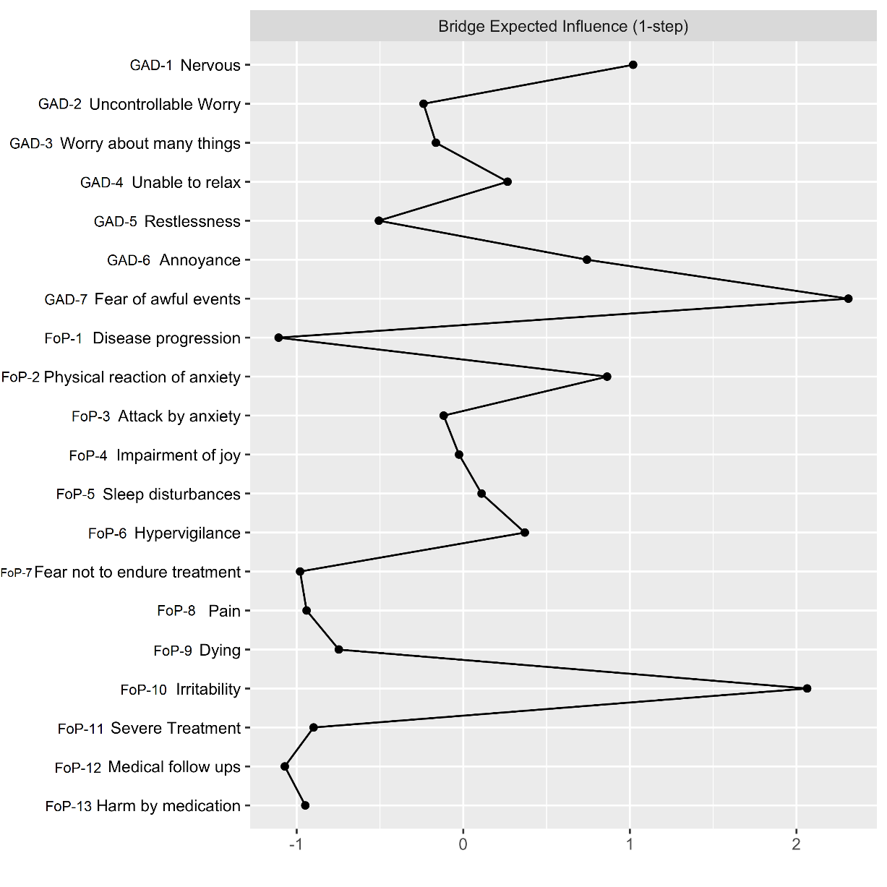
Figure S2 Centrality plot for the association network depicting the bridge expected influence (BEI) of each node (GAD and FoP items). Higher values indicate more associations with the other construct.

