Appendix A Illustrations of the course of QL and SuMsc over time in relation to various variables

Concerning the variables that were significantly associated with QL or SumSc over time in the overall multivariate models, the figures in Appendix A illustrate the course of QL and SumSc over time in relation to each variable.
A smaller deterioration and/or a larger improvement indicates a better course in QL or SumSc.

A1. The course of HRQOL from baseline to 24 months after treatment in relation to variables assessed at baseline

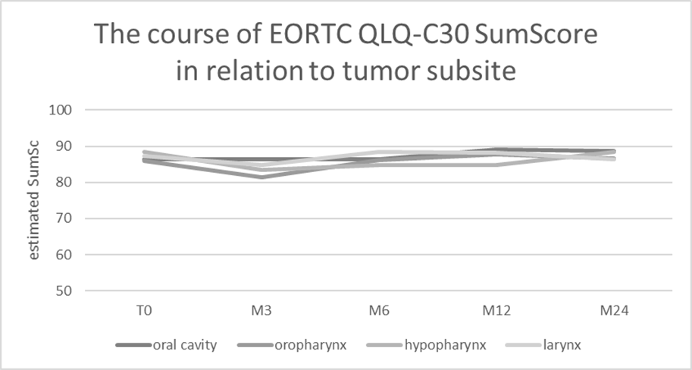
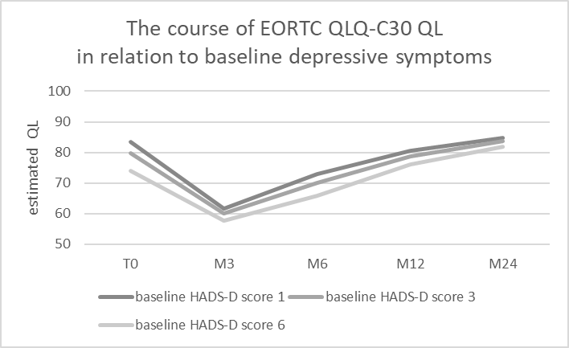
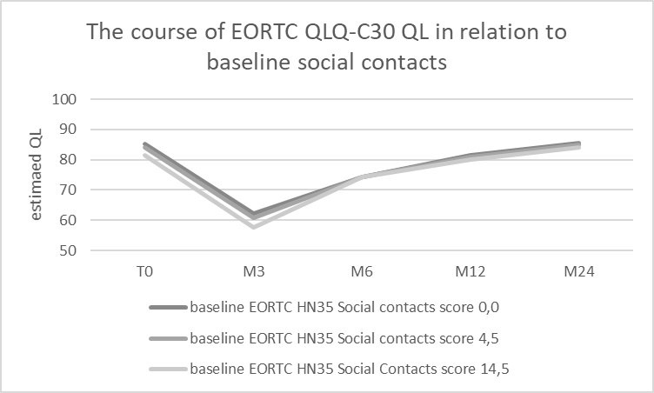
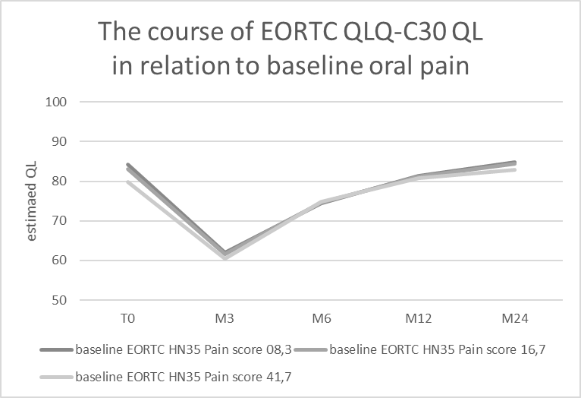

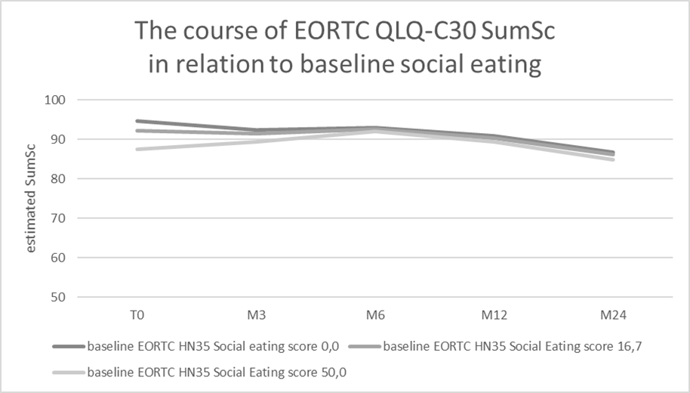

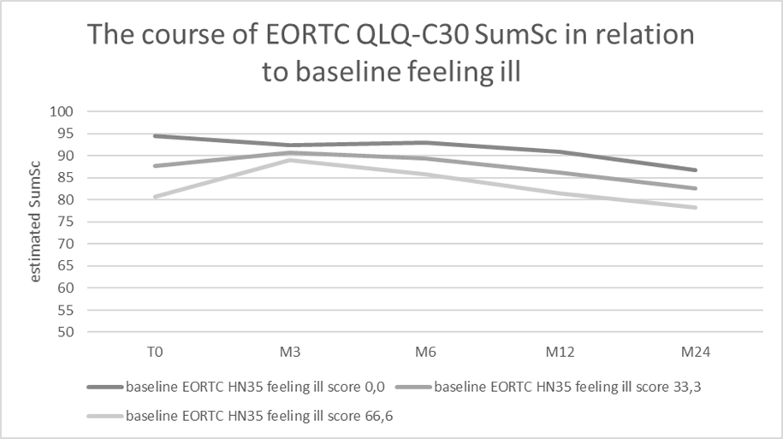

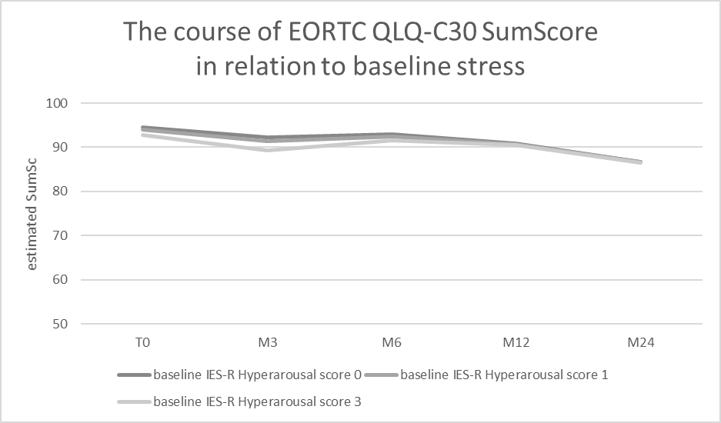
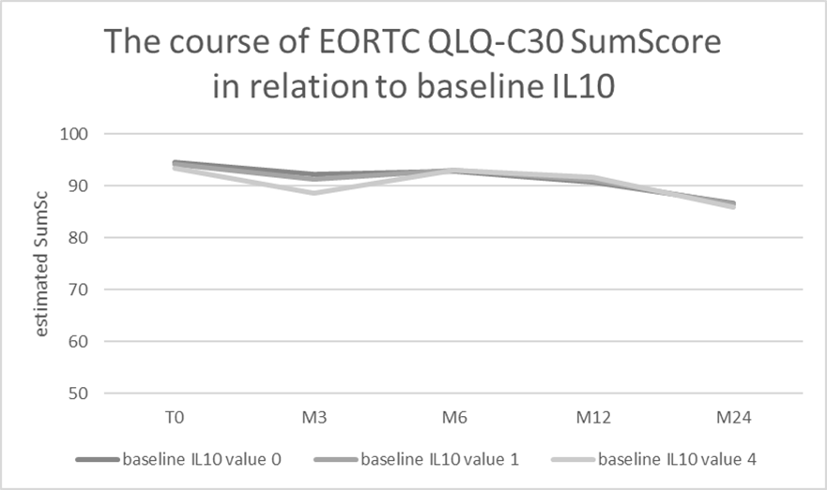
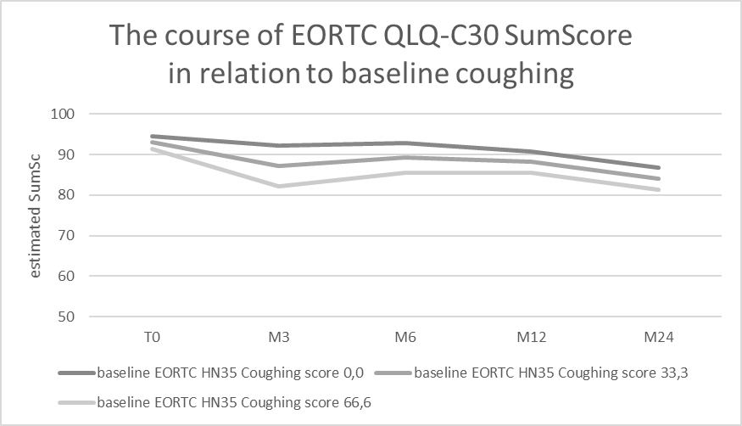
A2. The course of HRQOL from 6 to 24 months after treatment in relation to variables assessed at 6 months after treatment
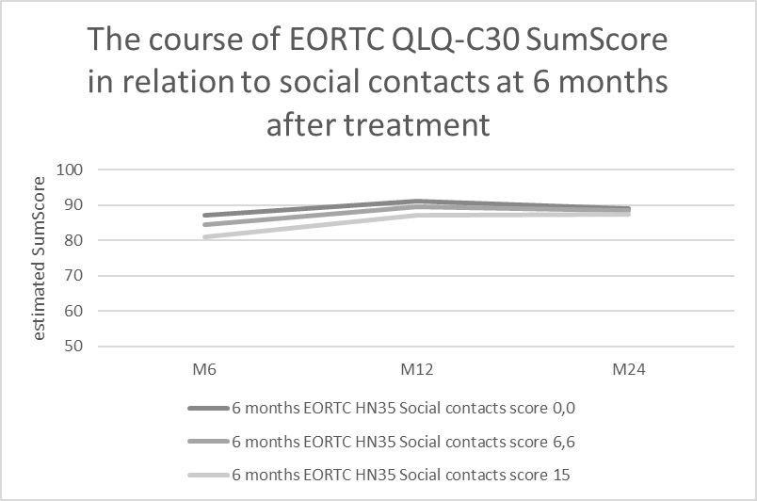

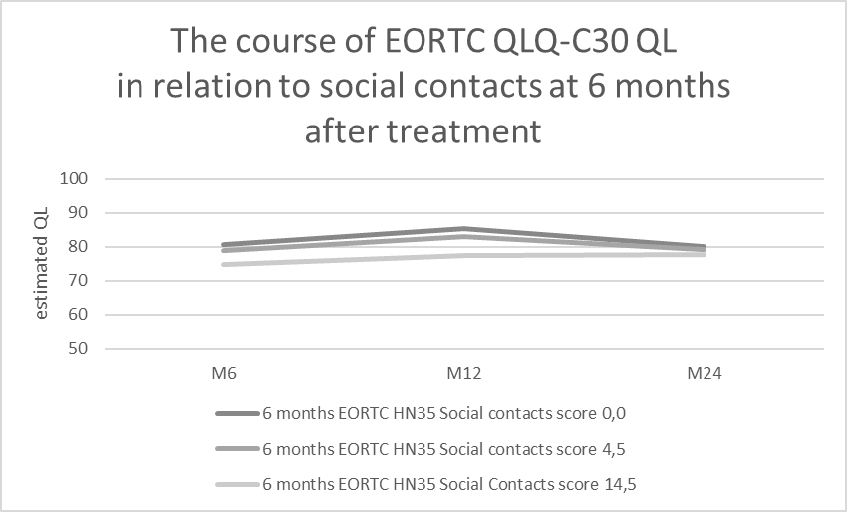
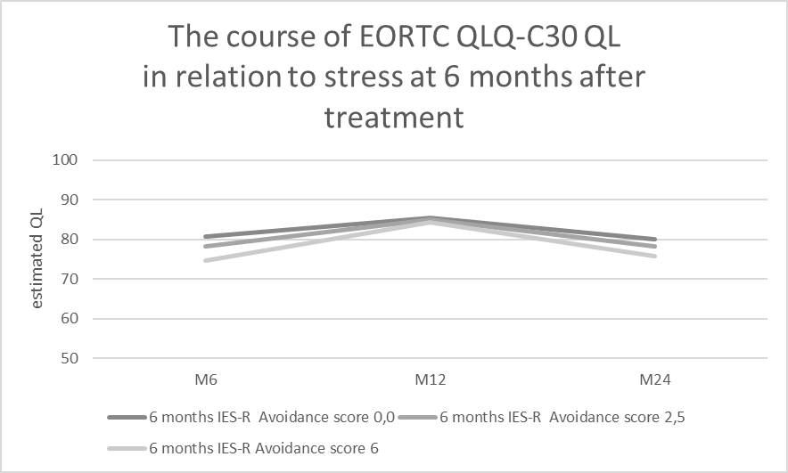
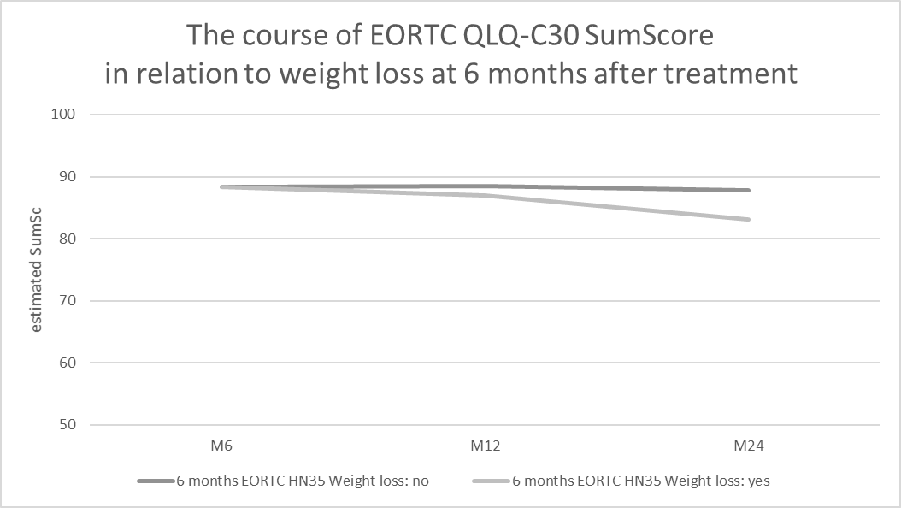

A3. The course of HRQOL from 6 to 24 months after treatment in relation to a change in variables between baseline and at 6 months after treatment
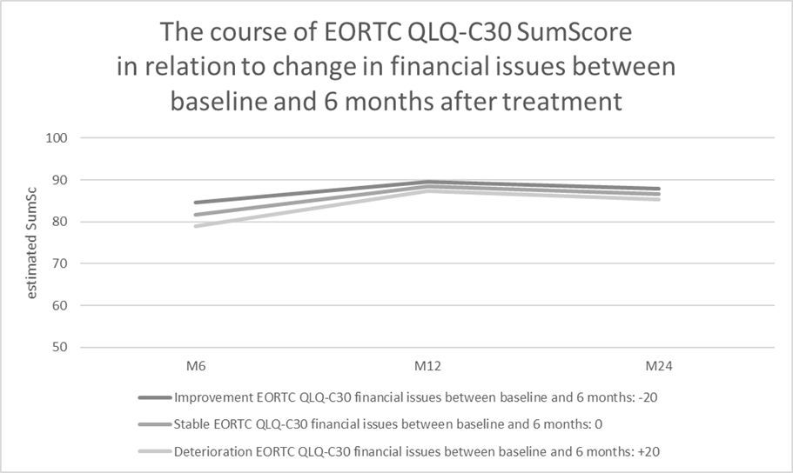
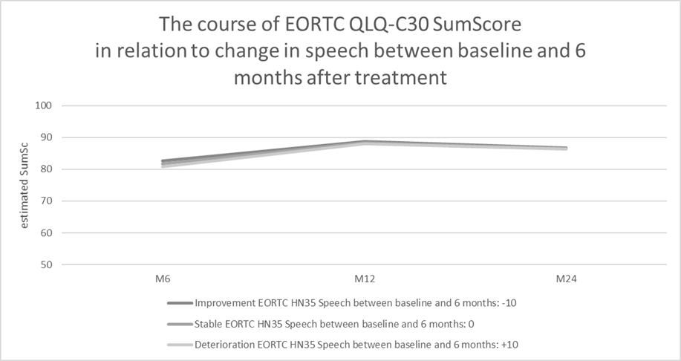
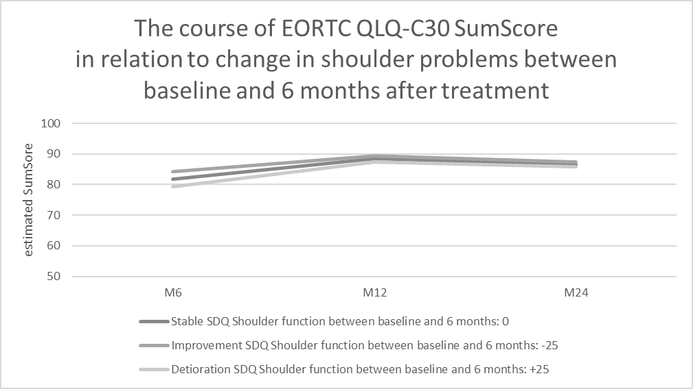

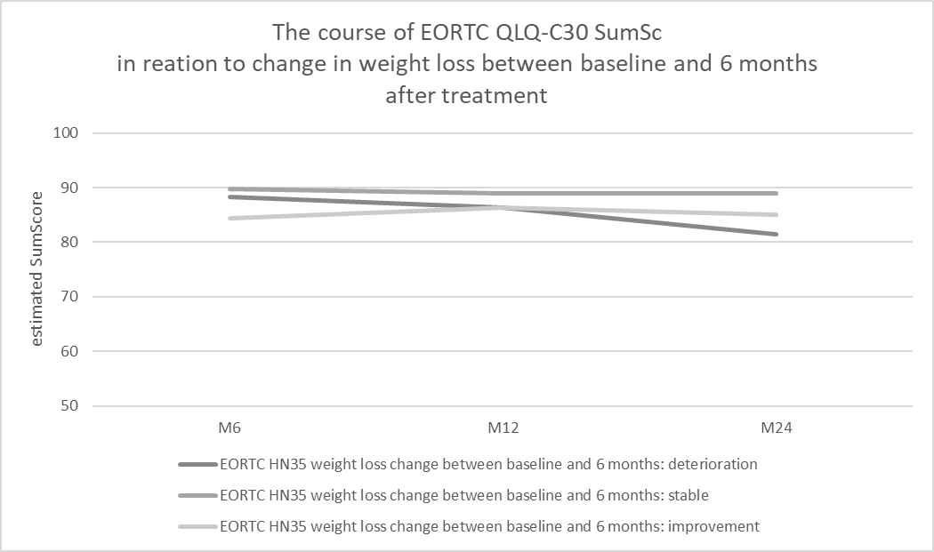

Note: To better visualize the results, the estimates of QL and SumSc are presented on a smaller scale (50-100 instead of 0-100).
Abbreviations:
T0 baseline (after diagnosis, before treatment)); M3, M6, M12, M24L 3, 6, 12, 24 months after treatment; EORTC QLQ-C30 QL/SumSc/HN 35: European Organization for Research and Treatment of Cancer Quality of Life Questionnaire C30 global quality of life scale/sum score/head and neck 35 module; HADS-D: Depression subscale of the Hospital Anxiety and Depression Scale; IES-R Impact of Event Scale-Revised; IL10 Interleukin-10;SDQ Shoulder Disability Questionnaire

