Supplemental material

Online Resource 2 Five device-supported mobility exercises (FIVE®)

Component | Addressed parts of the body | Demonstration
Exercise 1  Chest-Mover | Shoulder and breast muscles  Intercostal muscles  Abdominal muscles  Shoulder girdle | 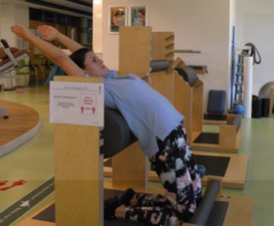
Exercise 2  Lateral-Mover | Transverse abdominal muscles  Shoulder girdle muscles  Shoulder girdle | 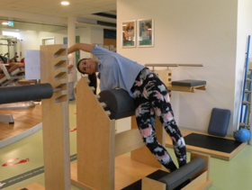
Exercise 3  Calf stone | Hamstring muscles  Shoulder girdle muscles  Shoulder girdle | 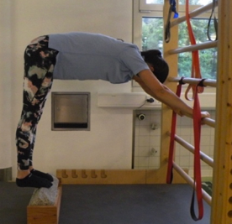
Exercise 4  Breast-shoulder girdle | Shoulder and breast muscles  Shoulder girdle | 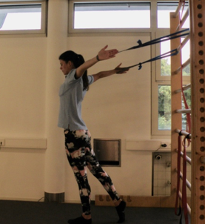
Exercise 5 Forearms / hands | Forearm muscles  Wrist | 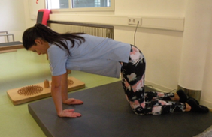
Hold end position for 20 seconds or five deep breaths; 2-3 sets per exercise

Effects of combined exercises on shoulder mobility and strength of the upper extremities in breast cancer rehabilitation: a three-week randomized controlled trial

Supportive Care in Cancer

Michels D, Heckel A, König S

dominique.michels@student.uni-tuebingen.de

