Name: _____________________________ DOB: ___________ Age: _______

Seminoma Non-Seminoma : _____________________________________

Date of Diagnosis: __________ Age at diagnosis: ____________

Stage: T__ N__ M__ S__ Stage Group: _____

Orchiectomy: _____________ Side : ______

Chemotherapy: __________ EOT : ___________

Chemotherapy 2: ________________ N/A EOT: ___________

RPLND: ______________ N/A Radiotherapy: __________ N/A

Allergies: ____________

Weight: _______ kg Height: ______ cm BMI: _____ Kg/m²

Co Morbidities: (With Dates)

1._____________________ 5._______________________

2._____________________ 6._______________________

3._____________________ 7._______________________

4._____________________ 8._______________________

Current Medications:

1._____________________ 5._______________________

2._____________________ 6._______________________

3._____________________ 7._______________________

4._____________________ 8._______________________

Smoking Status:

Smoker Ex-Smoker Non-Smoker

Alcohol Intake:
Regular Occasional Units/week: _________

B Symptoms:
Night sweats Yes No Duration: _______
Unintentional Weight loss Yes No Duration: _______ Amount: ___Kg
Loss of energy Yes No Duration: _______

Cardiovascular Review:

 |  | Yes | No
 | Did you notice any recent change in exercise tolerance?
 | Do you feel any chest discomfort on exertion?
 | Do you feel any Shortness of Breath on Exertion?
 | Do you feel any shortness of breath on lying down?
 | Do you wake up at night feeling short of breath?
 | Do you get any swelling in your legs?

Respiratory Review:

 |  | Yes | No
 | Do you feel any difficulty in breathing?
 | Do you have any new persistent cough?
 | Do you hear any whistling sounds in your chest?
 | Do you find difficult to catch your breath?
 | Do you have any coughing at night?

Raynaud’s Phenomenon:

 |  | Yes | No
 | Are your fingers sensitive to the cold?
 | Do your fingers change colour in response to cold (white, red, blue)?
 | Do you get numbness or pain in the affected area when they change colour?
 | Do you feel stinging or throbbing when affected area warms up?

Hearing Review:

 |  | Yes | No
 | Do you experience any difficulty in hearing?
 | Do you hear any buzzing or ringing when its quiet?

Testicular:

 |  | Yes | No
 | Have you noticed any pain or tenderness in your testicles?
 | Have you noticed any tenderness in your testicles?
 | Have you noticed any abnormal swelling in your testicles?

Examination:

General Exam:

BP: _____ Pulse: ____ Respiratory Rate: ____ Temp: _____ O₂ Sats: ____

 | Yes | No | Details
Pedal Oedema
Sacral Oedema
Raised JVP
Muscle wasting

Lymph node exam:
Region | Normal | Abnormal | Details
Peri-auricular
Sub-mandibular
Cervical
Supraclavicular
Axillary
Inguinal

Cardiovascular:
 | Yes | No | Details
Added heart sound
Irregular Rhythm
Other

Respiratory:
 | Yes | No | Details
Wheeze
Crepitations
Basal crepitation
Other

Abdomen:
 | Yes | No | Details
Palpable mass
Hepatomegaly
Splenomegaly

Testicular exam:
 | Yes | No | Details
Tenderness
Swelling
Prosthesis

Blood Results:
 | Value | Range | Date | Comments
WCC
Hb
Platelets
Creatinine
Creatinine Clearance
Glucose
HbA1c
Total Cholesterol
Triglycerides
Serum Testosterone
LH
FSH
AFP
HCG
LDH
Impression:

Plan:

HADS:

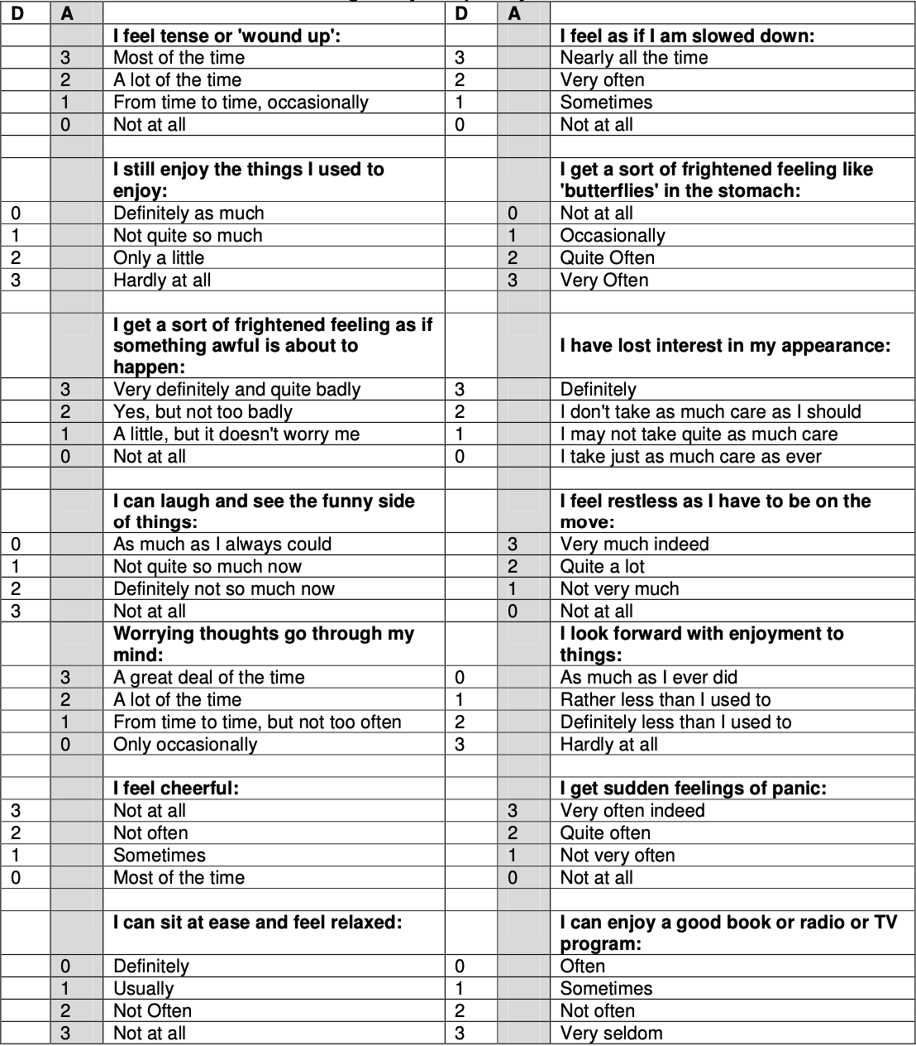

Anxiety Score: _______ Depression Score: ___________

