Supplementary material
Supplement to: Antherieu G et al. Neutropenic events associated with new anticancer treatments, from pathophysiology to practice: a scoping review. NEW Group (Neutropenic Events Working Group)

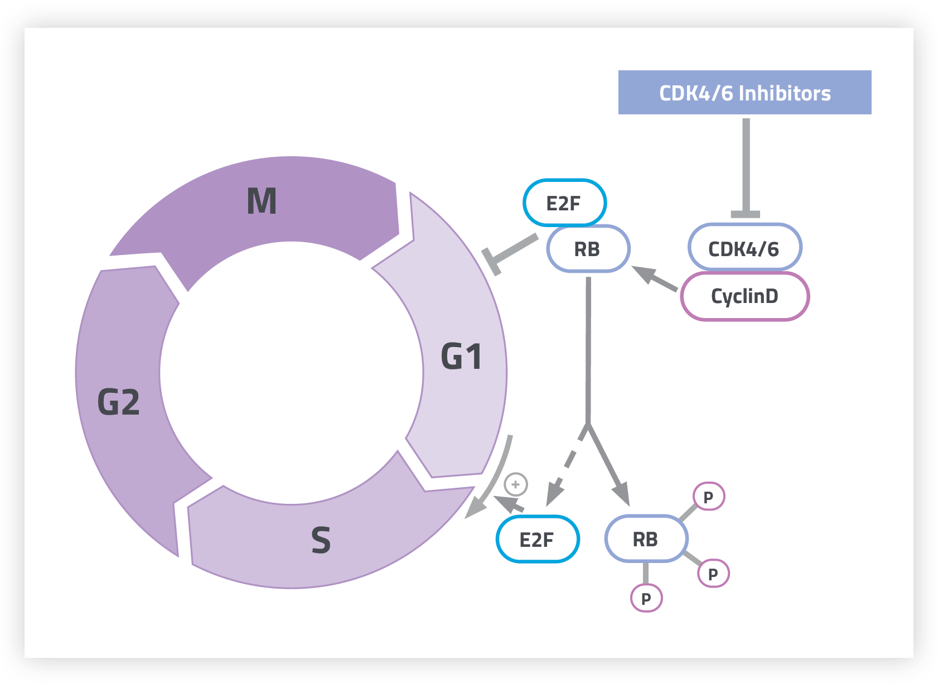
Figure S1 : CDK4/6 inhibitors mechanisms of action²

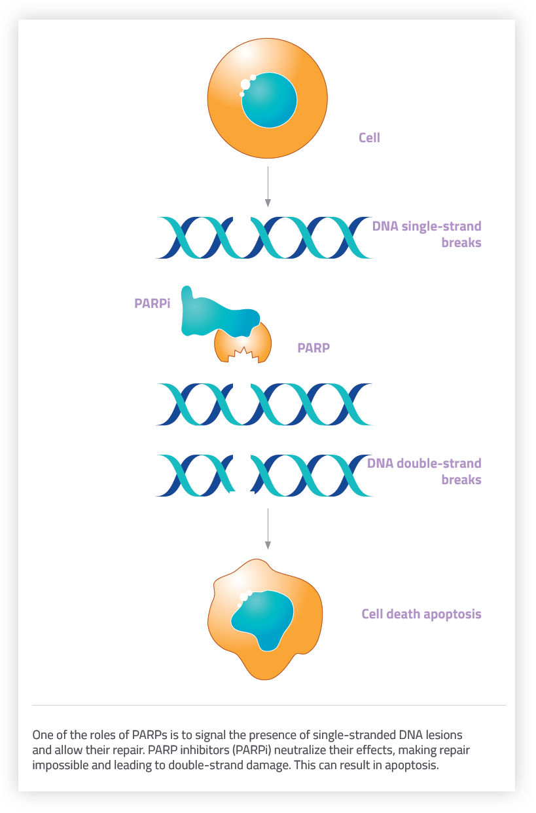
Figure S2 : PARP inhibitors mechanisms of action²⁸⁻³¹

Mechanism of neutropenia | Neutropenia incidence* |  | Neutropenia management
Decreased granulocyte generation capacity | All grade | 36% | There is no argument to support the use  of GCSF
Reduced resilience of CSH to DNA damage | All grade | 36% | There is no argument to support the use  of GCSF
Preferential survival of apoptotic pathway-mutated CSH | Grade 3+ | 22% | Dose management or withholding  of PARPi therapy
Direct CSH toxicity | Grade 3+ | 22% | Dose management or withholding  of PARPi therapy
Table S1: PARP inhibitors induced neutropenia, * in main phase 3 trials^{32-35,40-55}

Name | Target | FDA-approved indication
Ipilimumab | CTLA-4–blocking antibody | Melanoma
Nivolumab | PD-1–blocking antibody | Melanoma, renal cell carcinoma, Hodgkin lymphoma, squamous cell carcinoma of the head and neck, urothelial carcinoma, colorectal cancer, and hepatocellular carcinoma
Ipilimumab + Nivolumab | CTLA-4–blocking antibody + PD-1–blocking antibody | Melanoma, renal cell carcinoma, hepatocellular carcinoma, pleural mesothelioma, and colorectal cancer
Pembrolizumab | PD-1–blocking antibody | Melanoma, non-small-cell lung cancer, small-cell lung cancer, head and neck squamous cell cancer, Hodgkin lymphoma, primary mediastinal large B-cell lymphoma, urothelial carcinoma,  colorectal cancer, gastric cancer, esophageal cancer, cervical cancer, hepatocellular cancer, Merkel cell carcinoma, renal cell carcinoma, and endometrial carcinoma
Cemiplimab | PD-1–blocking antibody | Urothelial carcinoma
Avelumab | PD-L1–blocking antibody | Urothelial carcinoma, Merkel cell carcinoma, and renal cell carcinoma
Durvalumab | PD-L1–blocking antibody | Urothelial carcinoma
Atezolizumab | PD-L1–blocking antibody | Urothelial carcinoma, non-small-cell lung cancer, and triple-negative breast cancer
Dostarlimab | PD-1–blocking antibody | Endometrial cancer
Retifanlimab | PD-1–blocking antibody | Merkel cell carcinoma
Tremelimumab  + Durvalumab | CTLA-4–blocking antibody  + PD-L1–blocking antibody | Hepatocellular carcinoma
Toripalimab | PD-1–blocking antibody | Nasopharyngeal carcinoma
Table S2 : Immune checkpoint inhibitors and their clinical indications⁵⁶
 |  | CTLA-4 | PD-(L)1
CD8+ T lymphocytes | Direct cytotoxicity | X | X
Th2 CD4+ lymphocytes | Enhances autoantibody production | X | X
NK cells | Direct and antibody-dependent cytotoxicity |  | X
Table S3 : neutrophil toxicity associated with immune checkpoint inhibitors⁵⁶

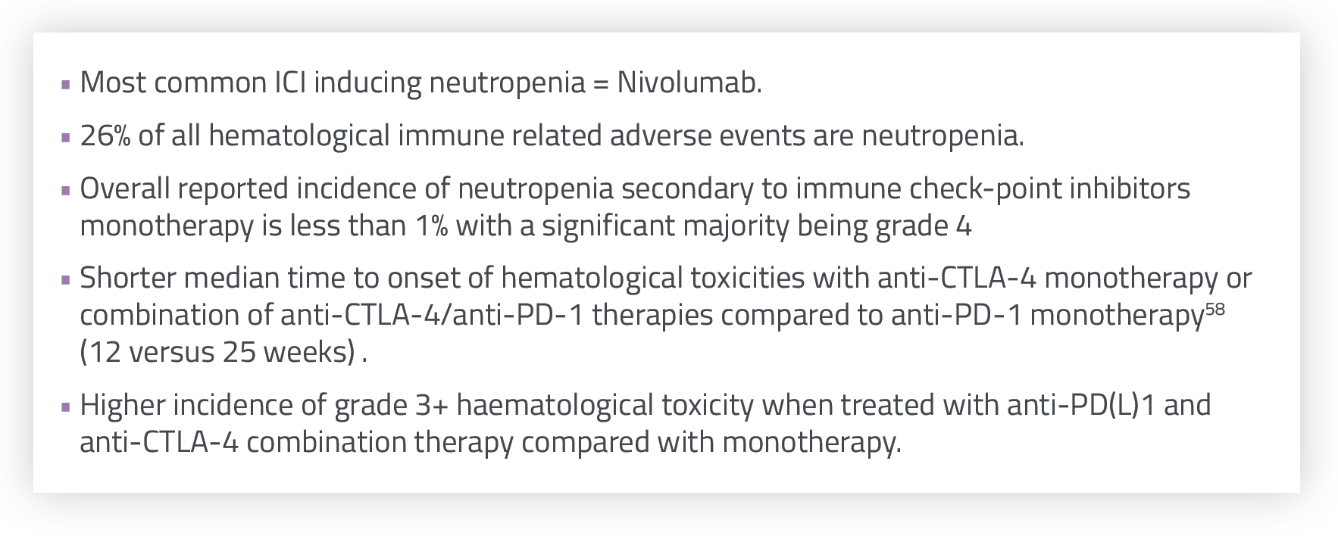
Figure S3 : Occurrence of neutropenia with immune checkpoint inhibitors ^{58,67-72}
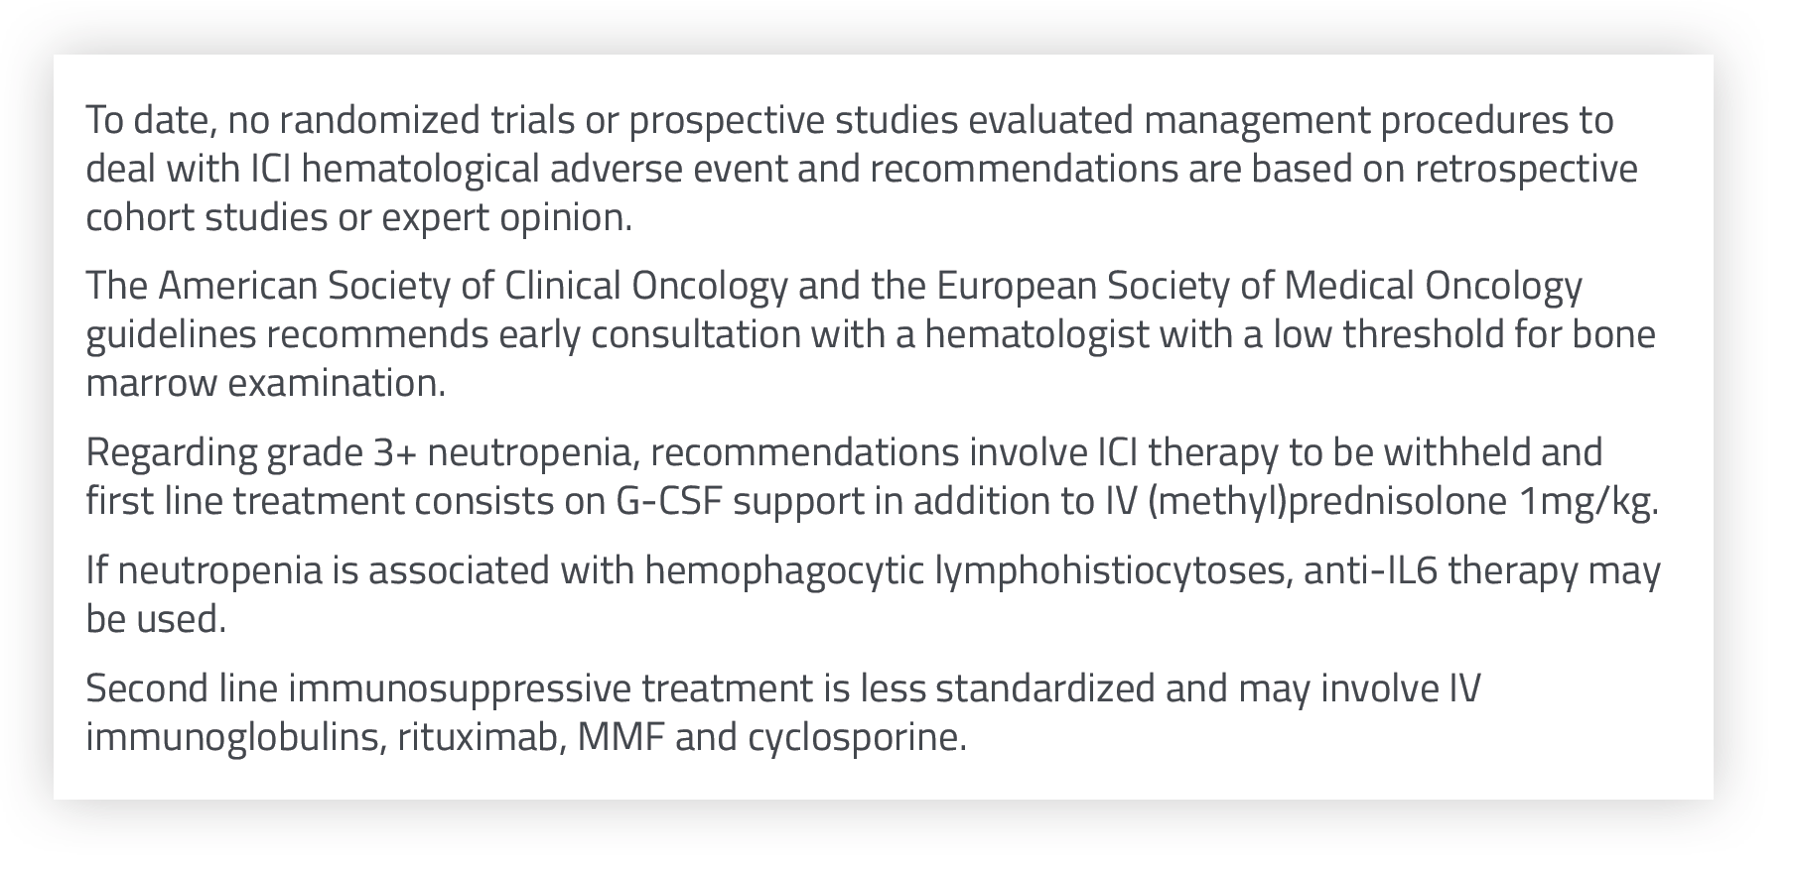
Figure S4 : Management of neutropenia associated with immune checkpoint inhibitors^{56,63,70,74}

 | Rituximab | Obinutuzumab
Direct cell death | + | ++
Antibody dependent cellular cytotoxicity | + | ++
Complement dependent cytotoxicity | ++ | 0
Antibody dependent phagocytosis | + | ++
Table S4 : Rituximab and obinutuzumab mechanisms of action⁸¹⁻⁸³

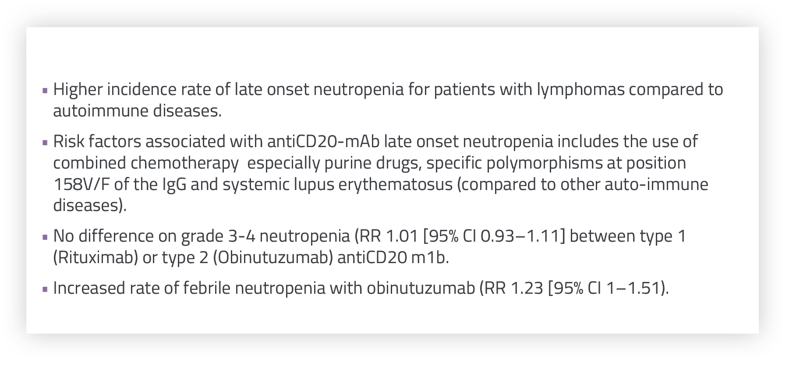
Figure S5 : data from clinical trials on antiCD20-mAb associated neutropenia⁹¹⁻⁹⁷

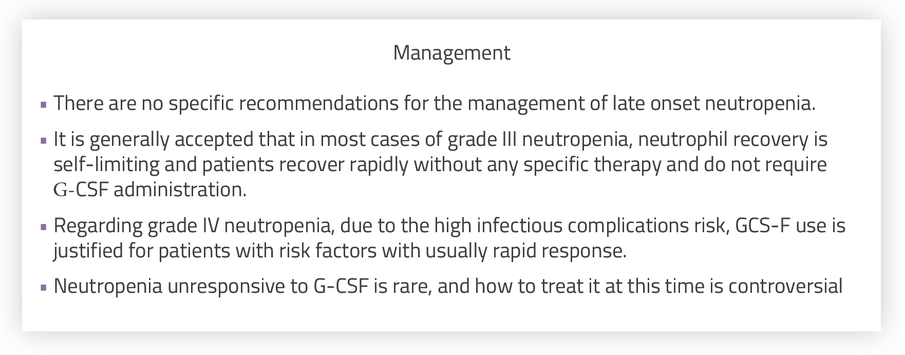
Figure S6 : Management of neutropenia associated with antiCD20-mAb^{84,91, 98, 99}

