Appendix A
Socioeconomic differences in labour market attachment after breast cancer: A population-based matched cohort study
Cathrine F. Hjorth, István Bakos, Deirdre Cronin Fenton

Figure A.1. Flowchart for cohort selection

All patients registered in the DBCG database with stage I-III breast cancer
N=14,029

Final breast cancer cohort
N=13,443
Matching not possible
N=27
Received student grant within 4 weeks before breast cancer diagnosis
N=226
Not resident in DK one year before breast cancer
N=98
Not aged 25–55 years
N=228
Not registered in the Population registry
N=7

Table A.1. Covariate information
Covariate | Data source | Variables | Details on data management | Time of measurement
Immigration status | Danish Population Registry | Ie_type and opr_land | Immigrant if ie_type=2 and 5101<= opr_land <=5902 or ie_type =0, 1 or 3. | At index
Region | Danish Population Registry | reg | Used for matching | At index
Cohabitation | Danish Population Registry | FAMILIE_TYPE | Cohabiting if fulfilling one of following criteria 1) being married, 2) in a registered partnership, 3) share address with person with common child, 4) living with one person of the opposite sex and age difference is <15 years, with no children, and share address. | The year prior to index year
Employment | The Integrated Database for Labour Market Research | Pstill/PSOC_STATUS_KODE | 11-37 / 110-138 | The year prior to index year
Education | The Population’s Education Register | HF_AUDD | We used the format AUDD2014_L1L2_KT to categorize into:  Short: ISCED 0–2 ~ <10 years  Medium: ISCED 3–4 ~ 10 to 14 years  Long: ISCED 5–8 ~ ≥15 years  No completed education or missing education was included as a separate group in the adjustment sets. | At index
Estrogen receptor status | Danish Breast Cancer Group’s clinical database | P72 | Until 1.7.2010, <10% estrogen receptor is categorized as negative. After this date, the cut-off was 1%. | At index
Stage | Danish Breast Cancer Group’s clinical database | T  n | T refers to tumor size in mm, and N to number of positive lymph nodes. These were summarized according to the TNM (tumor, node, metastasis) classification system. | At index
Grade | Danish Breast Cancer Group’s clinical database | P50, p51, p52 and p63a |  | At index
Surgery type | Danish Breast Cancer Group’s clinical database | M45 | If M45= 1 or 3 then Mastectomy, if M45=2 or 4 then lumpectomy. | At index
HER2 status | Danish Breast Cancer Group’s clinical database | P137 |  | At index
ITT Chemotherapy | Danish Breast Cancer Group’s clinical database | ITT_KEMO  iKE | ITT adjuvant chemotherapy, yes or no. | At index
ITT endocrine therapy | Danish Breast Cancer Group’s clinical database | ITT_ENDO  iET | ITT adjuvant endocrine therapy, yes or no | At index
Date of breast cancer diagnosis | Danish Breast Cancer Group’s clinical database | M24, M23 and M25 |  | At index
Recurrence date | Danish Breast Cancer Group’s clinical database | Ob3 ob2 ob4 |  | At index

Table A.2. Nordic Multimorbidity Index¹
Condition | Weight | International Classification of Diseases, version 10  (ICD-10) | Anatomical Therapeutic Chemical Classification System (ATC)
Secondary malignant neoplasms and malignancy of unspecified site | 22 | C76-C79, C80
Malignant neoplasm of bronchus and lung | 19 | C34
Alcoholic liver disease, liver fibrosis, cirrhosis, and failure | 13 | K70, K72, K74, K766-K767
Mental and behavioral disorders due to use of alcohol | 12 | F10
Decubitus ulcer and pressure area | 11 | L89
Anti-dementia drugs | 11 |  | N06D
Chronic viral hepatitis | 10 | B18
Dementia | 9 | F00-F03, G30
Leukemia | 8 | C91-C95
Malignant neoplasm of bladder | 8 | C67
Drugs for constipation | 8 |  | A06A
Tumor of brain or meninge | 8 | C70, C71, C751-C753, D32, D330-D332, D352-D354, D42, D430-D432, D443-D445
Multiple sclerosis | 7 | G35
Other interstitial pulmonary diseases | 7 | J84
Drugs used in opioid dependence | 7 |  | N07BC
Parkinson’s disease and other parkinsonism | 7 | G20-G22
Antipsychotics | 7 |  | N05A excl. N05AN
Chronic kidney disease and unspecified kidney failure | 7 | N18-N19
Volume depletion | 6 | E86
Atherosclerosis, thrombosis, embolism, and other peripheral arterial disease | 5 | I70, I73-I74, I77
Iron preparations | 5 |  | B03A
Antipropulsives | 5 |  | A07DA
Diseases of teeth and supporting structures | 5 |  | K02-K06, K08
High-ceiling diuretics | 5 |  | C03C, C03EB
Long-acting anti-muscarinic agents | 5 |  | R03BB04-07
Anaemia | 5 | D50-D59, D60-D64
Malignant neoplasm of prostate | 5 | C61
Epilepsy | 5 | G40-G41
Insulins and analogues | 4 |  | A10A
Pneumonia | 4 | J12-J18
Chronic lower respiratory diseases and failure | 4 | J41-J44, J47, J961, J969
Digitalis glycosides | 4 |  | C01AA
Malignant neoplasm of breast | 4 | C50
Cerebrovascular disease | 4 | I60-I69
Aneurysm and dissection of aorta and other arteries | 4 | I71-I72
Mental and behavioural disorders due to use of tobacco | 4 | F17
Heart failure | 4 | I110, I130, I132, I420, I426-I429, I50
Short-acting beta agonists | 3 |  | R03AC02-05
Aldosterone antagonists | 3 |  | C03DA
Antidepressants | 3 |  | N06A
Opioids | 2 |  | N02A
Anilides | 2 |  | N02BE
Type 2 diabetes mellitus | 2 | E11
Aortic and mitral valve disease | 2 | I05-I06, I34-I35
Glucocorticoids for systemic use | 2 |  | H02AB
Platelet aggregation inhibitors excl. heparin | 2 |  | B01AC
Benzodiazepines and related drugs | 1 |  | N05BA, N05CD, N05CF
Beta-lactam antibacterials, penicillins | 1 |  | J01C
Angiotensin receptor blockers incl. combinations | -2 |  | C09C, C09D
Statins | -3 |  | C10AA

Table A.3. Single measures included in the social vulnerability index and their weights and time of measurement
Measure | Categories | Description | Data source and variable | Weight | Time of measurement
Marital status | Unmarried | Never married, divorced, or widowed | The Population Registry, | 2 | Date of diagnosis
Marital status | Married | Married or in a registered partnership | The Population Registry, | 0 | Date of diagnosis
Ethnicity | Non-Danish | Immigrants and descendants | The Population Registry | 1 | Not applicable
Ethnicity | Danish | Born in Denmark with Danish parents | The Population Registry | 0 | Not applicable
Educational level | Short | ISCED 0–2: mandatory primary and lower secondary school | The Population’s Education Registry, variable hfaudd  Format: | 1 | Date of diagnosis
Educational level | Medium | ISCED 3–4: optional upper secondary school and vocational education |  | 0.5 | Date of diagnosis
Educational level | Long | ISCED 5–8: bachelor degree, business academy education, or higher educational level |  | 0 | Date of diagnosis
Equated disposable income | Low | < 1st quartile | Danish Income Statistics Registry (multiple variables), the Population Registry (variable family ID), and (Family Income Statistics, multiple variables)  Statistikbanken for the quartile of this variable in the general population by age group and calendar year | 2 | Calendar year prior to year of diagnosis
Equated disposable income | Medium | 1st to 3rd quartile |  | 0.5 | Calendar year prior to year of diagnosis
Equated disposable income | High | > 3rd quartile |  | 0 | Calendar year prior to year of diagnosis
Unemploymentª | Workforce detachment | Received unemployment benefits | DREAM, codes outlined in Table 3. | 2 | Exact year up to diagnosis
Unemploymentª | Employed | No unemployment benefits | DREAM, codes outlined in Table 3. | 0 | Exact year up to diagnosis
Psychiatric comorbidity | Severe | One or more severe psychiatric comorbidity | Danish National Patient Registry (LPR-PSYK); ICD-10 codes outlined in Table 4. | 5 | Exact year up to diagnosis
Psychiatric comorbidity | Moderate | One or more moderate but no severe psychiatric comorbidity |  | 2 | Exact year up to diagnosis
Psychiatric comorbidity | None | No psychiatric diagnoses |  | 0 | Exact year up to diagnosis
Somatic comorbidity | Two or more | Two or more ICD-10 codes from the Elixhauser index | Danish National Patient Registry; ICD-10 codes outlined in Table 5 | 1 | Exact year up to diagnosis
Somatic comorbidity | One | One ICD-10 code from the Elixhauser index |  | 0.5 | Exact year up to diagnosis
Somatic comorbidity | None | No ICD-10 codes from the Elixhauser index |  | 0 | Exact year up to diagnosis
ª=As phrased by Møller et al.,² but covers both temporary and permanent workforce detachment, including social assistance, unemployment compensations, immigrations benefit etc. (see Table A.4).

Table A.4. DREAM codes used for rSVI unemployment and the study outcomes assessments.
Category | DREAM codes | Outcomes
Temporary unemployment benefits | 111-115, 121, 124-126, 211-219, 221, 231, 232, 299, 511, 522, 541, 759 | Out of workforce
Social assistance | 130-139, 151-153, 710-719, 730-739 | Out of workforce
Education or upskilling, not health related | 140-149, 222, 224, 225, 414, 720-729 | Out of workforce
Immigration benefits | 160, 163-169, 700, 703-709 | Out of workforce
Unemployed awaiting flexible job | 740-748 | Out of workforce
Rehabilitation | 750-758, 760, 763-768, 791, 792 | Out of workforce
Flex job | 622, 771-774, 779, 796 | Out of workforce
Disability pension | 783, 784, 793, 797, 781 | Disability pension
Disability pensioner in light-duty job | 761, 762, 769, 782 | Disability pension
Vocational rehabilitation program | 810, 813-818 | Out of workforce
Workability clarification | 785, 870, 873-878 | Out of workforce
Sick leave benefitª | 890-899 | Sick leave
Parental leave ^{b} |  | N/A
ª Includes long-term sick leave, defined as sick leaves lasting longer than 14-30 days, depending on the year.³ The variation is due to changes in the length of employer paid sick leave in Denmark (short term sick leave), before the government compensate the employer (long term sick leave).
^{b} The original SVI considers women on parental leave as unemployed. We chose not to count parental leave, as this would categorize some women as socially vulnerable based on this criterion.

Table A.5. ICD-10 codes used to classify psychiatric comorbidity in the rSVI
Diagnoses | ICD-10 codes
Severe psychiatric comorbidity
Schizophrenia | F20.0-20.9
Schizotypal disorder | F21.0-21.9
Other psychoses | F22.0-29.9
Manic and bipolar disorders | F30.0-31.9
Borderline personality disorder | F60.3
Moderate psychiatric comorbidity
Mild or moderate depression | F32.1, F32.2, F32.8-32.9, F33.1, F33.2, F33.4-33.9
Severe depression | F32.2, F32.3, F33.2, F33.3
Other affective disorders | F34.0-39.9
Anxiety disorders | F40.0-41.9
Obsessive-compulsive disorder | F42.0-42.9
Reaction to severe stress and adjustment disorders | F43.0-43.9
Eating disorders | F50.0-50.9
Specific personality disorders | F60.0-60.30, F60.32-62.9
Attention-deficit hyperactivity disorders | F90.0-90.9, F98.8C
Conduct disorders | F91.0-92.9

Table A.6. ICD-10 codes used for the Elixhauser Comorbidity Index⁴
Comorbidity | ICD-10 Codes
Congestive heart failure | I09.9, I11.0, I13.0, I13.2, I25.5, I42.0, I42.5 - I42.9, I43.x, I50.x, P29.0
Cardiac arrhythmias | I44.1 - I44.3, I45.6, I45.9, I47.x - I49.x, R00.0, R00.1, R00.8, T82.1, Z45.0, Z95.0
Valvular disease | A52.0, I05.x - I08.x, I09.1, I09.8, I34.x - I39.x, Q23.0 - Q23.3, Z95.2 - Z95.4
Pulmonary circulation disorders | I26.x, I27.x, I28.0, I28.8, I28.9
Peripheral vascular disorders | I70.x, I71.x, I73.1, I73.8, I73.9, I77.1, I79.0, I79.2, K55.1, K55.8, K55.9, Z95.8, Z95.9
Hypertension, uncomplicated | I10.x
Hypertension, complicated | I11.x - I13.x, I15.x
Paralysis | G04.1, G11.4, G80.1, G80.2, G81.x, G82.x, G83.0 - G83.4, G83.9
Other neurological disorders | G10.x - G13.x, G20.x - G22.x, G25.4, G25.5, G31.2, G31.8, G31.9, G32.x,  G35.x - G37.x, G40.x, G41.x, G93.1, G93.4, R47.0, R56.x
Chronic pulmonary disease | I27.8, I27.9, J40.x - J47.x, J60.x - J67.x, J68.4, J70.1, J70.3
Diabetes, uncomplicated | E10.0, E10.1, E10.9, E11.0, E11.1, E11.9, E12.0, E12.1, E12.9, E13.0, E13.1, E13.9, E14.0, E14.1, E14.9
Diabetes, complicated | E10.2 - E10.8, E11.2 - E11.8, E12.2 - E12.8, E13.2 - E13.8, E14.2 - E14.8
Hypothyroidism | E00.x - E03.x, E89.0
Liver disease | B18.x, I85.x, I86.4, I98.2, K70.x, K71.1, K71.3 - K71.5, K71.7, K72.x - K74.x,  K76.0, K76.2 - K76.9, Z94.4
Peptic ulcer disease, excluding bleeding | K25.7, K25.9, K26.7, K26.9, K27.7, K27.9, K28.7, K28.9
AIDS/HIV | B20.x - B22.x, B24.x
Lymphoma | C81.x - C85.x, C88.x, C96.x, C90.0, C90.2
Metastatic cancer | C77.x - C80.x
Solid tumour without metastasis | C00.x - C26.x, C30.x - C34.x, C37.x - C41.x, C43.x, C45.x - C58.x, C60.x - C76.x, C97.x
Rheumatoid arthritis/collagen vascular diseases | L94.0, L94.1, L94.3, M05.x, M06.x, M08.x, M12.0, M12.3, M30.x, M31.0 - M31.3, M32.x - M35.x, M45.x, M46.1, M46.8, M46.9
Coagulopathy | D65 - D68.x, D69.1, D69.3 - D69.6
Obesity | E66.x
Weight loss | E40.x - E46.x, R63.4, R64
Fluid and electrolyte disorders | E22.2, E86.x, E87.x
Blood loss anaemia | D50.0
Deficiency anaemia | D50.8, D50.9, D51.x - D53.x
Alcohol abuse | F10, E52, G62.1, I42.6, K29.2, K70.0, K70.3, K70.9, T51.x, Z50.2, Z71.4, Z72.1
Drug abuse | F11.x - F16.x, F18.x, F19.x, Z71.5, Z72.2
Psychoses | F20.x, F22.x - F25.x, F28.x, F29.x, F30.2, F31.2, F31.5
Depression | F20.4, F31.3 - F31.5, F32.x, F33.x, F34.1, F41.2, F43.2

Figure A.2. Sick leave among breast cancer patients compared to matched comparisons, restricted to breast cancer patients assigned intention-to-treat A) chemotherapy and B) endocrine therapy

A:
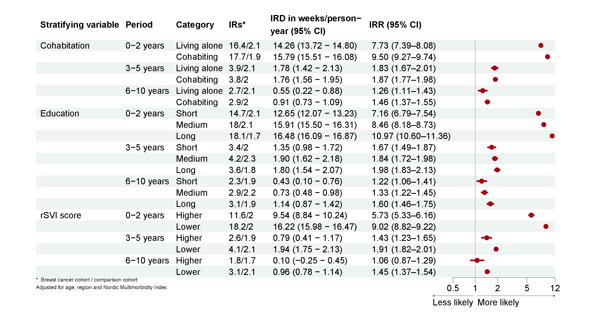
B: 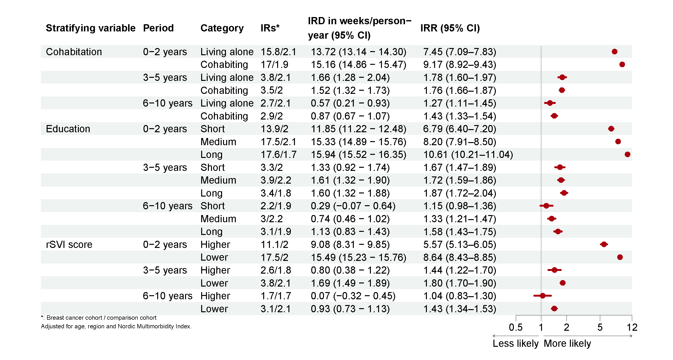

Figure A.3. Workforce detachment among breast cancer patients compared to matched comparisons, restricted to breast cancer patients assigned intention-to-treat A) chemotherapy and B) endocrine therapy

A:

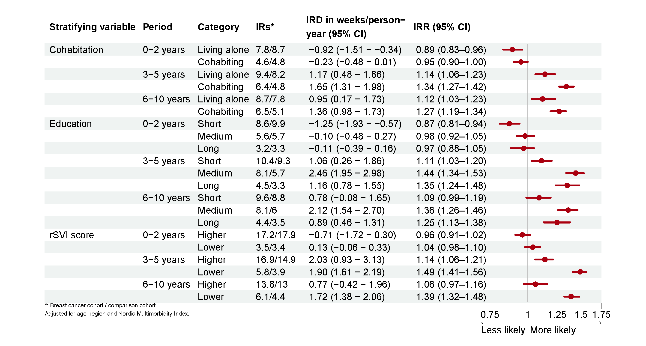
B: 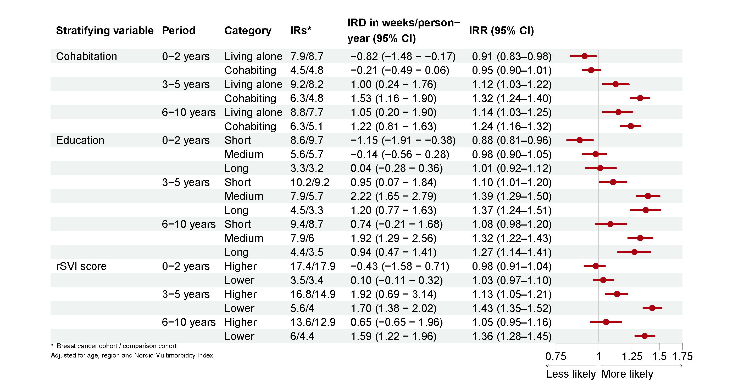

Figure A.4. Disability pension among breast cancer patients compared to matched comparisons, restricted to breast cancer patients assigned intention-to-treat A) chemotherapy and B) endocrine therapy

A:
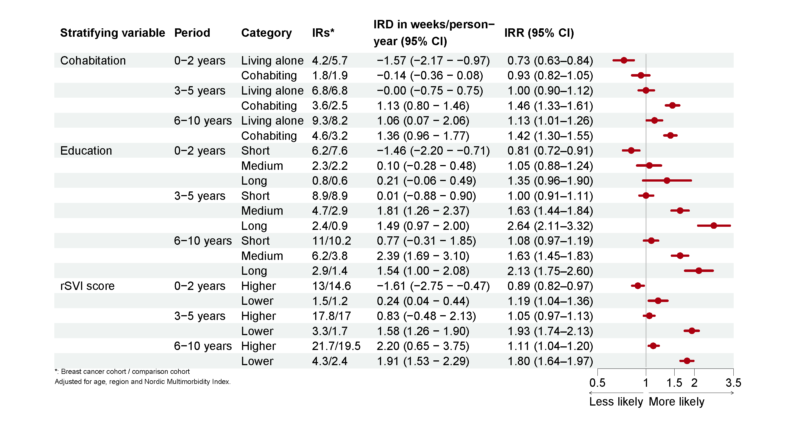
B:

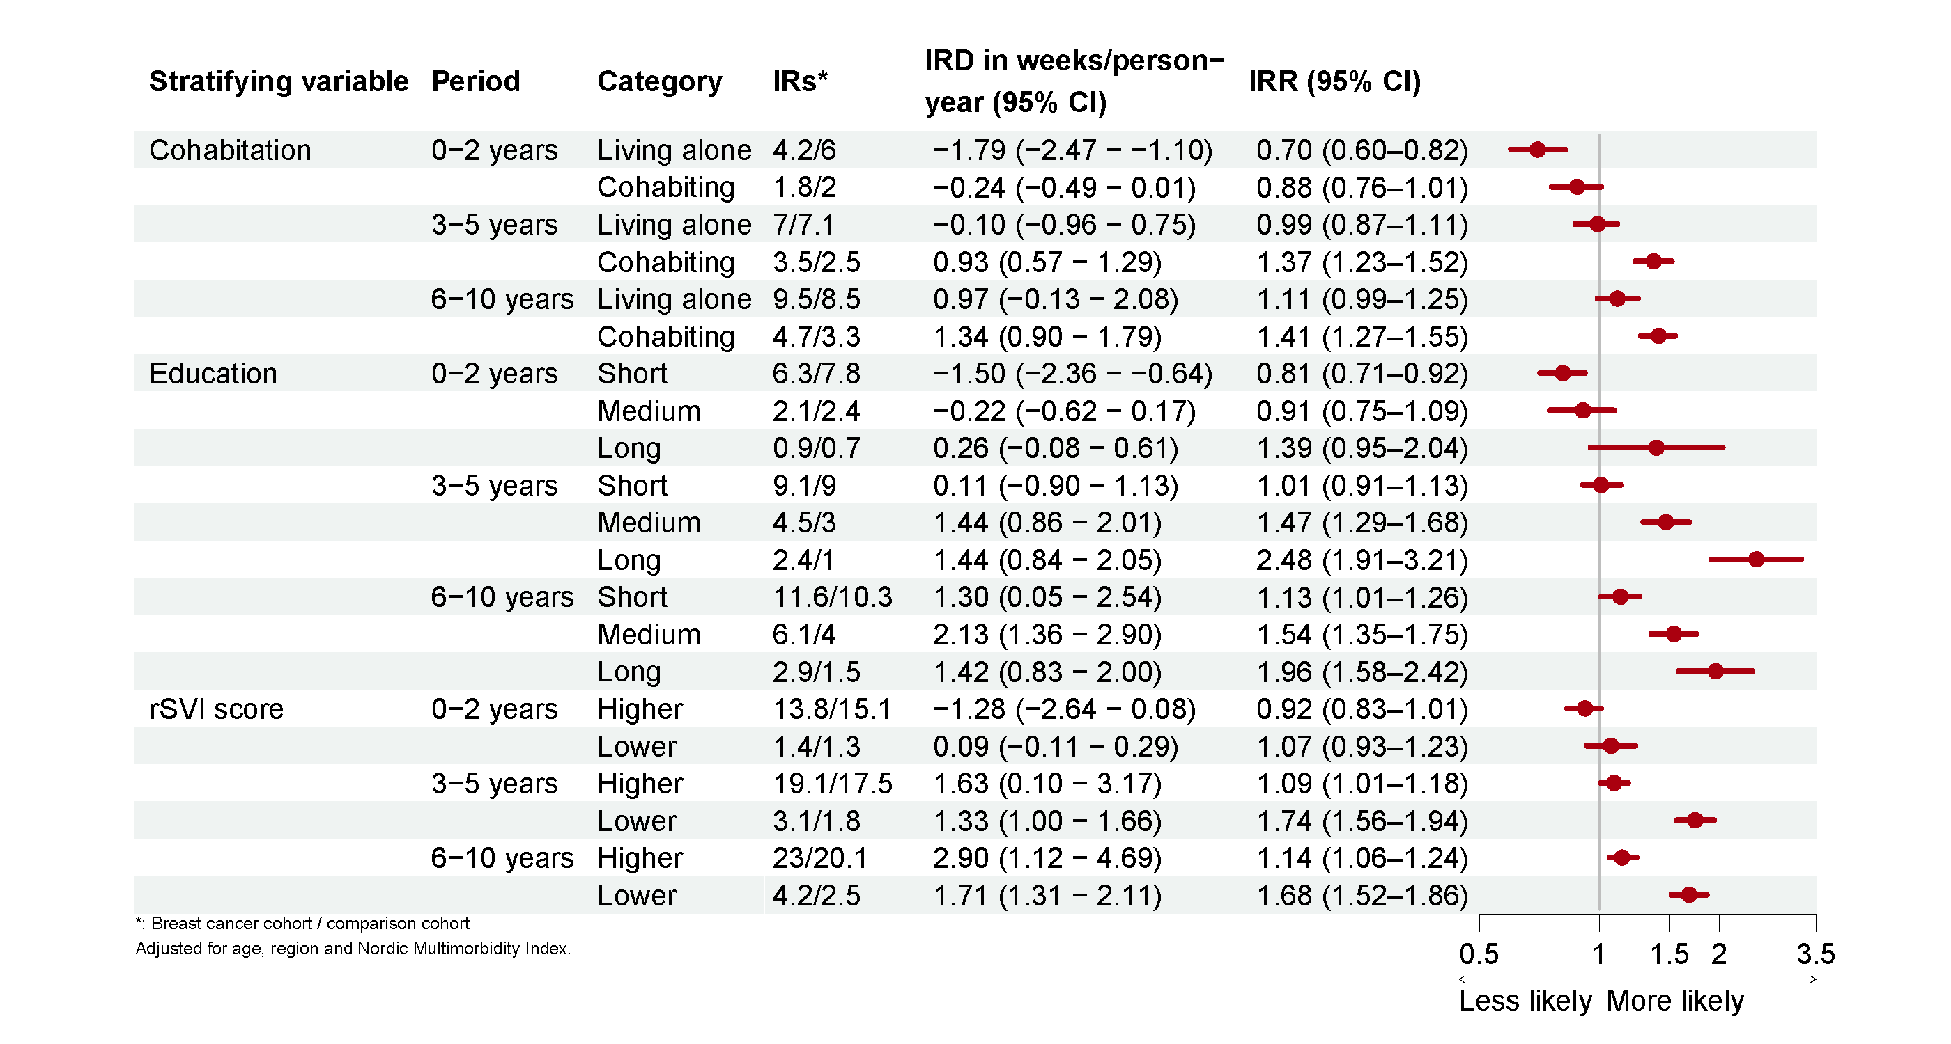

Figure A.5. Sick leave, workforce detachment and disability pension among breast cancer patients compared to matched comparisons, restricted to women employed prior to index

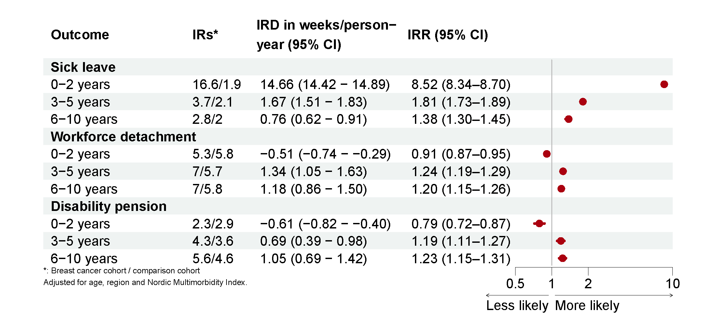

Figure A.6. Sick leave among employed breast cancer patients compared to matched comparisons, stratified by cohabitation, education and rSVI.

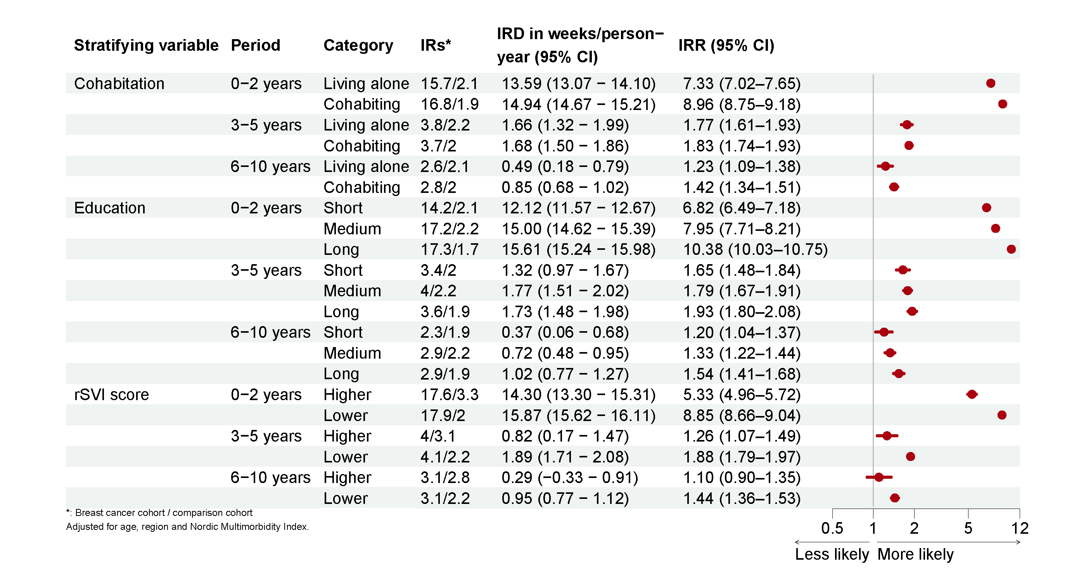

Figure A.7. Workforce detachment among employed breast cancer patients compared to matched comparisons, stratified by cohabitation, education and rSVI.

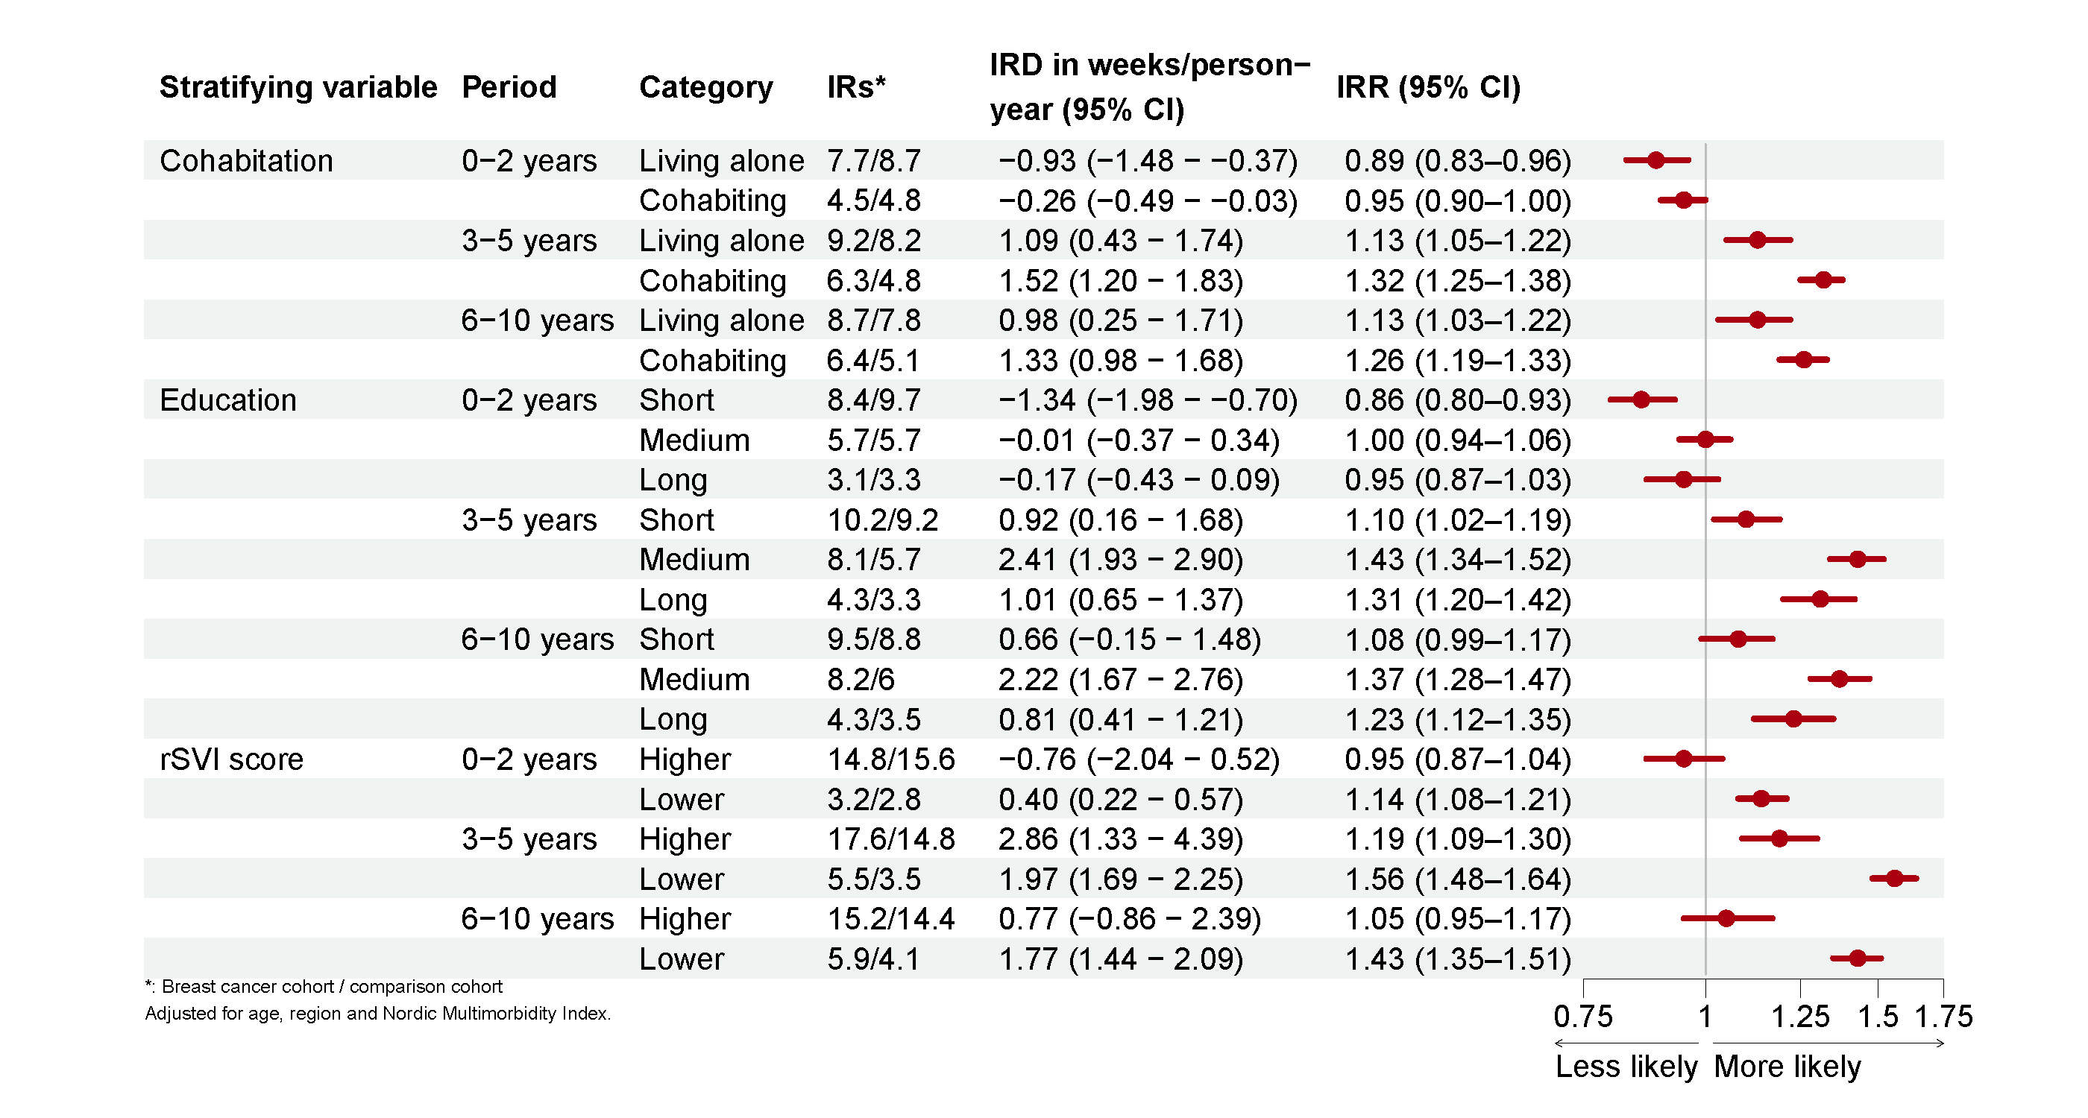

Figure A.8. Disability pension among employed breast cancer patients compared to matched comparisons, stratified by cohabitation, education and rSVI.
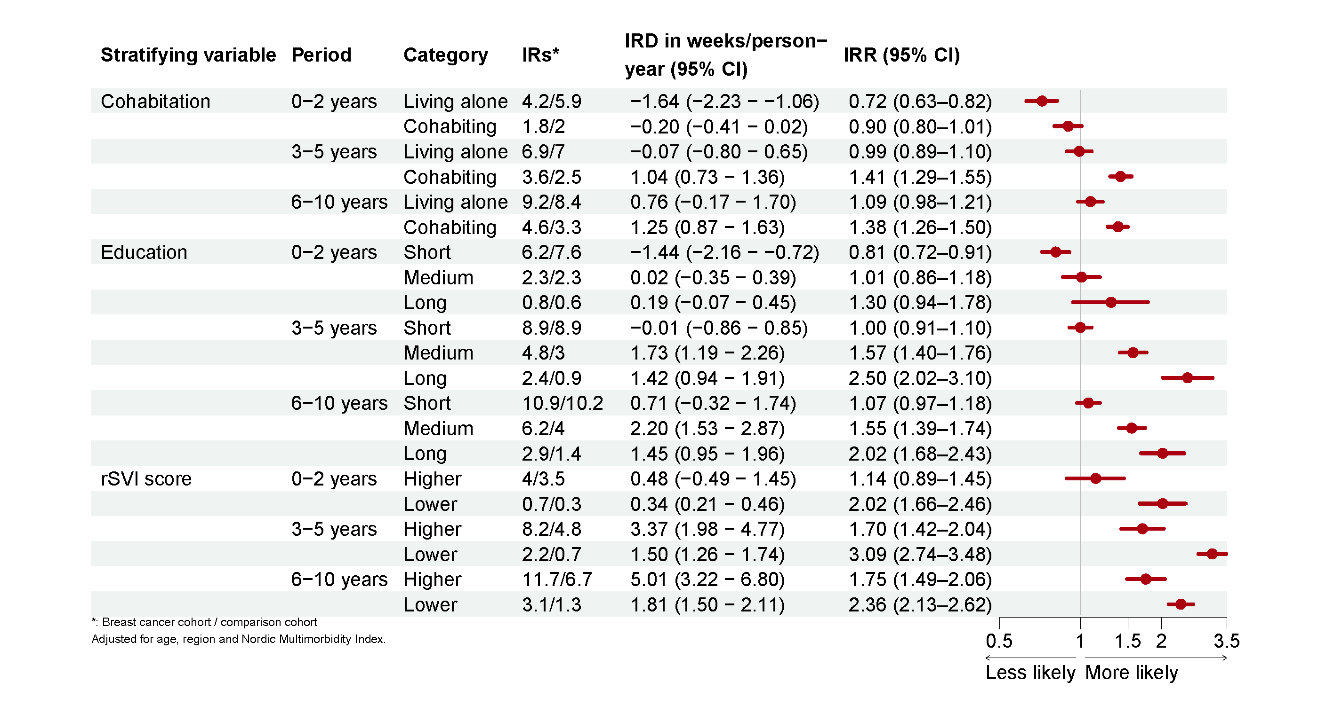

Figure A.9. Annual incidence rate per. 1,000 person years of disability pension in women with breast cancer and the general population

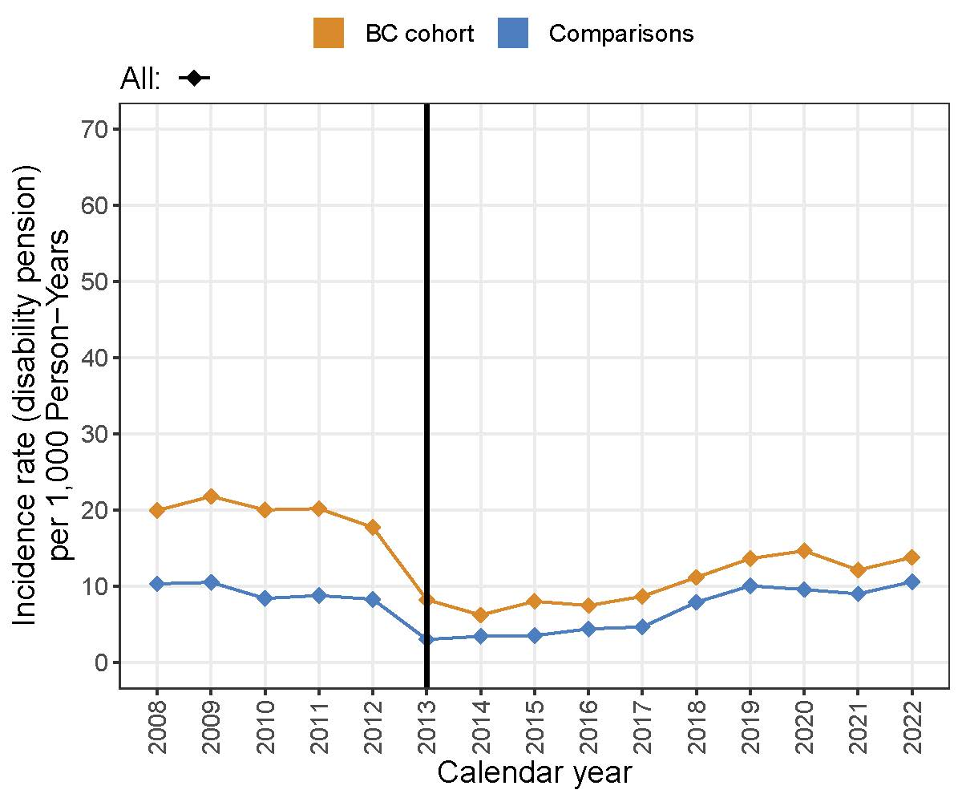

Figure A.10. Annual incidence rate per. 1,000 person years of disability pension in women with breast cancer and the general population by age, cohabitation status, education and social vulnerability
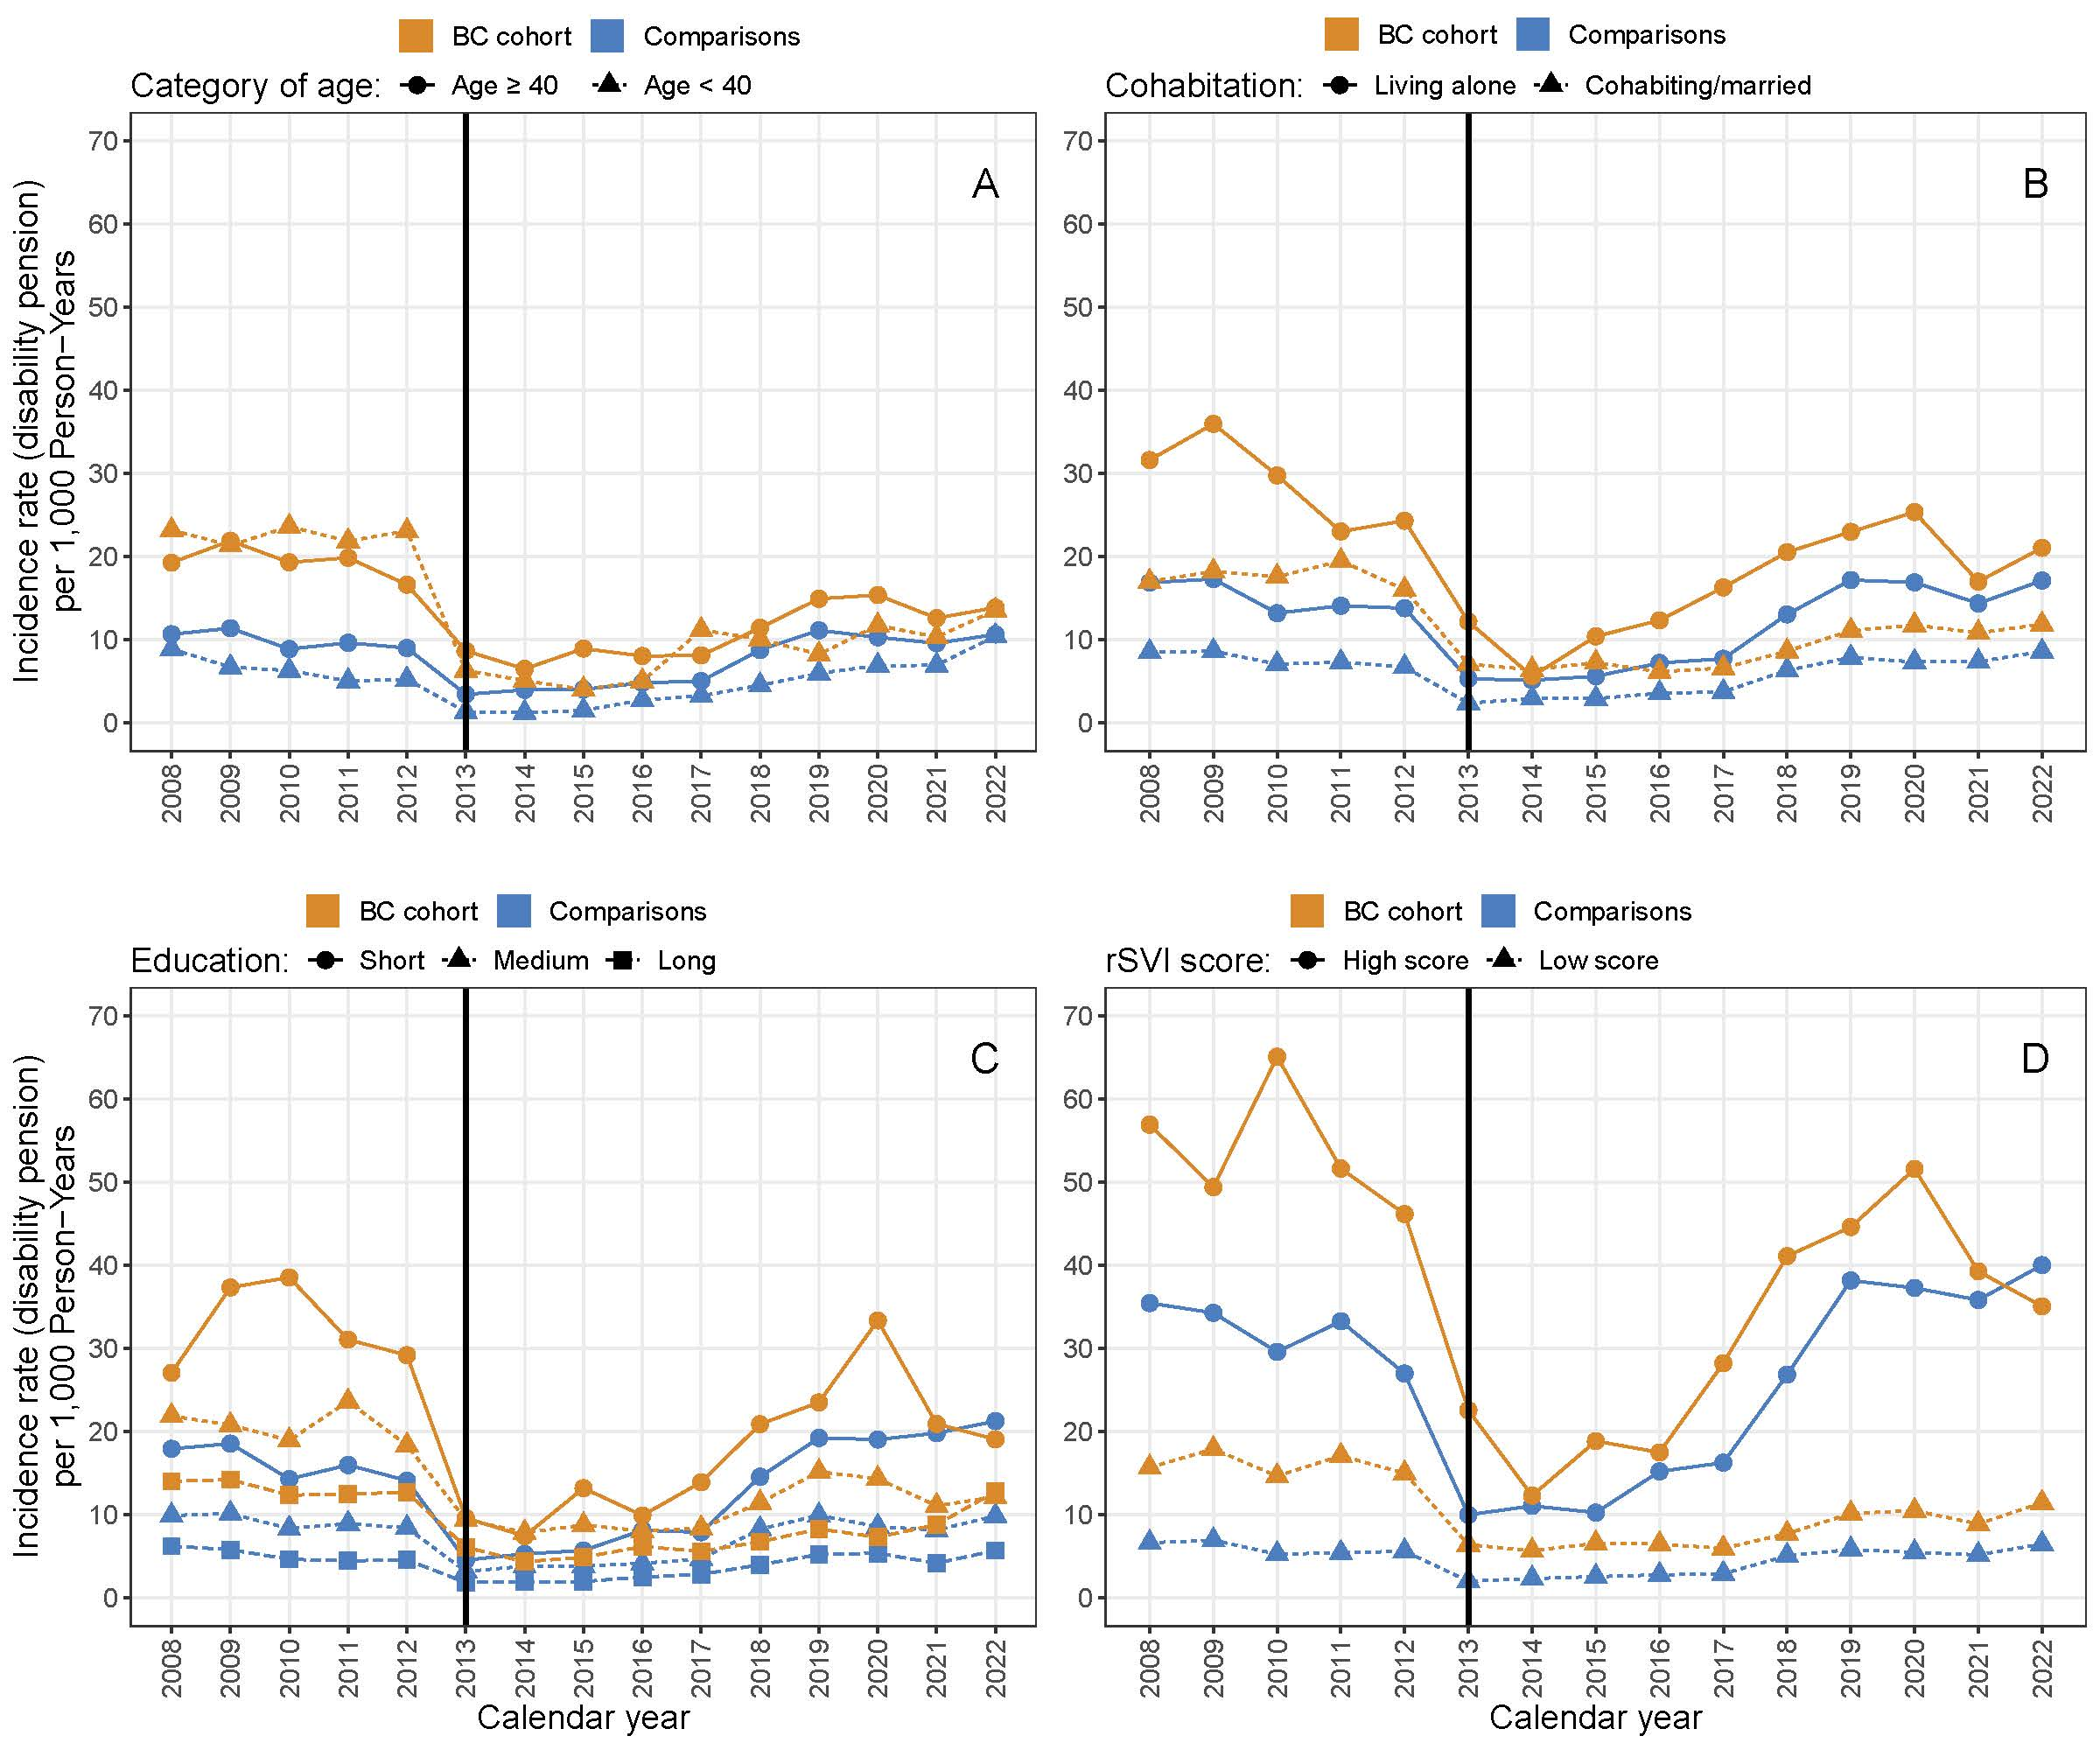

References
1. Kristensen KB, Lund LC, Jensen PB, et al. Development and Validation of a Nordic Multimorbidity Index Based on Hospital Diagnoses and Filled Prescriptions. Clin Epidemiol. 2022;14:567-579. doi:10.2147/CLEP.S353398
2. Møller JJK, la Cour K, Pilegaard MS, Möller S, Jarlbaek L. Identification of socially vulnerable cancer patients - development of a register-based index (rSVI). Support Care Cancer Off J Multinatl Assoc Support Care Cancer. 2022;30(6):5277-5287. doi:10.1007/s00520-022-06937-3
3. Hjorth CF, Kjærulff TM, Thomsen MK, et al. SEPLINE: Socioeconomic Position in Epidemiological Research-A National Guideline on Danish Registry Data. Clin Epidemiol. 2025;17:593-624. doi:10.2147/CLEP.S520772
4. Elixhauser A, Steiner C, Harris DR, Coffey RM. Comorbidity measures for use with administrative data. Med Care. 1998;36(1):8-27. doi:10.1097/00005650-199801000-00004

