Effectiveness of Manual Interventions on Overall Symptoms, Pain and Quality of Life in Patients with Chemotherapy-Induced Peripheral Neuropathy: A Systematic Review and Meta-analysis

Supplementary Files

Index of supplementary materials
Supplementary 1. PRISMA 2020 Checklist
Supplementary 2. Detailed Search Strategy
Supplementary 3. Supplementary Meta-Analysis Forest Plots
  - Forest plot comparing symptom score of CIPN between intervention and control group.
  - Forest plot comparing the sensory dimension of patients with CIPN between intervention and control group.
  - Forest plot comparing the motor dimension of patients with CIPN between intervention and control group.
  - Forest plot comparing Pain score of patients with CIPN between intervention and control group.
  - Forest plot comparing quality of life of patients with CIPN between intervention and control group.
  - Forest plot comparing sleep quality of patients with CIPN between intervention and control group.
  - Forest Plot for Anxiety Outcomes
  - Forest Plot for Depression Outcomes
Supplementary 4. Subgroup Analysis Forest Plots
  - Subgroup analysis of overall CIPN symptoms
  - Subgroup analysis of pain
  - Subgroup analysis of quality of life
Supplementary 5. Funnel plot of comparison: overall effect of manual therapy on pain score changes in CIPN patients.
Supplementary 6. Forest plots for sensitivity analyses excluding high-risk-of-bias studies.

Supplementary 1. PRISMA 2020 Checklist

Section and Topic | Item # | Checklist item | Location where item is reported
TITLE
Title | 1 | Identify the report as a systematic review. | Page 1
ABSTRACT
Abstract | 2 | See the PRISMA 2020 for Abstracts checklist. | Page 2
INTRODUCTION
Rationale | 3 | Describe the rationale for the review in the context of existing knowledge. | Page 3-4
Objectives | 4 | Provide an explicit statement of the objective(s) or question(s) the review addresses. | Page 5
METHODS
Eligibility criteria | 5 | Specify the inclusion and exclusion criteria for the review and how studies were grouped for the syntheses. | Page 6
Information sources | 6 | Specify all databases, registers, websites, organisations, reference lists and other sources searched or consulted to identify studies. Specify the date when each source was last searched or consulted. | Page 7
Search strategy | 7 | Present the full search strategies for all databases, registers and websites, including any filters and limits used. | Page 7  Supplementary Material 2
Selection process | 8 | Specify the methods used to decide whether a study met the inclusion criteria of the review, including how many reviewers screened each record and each report retrieved, whether they worked independently, and if applicable, details of automation tools used in the process. | Page 8
Data collection process | 9 | Specify the methods used to collect data from reports, including how many reviewers collected data from each report, whether they worked independently, any processes for obtaining or confirming data from study investigators, and if applicable, details of automation tools used in the process. | Page 8
Data items | 10a | List and define all outcomes for which data were sought. Specify whether all results that were compatible with each outcome domain in each study were sought (e.g. for all measures, time points, analyses), and if not, the methods used to decide which results to collect. | Page 9
Data items | 10b | List and define all other variables for which data were sought (e.g. participant and intervention characteristics, funding sources). Describe any assumptions made about any missing or unclear information. | Page 9-10
Study risk of bias assessment | 11 | Specify the methods used to assess risk of bias in the included studies, including details of the tool(s) used, how many reviewers assessed each study and whether they worked independently, and if applicable, details of automation tools used in the process. | Page 10
Effect measures | 12 | Specify for each outcome the effect measure(s) (e.g. risk ratio, mean difference) used in the synthesis or presentation of results. | Page 9-10
Synthesis methods | 13a | Describe the processes used to decide which studies were eligible for each synthesis (e.g. tabulating the study intervention characteristics and comparing against the planned groups for each synthesis (item #5)). | Page 9
Synthesis methods | 13b | Describe any methods required to prepare the data for presentation or synthesis, such as handling of missing summary statistics, or data conversions. | Page 9
Synthesis methods | 13c | Describe any methods used to tabulate or visually display results of individual studies and syntheses. | Page 9-15
Synthesis methods | 13d | Describe any methods used to synthesize results and provide a rationale for the choice(s). If meta-analysis was performed, describe the model(s), method(s) to identify the presence and extent of statistical heterogeneity, and software package(s) used. | Page 9
Synthesis methods | 13e | Describe any methods used to explore possible causes of heterogeneity among study results (e.g. subgroup analysis, meta-regression). | Page 9
Synthesis methods | 13f | Describe any sensitivity analyses conducted to assess robustness of the synthesized results. | Page 9
Reporting bias assessment | 14 | Describe any methods used to assess risk of bias due to missing results in a synthesis (arising from reporting biases). | Page 10
Certainty assessment | 15 | Describe any methods used to assess certainty (or confidence) in the body of evidence for an outcome. | Page 10-11
RESULTS
Study selection | 16a | Describe the results of the search and selection process, from the number of records identified in the search to the number of studies included in the review, ideally using a flow diagram. | Page 11
Study selection | 16b | Cite studies that might appear to meet the inclusion criteria, but which were excluded, and explain why they were excluded. | Page 11
Study characteristics | 17 | Cite each included study and present its characteristics. | Page12-19
Risk of bias in studies | 18 | Present assessments of risk of bias for each included study. | Page 20-24
Results of individual studies | 19 | For all outcomes, present, for each study: (a) summary statistics for each group (where appropriate) and (b) an effect estimate and its precision (e.g. confidence/credible interval), ideally using structured tables or plots. | Page 25-29
Results of syntheses | 20a | For each synthesis, briefly summarise the characteristics and risk of bias among contributing studies. | Page 20-29
Results of syntheses | 20b | Present results of all statistical syntheses conducted. If meta-analysis was done, present for each the summary estimate and its precision (e.g. confidence/credible interval) and measures of statistical heterogeneity. If comparing groups, describe the direction of the effect. | Page 20-24
Results of syntheses | 20c | Present results of all investigations of possible causes of heterogeneity among study results. | Page 29-31  Supplementary Material 4
Results of syntheses | 20d | Present results of all sensitivity analyses conducted to assess the robustness of the synthesized results. | Page 20-24  Supplementary Material 5&6
Reporting biases | 21 | Present assessments of risk of bias due to missing results (arising from reporting biases) for each synthesis assessed. | Page 21-22  Supplementary Material 5
Certainty of evidence | 22 | Present assessments of certainty (or confidence) in the body of evidence for each outcome assessed. | Page 31-32  Table 3
DISCUSSION
Discussion | 23a | Provide a general interpretation of the results in the context of other evidence. | Page 32
Discussion | 23b | Discuss any limitations of the evidence included in the review. | Page 38
Discussion | 23c | Discuss any limitations of the review processes used. | Page 38
Discussion | 23d | Discuss implications of the results for practice, policy, and future research. | Page 39-40
OTHER INFORMATION
Registration and protocol | 24a | Provide registration information for the review, including register name and registration number, or state that the review was not registered. | Page 5
Registration and protocol | 24b | Indicate where the review protocol can be accessed, or state that a protocol was not prepared. | NR
Registration and protocol | 24c | Describe and explain any amendments to information provided at registration or in the protocol. | NR
Support | 25 | Describe sources of financial or non-financial support for the review, and the role of the funders or sponsors in the review. | Page 41
Competing interests | 26 | Declare any competing interests of review authors. | Page 41
Availability of data, code and other materials | 27 | Report which of the following are publicly available and where they can be found: template data collection forms; data extracted from included studies; data used for all analyses; analytic code; any other materials used in the review. | NR

Supplementary 2. Detailed Search Strategy

Database | Search strategy | Date | Num.
PubMed | #1 Search “Peripheral Nervous System Diseases” [MeSH]  #2 Search (("Paresthesias"[Title/Abstract] OR "Formication"[Title/Abstract] OR "Formications"[Title/Abstract] OR "Distal Paresthesia"[Title/Abstract] OR "Distal Paresthesias"[Title/Abstract] OR "Painful Paresthesia"[Title/Abstract] OR "Painful Paresthesias"[Title/Abstract] OR "Dysesthesia"[Title/Abstract] OR "Paresthesia"[Title/Abstract] OR ("Neurotoxicity Syndromes"[Title/Abstract] OR "Neurotoxicity Syndrome"[Title/Abstract] OR "Nervous System Poisoning"[Title/Abstract] OR "Neurotoxic Disorders"[Title/Abstract] OR "Neurotoxic Disorder"[Title/Abstract] OR "Toxic Encephalitis"[Title/Abstract] OR "Toxic Encephalopathies"[Title/Abstract] OR "Toxic Encephalopathy"[Title/Abstract]) OR ("Neuralgia"[Title/Abstract] OR "Neuralgias"[Title/Abstract] OR "Neurodynia"[Title/Abstract] OR "Neuropathic Pain"[Title/Abstract] OR "Neuropathic Pains"[Title/Abstract] OR "Nerve Pain"[Title/Abstract] OR "Paroxysmal Nerve Pain"[Title/Abstract] OR "Atypical Neuralgia"[Title/Abstract] OR "Atypical Neuralgias"[Title/Abstract] OR "Ilioinguinal Neuralgia"[Title/Abstract] OR "Ilioinguinal Neuralgias"[Title/Abstract] OR "Perineal Neuralgia"[Title/Abstract] OR "Perineal Neuralgias"[Title/Abstract] OR "Supraorbital Neuralgia"[Title/Abstract]) OR ("Peripheral Nervous System Diseases"[Title/Abstract] OR "Peripheral Nervous System Disorders"[Title/Abstract] OR "Peripheral Neuropathies"[Title/Abstract] OR "Peripheral Neuropathy"[Title/Abstract] OR "Peripheral Nervous System Disease"[Title/Abstract] OR "PNS Diseases"[Title/Abstract] OR "PNS Disease"[Title/Abstract] OR "Peripheral Nerve"[Title/Abstract] OR "Peripheral Nerve Disease"[Title/Abstract])) AND ("Neoplasms"[Title/Abstract] OR "Tumors"[Title/Abstract] OR "Neoplasia"[Title/Abstract] OR "Neoplasias"[Title/Abstract] OR "Neoplasm"[Title/Abstract] OR "Tumor"[Title/Abstract] OR "Cancer"[Title/Abstract] OR "Cancers"[Title/Abstract] OR "malignant neoplasm"[Title/Abstract] OR "Malignancy"[Title/Abstract] OR "Malignancies"[Title/Abstract] OR "malignant neoplasms"[Title/Abstract] OR "benign neoplasms"[Title/Abstract] OR "benign neoplasm"[Title/Abstract])) OR ("chemotherapy-induced peripheral neuropathy"[Title/Abstract] OR "CIPN"[Title/Abstract])  #3 Search “Massage” [MeSH]  #4 Search “Acupressure” [MeSH]  #5 Search (("non pharmacologic treatment"[Title/Abstract] OR "Rehabilitation"[Title/Abstract] OR "Physical"[Title/Abstract]) AND "rehabilitation medicine"[Title/Abstract]) OR "integrative medicine"[Title/Abstract] OR "physical therapy modalities"[Title/Abstract] OR "complementary therapies"[Title/Abstract] OR "Massage"[Title/Abstract] OR "Acupressure"[Title/Abstract] OR "zone therapy"[Title/Abstract] OR "zone therapies"[Title/Abstract] OR "massage therapy"[Title/Abstract] OR "massage therapies"[Title/Abstract] OR "craniosacral massage"[Title/Abstract] OR "Reflexology"[Title/Abstract] OR "manipulation therapy"[Title/Abstract] OR "manipulation therapies"[Title/Abstract] OR "manual therapies"[Title/Abstract] OR "manual therapy"[Title/Abstract] OR "Bodywork"[Title/Abstract] OR "Bodyworks"[Title/Abstract] OR "Rolfing"[Title/Abstract]  #6 #3 OR #4 OR #5  #7 #1 OR #2  #6 AND #7 | 2025.6.18 | 670
Embase | #1 ('paresthesias':ab,ti OR 'formication':ab,ti OR 'formications':ab,ti OR 'distal paresthesia':ab,ti OR 'distal paresthesias':ab,ti OR 'painful paresthesia':ab,ti OR 'painful paresthesias':ab,ti OR 'dysesthesia':ab,ti OR 'paresthesia':ab,ti OR 'neurotoxicity syndromes':ab,ti OR 'neurotoxicity syndrome':ab,ti OR 'nervous system poisoning':ab,ti OR 'neurotoxic disorders':ab,ti OR 'neurotoxic disorder':ab,ti OR 'toxic encephalitis':ab,ti OR 'toxic encephalopathies':ab,ti OR 'toxic encephalopathy':ab,ti OR 'neuralgia':ab,ti OR 'neuralgias':ab,ti OR 'neurodynia':ab,ti OR 'neuropathic pain':ab,ti OR 'neuropathic pains':ab,ti OR 'nerve pain':ab,ti OR 'paroxysmal nerve pain':ab,ti OR 'atypical neuralgia':ab,ti OR 'atypical neuralgias':ab,ti OR 'ilioinguinal neuralgia':ab,ti OR 'ilioinguinal neuralgias':ab,ti OR 'perineal neuralgia':ab,ti OR 'perineal neuralgias':ab,ti OR 'supraorbital neuralgia':ab,ti OR 'peripheral nervous system diseases':ab,ti OR 'peripheral nervous system disorders':ab,ti OR 'peripheral neuropathies':ab,ti OR 'peripheral neuropathy':ab,ti OR 'peripheral nervous system disease':ab,ti OR 'pns diseases':ab,ti OR 'pns disease':ab,ti OR 'peripheral nerve':ab,ti OR 'peripheral nerve disease':ab,ti) AND ('neoplasms':ab,ti OR 'tumors':ab,ti OR 'neoplasia':ab,ti OR 'neoplasias':ab,ti OR 'neoplasm':ab,ti OR 'tumor':ab,ti OR 'cancer':ab,ti OR 'cancers':ab,ti OR 'malignant neoplasm':ab,ti OR 'malignancy':ab,ti OR 'malignancies':ab,ti OR 'malignant neoplasms':ab,ti OR 'benign neoplasms':ab,ti OR 'benign neoplasm':ab,ti) OR 'chemotherapy-induced peripheral neuropathy':ab,ti OR 'cipn':ab,ti  #2 ('non-pharmacologic treatment':ab,ti OR rehabilitation:ab,ti OR physical:ab,ti) AND 'rehabilitation medicine':ab,ti OR 'integrative medicine':ab,ti OR 'physical therapy modalities':ab,ti OR 'complementary therapies':ab,ti OR massage:ab,ti OR acupressure:ab,ti OR 'zone therapy':ab,ti OR 'zone therapies':ab,ti OR 'massage therapy':ab,ti OR 'massage therapies':ab,ti OR 'craniosacral massage':ab,ti OR reflexology:ab,ti OR 'manipulation therapy':ab,ti OR 'manipulation therapies':ab,ti OR 'manual therapies':ab,ti OR 'manual therapy':ab,ti OR bodywork:ab,ti OR bodyworks:ab,ti OR rolfing:ab,ti  #1 AND #2 | 2025.6.18 | 165
Cochrane | #1 (("Paresthesias" OR "Formication" OR "Formications" OR "Distal Paresthesia" OR "Distal Paresthesias" OR "Painful Paresthesia" OR "Painful Paresthesias" OR "Dysesthesia" OR "Paresthesia" OR ("Neurotoxicity Syndromes" OR "Neurotoxicity Syndrome" OR "Nervous System Poisoning" OR "Neurotoxic Disorders" OR "Neurotoxic Disorder" OR "Toxic Encephalitis" OR "Toxic Encephalopathies" OR "Toxic Encephalopathy") OR ("Neuralgia" OR "Neuralgias" OR "Neurodynia" OR "Neuropathic Pain" OR "Neuropathic Pains" OR "Nerve Pain" OR "Paroxysmal Nerve Pain" OR "Atypical Neuralgia" OR "Atypical Neuralgias" OR "Ilioinguinal Neuralgia" OR "Ilioinguinal Neuralgias" OR "Perineal Neuralgia" OR "Perineal Neuralgias" OR "Supraorbital Neuralgia") OR ("Peripheral Nervous System Diseases" OR "Peripheral Nervous System Disorders" OR "Peripheral Neuropathies" OR "Peripheral Neuropathy" OR "Peripheral Nervous System Disease" OR "PNS Diseases" OR "PNS Disease" OR "Peripheral Nerve" OR "Peripheral Nerve Disease")) AND ("Neoplasms" OR "Tumors" OR "Neoplasia" OR "Neoplasias" OR "Neoplasm" OR "Tumor" OR "Cancer" OR "Cancers" OR "malignant neoplasm" OR "Malignancy" OR "Malignancies" OR "malignant neoplasms" OR "benign neoplasms" OR "benign neoplasm")) OR ("chemotherapy-induced peripheral neuropathy" OR "CIPN") in Title Abstract Keyword - (Word variations have been searched)  #2 "Non-pharmacologic Treatment" OR "Rehabilitation" OR "Physical and Rehabilitation Medicine" OR "Integrative Medicine" OR "Physical Therapy Modalities" OR "Complementary Therapies" OR "Massage" OR "Acupressure" OR "Zone Therapy" OR "Zone Therapies" OR "Massage Therapy" OR "Massage Therapies" OR "Craniosacral Massage" OR "Reflexology" OR "Manipulation Therapy" OR "Manipulation Therapies" OR "Manual Therapies" OR "Manual Therapy" OR "Bodywork" OR "Bodyworks" OR "Rolfing" in Title Abstract Keyword - (Word variations have been searched)  #1 AND #2 |  | 157
WOS | (TS=(Peripheral Nervous System Diseases) OR AB=(("Paresthesias" OR "Formication" OR "Formications" OR "Distal Paresthesia" OR "Distal Paresthesias" OR "Painful Paresthesia" OR "Painful Paresthesias" OR "Dysesthesia" OR "Paresthesia" OR ("Neurotoxicity Syndromes" OR "Neurotoxicity Syndrome" OR "Nervous System Poisoning" OR "Neurotoxic Disorders" OR "Neurotoxic Disorder" OR "Toxic Encephalitis" OR "Toxic Encephalopathies" OR "Toxic Encephalopathy") OR ("Neuralgia" OR "Neuralgias" OR "Neurodynia" OR "Neuropathic Pain" OR "Neuropathic Pains" OR "Nerve Pain" OR "Paroxysmal Nerve Pain" OR "Atypical Neuralgia" OR "Atypical Neuralgias" OR "Ilioinguinal Neuralgia" OR "Ilioinguinal Neuralgias" OR "Perineal Neuralgia" OR "Perineal Neuralgias" OR "Supraorbital Neuralgia") OR ("Peripheral Nervous System Diseases" OR "Peripheral Nervous System Disorders" OR "Peripheral Neuropathies" OR "Peripheral Neuropathy" OR "Peripheral Nervous System Disease" OR "PNS Diseases" OR "PNS Disease" OR "Peripheral Nerve" OR "Peripheral Nerve Disease")) AND ("Neoplasms" OR "Tumors" OR "Neoplasia" OR "Neoplasias" OR "Neoplasm" OR "Tumor" OR "Cancer" OR "Cancers" OR "malignant neoplasm" OR "Malignancy" OR "Malignancies" OR "malignant neoplasms" OR "benign neoplasms" OR "benign neoplasm")) OR ("chemotherapy-induced peripheral neuropathy" OR "CIPN") AND AB="Non-pharmacologic Treatment" OR "Rehabilitation" OR "Physical and Rehabilitation Medicine" OR "Integrative Medicine" OR "Physical Therapy Modalities" OR "Complementary Therapies" OR "Massage" OR "Acupressure" OR "Zone Therapy" OR "Zone Therapies" OR "Massage Therapy" OR "Massage Therapies" OR "Craniosacral Massage" OR "Reflexology" OR "Manipulation Therapy" OR "Manipulation Therapies" OR "Manual Therapies" OR "Manual Therapy" OR "Bodywork" OR "Bodyworks" OR "Rolfing" |  | 184
CINAHL | S1 AB=(("Paresthesias" OR "Formication" OR "Formications" OR "Distal Paresthesia" OR "Distal Paresthesias" OR "Painful Paresthesia" OR "Painful Paresthesias" OR "Dysesthesia" OR "Paresthesia" OR ("Neurotoxicity Syndromes" OR "Neurotoxicity Syndrome" OR "Nervous System Poisoning" OR "Neurotoxic Disorders" OR "Neurotoxic Disorder" OR "Toxic Encephalitis" OR "Toxic Encephalopathies" OR "Toxic Encephalopathy") OR ("Neuralgia" OR "Neuralgias" OR "Neurodynia" OR "Neuropathic Pain" OR "Neuropathic Pains" OR "Nerve Pain" OR "Paroxysmal Nerve Pain" OR "Atypical Neuralgia" OR "Atypical Neuralgias" OR "Ilioinguinal Neuralgia" OR "Ilioinguinal Neuralgias" OR "Perineal Neuralgia" OR "Perineal Neuralgias" OR "Supraorbital Neuralgia") OR ("Peripheral Nervous System Diseases" OR "Peripheral Nervous System Disorders" OR "Peripheral Neuropathies" OR "Peripheral Neuropathy" OR "Peripheral Nervous System Disease" OR "PNS Diseases" OR "PNS Disease" OR "Peripheral Nerve" OR "Peripheral Nerve Disease")) AND ("Neoplasms" OR "Tumors" OR "Neoplasia" OR "Neoplasias" OR "Neoplasm" OR "Tumor" OR "Cancer" OR "Cancers" OR "malignant neoplasm" OR "Malignancy" OR "Malignancies" OR "malignant neoplasms" OR "benign neoplasms" OR "benign neoplasm")) OR ("chemotherapy-induced peripheral neuropathy" OR "CIPN")  S2 AB="Non-pharmacologic Treatment" OR "Rehabilitation" OR "Physical and Rehabilitation Medicine" OR "Integrative Medicine" OR "Physical Therapy Modalities" OR "Complementary Therapies" OR "Massage" OR "Acupressure" OR "Zone Therapy" OR "Zone Therapies" OR "Massage Therapy" OR "Massage Therapies" OR "Craniosacral Massage" OR "Reflexology" OR "Manipulation Therapy" OR "Manipulation Therapies" OR "Manual Therapies" OR "Manual Therapy" OR "Bodywork" OR "Bodyworks" OR "Rolfing"  S1 AND S2 |  | 380
ProQuest | abstract((("Paresthesias" OR "fornication" OR "fornications" OR "Distal Paresthesia" OR "Distal Paresthesias" OR "Painful Paresthesia" OR "Painful Paresthesias" OR "Dysesthesia" OR "Paresthesia" OR ("Neurotoxicity Syndromes" OR "Neurotoxicity Syndrome" OR "Nervous System Poisoning" OR "Neurotoxic Disorders" OR "Neurotoxic Disorder" OR "Toxic Encephalitis" OR "Toxic Encephalopathies" OR "Toxic Encephalopathy") OR ("Neuralgia" OR "neuralgia" OR "Neurodynia" OR "Neuropathic Pain" OR "Neuropathic Pains" OR "Nerve Pain" OR "Paroxysmal Nerve Pain" OR "Atypical Neuralgia" OR "Atypical neuralgia" OR "Ilioinguinal Neuralgia" OR "Ilioinguinal neuralgia" OR "Perineal Neuralgia" OR "Perineal neuralgia" OR "Supraorbital Neuralgia") OR ("Peripheral Nervous System Diseases" OR "Peripheral Nervous System Disorders" OR "Peripheral Neuropathies" OR "Peripheral Neuropathy" OR "Peripheral Nervous System Disease" OR "PNS Diseases" OR "PNS Disease" OR "Peripheral Nerve" OR "Peripheral Nerve Disease")) AND ("Neoplasms" OR "Tumors" OR "Neoplasia" OR "Neoplasias" OR "Neoplasm" OR "Tumor" OR "Cancer" OR "Cancers" OR "malignant neoplasm" OR "Malignancy" OR "Malignancies" OR "malignant neoplasms" OR "benign neoplasms" OR "benign neoplasm")) OR ("chemotherapy-induced peripheral neuropathy" OR "cion")) AND abstract("Non-pharmacologic Treatment" OR "Rehabilitation" OR "Physical and Rehabilitation Medicine" OR "Integrative Medicine" OR "Physical Therapy Modalities" OR "Complementary Therapies" OR "Massage" OR "Acupressure" OR "Zone Therapy" OR "Zone Therapies" OR "Massage Therapy" OR "Massage Therapies" OR "Craniosacral Massage" OR "Reflexology" OR "Manipulation Therapy" OR "Manipulation Therapies" OR "Manual Therapies" OR "Manual Therapy" OR "Bodywork" OR "bodywork" OR "Rolfing") |  | 47
China National Knowledge Infrastructure | 主题=化疗所致周围神经病变 + 化疗相关周围神经病变 + 化疗性周围神经病变 + 化疗周围神经病变 + CIPN  主题=非药物干预 + 补充替代疗法 + 中医外治 + 物理治疗 + 康复护理 + 按摩疗法 + 推拿 + 指压 + 反射疗法 + 耳穴按压 + 耳穴 + 穴位按压 + 手法治疗 |  | 43
Wan fang Data | 主题:(化疗所致周围神经病变 OR 化疗相关周围神经病变 OR 化疗性周围神经病变 OR 化疗周围神经病变 OR CIPN) and 主题:(非药物干预 OR 补充替代疗法 OR 中医外治 OR 物理治疗 OR 康复护理 OR 按摩疗法 OR 推拿 OR 指压 OR 反射疗法 OR 耳穴按压 OR 耳穴 OR 穴位按压 OR 手法治疗) |  | 106
Total |  |  | 1752

Supplementary 3. Supplementary Meta-Analysis Forest Plots
  - Forest plot comparing symptom score of CIPN between intervention and control group.
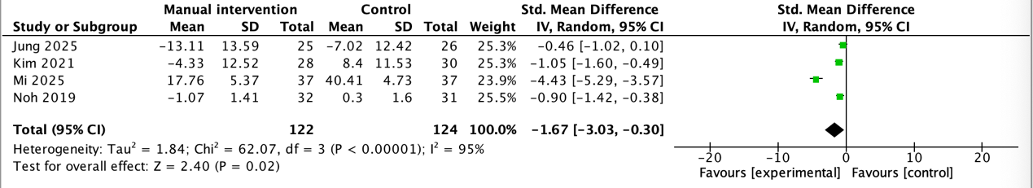
  - Forest plot comparing the sensory dimension of patients with CIPN between intervention and control group.
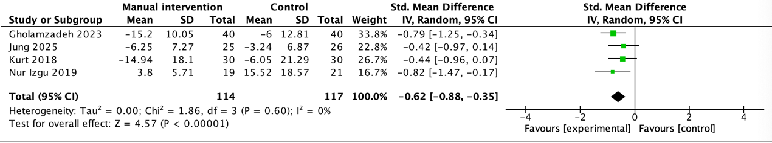
  - Forest plot comparing the motor dimension of patients with CIPN between intervention and control group.
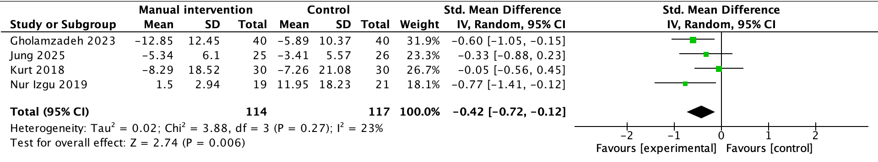
  - Forest plot comparing Pain score of patients with CIPN between intervention and control group.
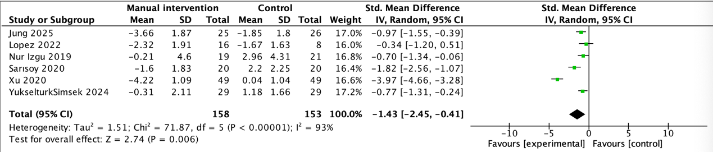
  - Forest plot comparing quality of life of patients with CIPN between intervention and control group.
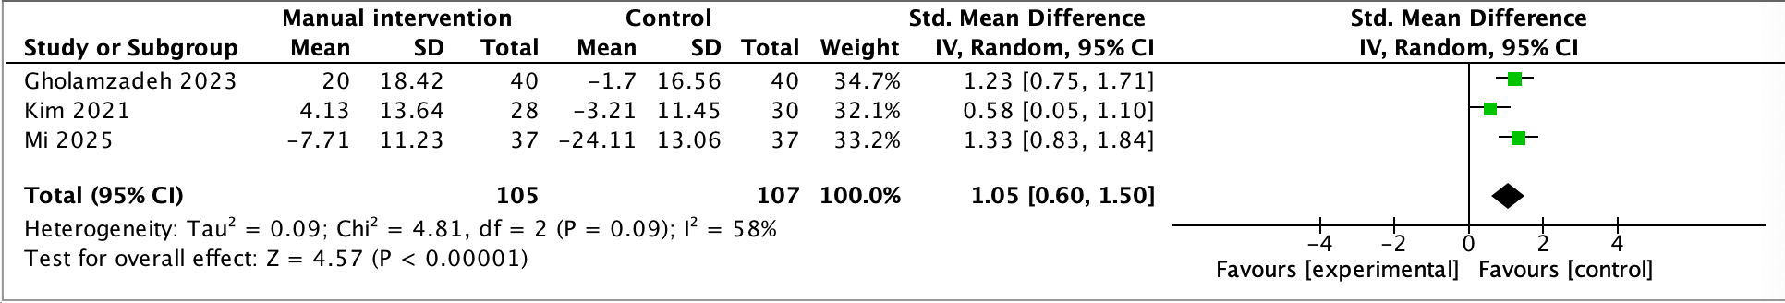
  - Forest plot comparing sleep quality of patients with CIPN between intervention and control group.
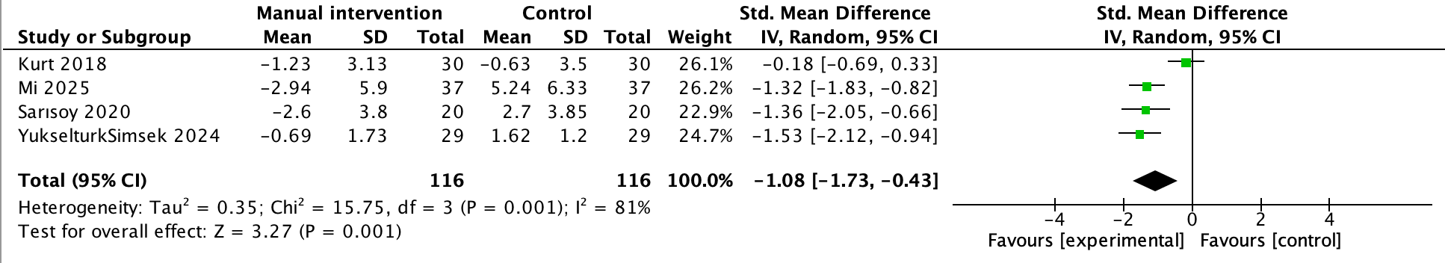
  - Forest Plot for Anxiety Outcomes
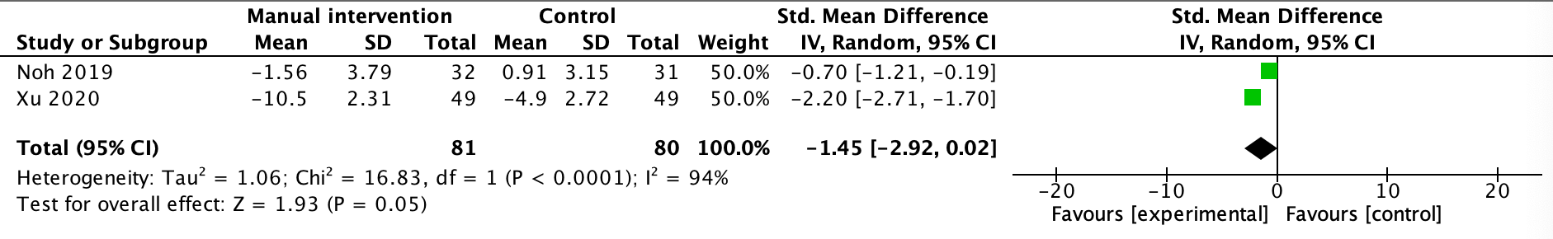
  - Forest Plot for Depression Outcomes
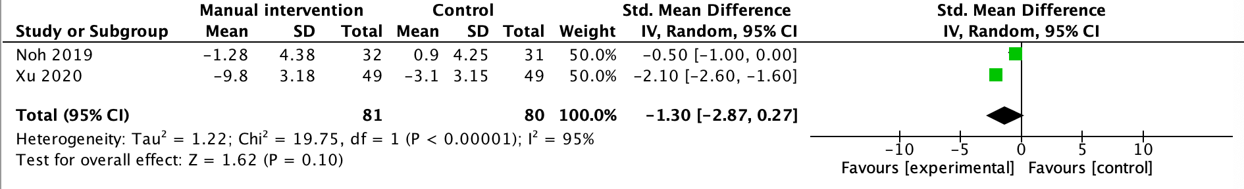
Supplementary 4. Subgroup Analysis Forest Plots
  - Subgroup analysis of overall CIPN symptoms
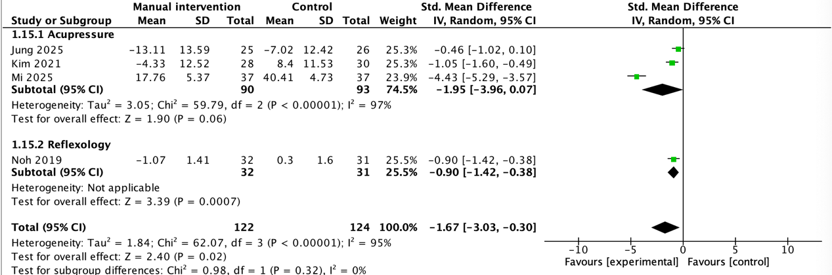
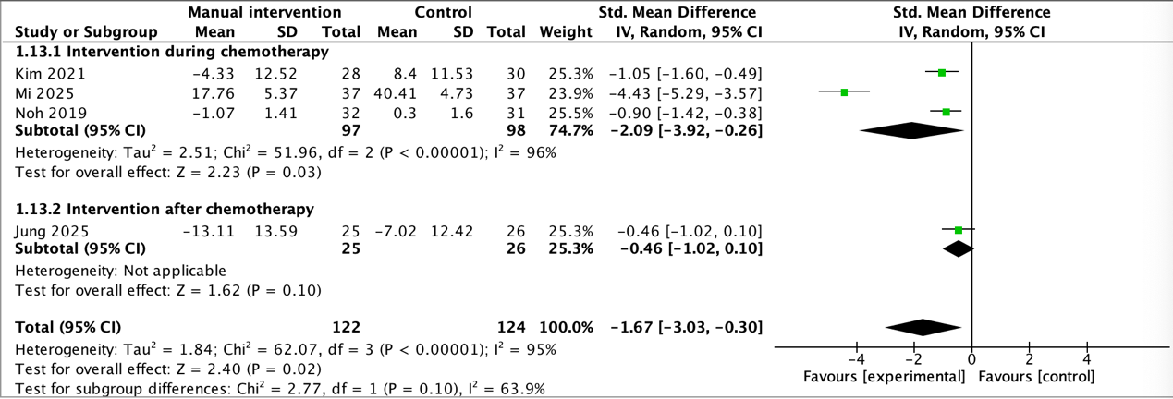
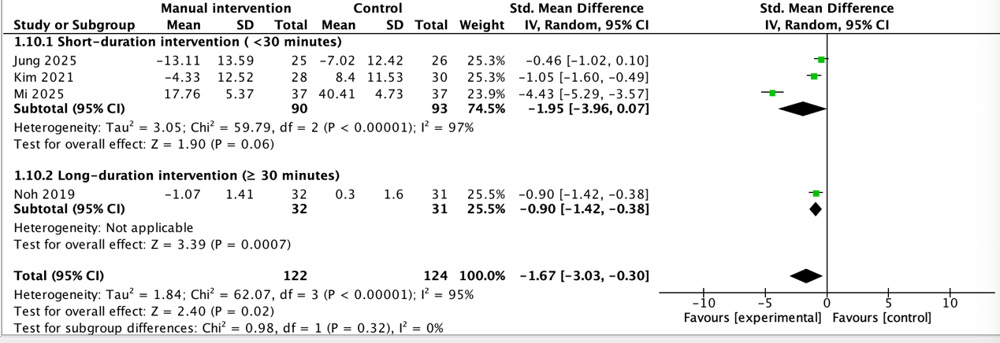

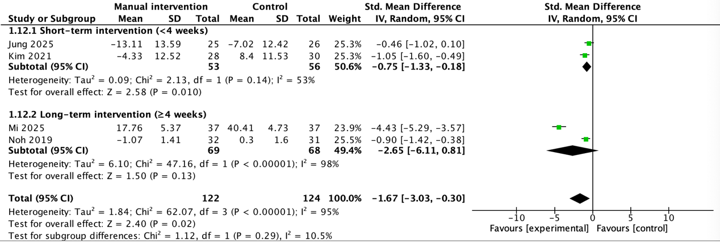

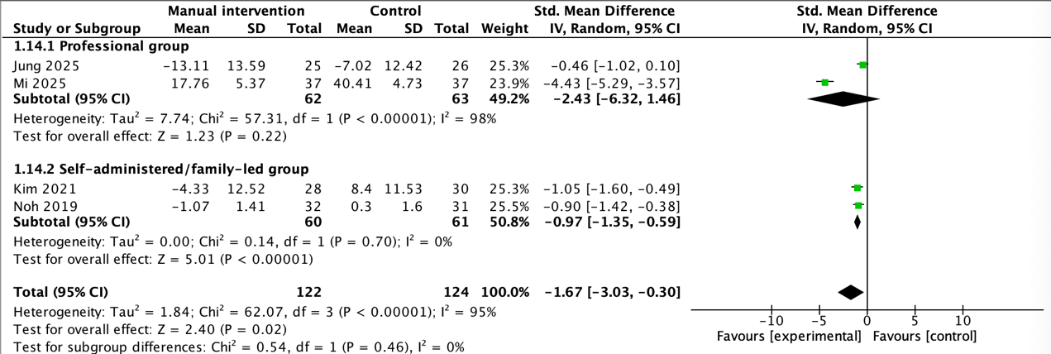
  - Subgroup analysis of pain
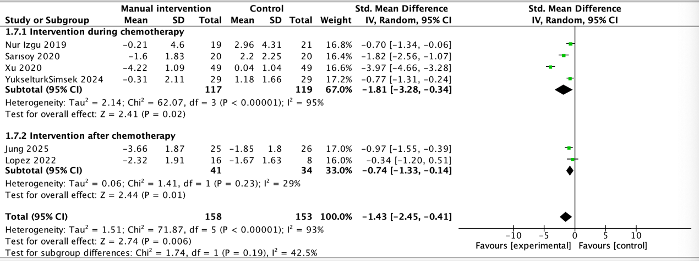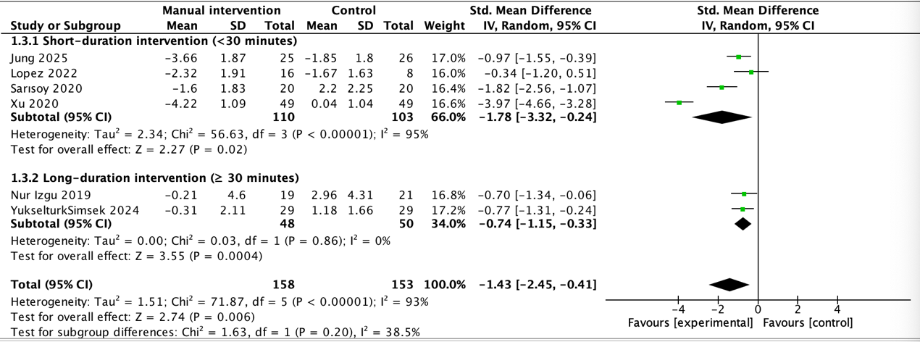

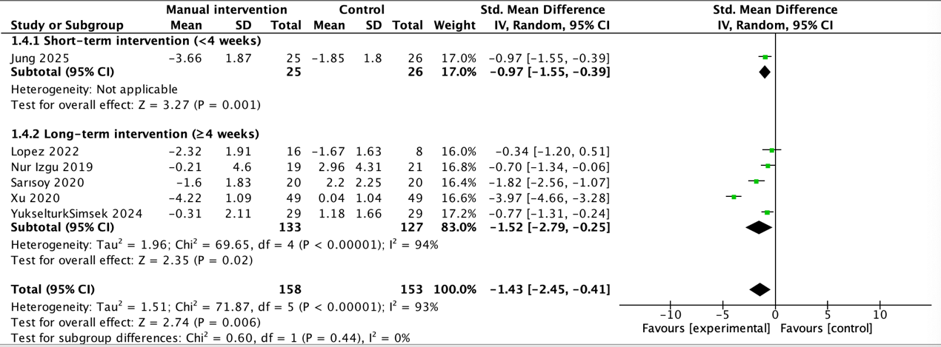
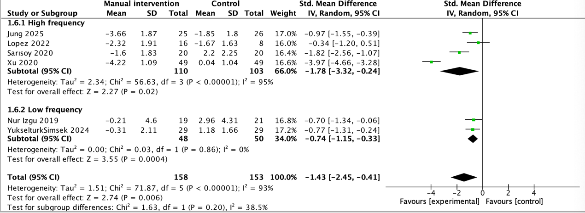
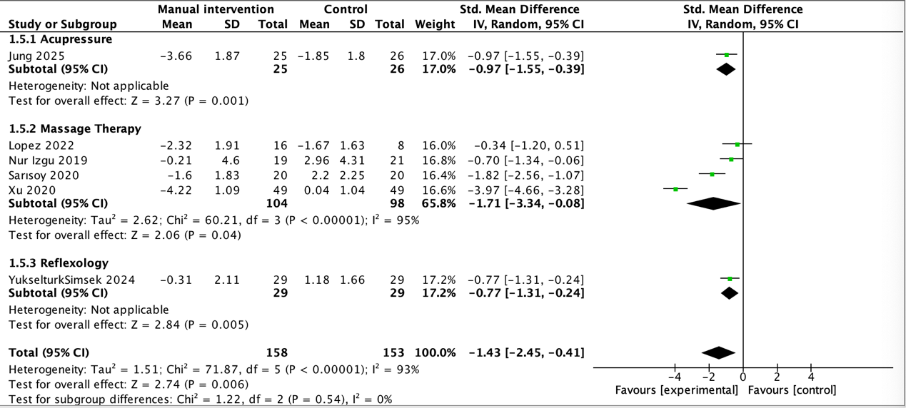
  - Subgroup analysis of quality of life
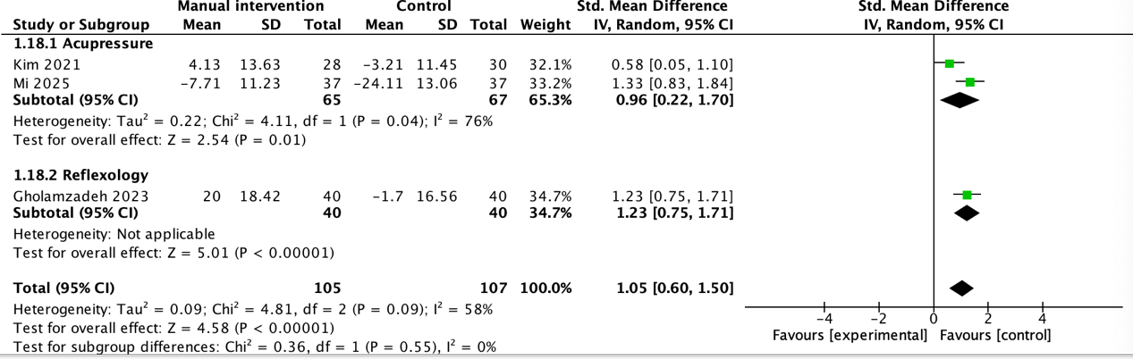
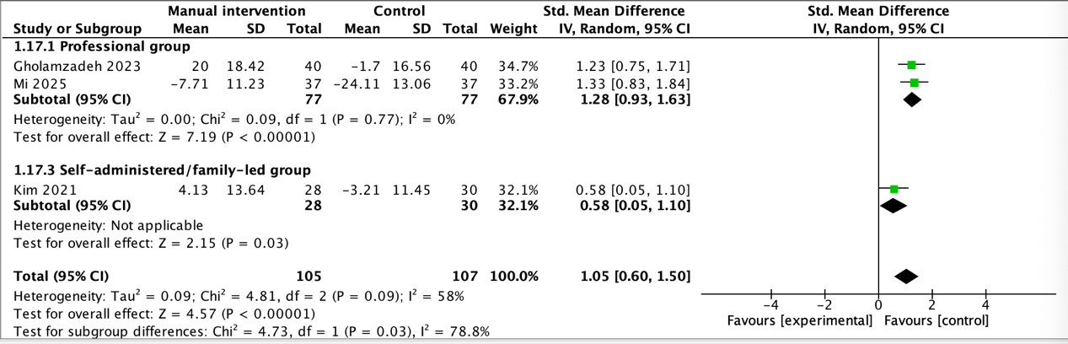
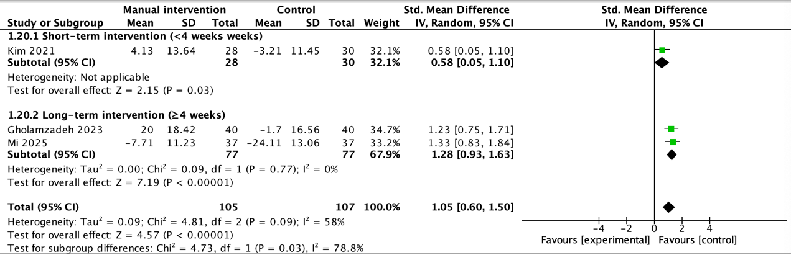

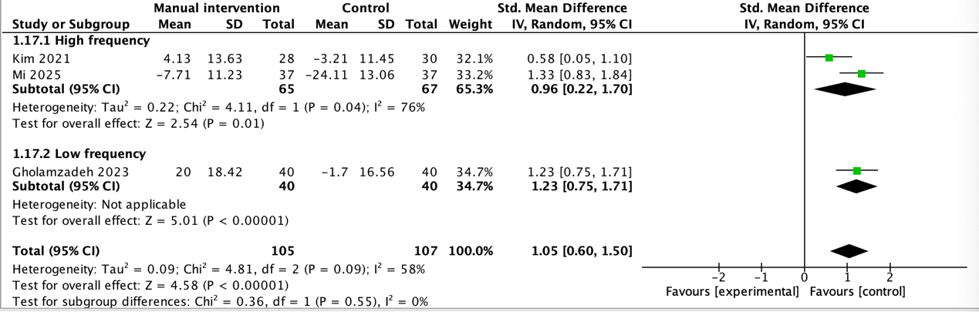
Supplementary 5. Funnel plot of comparison: overall effect of manual therapy on pain score changes in CIPN patients.

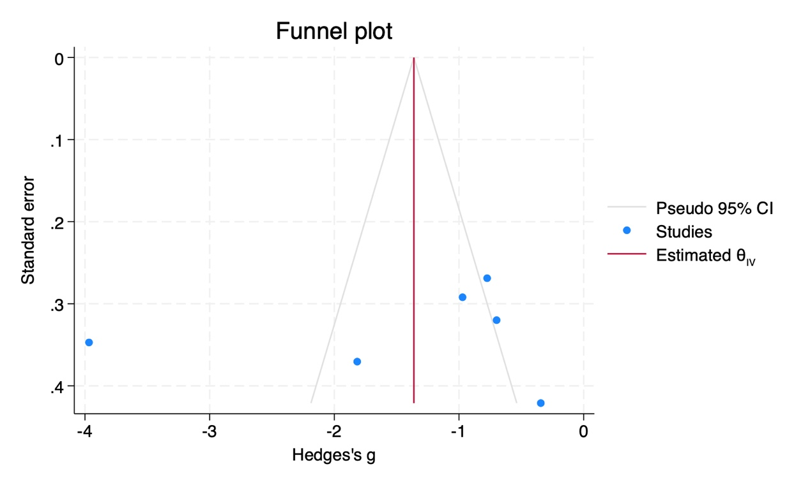
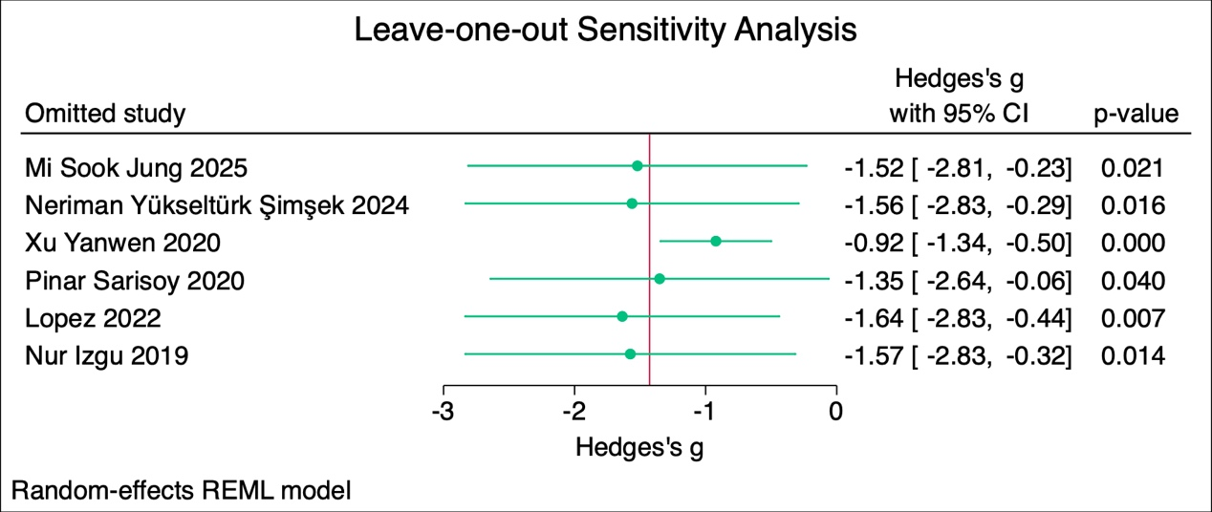

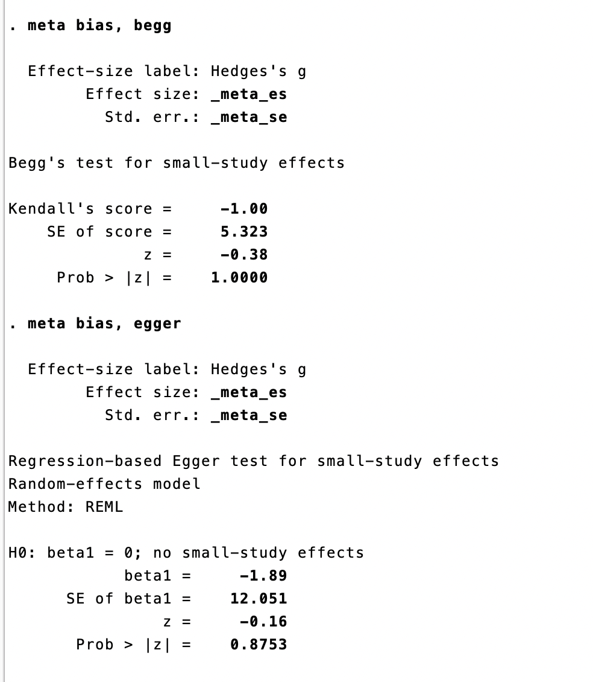
Supplementary 6. Forest plots for sensitivity analyses excluding high-risk-of-bias studies
Sensitivity analysis for overall CIPN symptoms
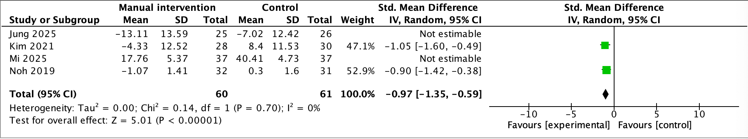

Sensitivity analysis for pain
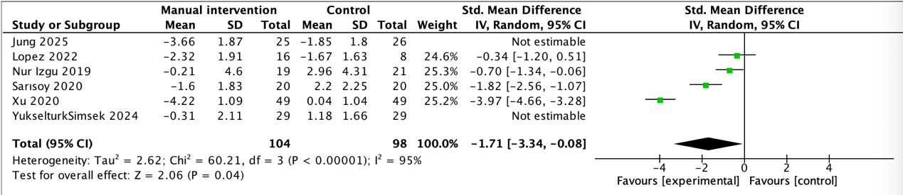
Sensitivity analysis for quality of life
