Supplementary material
Fig. S1: Individual course of perceived dysgeusia (mean score of two items for taste problems) over eight week treatment period (per cancer type and treatment group unadjusted data)
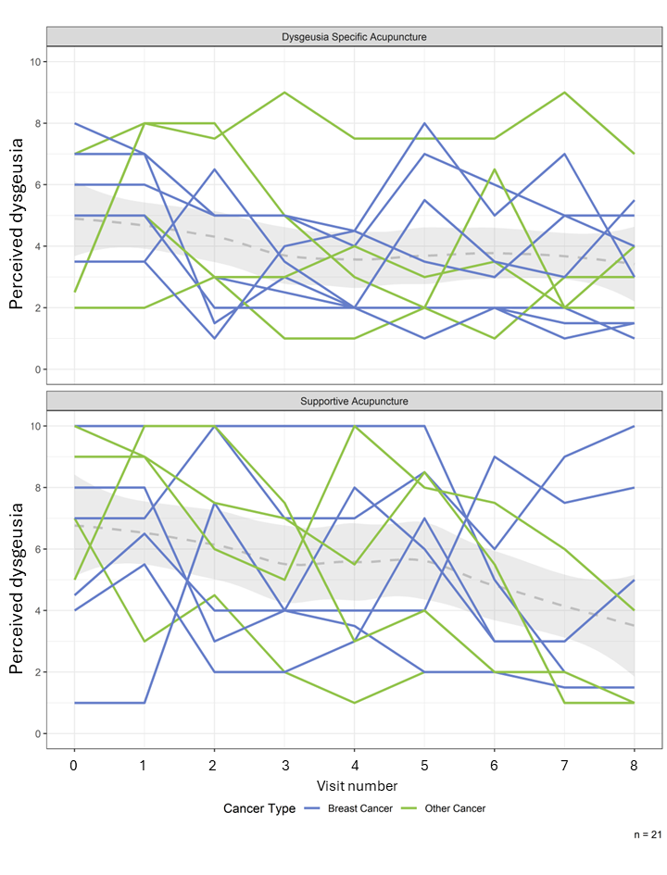
Note: Shaded area represents the 95% confidence band for each time point.

Fig. S2: Individual course of QoL (FACT-G) over 24 weeks per cancer type and treatment group, (per cancer type and treatment group, unadjusted data)
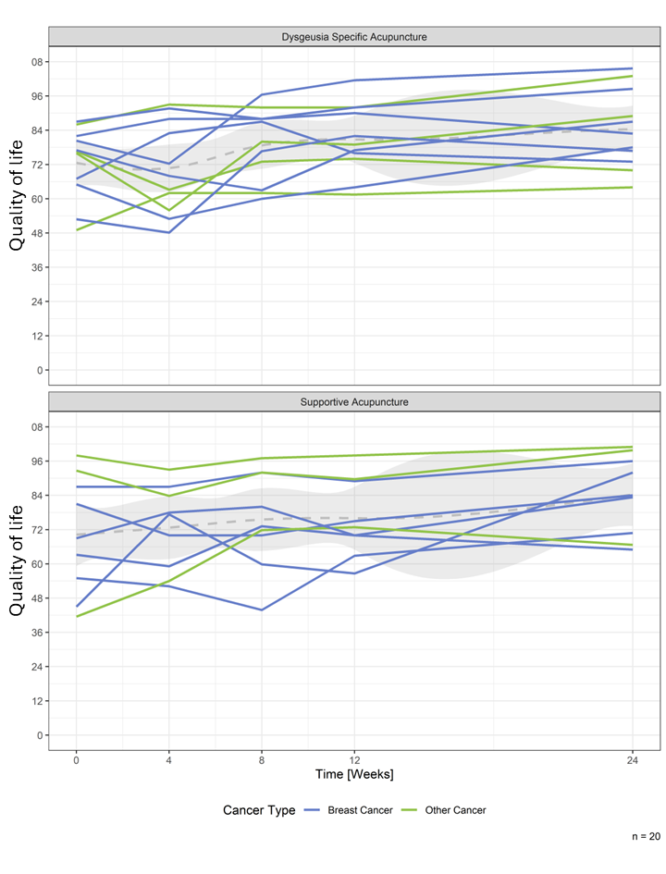
Note: Shaded area represents the 95% confidence band for each time point.
Fig. S3: Individual course of fatigue over 24 weeks (FACIT-F) (per cancer type and treatment group, unadjusted data)
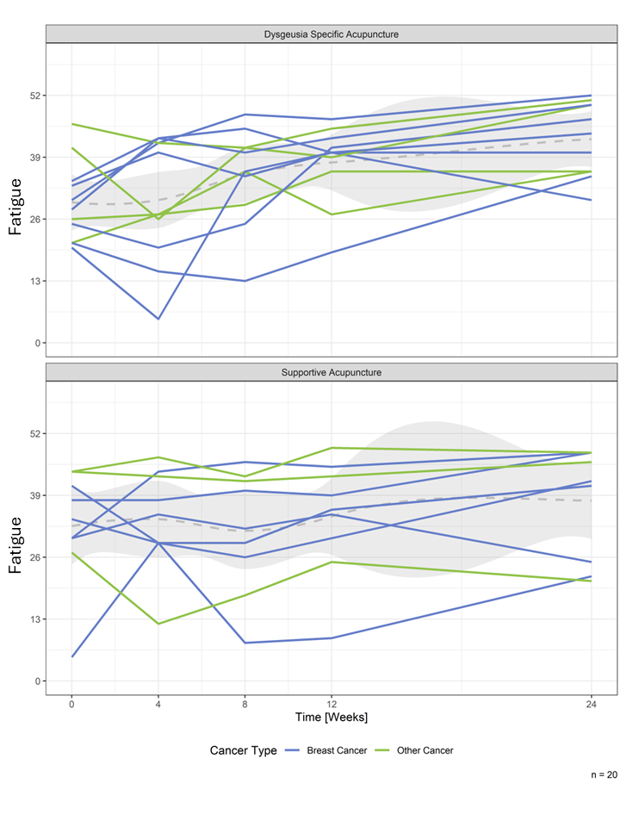
Note: Shaded area represents the 95% confidence band for each time point.
Fig. S4: Individual course of objective taste test before, mid and after acupuncture treatment (per cancer type and treatment group, unadjusted data)
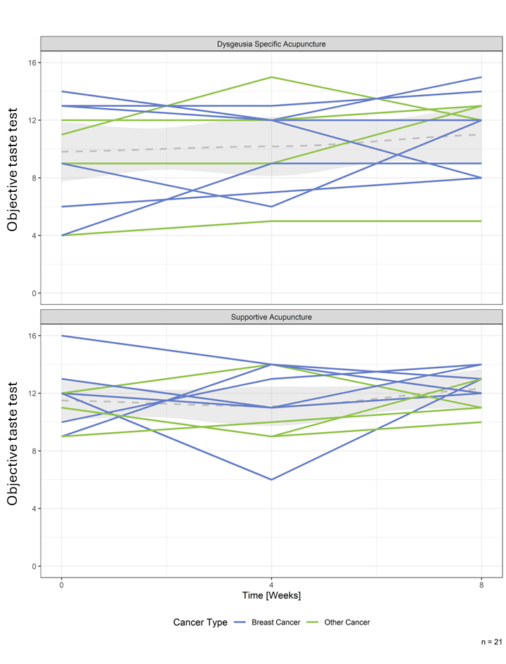
Note: Shaded area represents the 95% confidence band for each time point.
Fig. S5: Individual course of objective smell test before, mid and after acupuncture treatment (per cancer type and treatment group, unadjusted data)
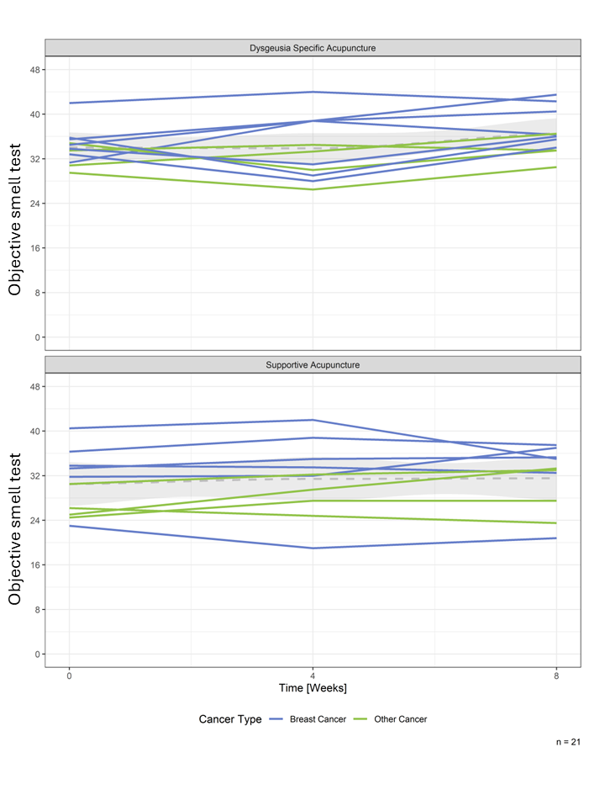
Note: Shaded area represents the 95% confidence band for each time point.
Fig. S6: Individual course of perceived distress over 24 weeks (per cancer type and treatment group, unadjusted data)
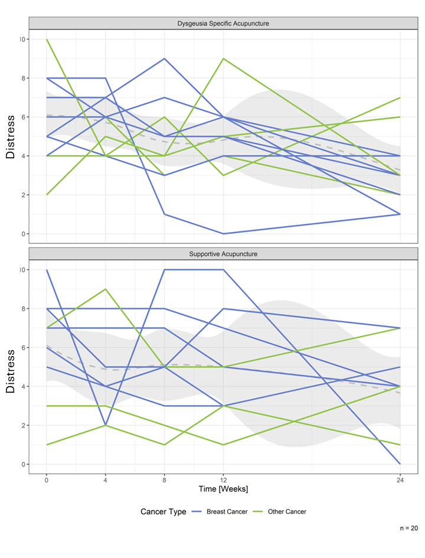
Note: Shaded area represents the 95% confidence band for each time point.
Fig. S7: Course of symptoms (taste problems) based on the patient diary for each individual and for both treatments on a numeric rating scale (1 to 10).

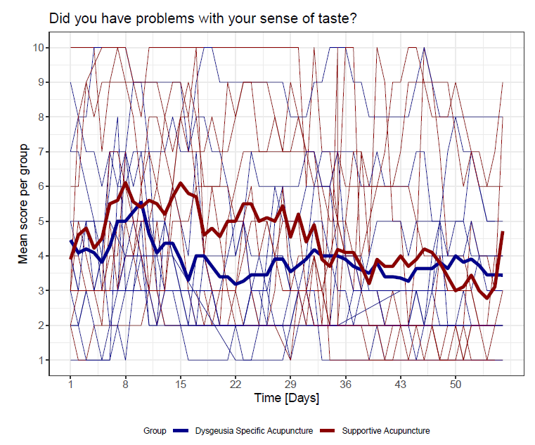

Fig. S8: Course of symptoms (smell/taste problems) based on the patient diary for each individual and for both treatments on a numeric rating scale (1 to 10).

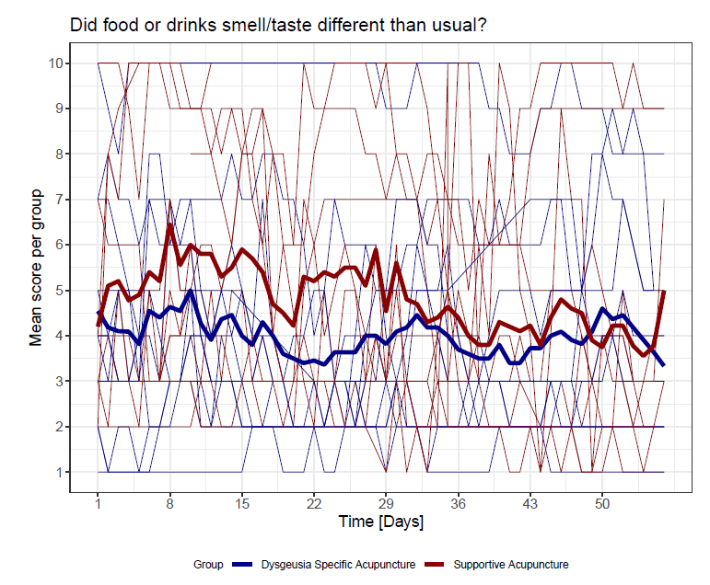
Fig. S9: Course of symptoms (eating discomfort) based on the patient diary for each individual and for both treatments on a numeric rating scale (1 to 10).

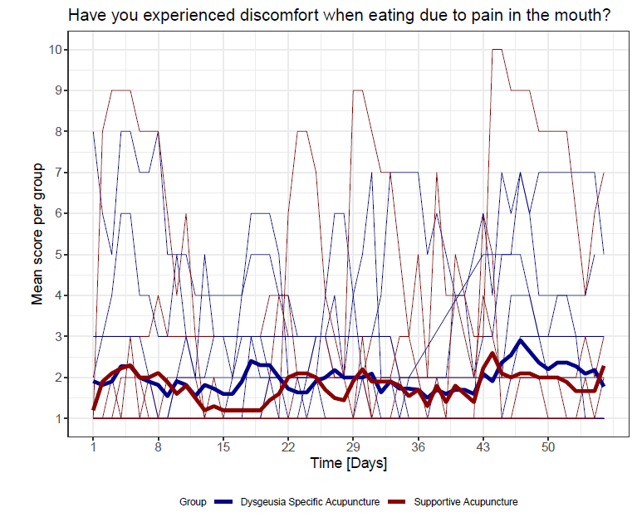

Fig. S10: Course of symptoms (dry mouth) based on the patient diary for each individual and for both treatments on a numeric rating scale (1 to 10).

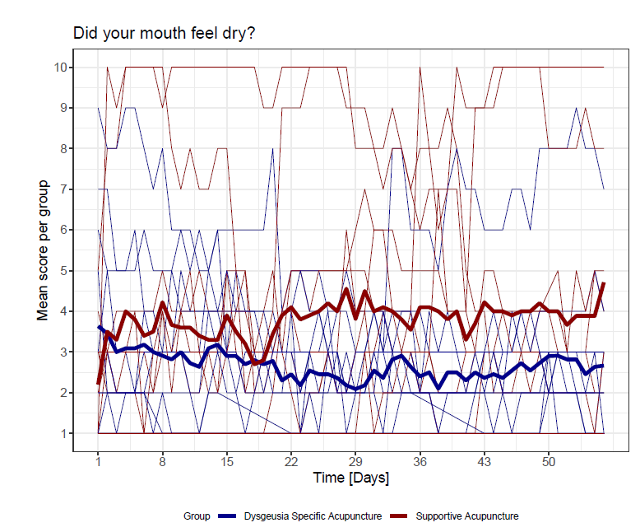

Fig. S11: Course of symptoms (reduced appetite) based on the patient diary for each individual and for both treatments on a numeric rating scale (1 to 10).

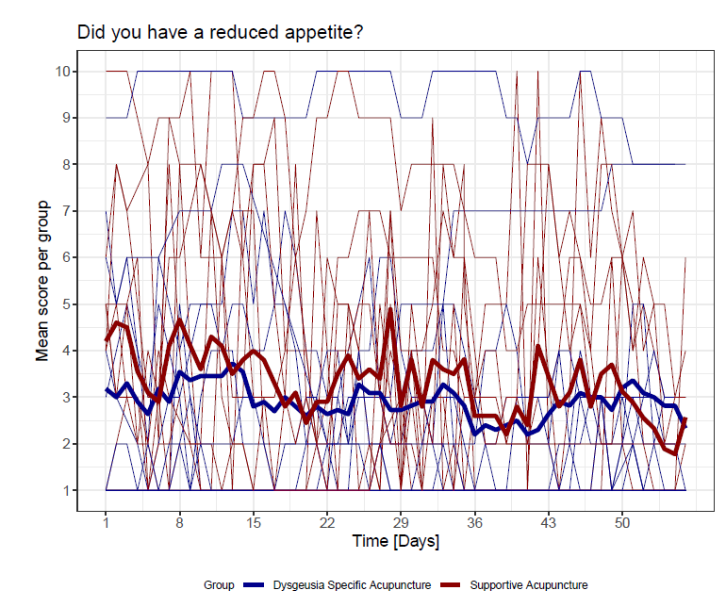

Fig. S12: Course of symptoms (sickness) based on the patient diary for each individual and for both treatments on a numeric rating scale (1 to 10).
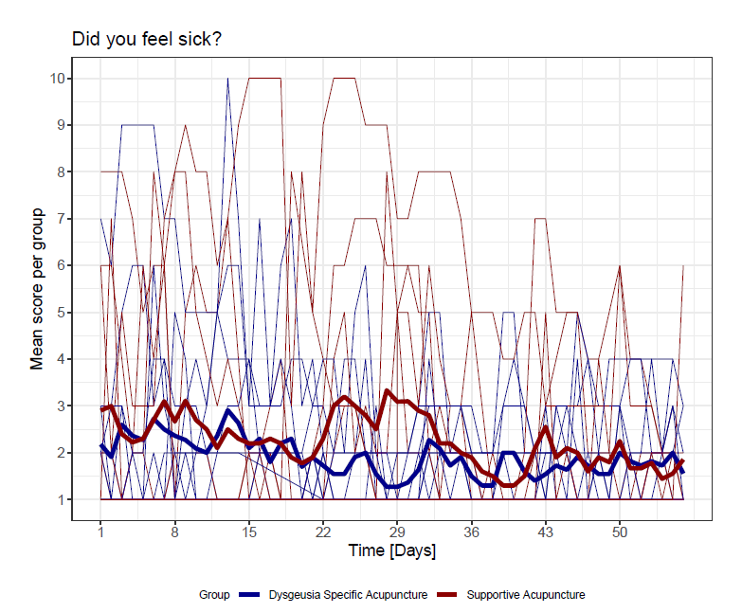

Fig. S13: Course of symptoms (numbess) based on the patient diary for each individual and for both treatments on a numeric rating scale (1 to 10).

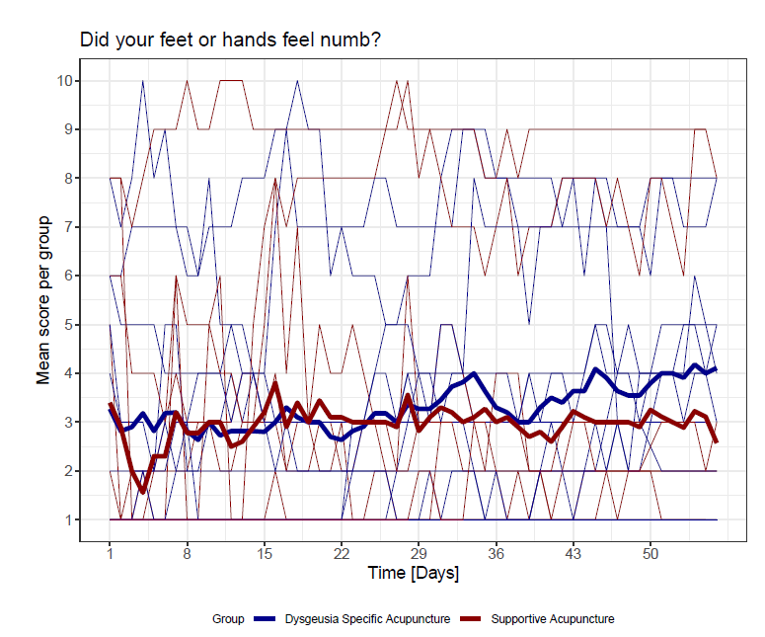

Fig. S14: Course of symptoms (tingling sensation) based on the patient diary for each individual and for both treatments on a numeric rating scale (1 to 10).

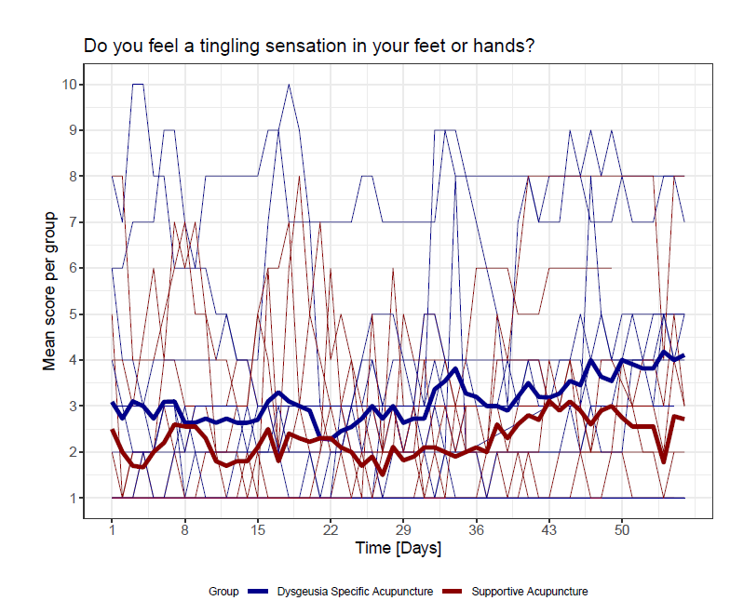

Fig. S15: Course of symptoms (exhaustion) based on the patient diary for each individual and for both treatments on a numeric rating scale (1 to 10).

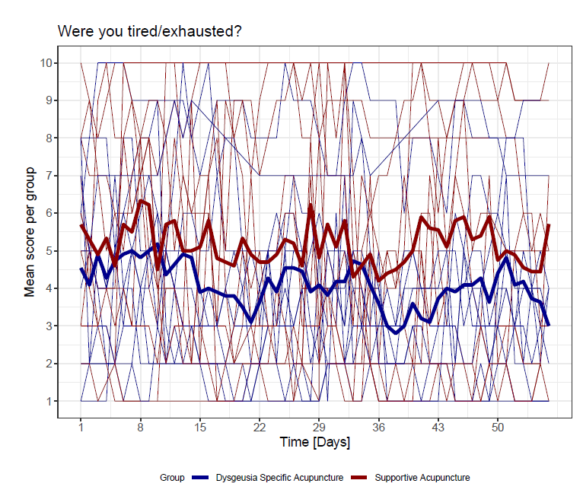

In the following Figures the lines show nine different symptoms from the patient diary which were assessed on a daily basis.
Question 1: Did food or drinks smell/taste different than usual?
Question 2: Did you have problems with your sense of taste?
Question 3: Have you experienced discomfort when eating due to pain in the mouth?
Question 4: Did your mouth feel dry?
Question 5: Did you have a reduced appetite?
Question 6: Did you feel sick?
Question 7: Did your feet or hands feel numb?
Question 8: Do you feel a tingling sensation in your feet or hands?
Question 9: Were you tired/exhausted?

The dots below the Figure show the chemotherapy treatment, the practicing of acupressure and vomiting of included patients per day. Bold dots represent a “Yes” whereas unfilled dots represent a “No” response. Questions were as follows:
Chemo: Have you had chemotherapy today?
Vomit: Have you vomited today?
Acupressure: Have you performed acupressure today?

Fig. S16: Individual course illustrating nine symptoms from the patient diary (Pat.945-7)
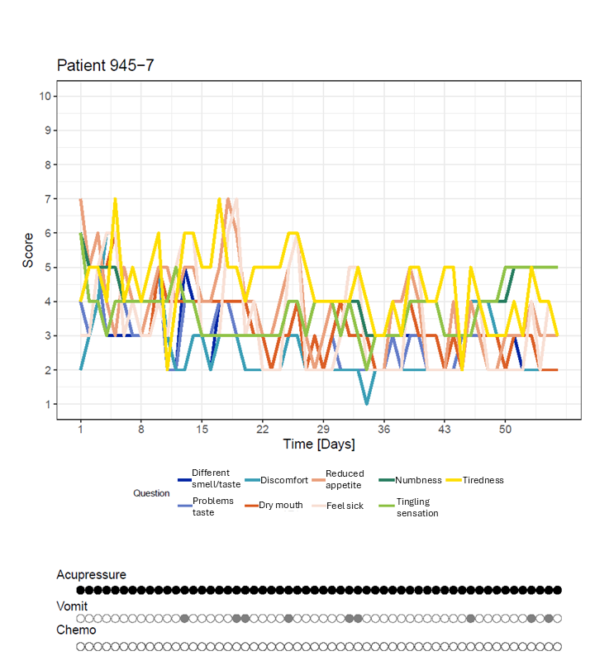

Fig. S17: Individual course illustrating nine symptoms from the patient diary (Pat. 946-1)
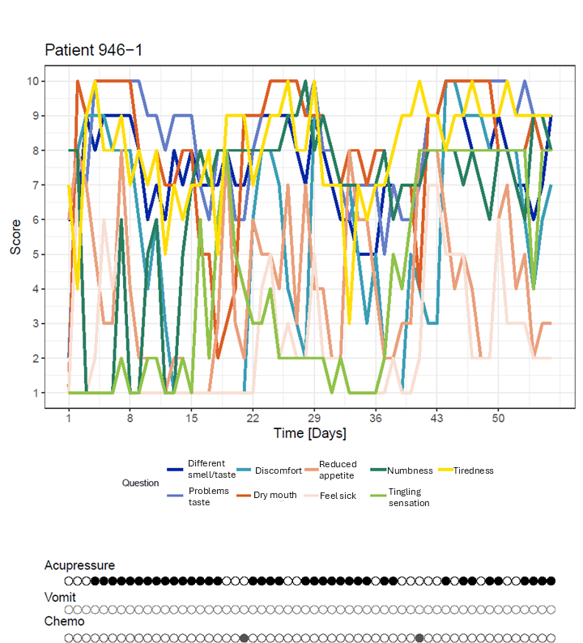

Fig. S18: Individual course in intervention group with early termination of chemotherapy, illustrating nine symptoms from the patient diary (Pat. 945-2)
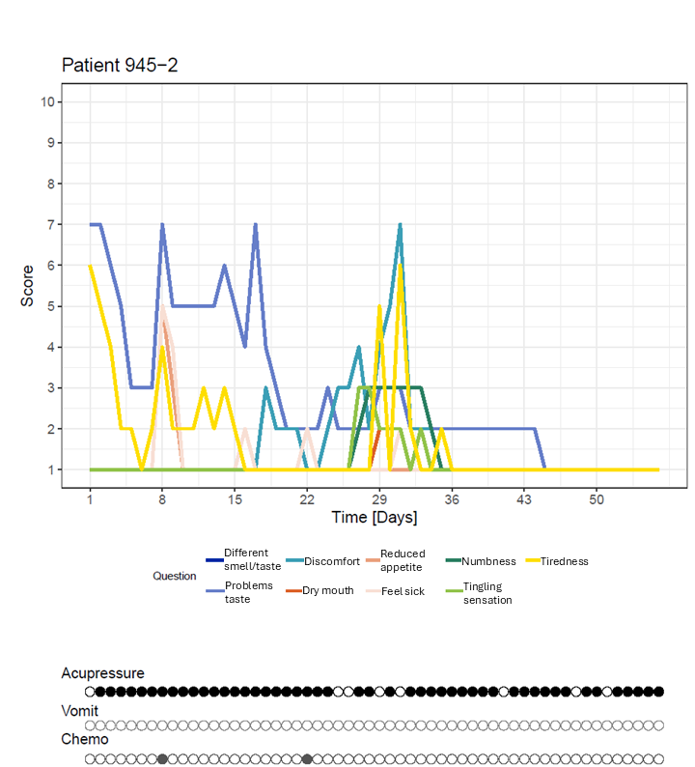

Fig. S19: Individual course in control group with early termination of chemotherapy, illustrating nine symptoms from the patient diary (Pat. 946-2)
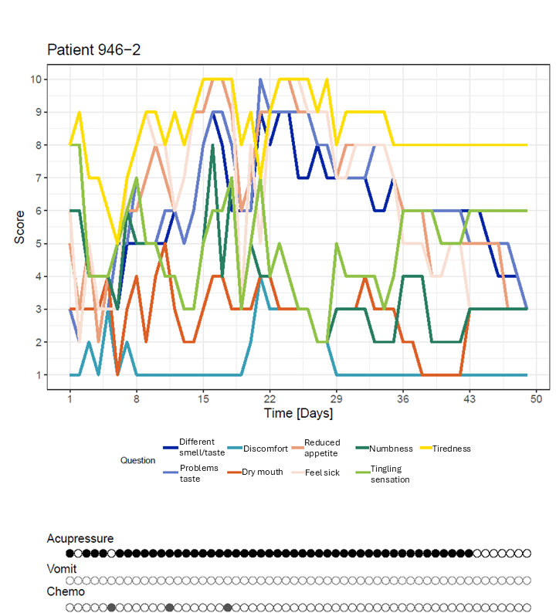

Fig. S20: Association between perceived dysgeusia (x-axis) and objective taste or smell test (y-axis)

