Supplementary Material 1. Interview guide and journey map

General questions for the interview:
- The questionnaire you completed asked about your information needs during your cancer journey. Tell me about your own cancer journey, from early on until now.
- Describe your personal experiences as a series of steps.
- Touchpoints along the cancer journey
  - What were you doing/actions taken during this time?
  - What were you thinking during this time?
  - Who did you speak to during this time?
  - What were you feeling during this time?
- Tell me about your information needs and experiences.
- Tell me about your communication needs and experiences.
- Were there aspects of information/communication that were particularly helpful?
- Were there aspects about the information/communication that you would change if you could?

Journey map:
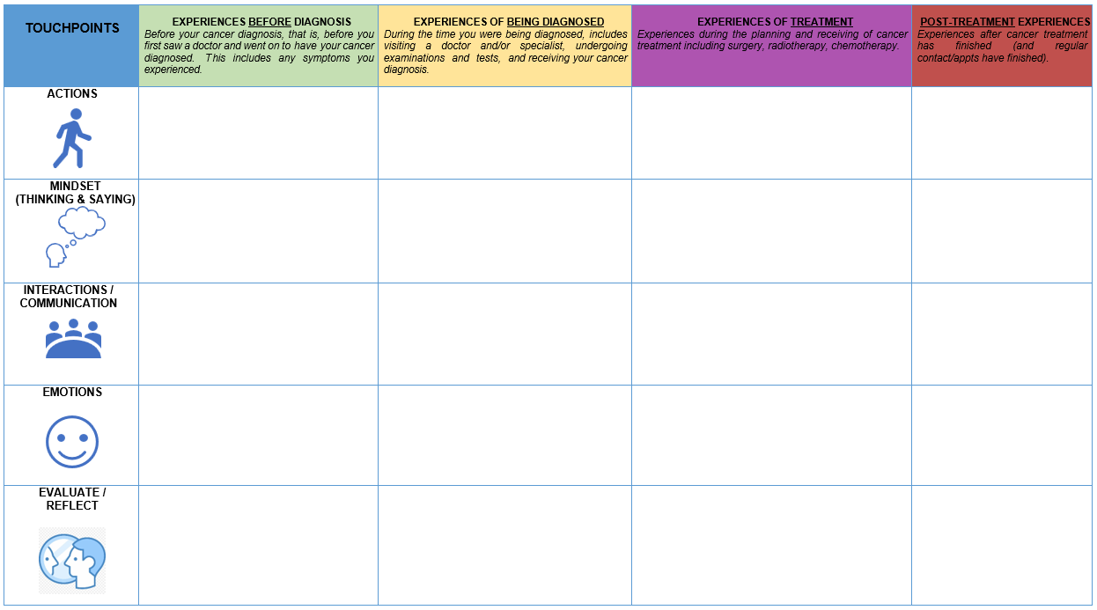

Supplementary Table 1. Additional table comparing total SCIP-B scores (mean, SD) by analytical approaches
Touchpoint | Raw summary of all available data | Raw summary of those with complete data only (n=26) | Mixed model (unstructured) | Mixed model (unstructured) with age
Pre-diagnosis | 20.8 (7.1) | 21.3 (7.0) | 20.9 (18.5, 23.3) | 20.9 (18.5, 23.2)
Diagnosis | 24.0 (8.4) | 23.5 (8.6) | 24.2 (21.5, 26.6) | 24.1 (21.6, 26.6)
Treatment | 24.8 (8.2) | 24.2 (8.3) | 24.6 (21.6, 27.6) | 24.7 (21.6, 27.7)
SCIP-B: Satisfaction with Cancer Information Profile.¹²

Supplementary Table 2. Comparison of characteristics between study participants and non-participants
Characteristicsª | Participants |  | Non-participants
Characteristicsª | n | (%) | n | (%)
Number of women | 39 |  | 73
Primary site
Vaginal | 6 | (15) | 15 | (21)
Vulvar | 33 | (85) | 58 | (79)
Age group at diagnosis
<50 years | 5 | (13) | 11 | (15)
50-69 years | 19 | (49) | 35 | (48)
>70 years | 15 | (38) | 27 | (37)
Remoteness^{b} of residence at diagnosis
Major city | 25 | (64) | 50 | (69)
Inner regional | 9 | (23) | 12 | (16)
Outer regional/remote/very remote | 5 | (13) | 11 | (15)
Socio-economic status^{c}
Disadvantaged | np | (<20) | 15 | (21)
Middle | 28 | (72) | 48 | (66)
Affluent | np | (<15) | 10 | (14)
ª Source: Queensland Cancer Register.
^{b} Remoteness: The relative remoteness of residence at time of diagnosis is derived from the Australian Standard Geographical Classification (ASGC).¹⁹
^{c} Socio-economic status: Based on the Socio-Economic Indexes for Areas (SEIFA).²⁰
np. not publishable (cell count supressed due to small numbers).

