Supplementary Materials

Supplementary Materials 1: Patient question form used for FR assessment
- Have you fallen in the past 12 months? (yes/no)
- Do you feel unsteady when standing or walking? (yes/no)
- Are you afraid of falling? (yes/no)
If “no” to all 3 questions: the patient is at low fall risk
If “no” to question 1, but “yes” to either question 2 or 3: perform a gait speed test
If “yes” to question 1: assess for the presence of severity criteria
Severity criteria:
- Was the fall traumatic (wound, fracture, sprain)?
- Have you fallen two or more times?
- Do you show signs of frailty, such as needing help with shopping, heavy housework, transport, medication management, or finances (iso-resource group (GIR)5 level)?
- Did you remain on the ground for more than 1 hour or were you unable to get up on your own?
- Did you lose consciousness before the fall.
If “yes” to any of the 5 severity criteria: the patient is at high fall risk
If “no” to all 5 severity criteria: perform a gait speed test

Supplementary Materials 2: Question form used for identify FR factors
- "Has a healthcare professional previously assessed your fall risk?" (yes/no)
- "Did they make any recommendations?" (yes/no)
- "Was this assessment conducted within the past twelve months?" (yes/no)

Supplementary Materials 3: Description of recommended interventions for FR
Low FR | - Primary prevention by encouraging adapted physical activity  - General educational prevention advice  - Repeat screening every year
Intermediate FR | - Enhanced secondary prevention with a physiotherapy prescription  - General educational prevention advice  - Repeat screening every year
High FR | - Indication for a multidimensional assessment to coordinate secondary prevention interventions  - Physiotherapy prescription provided  - Reevaluation recommended at 3 months  - Phone interview with patients at 3 months (+/- 7 days) to verify the effective implementation of recommendations

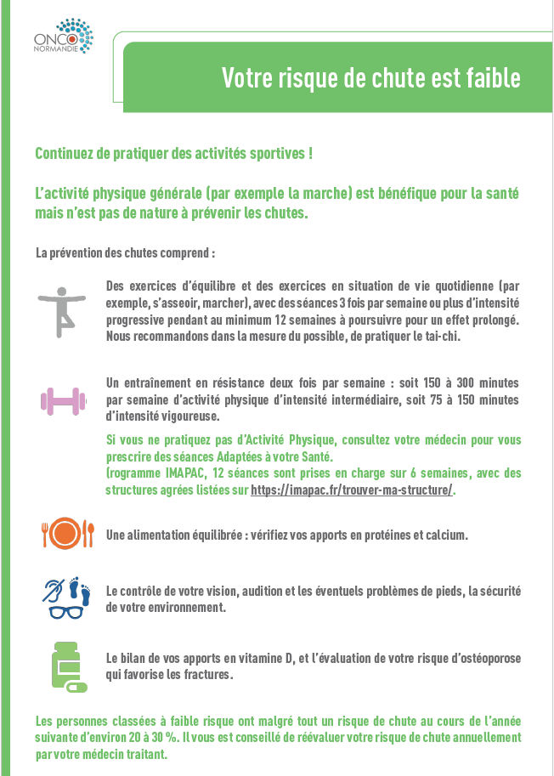
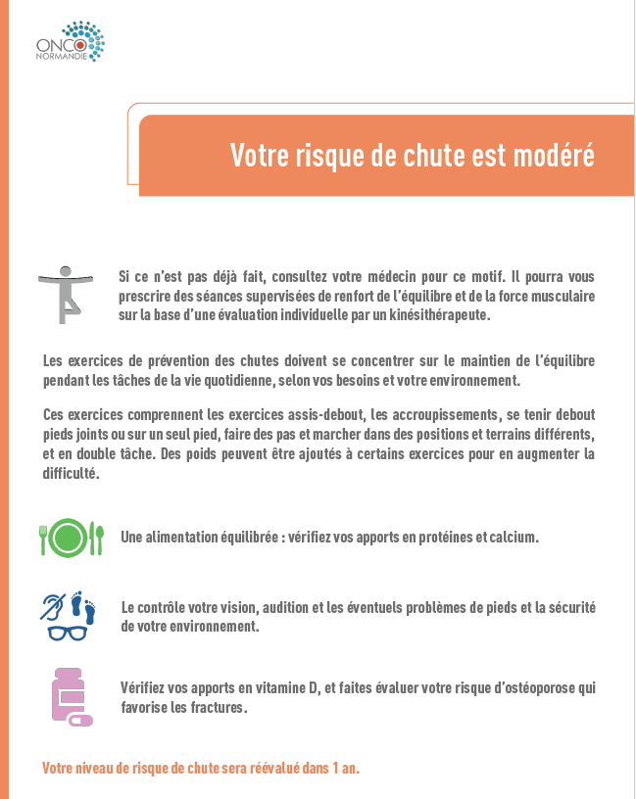
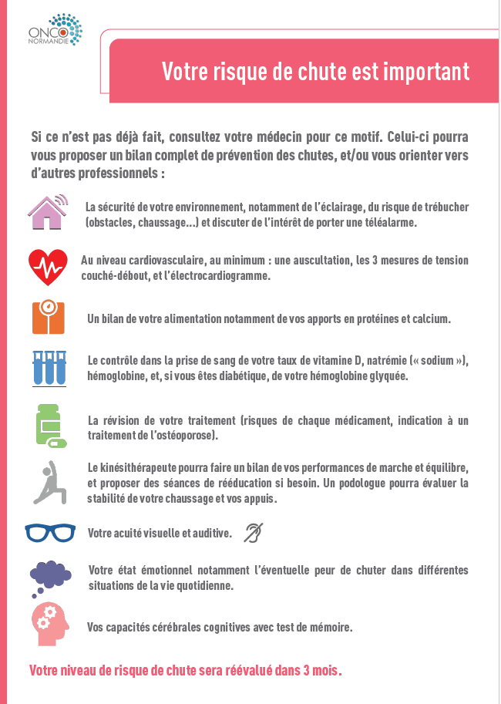
Supplementary Materials 4: Patient recommendation sheets according to the established fall risk level, based on international guidelines and reviewed by the Regional User Committee of the Regional Health Agency, within the framework of Patient Public Involvement

Supplementary Materials 5: Template of the questionnaire used for the 3 months follow-up phone interview of older patients with high FR
- Have you fallen in the past 3 months? (yes/no)
- Have you received a personalized assessment covering:
  - At least a cardiovascular check-up including: auscultation, three blood pressure measurements lying down and standing, and an electrocardiogram? (yes/no/partially/don’t know)
  - A nutritional assessment, especially regarding your protein and calcium intake? (yes/no/don’t know)
  - Biological testing of vitamin D levels, sodium levels, and hemoglobin?
  - If diabetic, glycated hemoglobin (HbA1c)? (yes/no/partially/don’t know)
  - Medication review (risks of each medication, osteoporosis treatment)? (yes/no/don’t know)
  - Home safety assessment, including the potential benefit of wearing a personal emergency alarm? (yes/no/don’t know)
  - Physical performance related to walking and balance, foot stability, and appropriate footwear? (yes/no/partially/don’t know)
  - Visual and hearing acuity? (yes/no/don’t know)
  - Psychological reserves, including possible fear of falling in different situations? (yes/no/don’t know)
  - Cognitive brain capacities (memory test)? (yes/no/don’t know)

When “yes” is answered to any question: this assessment was carried out by: your general practitioner / your oncologist / a paramedical team / other (please specify)

If the answer was “no” to all items:
- Lack of availability of healthcare professionals: (yes/no)
- Patient refusal: (yes/no)
- Patient deceased/lost to follow-up: (yes/no)
- Postponed due to priorities related to the cancer care pathway: (yes/no)

Supplementary Materials 6: STOPPFall translation in ATC classification
Code Level | ATC_code | Contents
4 | A02BA | H2-RECEPTOR ANTAGONISTS
4 | A03AB | SYNTHETIC ANTICHOLINERGICS, QUATERNARY AMMONIUM COMPOUNDS
4 | A03BA | BELLADONNA ALKALOIDS, TERTIARY AMINES
3 | C01D | VASODILATORS USED IN CARDIAC DISEASES
3 | C02A | ANTIADRENERGIC AGENTS, CENTRALLY ACTING
4 | C02CA | ALPHA-ADRENORECEPTOR ANTAGONISTS
3 | C02L | ANTIHYPERTENSIVES AND DIURETICS IN COMBINATION
2 | C03 | DIURETICS
4 | C09BA | ACE INHIBITORS AND DIURETICS
4 | C09DA | ANGIOTENSIN II RECEPTOR BLOCKERS (ARBS) AND DIURETICS
3 | G04CA | ALPHA BLOCKERS USED IN BENIGN PROSTATIC HYPERTROPHY
4 | G04BD | DRUGS FOR URINARY FREQUENCY AND INCONTINENCE
4 | N01AH | OPIOID ANESTHETICS
3 | N02A | OPIOIDS
2 | N03 | ANTIEPILEPTICS
3 | N04A | ANTICHOLINERGIC AGENTS
3 | N05A | ANTIPSYCHOTICS
4 | N05BA | BENZODIAZEPINE DERIVATIVES
4 | N05CD | BENZODIAZEPINE DERIVATIVES
4 | N05CF | BENZODIAZEPINE RELATED DRUGS
3 | N06A | ANTIDEPRESSANTS
2 | R06 | ANTIHISTAMINES FOR SYSTEMIC USE
4 | S01FA | ANTICHOLINERGICS

Supplementary Materials 7 : Literature comparison regarding the translation of the STOPPFall for the CHUPACHOUP study:
 | ATC code | CHUPACHOUP study | Doyle et al. [30]  (Ireland) | Jeevanji et al. [42]  (Switzerland)
Benzodiazepines | N05BA
Benzodiazepines | N05CD
Benzodiazepines | N03AE
Benzodiazepine-related drugs | N05CF
Antipsychotics | N05A
Opioids | N01AH
Opioids | N02A
Opioids | R05DA
Antidepressants | N06A
Antidepressants | N06CA | Unclassified in France
Antiepileptics | N03
Diuretics | C03
Diuretics | C02L
Diuretics | C07B
Diuretics | C07C | Unclassified in France
Diuretics | C07D
Diuretics | C08GA
Diuretics | C09BA
Diuretics | C09BX01, 03, 13 | Unclassified in France
Diuretics | C09DA
Diuretics | C09DX01, 03, 06, 07 | Unclassified in France
Diuretics | C09XA52, 54 | Unclassified in France
Alpha-blockers for benign prostatic hyperplasia | G04CA
Alpha-blockers used as antihypertensives | C02CA
Vasodilators used in cardiac diseases | C01D
Medications for overactive bladder and urge incontinence | G04BD
Medications for overactive bladder and urge incontinence | G04CA53 | Unclassified in France
Centrally-acting antihypertensives | C02A
Antihistamines | N07CA02 | Unclassified in France
Antihistamines | R06A
Anticholinergics | S01FA
Anticholinergics | A03BA
Anticholinergics | N04A
Anticholinergics | A03AB
Anticholinergics | A02BA

Included in translation
Non included in translation
Partially included in translation

