Supplementary Materials

Supplementary Table 1: Illustrates the allocation of distinct image classes across the Train, Validation, and Test sets
Class | Train (80%) | Validation (20%) | Test
Bottle | 5,542 | 978 | 1,116
Canister | 128 | 22 | 30
Can | 479 | 84 | 98
Detergent | 803 | 141 | 144
Cardboard | 553 | 98 | 162
Total | 7,505 | 1,323 | 1,550

Supplementary Table 2: Displays trash images from five super-classes before and after augmentations in the training set
Classes | Before Augmentations | After Augmentations
Bottle | 5,542 | 30,000
Canister | 128 | 1,500
Can | 479 | 1,500
Detergent | 803 | 6,000
Cardboard | 553 | 3,000
Total | 7,505 | 45,000

Supplementary Table 3: The specific training parameters of the highest-performing pre-trained CNN models, namely Densenet201, Resnet18, and the proposed custom CNN model 2S_DenseViT, are shown.
Training Parameters | Densenet201 | MaxViT-T | 2S_DenseViT
Input dimension | 224 × 224 × 3 | 224 × 224 × 3 | 224 × 224 × 3
Batch size | 8 | 8 | 8
q order | 1 | 1 | 1
Number of epochs | 30 | 30 | 30
Learning rate | 0.00001 | 0.00001 | 0.00001
Epoch stopping criteria | 30 | 30 | 20
Optimizer | Adam | Adam | Adam
Final Activation Function | LogSoftMax | LogSoftMax | LogSoftMax
Learning rates drop factor | 0.1 | 0.1 | 0.1

Supplementary Table 4: An analysis of training parameters in YOLOv5l, YOLOv8x, and GELAN-E models.
Training Parameters | YOLOv5l | YOLOv8x | GELAN-E
Input dimension | 640 × 640 × 3 | 640 × 640 × 3 | 640 × 640 × 3
Learning Rate | 0.001 | 0.001 | 0.001
Epoch | 100 | 100 | 100
Optimizer | SGD | SGD | SGD
Confidence Threshold | 0.2 | 0.2 | 0.2
IoU Threshold | 0.5 | 0.5 | 0.5

Supplementary Figure 1: Sample images from Warp Dataset.

Supplementary Figure 2: The structure and design of GELAN.

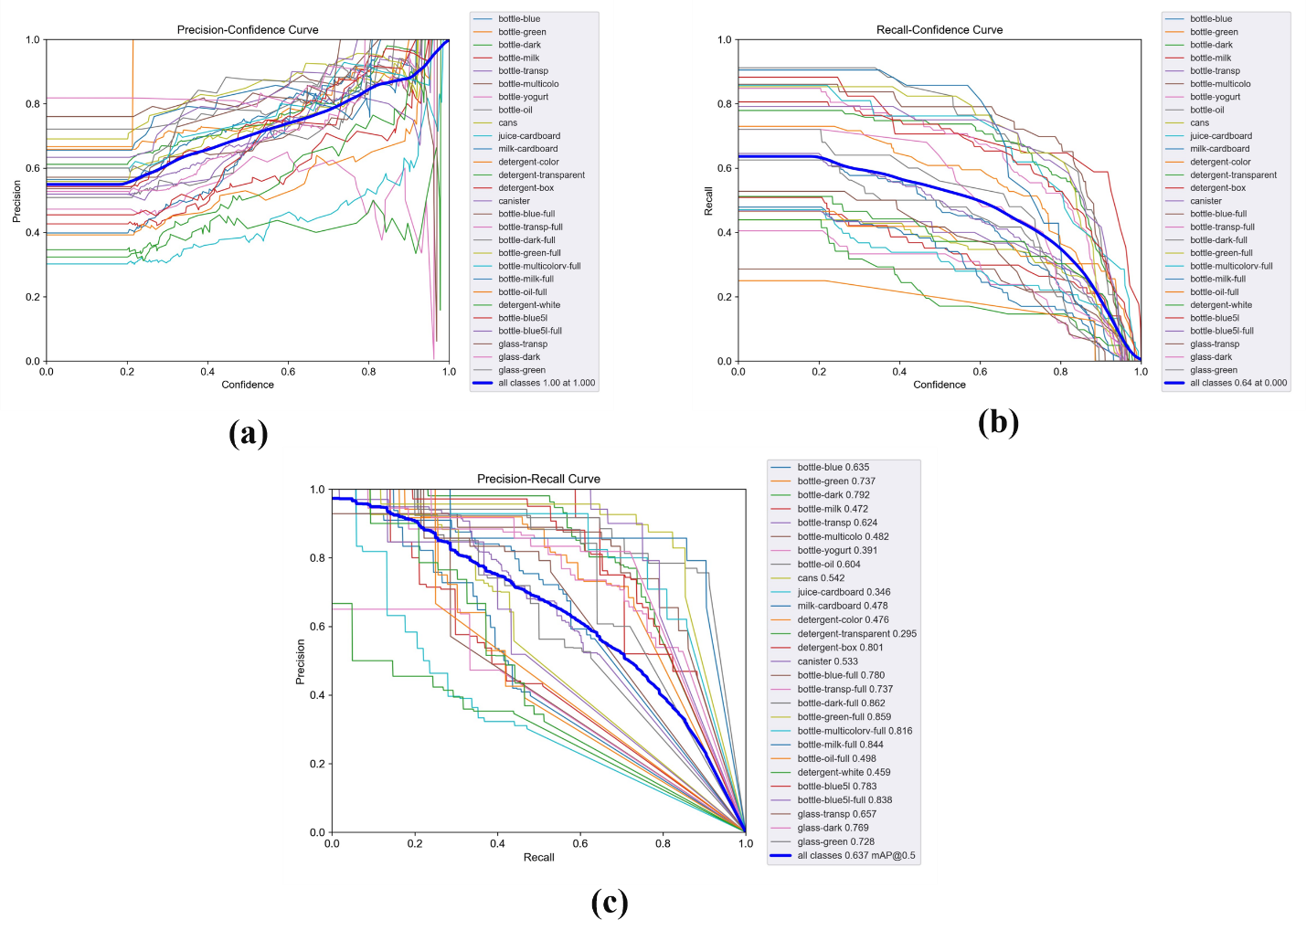
Supplementary Figure 3: Performance evaluation curves for GELAN-E model (a) Precision-Confidence curve, (b) Recall-Confidence curve, and (c) Precision-Recall curve.

