Supplementary Material
Supplementary Material for:
S2LU: An Activation Function Based on Skew Student's t-distribution for Improved Neural Network Performance

Section S1. Parameter Sensitivity Analysis
This section provides the detailed methodology and supporting figures for the parameter sensitivity analysis of the SSLU activation function, as discussed in Section [4] of the main paper.

S1.1. Experimental Setup for Parameter Sweep
The experimental study utilized the CIFAR-10 and CIFAR-100 datasets. For training samples, we applied RandomCrop ($32×32$, padding=4) and RandomHorizontalFlip augmentations, followed by per-channel normalization. During training, a batch size of $128$ was used for CIFAR-10 and $64$ for CIFAR-100. Each training was repeated for 30 epochs using 3 different random seeds ($\text{seed}=\{42,123,456\})$ to ensure robustness.
Adam optimization was employed with an initial learning rate of $1×{10}^{-3}$. A MultiStepLR scheduler was used to decay the learning rate by a factor of $γ=0.1$ at the ${18}^{th}$ and ${26}^{th}$ epochs. For the activation screening, we tested a grid of parameters where $α∈\{0.0,0.001,0.0025,0.005,0.01,1.0\}$ and $β∈\{1.0,3.0,5.0,7.0\}$. The validation performance for each $\left(α,β\right)$ pair was recorded at the end of every epoch. The model weights with the best validation result were then evaluated on the test set. Finally, the mean and standard deviation across the three repetitions were calculated for each parameter combination to analyze the stability, generalizability, and plateau behavior of SSLU.

S1.2. Analysis Results and Figures
The figures below visualize the results of the parameter sweep described in S1.1.
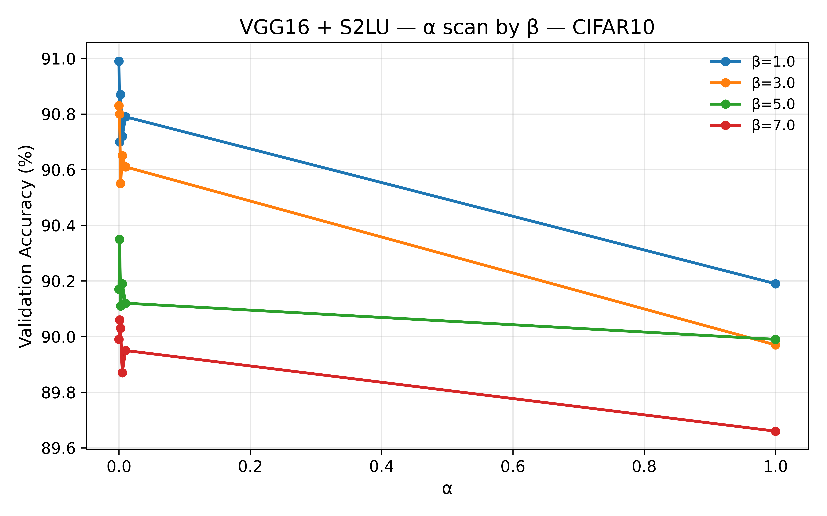  (a) | 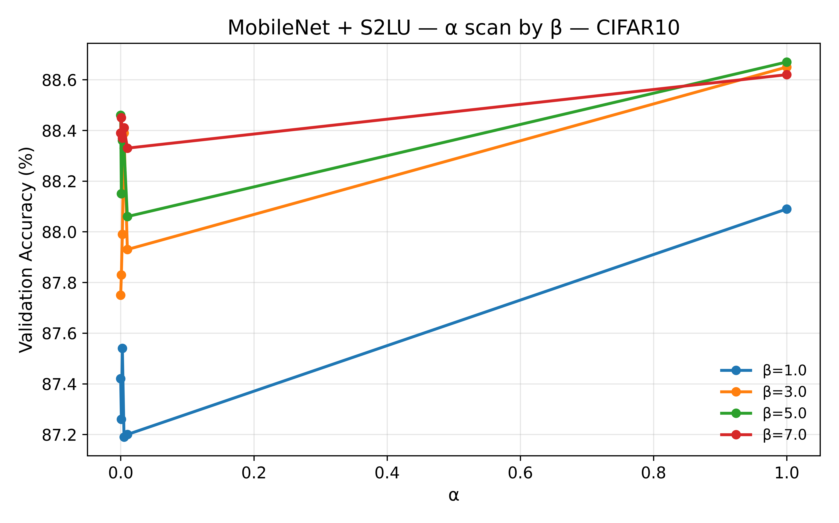  (b)
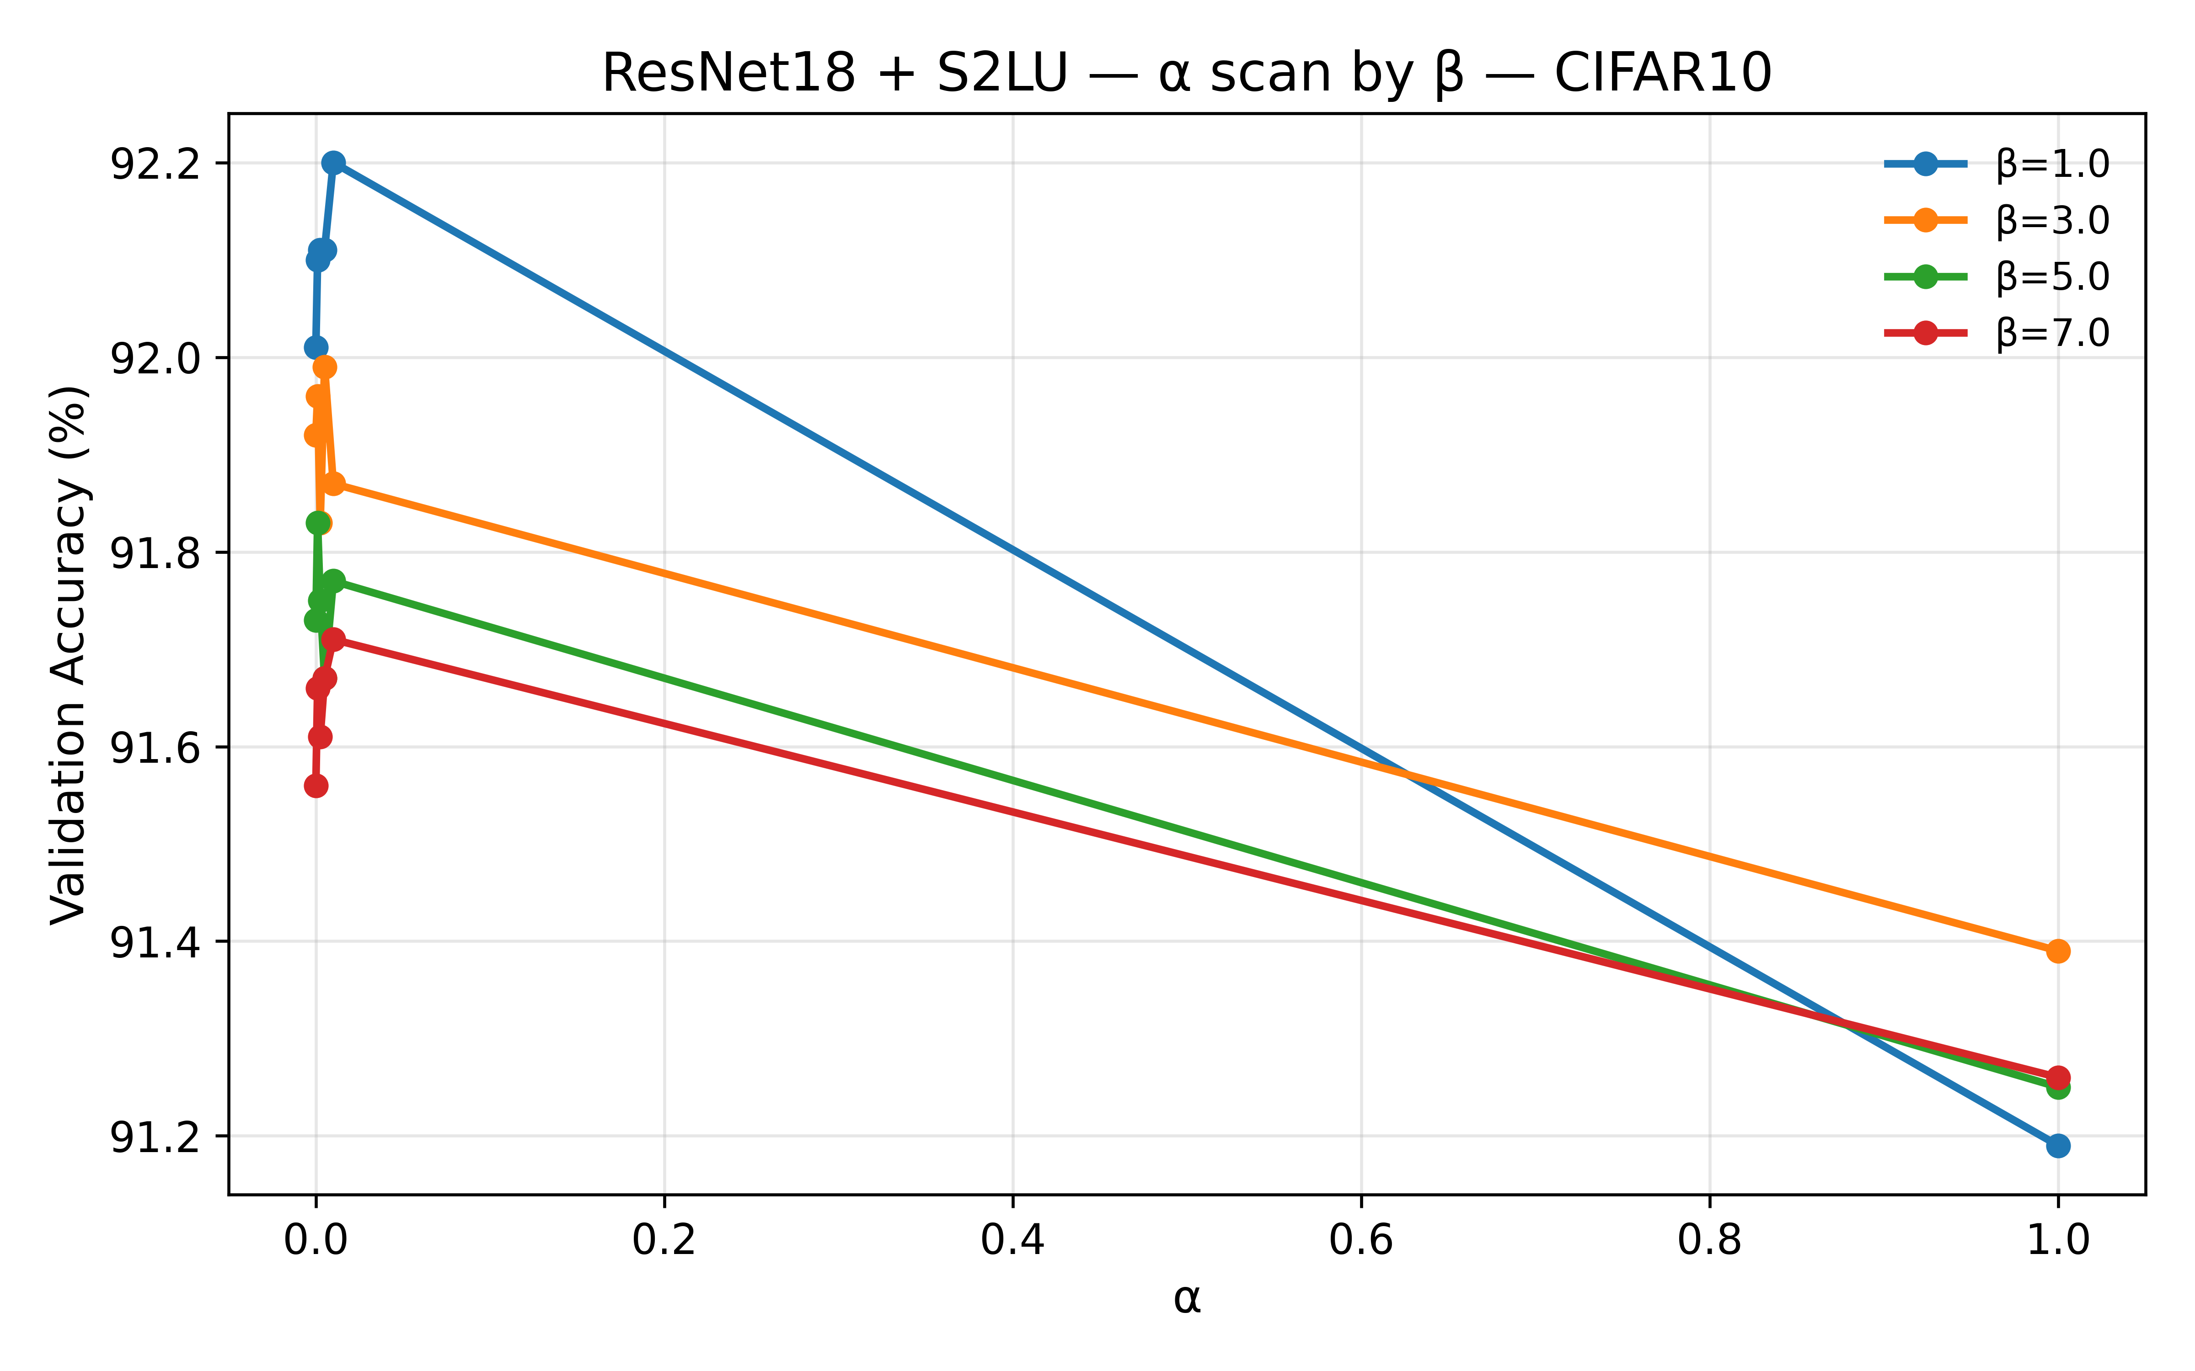  (c) | 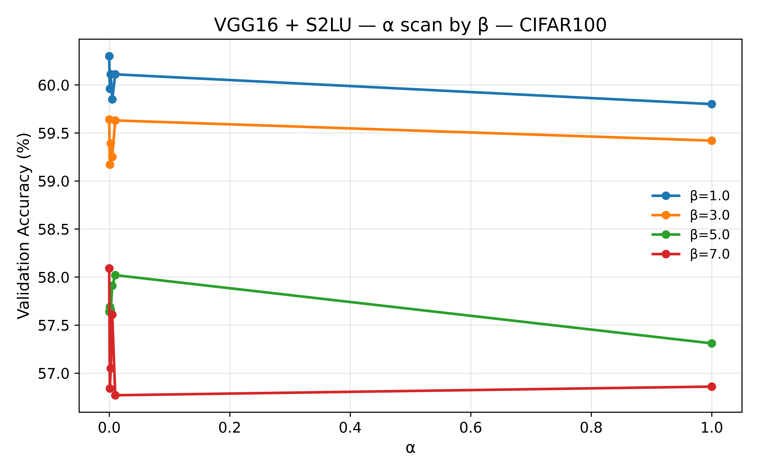  (d)
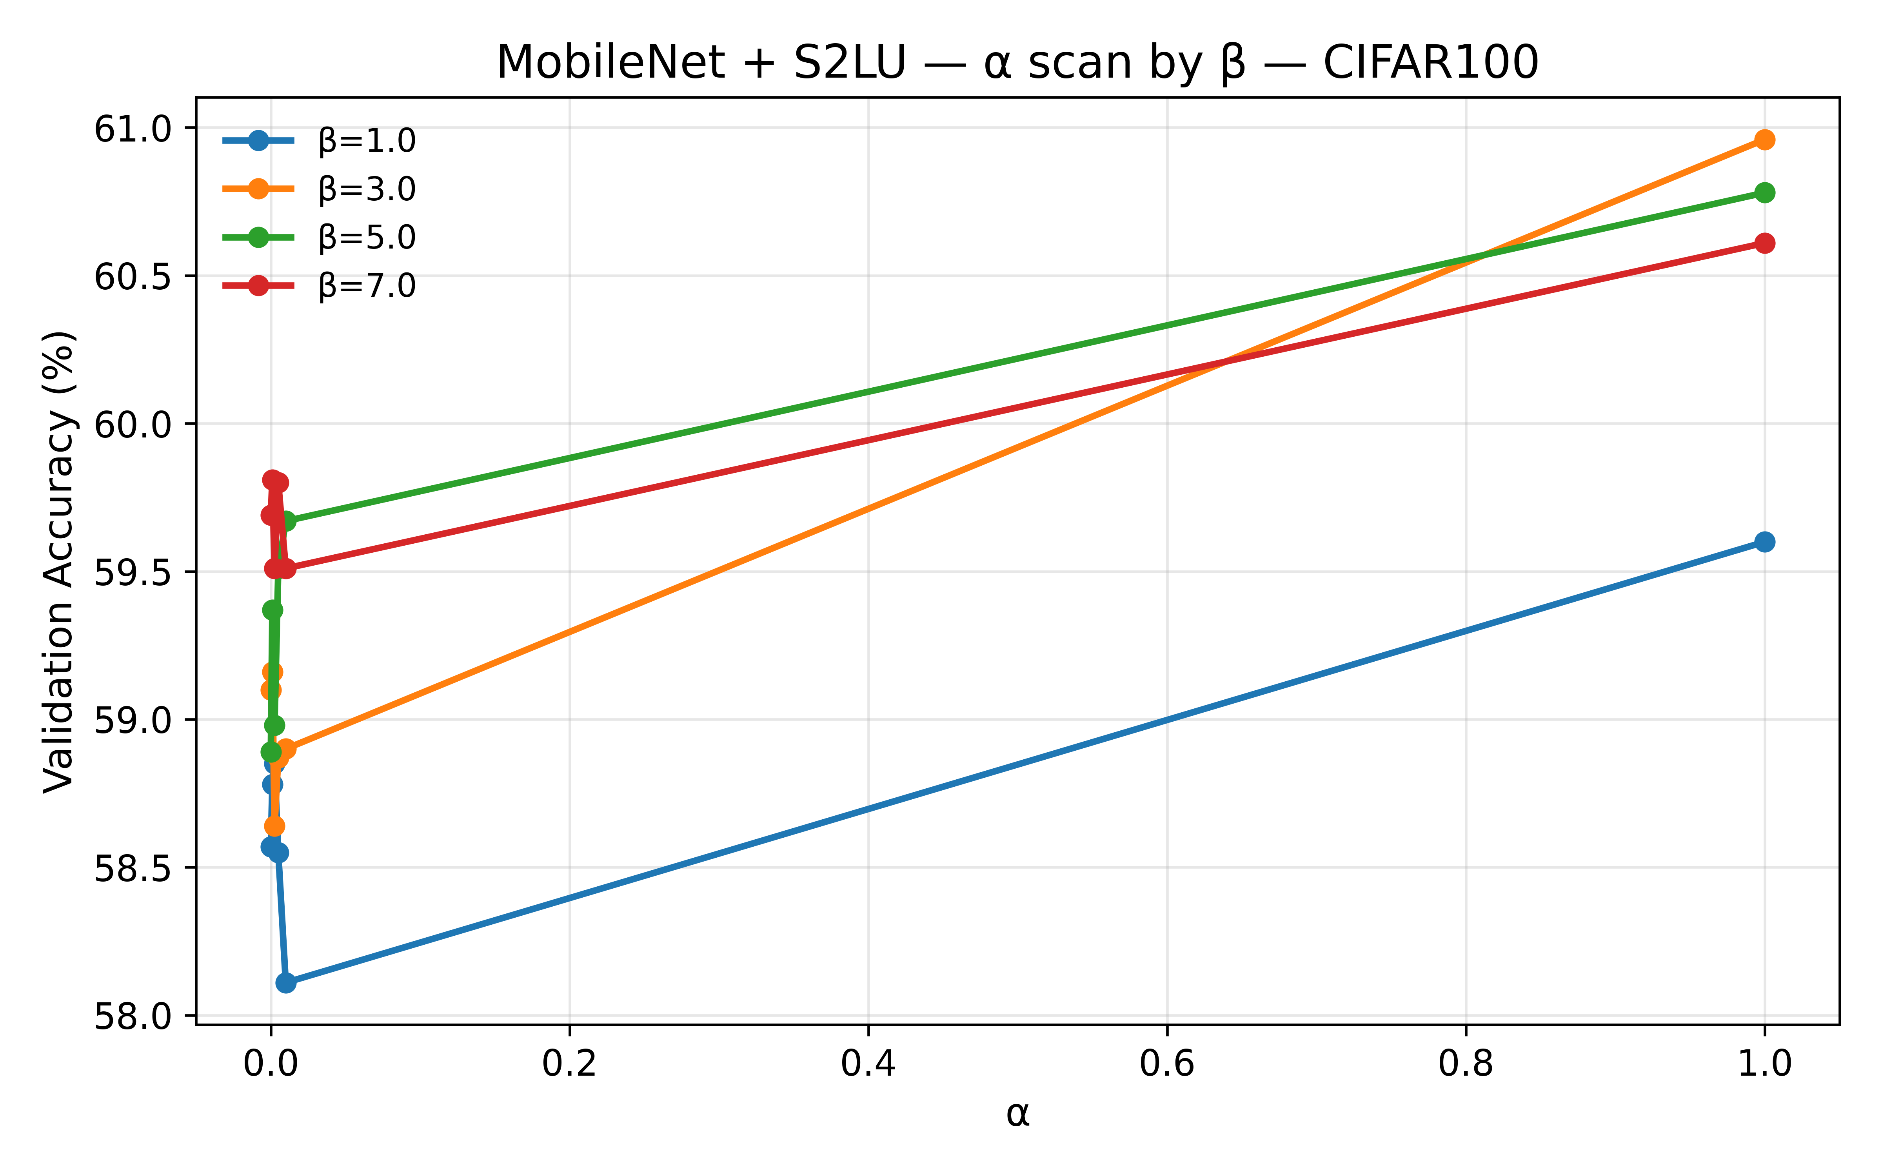  (e) | 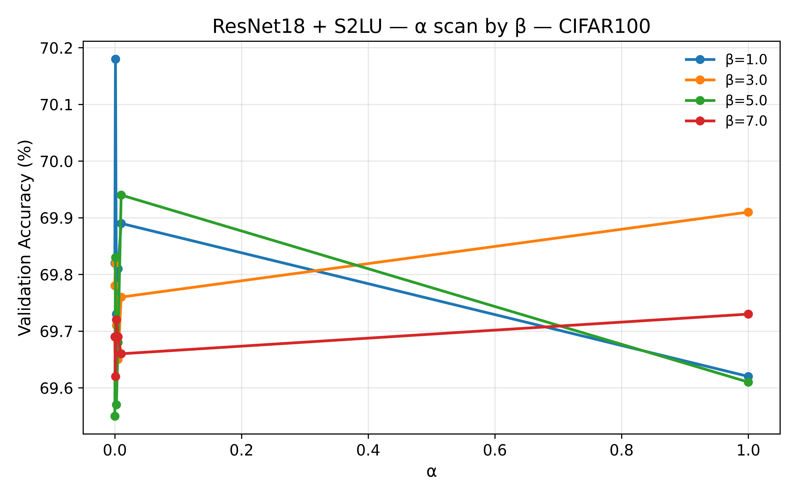  (f)
Figure S1. Validation accuracy of SSLU as a function of parameters $α$ and $β$ across different architectures and datasets.
Each plot shows the peak validation accuracy (%) on the y-axis against the $α$ parameter on the x-axis. Each colored line represents a different $β$ value ($β∈\{1.0,3.0,5.0,7.0\}$), as indicated in the legend. The plots correspond to: (a) VGG16 on CIFAR-10 b) MobileNet on CIFAR-10 (c) ResNet18 on CIFAR-10 (d) VGG16 on CIFAR-100 (e) MobileNet on CIFAR-100 (f) ResNet18 on CIFAR-100

