Supplementary file 2

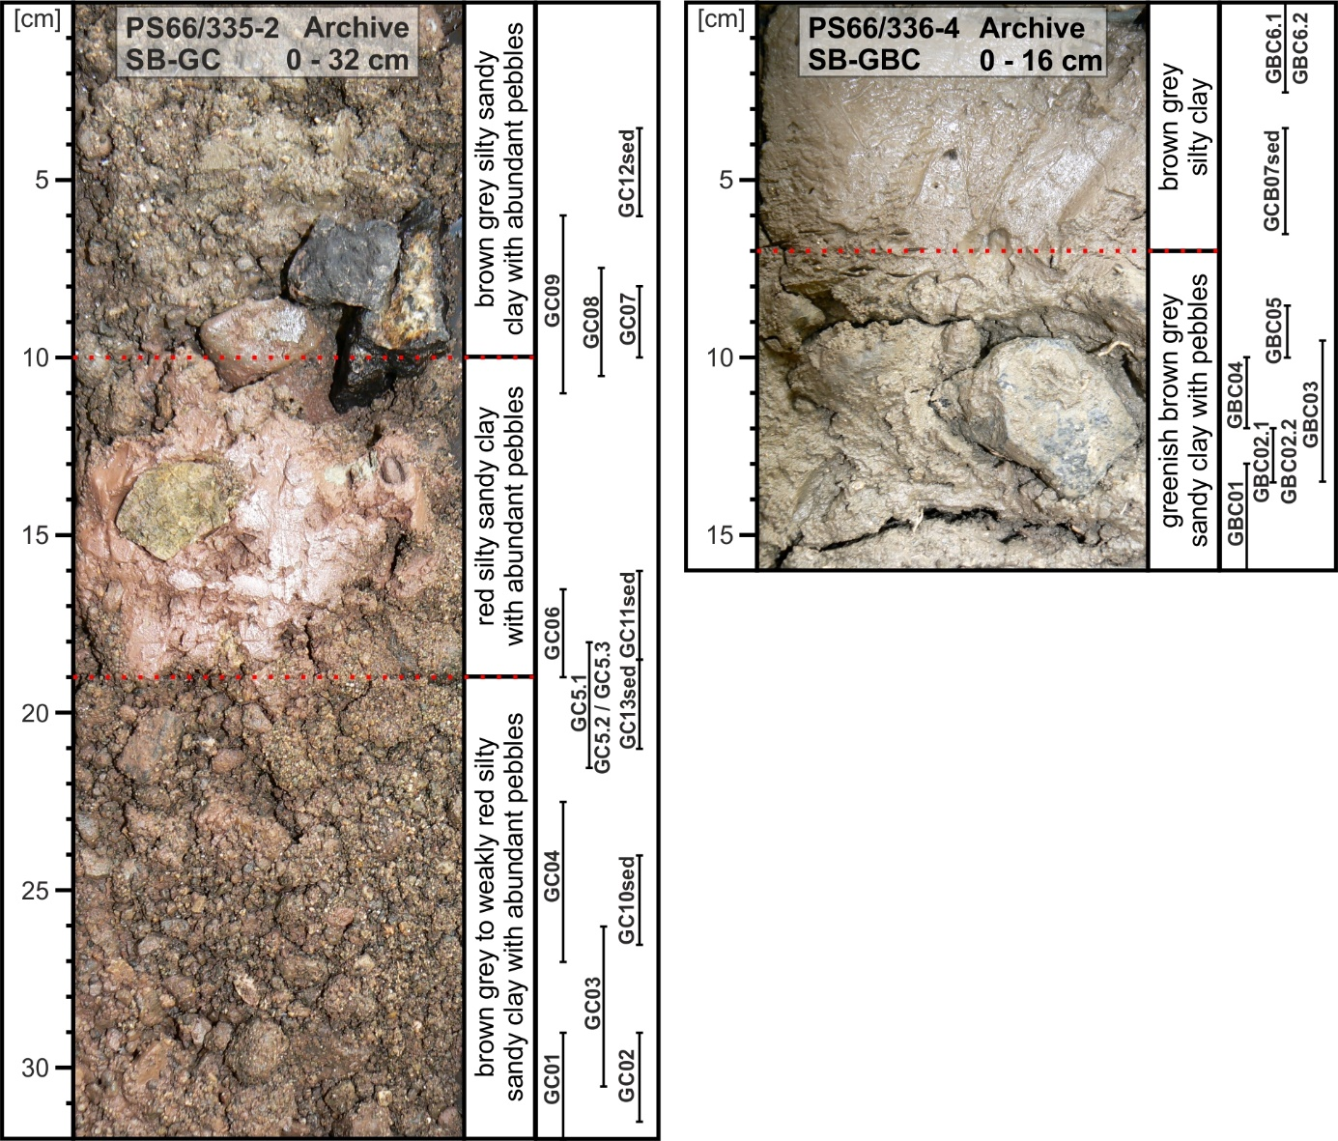
Photographs and description of the archive halves of the cores SB-GC (PS66/335-2) and SB-GBC (PS66/336-4)
The depth of the samples is indicated on the right side. Note that both the archive half and the working half of the cores were sampled and that samples indicated may not be in the archive half.

Petrographic description of the unconsolidated sediments
The unconsolidated sediments of the SB-GC core are distinctively brownish to reddish silty to sandy clay with sand- to gravel-sized lithoclasts. The lithoclasts comprise basalt, dolerite, red sandstone, calcareous sandstone, and limestone. Some fragments of fossils such as foraminifers, and echinoderms, as well as grains of quartz, muscovite, calcite, plagioclase, clinopyroxene and opaque minerals are present. Mostly angular to slightly rounded pebbles are abundant throughout the SB-GC core and reach up to 4 cm in size.
The unconsolidated sediments of the SB-GBC core consist of brown-greyish silty mud and greenish-brown greyish sandy mud. These sediments clearly differ from the brownish to reddish sediments of the SB-GC core. The sediments of the SB-GBC core include sand- to gravel-sized lithoclasts of altered basalts and oolithes, several fossils, such as foraminifers and echinoderm fragments, and silt- to sand-sized mineral clasts, mainly quartz crystals. Some mostly angular pebbles, up to 4 cm in size, are present close to the top of the core, but are more abundant in the lower part.

