Supplementary file 7
Major element variations
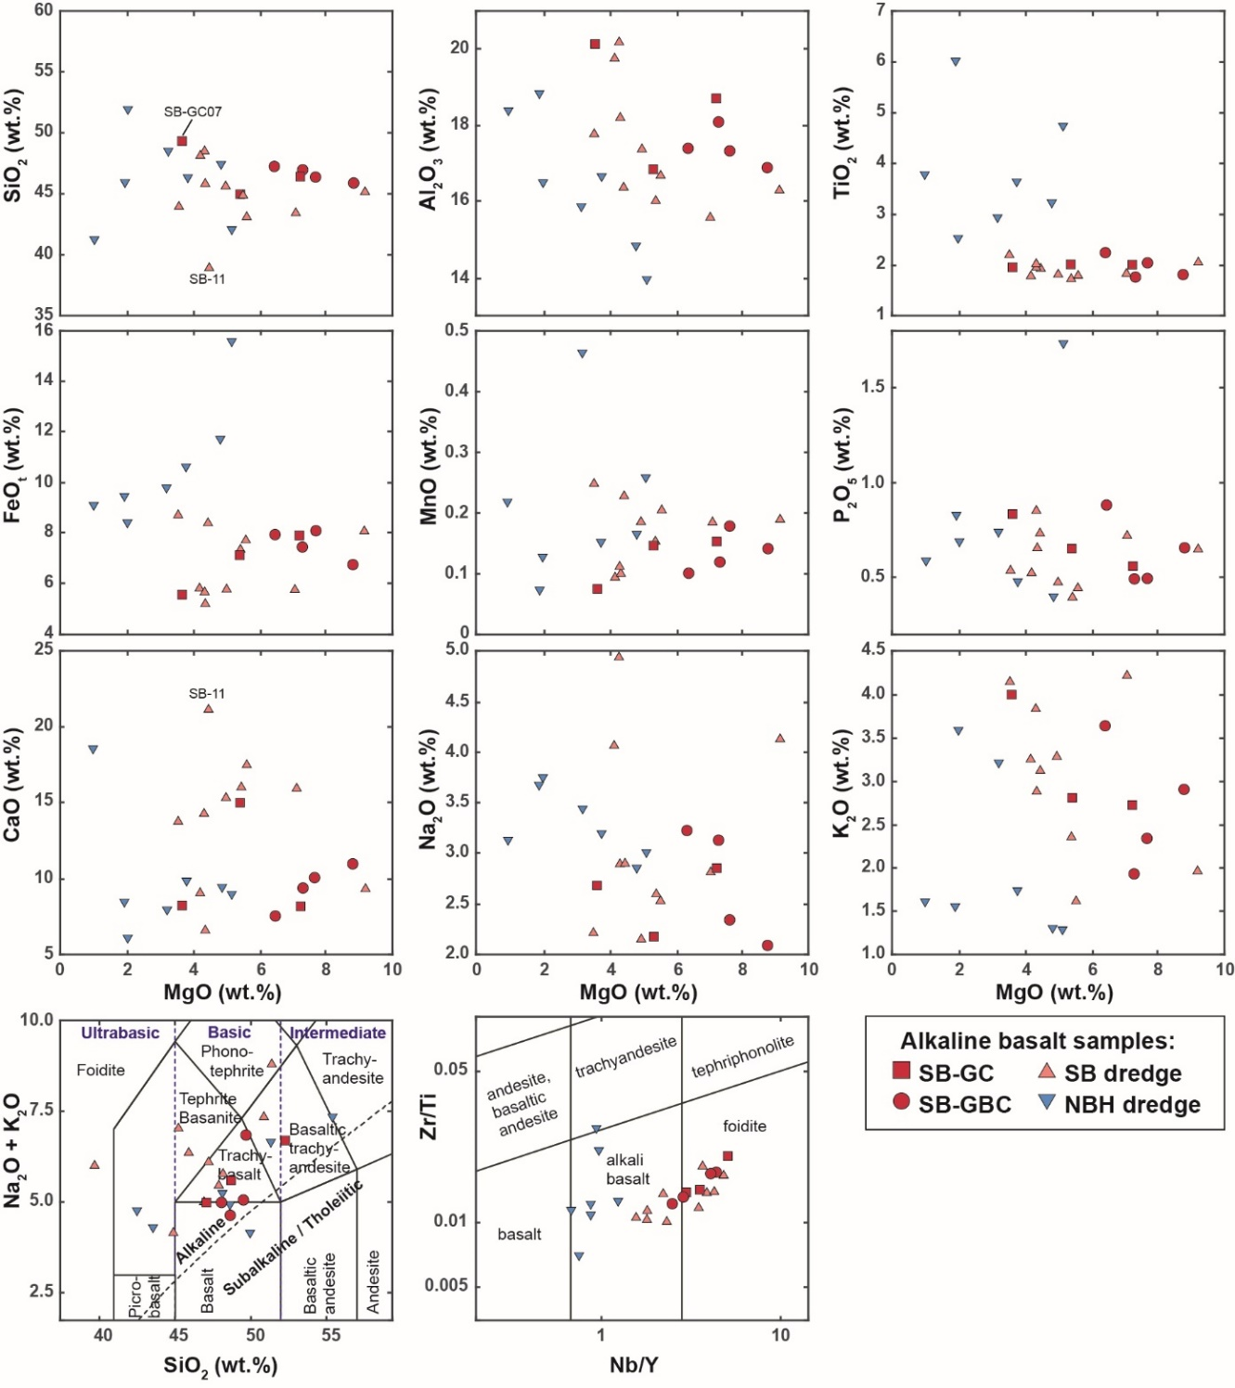
Plots of major element variations versus MgO for alkaline basaltic rock samples from the SB-GC and SB-GBC cores (this study) as well as from the SB and NBH dredges (Riefstahl et al. 2013). Additionally, the samples are shown in classification diagrams for volcanic rocks: the Total alkalis vs. SiO₂ (TAS) diagram (LeMaitre 2002) and the Zr/Ti vs. Nb/Y diagram from Pearce (1996).

References:

LeMaitre RW (ed) (2002) Igneous rocks. A classification and glossary of terms. 2nd ed. Cambridge University Press.
Pearce JA (1996) A user’s guide to basalt discrimination diagrams. In: Wyman DA (ed) Trace element geochemistry of volcanic rocks: Applications for massive sulphide exploration, Geological Association of Canada, Short Course Notes 12, pp 79-113.

Riefstahl F, Estrada S, Geissler WH, Jokat W, Stein R, Kämpf H, Dulski P, Naumann R, Spiegel C (2013) Provenance and characteristics of rocks from the Yermak Plateau, Arctic Ocean: Petrographic, geochemical and geochronological constraints. Mar. Geol. 343:125–145. https://doi.org/10.1016/j.margeo.2013.06.009

