Supplementary Information for “Development and physical characteristics of the Irish shelf-edge Macnas Mounds, Porcupine Seabight, NE Atlantic”
Krueger et al.

Core C074 description
Core C074 is 560 cm long (Figure S1.1). From 560 to 541 cm, numerous black spots were observed in a dark grey matrix comprised of clays. At 551 cm, a 1 cm-thick bryozoan-rich layer was noted. From 541 to 416 cm, the matrix is dark greyish brown, and its particulate size gradually coarsens to silt-grade. At 476 cm, a single small gastropod was found. At 465, 450 and 430 cm, other black spots were observed. From 416 to 388 cm, the silty matrix is very dark greyish brown with a small (< 1 cm) gastropod at 406 cm. From 388 to 212 cm, the matrix is dark greyish brown again with occasional black spots, gradually coarsening upwards. From 212 cm to the top, fragments of Desmophyllum pertusum occur within fine sand. The top 3 cm of the core have been reworked due to the entrance of the VibroCore in the sediment; apart from this, there are no obvious signs of reworking throughout the core. Over 80 coral fragments were observed throughout the section, as well as more occasional fossils (bivalves, echinoid spines and eunice tubes). An image from core C074 is provided (Figure S1.2) to visually display no corals migrated during the core cutting process. The top of the core corresponds to modern sediment surface.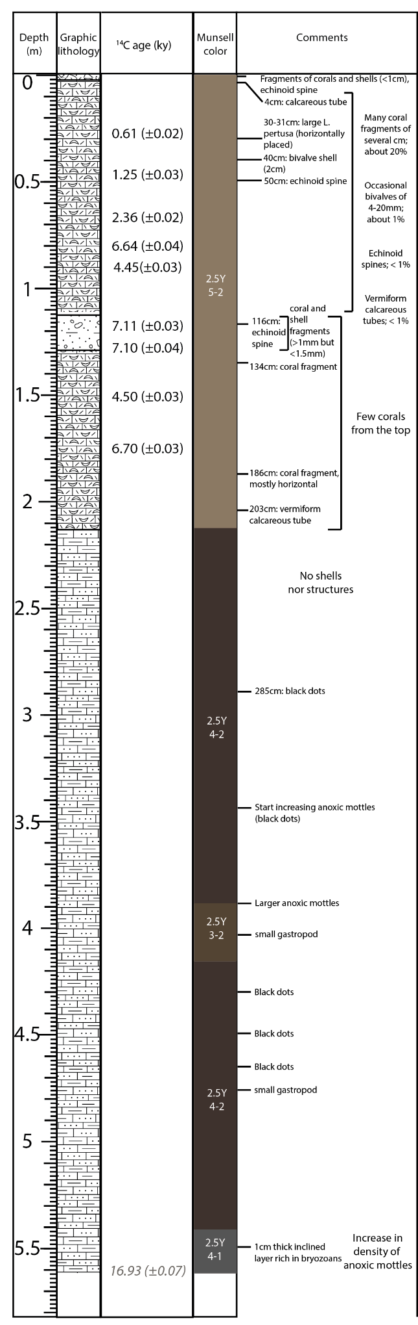
Fig. S1.1. Full core description for core C074.
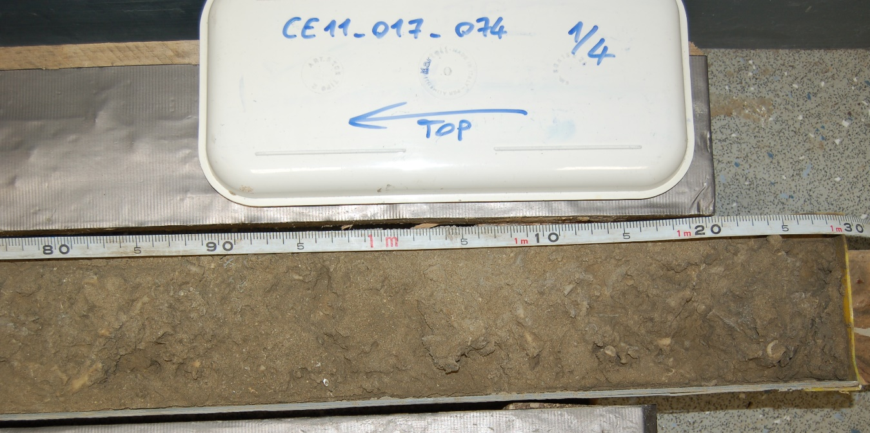
Fig. S1.2. Image of a section of core C074 to show no visible evidence of coral migration after core cutting.

Core C075 description
Core C075 is 486 cm long (Figure S1.3). From 486 to 444 cm, the sediment is comprised of dark greyish-brown medium silt with no other components. Occasional black bands of a few mm thickness are observed. From 442 to 366 cm, the mud is dark grey with additional black banding is occasionally observed, and grain size shifts from medium to fine silt. From 366 to 230 cm, the sediment is composed of dark greyish brown silt with no other components; the last occurrence of black banding occurs at 342 cm. From 230 to 210 cm, there is a gradual shift from very fine silt to very fine sand, with the first occurrence of D. pertusum occurring at 220 cm and continuing to the top of the core. From 230 to 215 cm, the sediment is dark greyish brown, transitioning to olive grey from 215 to 210 cm. From 210 to 167 cm, D. pertusum is very abundant in an olive-grey very fine sand. A calcareous worm tube was observed at 202 cm. A decrease in coral occurrence is noted, as well as occasional worm tubes and echinoid spines. From 167 to 88 cm, the matrix sediment between coral clasts is composed of olive coloured very fine sand with several occurrences of D. pertusum. Occasional worm tubes and other bioclasts are observed. From 88 to 42 cm, the olive grey very fine sand contains many bioclasts (echinoids, bivalves) in addition to D. pertusum. From 42 to 38 cm, a narrow band of light olive brown very fine sand is observed, within which D. pertusum, bivalves and echinoid spines are found. From 38 to 20 cm, light olive-grey fine sand is observed with D. pertusum, echinoid and bivalve clasts in addition to a single occurrence of the cold-water coral Madrepora oculata. Finally, the upper 20 cm of the core comprises a light colored olive-brown fine sand containing D. pertusum, bivalve shells and echinoid spines. The top of the core corresponds to modern sediment surface.
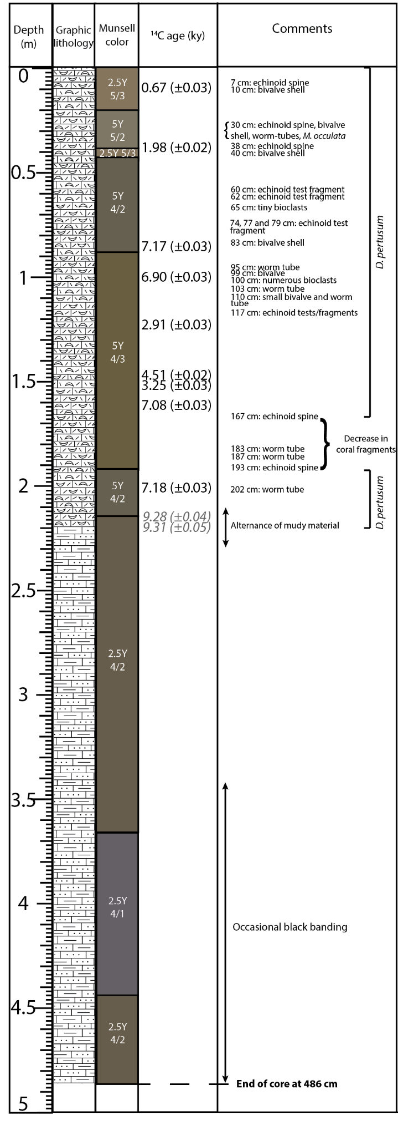
Fig. S1.3. Full core description for core C075.
Multi-Sensor Core Logger
The multi-sensor core logger (MSCL) for cores C074 and C075 are presented here. The logs represent two units, with the lower part exhibiting generally low values and the upper part showing high values and strong fluctuations in gamma density and P-wave velocity, while it is the opposite for magnetic susceptibility, with stable and high values in the lower part and stable and low values in the upper part of both logs.

The unit separation in core C074 is located around 280 cm (Figure S1.4). From the bottom of the core, there is a general density increase from 520 to 480 cm, which then decreases. Above that, the muddy section is distinguished in both gamma and P-wave velocity with some variations until it reaches 400 cm where the density and velocity stabilise. Gamma density in the top section of the core is separated at 103 cm, being slightly less dense. The P-wave velocity may show similar trends, but is less clear. Magnetic susceptibility displays a gradual decrease from the bottom of the core to 280 cm, and then stabilizes to a very low measurement to the top of the core.
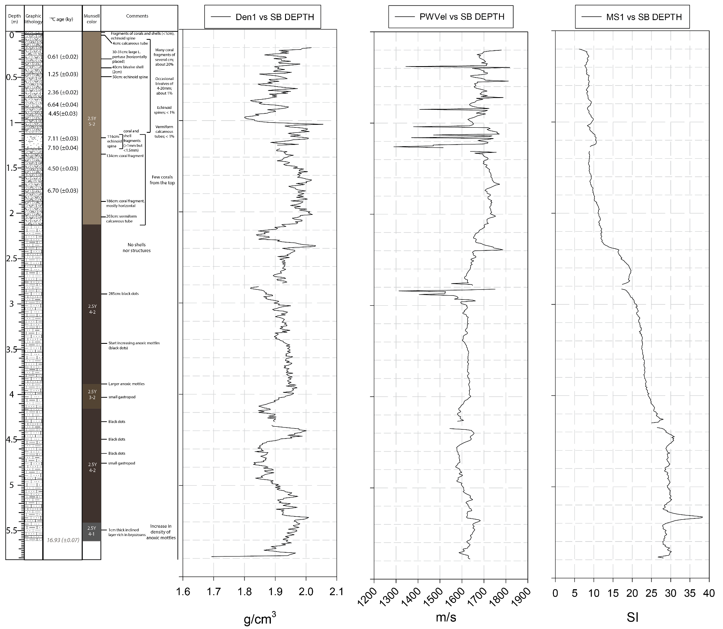
Fig. S1.4. Full core description and downcore log of gamma density, P-wave velocity, and magnetic susceptibility for core C074.

The main unit separation in core C075 is located around 230 cm (Figure S1.5). There is a general stability for all logged parameters from 486 to 345 cm, slightly transitioning to a slow decrease in both gamma and P-waves from 345 to 230 cm. Magnetic susceptibility exhibits a gradual decrease from 230 to 195 cm, while both gamma and P-waves show strong variations before an abrupt increase above 230 cm. The gamma density shows a slight decrease from 190 to 160 cm. This trend seems to correspond to the localized decrease in D. pertusum abundance as recorded in the core between 190 and 165 cm. This temporary decrease is less obviously recorded in the P-wave velocity log, but between 190 and 200 cm the velocity increases noticeably. A strong and brief positive anomaly is recorded in both gamma and P-waves at 108 cm, but no change is noted in the magnetic susceptibility.
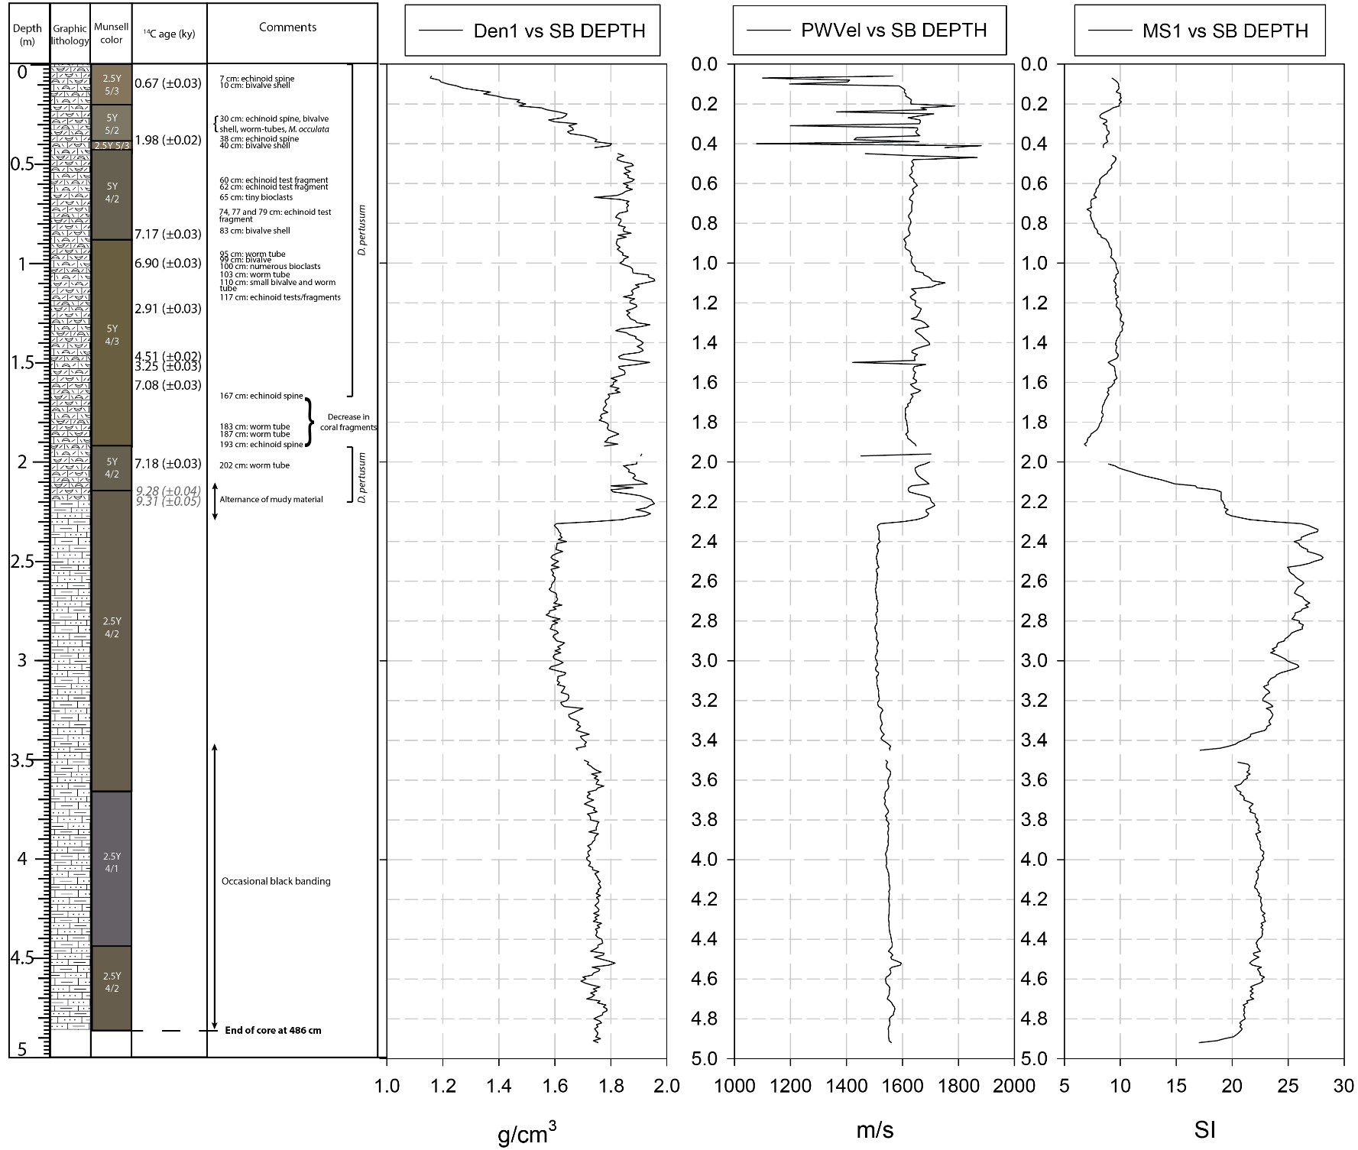
Fig. S1.5. Full core description and downcore log of gamma density, P-wave velocity, and magnetic susceptibility for core C075.

Preservation status of coral samples
Visibly unaltered D. pertusum samples were collected from core C075, cleaned with 5% H₂O₂ at room temperature for 12 hours, then rinsed thoroughly with deionized water. Corals were subsequently cleaned with successive ultrasonic baths in deionized water. Specimens were dried, mounted in epoxy resin and cut longitudinally with a low-speed saw. Observations using scanning electron microscopy (Figure S1.6; Mouchi et al. 2014), cathodoluminescence, and X-ray diffraction (Figure S1.7, S1.8) analyses did not show any sign of recrystallization or alteration in the samples used in this study.
Fig. S1.6. Scanning electron microscopy image of coral sample from core C075.

XRD analyses show aragonite and calcite content in a carbonate powder sampled inside the coral wall. Here, sample CE11075_125 (Figure S1.7) displays a small peak at the characteristic major calcite angle 29.4° (2θ), which is not the case for sample CE11075_123 (Figure S1.8). Samples presenting this calcite peak were not selected for dating analysis. There was no cathodoluminescence signal, indicating no recrystallization.
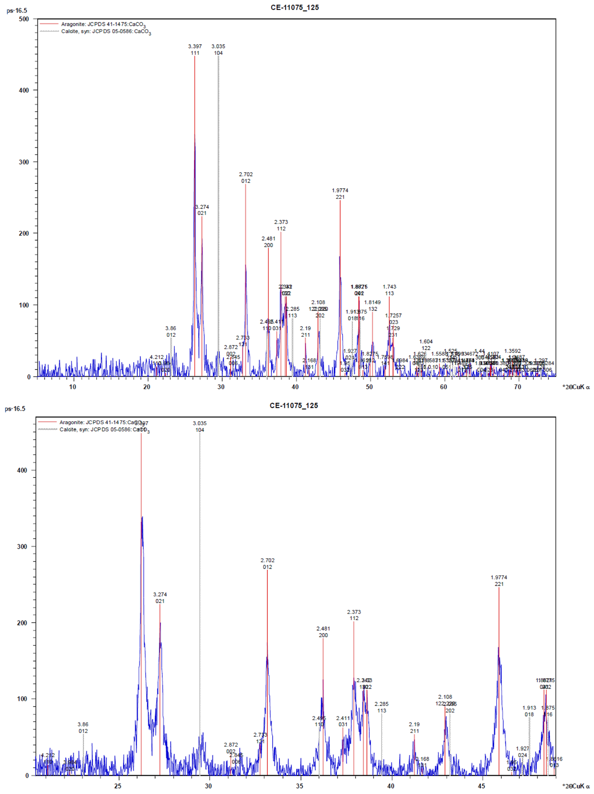
Fig. S1.7. XRD graphs from coral rubble sample CE11075-125 from core C075.
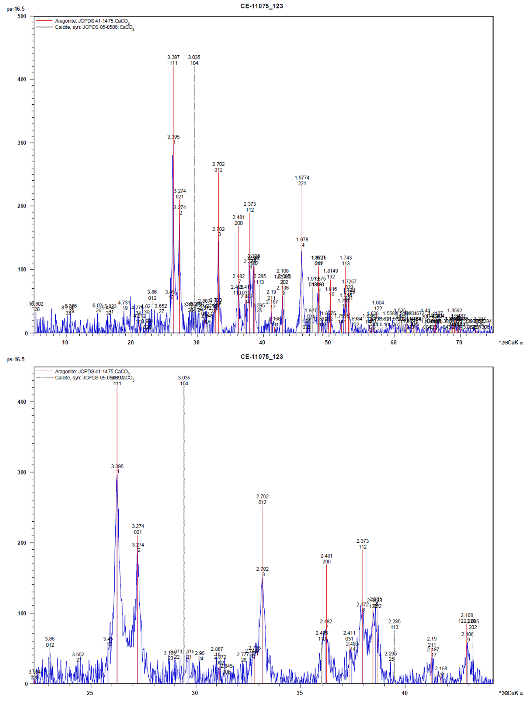
Fig. S1.8. XRD graphs from coral rubble sample CE11075-123 from core C075.

References
Mouchi et al 2014

