New insights into Cadomian basin evolution and stratigraphic affiliation of sedimentary units of Saxo-Thuringia, Germany: Part 1 – whole-rock and chert geochemistry and Rb–Sr and Sm–Nd isotope systematics
by Victoria Kühnemann, Guido Meinhold, Matthias Willbold, Jasper Berndt, Sebastian Weber

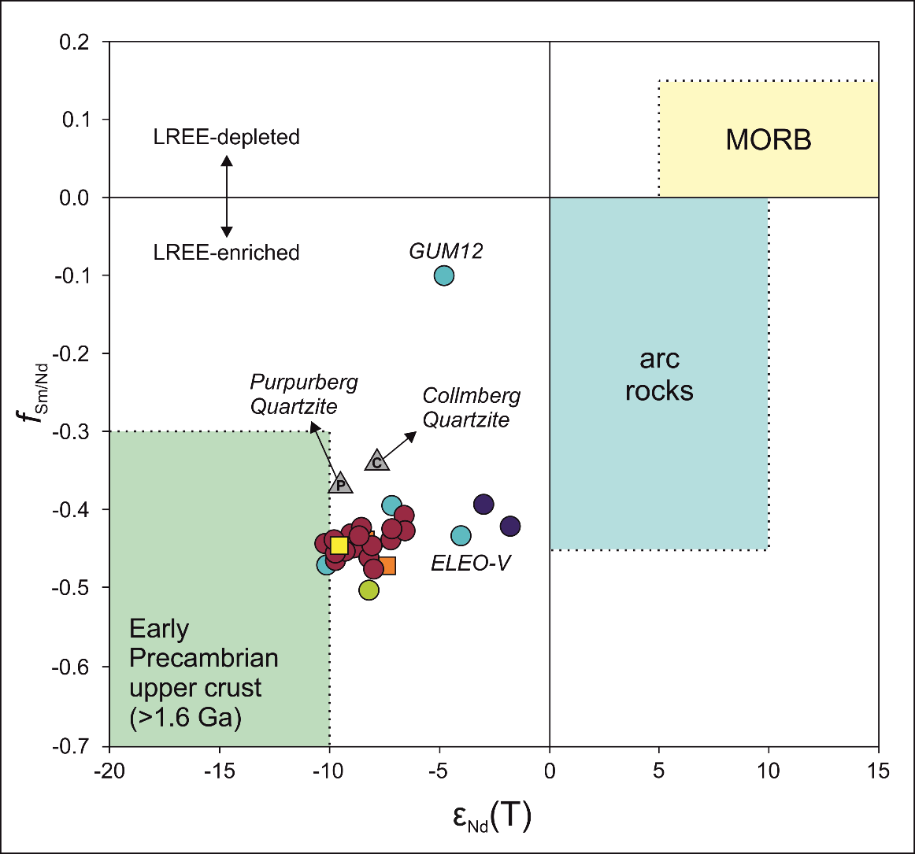

ESM4: f_{Sm/Nd} vs εNd(T) plot for provenance characterisation.
Reference fields according to McLennan & Hemming (1992).

