article title: HLA-DQB1*03:01 and HLA-DQA1*05:05 as key genetic determinants of infliximab response and immunogenicity in Japanese patients with inflammatory bowel disease

journal name: Journal of Gastroenterology

author names: Ryuya Osaka¹, Takeo Naito*¹, Seik-Soon Khor^{2,3}, Yoichi Kakuta¹, Yosuke Kawai², Masao Nagasaki^{4,5}, Hiroshi Meguro¹, Hideya Iwaki¹, Daisuke Okamoto¹, Hiroshi Nagai¹, Yusuke Shimoyama¹, Rintaro Moroi¹, Hisashi Shiga¹, Yoshitaka Kinouchi⁶, Atsushi Masamune¹

affiliation:
¹Division of Gastroenterology, Tohoku University Graduate School of Medicine, Sendai, Japan.
²Genome Medical Science Project, National Center for Global Health and Medicine, Tokyo, Japan
³Singapore Centre for Environmental Life Sciences Engineering, Nanyang Technological University, Singapore, Singapore.
⁴Division of Biomedical Information Analysis, Medical Research Center for High Depth Omics, Medical Institute of Bioregulation, Kyushu University, Japan
⁵Center for Genomic Medicine, Graduate School of Medicine, Kyoto University, Kyoto, Japan
⁶Student Health Care Center, Institute for Excellence in Higher Education, Tohoku University, Sendai, Japan

e-mail address of the corresponding author: takeo.naito.b3@tohoku.ac.jp
Supplementary Table 1. Summary of IFX administration protocols and outcomes in Crohn’s disease patients
Patterns of IFX administration protocols and outcomes | Number of cases (total CD patients = 219)
Observation ended without IFX discontinuation | 89
Observation ended after the standard protocol | 88 (98.9%)
Observation ended after dose escalation | 1 (1.1 %)
IFX discontinued due to disease recurrence | 130
IFX discontinued after the standard protocol | 77 (59.2 %)
IFX discontinued after dose escalation | 51 (39.2 %)
IFX discontinued after interval shortening | 1 (0.8 %)
IFX discontinued after dose escalation and subsequent interval shortening | 1 (0.8 %)

IFX, infliximab
Standard protocol: IFX maintenance therapy with 5 mg/kg administered every 8 weeks
Dose escalation: IFX maintenance therapy with 10 mg/kg administered every 8 weeks
Interval shortening: IFX maintenance therapy with 5 mg/kg administered every 4 weeks

Supplementary Table 2. Association between HLA-DQA1*05 and the risk of infliximab discontinuation in Crohn's disease in multi-variate analysis
Variables | N | P-value | HR (95% CI)
HLA-DQA1*05 carrier | 49 | 1.32E-04 | 2.25 (1.49-3.42)
Serum albumin levels at the baseline  < 3.5 g/dL | 94 | 1.72E-03 | 1.76 (1.24-2.52)
Location
L2 | 36 | 0.07 | 0.61 (0.36-1.03)
Behavior
B3 | 43 | 0.01 | 1.77 (1.17-2.70)
HLA, human leukocyte antigen; HR, hazard ratio; CI, confidence interval

Supplementary Table 3. Association between HLA-DQA1*05 and the risk of infliximab discontinuation in Ulcerative colitis in multi-variate analysis
Variables | N | P-value | HR (95% CI)
HLA-DQA1*05 carrier | 16 | 0.07 | 2.23 (0.95-5.23)
Serum albumin levels at the baseline  < 3.5 g/dL | 31 | 5.72E-04 | 3.54 (1.73-7.28)
Extent
E3 | 51 | 0.01 | 2.90 (1.30-6.47)
HLA, human leukocyte antigen; HR, hazard ratio; CI, confidence interval

Supplementary Table 4. The numbers of alleles with allele frequency of 5% or higher
HLA type | the number of alleles (2-digit resolution) | the number of alleles (4-digit resolution)
HLA-A | 6 | 8
HLA-C | 6 | 7
HLA-B | 7 | 8
HLA-DRB1 | 7 | 6
HLA-DQA1 | 3 | 7
HLA-DQB1 | 4 | 8
HLA-DPA1 | 2 | 3
HLA-DPB1 | 5 | 5
HLA, human leukocyte antigen

Supplementary Table 5. Association between HLA-DQB1*03 and the risk of infliximab discontinuation in Crohn's disease in multi-variate analysis
Variables | N | P-value | HR (95% CI)
HLA-DQB1*03 carrier | 133 | 2.17E-04 | 2.21 (1.45-3.37)
Serum albumin levels at the baseline  < 3.5 g/dL | 94 | 4.06E-03 | 1.94 (1.34-2.80)
Location
L2 | 36 | 0.42 | 0.80 (0.45-1.39)
Behavior
B3 | 43 | 0.01 | 1.73 (1.13-2.66)

HLA, human leukocyte antigen; HR, hazard ratio; CI, confidence interval

Supplementary Table 6. Association between HLA-DQB1*03 and the risk of infliximab discontinuation in Ulcerative colitis in multi-variate analysis
Variables | N | P-value | HR (95% CI)
HLA-DQB1*03 carrier | 40 | 0.02 | 2.25 (1.14-4.46)
Serum albumin levels at the baseline  < 3.5 g/dL | 31 | 1.22E-04 | 4.00 (1.97-8.11)
Extent
E3 | 51 | 3.47E-03 | 3.21 (1.47-7.01)

HLA, human leukocyte antigen; IFX, infliximab; HR, hazard ratio; CI, confidence interval

Supplementary Table 7. Effect of thiopurine co-therapy on the risk of infliximab discontinuation across risk HLA allele groups

HLA type | Carrier status | P-value  for thiopurine co-therapy | HR (95% CI)  for thiopurine co-therapy | P-value  for interaction
DQA1*05 | non-carrier | 0.058 | 0.63 (0.39 - 1.02)
 | carrier | 0.27 | 0.67 (0.33 - 1.36) | 0.87
DQB1*03 | non-carrier | 0.42 | 0.77 (0.41 - 1.45)
 | carrier | 0.44 | 0.81 (0.49 - 1.36) | 0.88
DQA1*05:05 | non-carrier | 0.061 | 0.64 (0.40 - 1.02)
 | carrier | 0.15 | 0.55 (0.24 - 1.24) | 0.72
DQB1*03:01 | non-carrier | 0.13 | 0.67 (0.40 - 1.12)
 | carrier | 0.23 | 0.67 (0.36 - 1.29) | 0.99
HLA, human leukocyte antigen; IFX, infliximab; HR, hazard ratio; CI, confidence interval

Supplementary Table 8. Haplotype analysis between each combination of HLA-DQA1 and HLA-DQB1 locus, and the risk of infliximab discontinuation (2-digit resolution, allele frequency > 0.05 and P-value < 0.05)
haplotype | frequency | P-value | HR (95% CI)
HLA-DQA1*05 ~ HLA-DQB1*03 | 0.11 | 1.85E-04 | 2.06 (1.41-3.01)
HLA-DQA1*03 ~ HLA-DQB1*03 | 0.22 | 2.56E-03 | 1.68 (1.20-2.35)
HLA-DQA1*03 ~ HLA-DQB1*04 | 0.17 | 0.01 | 0.63 (0.44-0.91)
HLA-DQA1*01 ~ HLA-DQB1*06 | 0.34 | 0.36 | 0.85 (0.61-1.20)
HLA-DQA1*01 ~ HLA-DQB1*05 | 0.10 | 0.91 | 1.02 (0.68-1.53)
HLA, human leukocyte antigen; IFX, infliximab; HR, hazard ratio; CI, confidence interval

Supplementary table 9. Haplotype analysis between each combination of HLA-DQA1 and HLA-DQB1 locus, and the risk of infliximab discontinuation (4-digit resolution, allele frequency > 0.05 and P-value < 0.05)
haplotype | frequency | P-value | HR (95% CI)
HLA-DQA1*05:05 ~ HLA-DQB1*03:01 | 0.08 | 3.38E-04 | 2.18 (1.42-3.34)
HLA-DQA1*03:02 ~ HLA-DQB1*03:03 | 0.14 | 0.02 | 1.58 (1.09-2.29)
HLA-DQA1*03:03 ~ HLA-DQB1*04:01 | 0.14 | 0.13 | 0.74 (0.51-1.09)
HLA-DQA1*01:02 ~ HLA-DQB1*06:02 | 0.07 | 0.16 | 0.69 (0.42-1.16)
HLA-DQA1*03:01 ~ HLA-DQB1*03:02 | 0.07 | 0.18 | 1.34 (0.87-2.07)
HLA-DQA1*01:03 ~ HLA-DQB1*06:01 | 0.21 | 0.33 | 0.84 (0.59-1.19)
HLA-DQA1*01:04 ~ HLA-DQB1*05:03 | 0.06 | 0.96 | 1.01 (0.62-1.65)
HLA, human leukocyte antigen; IFX, infliximab; HR, hazard ratio; CI, confidence interval

Supplementary table 10. Haplotype analysis of HLA-DQA1 alleles paired with HLA-DQB1*03:01 and the risk of infliximab discontinuation.
haplotype | frequency | proportion within DQB1*03:01 haplotypes (%) | P-value | HR (95% CI)
HLA-DQA1*05:05 ~ HLA-DQB1*03:01 | 0.08 | 57.1 | 3.38E-04 | 2.18 (1.42-3.34)
Non- HLA-DQA1*05:05 ~ HLA-DQB1*03:01 | 0.06 | 42.9 | 0.02 | 1.82 (1.10-3.03)
HLA-DQA1*03:03 ~ HLA-DQB1*03:01 | 0.01 | 8.6
HLA-DQA1*05:03 ~ HLA-DQB1*03:01 | 0.02 | 12.8
HLA-DQA1*05:07 ~ HLA-DQB1*03:01 | 0.02 | 12.8
HLA-DQA1*05:08 ~ HLA-DQB1*03:01 | 0.01 | 4.3
HLA-DQA1*06:01 ~ HLA-DQB1*03:01 | 0.01 | 4.3

HLA, human leukocyte antigen; IFX, infliximab; HR, hazard ratio; CI, confidence interval

Supplementary table 11. Association between each HLA type and anti-drug-antibody level
HLA type | Carrier status | ADA level  Median (interquartile range) | P-value  Wilcoxon rank sum test | Hodges–Lehmann estimate (95% CI) | P-value  Fisher's exact test
2-digits
HLA-DQA1*05 | non-carrier | 8.6 (8.0 - 12.9)
 | carrier | 57.9 (9.9 - 120.0) | 1.26E-03 | 48.1 (1.73 - 101.2) | 0.02
HLA-DQB1*03 | non-carrier | 9.2 (8.3–15.7)
 | carrier | 8.4 (7.9–18.6) | 0.43 | -0.27 (-0.94 - 0.57) | 0.82
4-digits
HLA-DQA1*05:05 | non-carrier | 8.7 (8.0 - 13.7)
 | carrier | 70.6 (53.5 - 94.9) | 3.54E-03 | 50.1 (31.9 - 110.1) | 0.02
HLA-DQB1*03:01 | non-carrier | 8.7 (8.0 - 13.3)
 | carrier | 49.1 (9.6 - 115.2) | 3.23E-03 | 32.5 (1.1 - 78.0) | 0.06
HLA-DQB1*03:02 | non-carrier | 9.1 (8.2 - 16.2)
 | carrier | 8.1 (7.9 - 11.7) | 2.00E-01 | -0.51 (-2.40 - 0.22) | 0.75
HLA-DQB1*03:03 | non-carrier | 8.7 (7.9 - 18.7)
 | carrier | 8.0 (7.7 - 9.2) | 1.40E-01 | -0.60 (-3.18 - 0.20) | 0.35

HLA, human leukocyte antigen; ADA, anti-drug-antibody

Supplementary Fig. 1. Kaplan–Meier curve of IFX persistence stratified by HLA-DQA1*05 carrier status in (a) Crohn’s disease, (b) Ulcerative colitis.
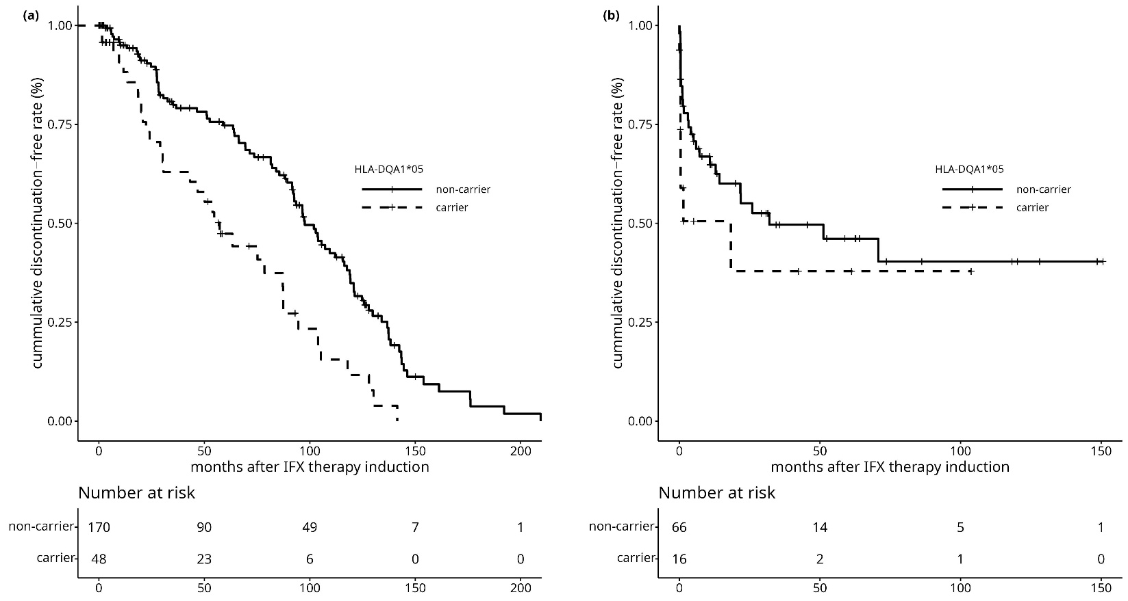

IFX, infliximab; HLA, human leukocyte antigen

Supplementary Fig. 2. Kaplan–Meier curve of IFX persistence stratified by HLA-DQB1*03 carrier status in (a) Crohn’s disease, (b) Ulcerative colitis.

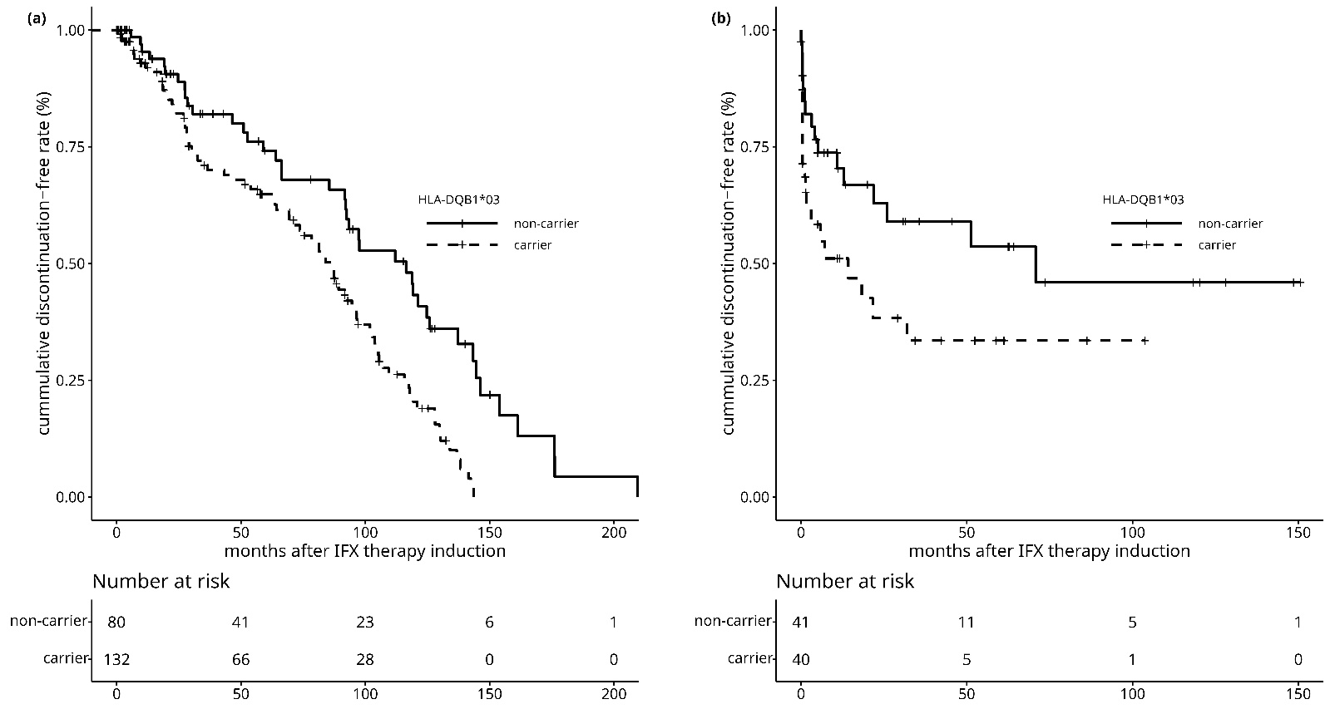
IFX, infliximab; HLA, human leukocyte antigen

Supplementary Fig. 3. Kaplan–Meier curve of IFX persistence stratified by HLA-DQA1*05/HLA-DQB1*03 carrier status and thiopurine co-therapy.

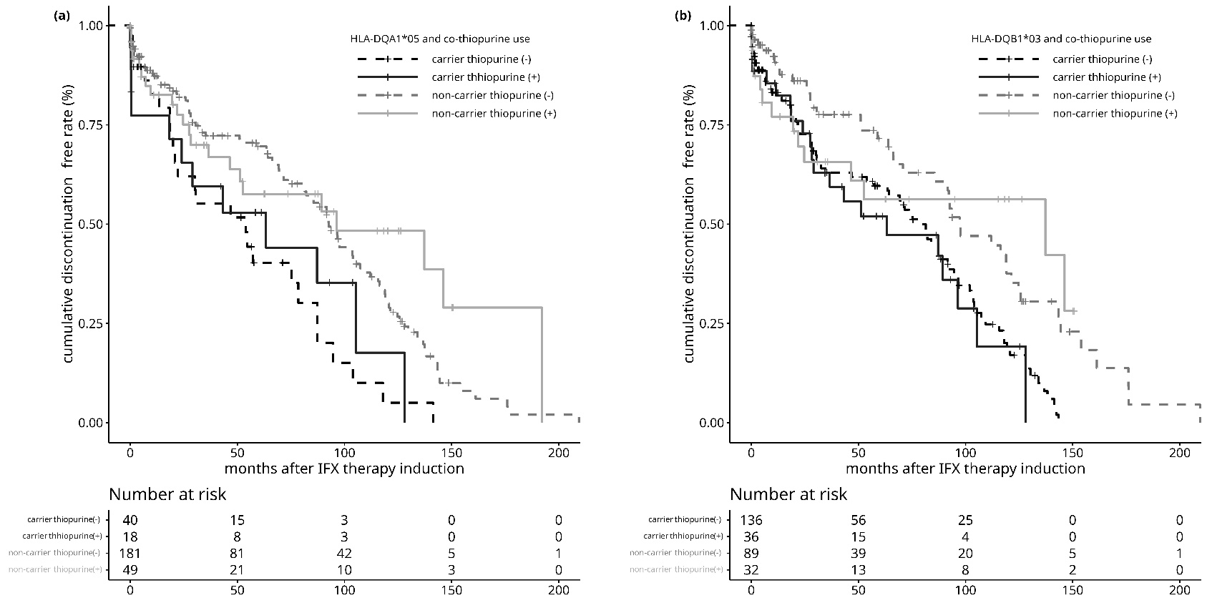
IFX, infliximab; HLA, human leukocyte antigen

Supplementary Fig. 4. Kaplan–Meier curve of IFX persistence stratified by HLA-DQA1*05:05/HLA-DQB1*03:01 carrier status and thiopurine co-therapy.

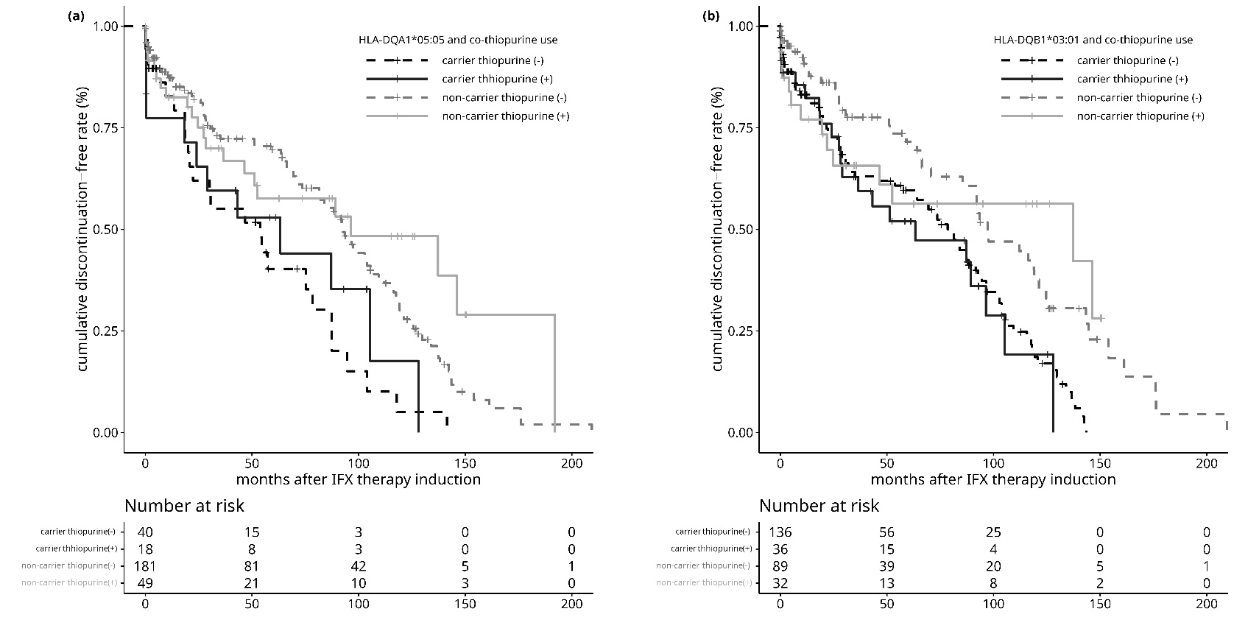
IFX, infliximab; HLA, human leukocyte antigen

