Table 1: Intra-observer Reliability of the Ultrasound Measurements
 | ICC | 95% CI |  | PooledSD | SEM | MDC
TDI (cm) | 0.894 | 0.800 | 0.946 | 0.034 | 0.011 | 0.030
DTE (cm) | 0.868 | 0.755 | 0.932 | 0.022 | 0.008 | 0.022
DTF (%) | 0.961 | 0.923 | 0.980 | 16.398 | 3.251 | 9.012
DE (cm) | 0.932 | 0.870 | 0.965 | 0.320 | 0.083 | 0.231
ICC Intraclass Correlation Coefficient, 95% CI 95% Confidence Interval, PooledSD Pooled Standard Deviation, SEM Standard Error of Measurement, MDC Minimal Detectable Change, TDI Diaphragm thickness at end-inspiration,TDE Diaphragm thickness at end-expiration, DE diaphragm excursion, DTF diaphragm thickness fraction, cm centimeter.

Table 2: Multicollinearity Assessment of Diaphragm Ultrasound Parameters Statistically Significant in Extubation Success
 | VIF | Condition Index | Eigenvalue
DE (cm) | 2.95 | 1.00 | 1.96
DTF (%) | 1.09 | 1.52 | 0.85
D-RSBI | 3.00 | 3.24 | 0.19
VIF: Variance Inflation Factor
DE diaphragm excursion, DTF diaphragm thickness fraction, D-RSBI diaphragmatic rapid shallow breathing index, cm centimeter.

Table 3: Correlation analysis of diaphragm ultrasound parameters statistically significant in extubation success
 | DE (cm) | DTF (%) | D-RSBI
DE (cm) | 1.00 | 0.229 (p = 0.053) | –0.834 (p < 0.001)
DTF (%) | 0.229 (p = 0.053) | 1.00 | –0.181 (p = 0.128)
D-RSBI | –0.834 (p < 0.001) | –0.181 (p = 0.128) | 1.00
Spearman’srhokorelasyon analizi ⁺Pearson korelasyon analizi *p<0.05
DE diaphragm excursion, DTF diaphragm thickness fraction, D-RSBI diaphragmatic rapid shallow breathing index, cm centimeter.

Table 4: ROC analysis results for diaphragm measurements in the diagnosis of failed extubation
 | AUC | SE | 95% CI | Delong test p
DE (cm) | 0.750 | 0.06 | 0.634-0.845 | 0.008*
D-RSBI | 0.649 | 0.08 | 0.528-0.758 | 0.008*
AUC: Area Under Curve SE: Standart error CI: Confidence interval *p<0.05
DE diaphragm excursion, D-RSBI diaphragmatic rapid shallow breathing index, cm centimeter.

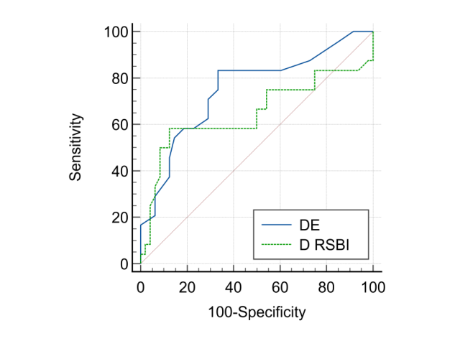
Figure 1: ROC curves of DE and D-RSBI parameters

Table 5: Multicollinearity assessment of the remaining parameters for the logistic regression model after excluding D-RSBI
 | VIF | Condition Index | Eigenvalue
DE (cm) | 1.36 | 1.00 | 2.11
DTF (%) | 1.25 | 1.45 | 1.00
Cdyn | 1.01 | 1.74 | 0.69
İntubation duration | 1.23 | 1.67 | 0.76
SCSS | 1.66 | 2.20 | 0.44
VIF: Variance Inflation Factor
DE diaphragm excursion, DTF diaphragm thickness fraction, D-RSBI diaphragmatic rapid shallow breathing index, Cdyn dynamic compliance, SCSS semiquantitative cough strength score, cm centimeter.

Table 6: Predictors of successful extubation identified by penalized logistic regression models (Ridge and LASSO)
 | Original OR | Ridge OR | LASSO OR
DE (cm) | 10.018 | 6.802 | 6.781
DTF (%) | 1.109 | 1.087 | 1.083
Cdyn | 1.094 | 1.071 | 1.064
OR: Odds ratio
DE diaphragm excursion, DTF diaphragm thickness fraction, Cdyn dynamic compliance, cm centimeter.

Table 7 : Bootstrap internal validation of the logistic regression model for extubation success (1000 Resamples)
 | Original Model | Bootstrap-Corrected
AUC | 0.864 | 0.842
Brier Score | 0.120 | 0.128
AUC: Area Under Curve

Table 8: Factors associated with successful extubation: Univariate logistic regression analysis.
 | OR | 95% CI | p
DE (cm) | 8.204 | 2.482 – 27.144 | 0.001*
DTF (%) | 1.118 | 1.042 – 1.199 | 0.001*
Cdyn | 1.064 | 1.011 – 1.119 | 0.027*
OR: Odds ratio CI: Confidence interval *p<0.05
DE diaphragm excursion, DTF diaphragm thickness fraction, Cdyn dynamic compliance, cm centimeter.

