Title
Postoperative Pulmonary Complications Following Major Emergency Abdominal Surgery: Incidence, Risk Factors, and Outcomes – an Observational study

Supplementary Materials – Index
Supplementary Materials
Supplementary Material S1 | Page 2
Supplementary Material S2 | Page 3
Supplementary Material S3 | Page 4
References (Supplementary) | Page 5

Supplementary Materials
Supplementary Material S1

Table S1: Definitions of Postoperative Pulmonary Complications
Complication | Definition
Respiratory failure | If one of the following criteria is met:  - Postoperative PaO2 <60 mmHg on room air.  - Postoperative PaO2 <8 kPA on room air.  - Ratio of PaO2 to inspired oxygen fraction <300.  - Arterial oxyhemoglobin saturation measured with pulse oximetry <90% and requiring oxygen therapy.  - Clinician suspecting the diagnosis
Atelectasis | If one of the following criteria is met:  - Lung opacification with a shift of the mediastinum, hilum, or hemidiaphragm toward the affected area, and compensatory overinflation in the adjacent nonatelectatic lung  - Clinician suspecting the diagnosis
Respiratory infection | If the clinician suspects the diagnosis or when a patient received antibiotics for a suspected respiratory infection and met at least one of the following criteria:  - New or changed sputum  - New or changed lung opacity on chest x-ray  - Fever  - Leukocyte count >12,000/u
Pleural effusion | If the clinician suspects the diagnosis or when a chest x-ray or ultrasound demonstrating one of the following:  - Blunting of the costophrenic angle  - Loss of the sharp silhouette of the ipsilateral hemidiaphragm in upright position  - Evidence of displacement of adjacent anatomical structures  - A hazy opacity in one hemithorax with preserved vascular shadows (in supine position)
Bronchospasm | Newly detected expiratory wheezing treated with bronchodilators or if the clinician suspects the diagnosis.
Pneumothorax | Air in the pleural space with no vascular bed surrounding the visceral pleura
Aspiration pneumonitis | Acute lung injury following inhalation of aspirated material.
Pulmonary edema | If the clinician suspects the diagnosis or in the presence of respiratory distress with concomitant radiological imaging showing signs of interstitial edema or alveolar edema.

Supplementary Material S2

Table S2: Description of Select Preoperative Comorbidities
Comorbidity | Definition
Respiratory comorbidity | One of the following:  - Emphysema  - Chronic obstructive pulmonary disease  - Asthma  - Chronic bronchitis  - Pulmonary fibrosis
Cardiac comorbidity | One of the following:  - Stable angina  - Chronic coronary heart disease (including heart failure)  - Previous myocardial infarction  - Atrial fibrillation
Cerebral comorbidity | One of the following:  - Previous apoplexy  - Previous transient ischemic attack  - Dementia  - Epilepsy  - Parkinsons disease  - Cerebral palsy  - Multiple sclerosis  - Congenital hydrocephalus  - Previous cerebral encephalopathy with late-effects  - Previous intracranial bleeding  - Intracranial hypertension  - Meningocele  - Cluster headache
Clinical Frailty Scale | Graded according to the following definitions*:  - People who are robust, active, energetic and motivated. They tend to exercise regularly and are among the fittest for their age.  - People who have no active disease symptoms but are less fit than category 1. Often, they exercise or are very active occasionally, e.g., seasonally.  - People whose medical problems are well controlled, even if occasionally symptomatic, but often are not regularly active beyond routine walking.  - Previously “vulnerable,” this category marks early transition from complete independence. While not dependent on others for daily help, often symptoms limit activities. A common complaint is being “slowed up” and/or being tired during the day.  - People who often have more evident slowing, and need help with high order instrumental activities of daily (finances, transportation, heavy housework). Typically, mild frailty progressively impairs shopping and walking outside alone, mean preparation, medications and begins to restrict light housework.  - People who need help with all outside activities and keeping house. Inside, they often have problems with stairs and need help with bathing and might need minimal assistance (cuing, standby) with dressing.  - Completely dependent for personal care, from whatever cause (physical or cognitive). Even so, they seem stable and not at high risk of dying (within ~6 months).  - Completely dependent for personal care and approaching end of life. Typically, they could not recover even from a minor illness.  - Approaching the end of life. This category applies to people with a life expectancy <6 months, who are not otherwise living with severe frailty (grade 8). (Many terminally ill people can still exercise until very close to death.)

*: The definitions used are as described by Rockwood & Theou (1).

Supplementary Material S3
Figure S1: Directed acyclic graph of potential risk factors and their relationship
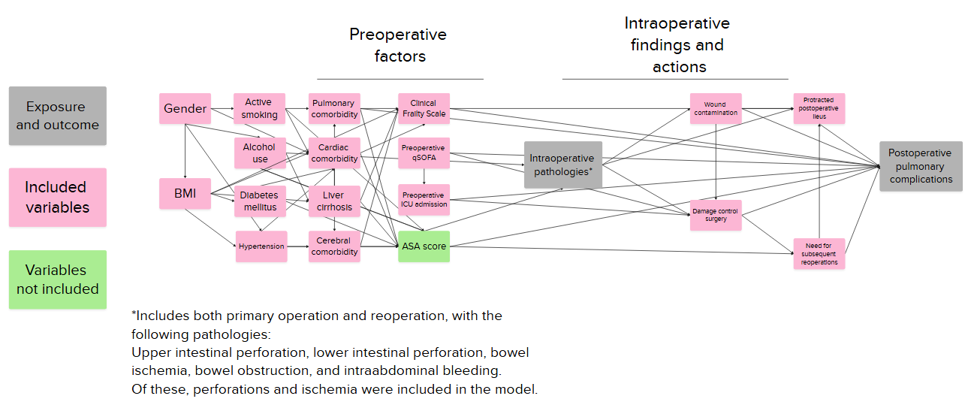

References (Supplementary)
1. Rockwood K, Theou O. Using the Clinical Frailty Scale in Allocating Scarce Health Care Resources. Can Geriatr J. september 2020;23(3):210–5.

