Distinct arbuscular mycorrhizal fungal communities associate with different manioc landraces and Amazonian soils
Mycorrhiza Clara P. Peña-Venegas*, Thomas W. Kuyper, John Davison, Teele Jairus, Martti Vasar, Tjeerd Jan Stomph, Paul C. Struik, Maarja Öpik. Corresponding author: cpena@sinchi.org.co; ORCID number: 0000-0001-6317-3767
Bitter manioc landraces | Sweet manioc landraces

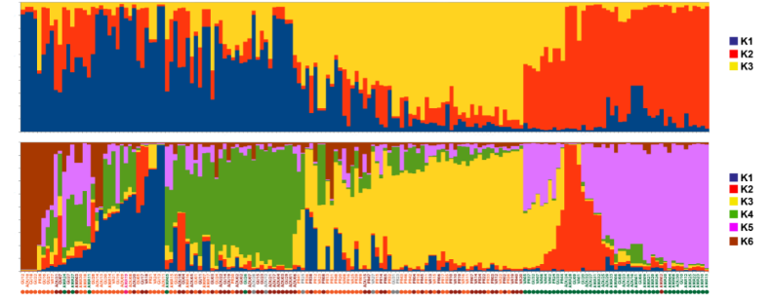
A | Y | B | G | C
Fig. A1 Genetic confirmation of preliminary field manioc landrace classification of manioc landraces collected. K are the number of populations run against samples that best discriminate manioc groups: A (Amarilla), Y (Yucuna), B (Borugo), G (Guava), C (Cáscara morada)

