Regulation of the leaf proteome by inoculation of Populus ×canescens with two Paxillus involutus isolates differing in root colonization rates

Agnieszka Szuba, Łukasz Marczak, Leszek Karliński, Joanna Mucha and Dominik Tomaszewski
Online Resource 2
Detailed data of IMP 7.0 analysis and MS/MS protein identification

The number of identified spots on the protein profiles analyzed with IMP 7.0 ranged from 757 to 1039. Depending on the quality of profiles, the number of matches for a given treatment was obtained (common spots for a given variant [a absence of one spot per match was allowed]; ranged from 881-1063). Matched spots (within a treatment) were compared with the other treatment. The number of matches between treatments was considered to be the final number of matches (679 for H and 819 for L) and treated as 100% of the proteome (see also the M&M section).

Spots were selected for MS/MS identification if they had significantly different abundances in two IMP 7.0 analyses: we compared the protein 2DE profiles generated from control, noninoculated plants with those from plants inoculated with P. involutus isolates H or L (ANOVA <0.05, ratio ≥1.2). Representative images of the protein 2DE profiles for all analysed treatments with differently abundant spots marked are presented in Figure S2-1 below.

Data for proteins selected for MS/MS identification from the leaves of plants inoculated with isolate H and L are presented in Table S1 below. The identified proteins were divided according to functional classification. For both analyses, the ratio/ANOVA values are given (for the original analysis and for the corresponding spots). Trends were marked: ↑ more in the inoculated variant, and ↓ less in the inoculated variant. A graphical presentation of the protein functional classification is presented in Fig. S2-2 and S2-3, below Table S2.

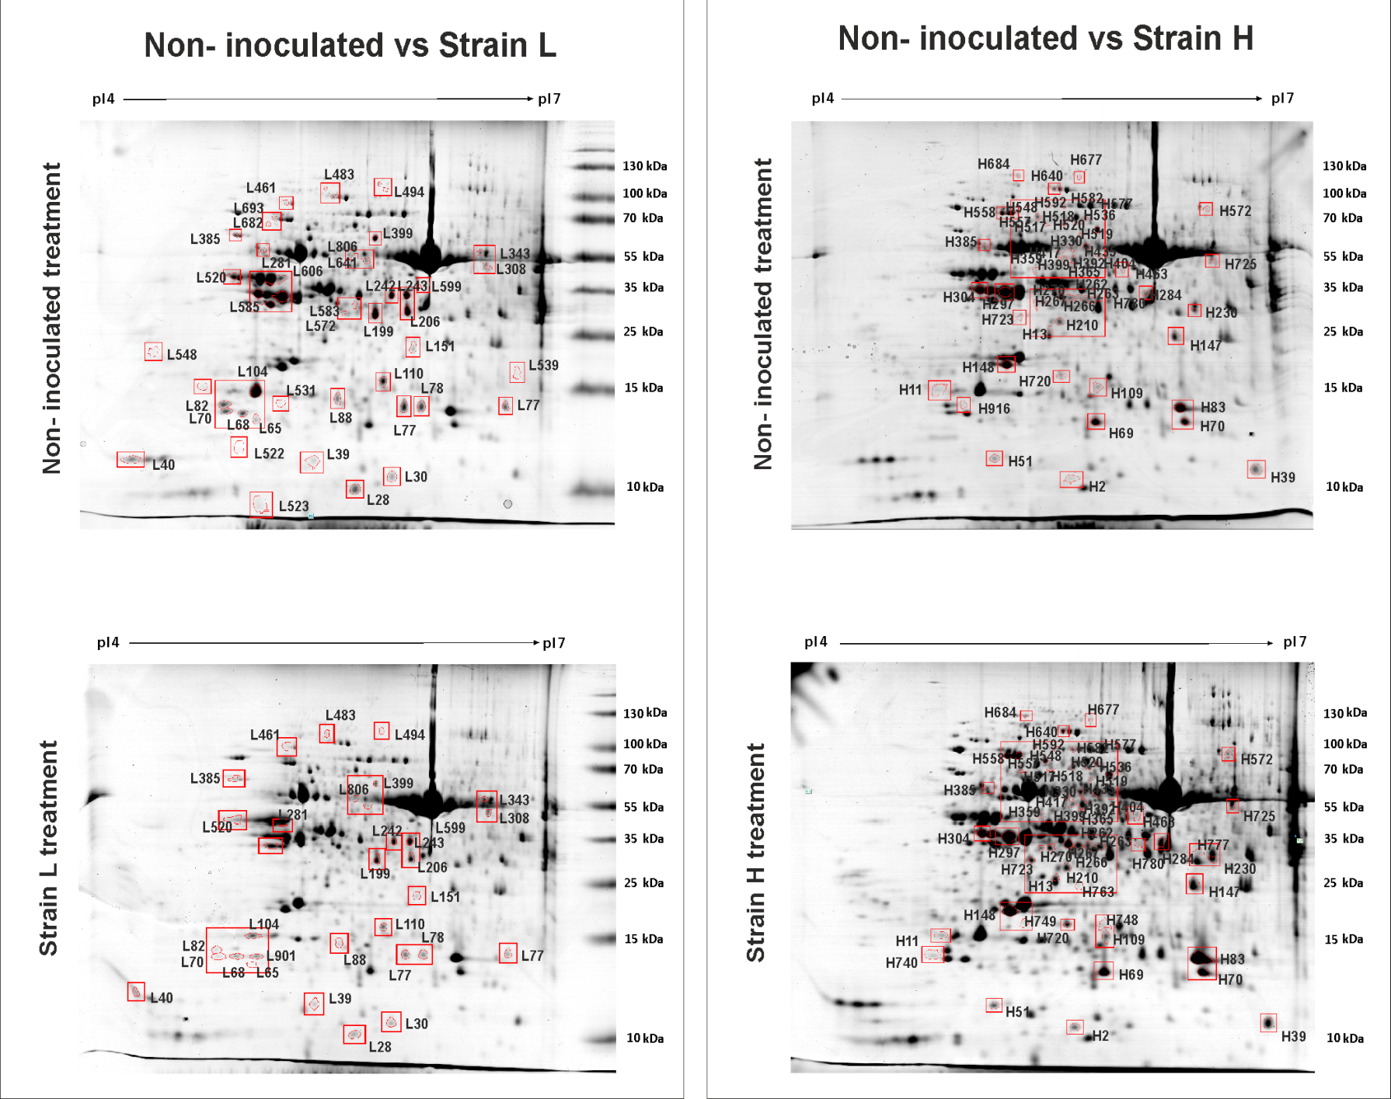
Fig. S2-1 Representative 2DE protein profiles with marked spots identified by MS/MS

Table S2 Poplar leaf proteins identified by MS/MS
.
No. | Match ID ^{a)} | Ratio/ anova^{a)} | Match ID (Isolate L) ^{a)} | Ratio/ anova (Isolate L) ^{a)} | pI/ MW exp. ^{a)} | Graphical score distribution | Identification number | Identification | Subcellular localization^{b)} | Score | Organism | Peptide Coverage | Peptide number | pI/ MW theor. | Peptides identified (Ions score) | Blast prediction ^{c)} | Blas- organism ^{c)} | Blat data ^{c)} | Functional group ^{d)} | COG class⁾
Noninoculated vs inoculated with isolate H
Protein metabolism (P)
1 | 2 | ↑2.02/0.000 | 1 | ↑1.17/0.014 | 5.6/16 | 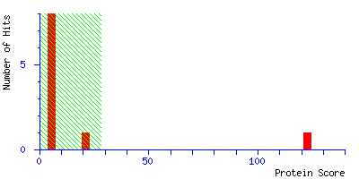 | IF5A1_ARATH | Eukaryotic translation initiation factor 5A-1 | - | 123 | Arabidopsis thaliana | 18% | 2 | 5.4/18 | K.TYPQQAGTIR.K (65)  K.KLEDIVPSSHNCDVPHVNR.T (60) | – |  |  | P | J
2 | 39 | ↑1.36/0.008 | 31 | ↓0.89/0.550 | 6.8/16 | 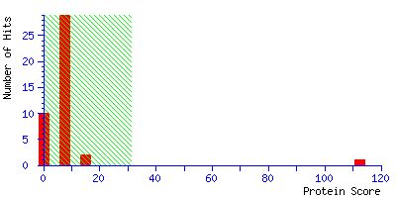 | tr|B9GZD4|B9GZD4_POPTR | Peptidyl-prolyl cis-trans isomerase | C | 112 | Populus trichocarpa | 14% | 4 | 9.5/29 | K.VYFDIGIGNPVGR.L (16)  K.DFMIQGGDFDK.G (32)  K.DFMIQGGDFDK.G (23)  R.HVVFGQVLEGMDIVK.L (64) | – |  |  | P | O
3 | 359 | ↑1.44/0.003 | – | – | 5.4/61 | 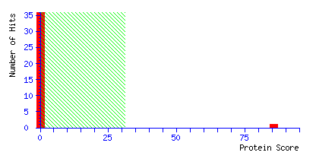 | tr|B9I0E1|B9I0E1_POPTR | RNA-binding protein 45 | - | 86 | Populus trichocarpa | 6% | 2 | 5.4/45 | K.QTGYPEGYGFIEFVSR.A (89)  R.CGFVQFANR.T (22) | – |  |  | P | S
4 | 399 | ↑1.32/0.024 | 311 | ↓1.63/0.021 | 5.6/67 | 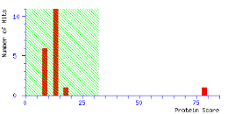 | tr|B9GH28|B9GH28_POPTR | Mitochondrial processing peptidase alpha subunit 2 family protein | M | 78 | Populus trichocarpa | 3% | 2 | 5.9/55 | K.SAVLFNLESR.M (38)  R.QFLTYGER.K (40) | – |  |  | P | O
5 | 404*** | ↑1.32/0.000 | 313 | ↑0.90/0.403 | 5.9/67 | 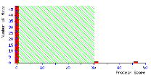 | PRS6B_ARATH | 26S protease regulatory subunit 6B homolog | - | 46 | Arabidopsis thaliana | 2% | 1 | 5.4/46 | K.KPDTDFEFYK.- (46) | – |  |  | P | O
6 | 430 | ↑1.36/0.007 | 335 | ↑1.09/0.120 | 5.7/72 | 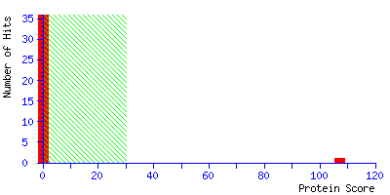 | tr|U5FXM4|U5FXM4_POPTR | Uncharacterized protein | M | 107 | Populus trichocarpa | 10% | 3 | 6.1/52 | R.LNSSLLEEFVAENYTAR.R (40)  K.SPGEPESVYTGGDFR.C (72)  R.ELTEVASPGAVDPVQLQR.A (46) | PREDICTED: mitochondrial-processing peptidase subunit alpha-like | Populus euphratica | 94/99/0.0 | P | O
7 | 577 | ↑1.52/0.000 | 819 | ↓1.47-0.051 | 5.7/106 | 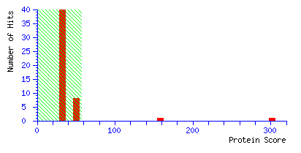 | gi|224074699 | Predicted protein | C | 309 | Populus trichocarpa | 11% | 7 | 4.8/75 | R.LGANFFR.T (14)  K.AIVWSGEELGAK.F (75)  R.AATDDEPFAGLAFK.I (53)  K.LSAGSYVMNANK.G (38)  R.MDFPDPVIK.V (35)  R.FEPMEAGTGYEFK.S (14)  R.MLEPIMK.V (13) | PREDICTED: elongation factor G-2, chloroplastic | Populus euphratica | 100/99/0.0 | P | J
8 | 592* | ↑1.40/0.010 | 442 | ↓0.86/0.324 | 5.4/109 | 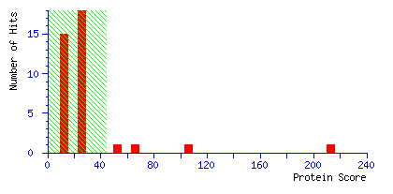 | gi|224067282 | Predicted protein | - | 213 | Populus trichocarpa | 7% | 4 | 5.2/76 | K.VLVSGNDFYAFPR.I (58)  K.GELFFITDR.K (46)  K.GLPVALVEYEGEQHGFR.K (59)  R.FTVADEIDPIR.I (49) | PREDICTED: Acylamino-acid-releasing enzyme. putative | Ricinus communis | 99/82/0.0 | P | O
9 | 677 | ↓1.57/0.027 | 491 | ↓0.81/0.324 | 5.8/155 | 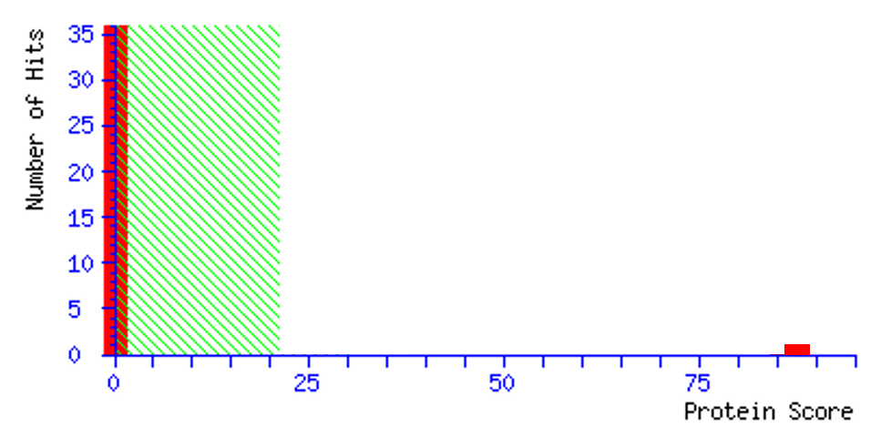 | gi|224130988 | Predicted protein | C | 84 | Populus trichocarpa | 2% | 2 | 6.0/109 | R.TLTPFGFQNEDR.T (34)  R.LVILPFESHGYAAR.E (50) | PREDICTED: probable glutamyl endopeptidase, chloroplastic isoform X1 | Populus euphratica | 100/95/0.0 | P | O
10 | 684 | ↑1.47/0.002 | 495 | ↑1.07/0.045 | 5.4/160 | 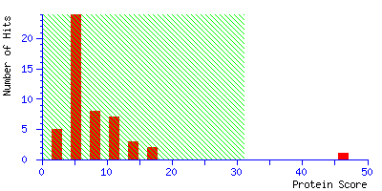 | tr|U5GLJ1|U5GLJ1_POPTR | Uncharacterized protein | C | 46 | Populus trichocarpa | 2% | 2 | 5.7/123 | R.IWFYGDDDPTER.L (29)  K.TLDVYDGSGAFLR.E (17) | PREDICTED: presequence protease 1, chloroplastic | Populus euphratica | 100/97/0.0 | P | O
11 | 725 | ↑1.91/0.000 | 308 | ↑1.40/0.013 | 6.6/66 | 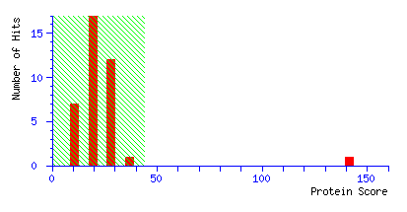 | gi|224102443 | Predicted protein | - | 142 | Populus trichocarpa | 5% | 2 | 6.0/54 | K.GYWGECGQR.G (26)  K.FNDEFMEQYEGHGGYSR.L (116) | PREDICTED: Alanine-2-oxoglutarate aminotransferase 1 family protein | Populus trichocarpa | 100/99/0.0 | P | E
12 | 780 | ↑1e6/0.002 | – | – | 6.0/49 | 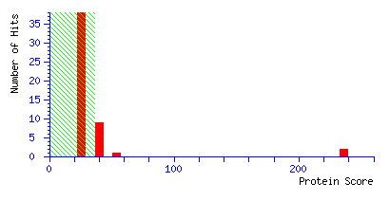 | tr|B9HLR6|B9HLR6_POPTR | Alanine-2-oxoglutarate aminotransferase 1 family protein | - | 236 | Populus trichocarpa | 14% | 7 | 6.0/54 | R.ALDYESLNENVK.K (83)  R.GELYLR.A (26)  K.EVADFIER.R (41)  R.GGYFEMTNIPPK.A (11)  K.GILESLR.R (34)  K.VPDVFYCLK.L (22)  K.LLEATGISTVPGSGFGQK.E (18) | – |  |  | P | E
Carbon fixation (F)
13 | 252 | ↑1.71/0.027 | – | – | 5.3/46 | 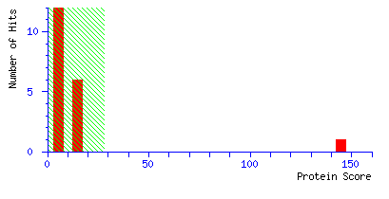 | ALFC1_ARATH | Probable fructose-bisphosphate aldolase 1, chloroplastic | C | 145 | Arabidopsis thaliana | 5% | 2 | 6.2/43 | R.LASIGLENTEANR.Q (99)  R.TAAYYQQGAR.F (46) | – |  |  | F | G
14 | 263 | ↑1.32/0.041 | 217 | ↑0.84/0.527 | 5.9/48 | 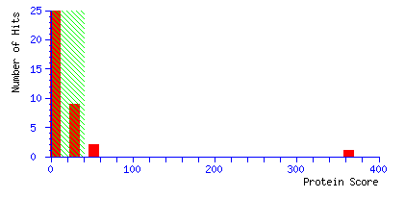 | gi|225431201 | PREDICTED: hypothetical protein | C | 363 | Vitis vinifera | 16% | 3 | 7.6/43 | R.LASIGLENTEANR.Q (113)  K.GLVPLVGSNDESWCQGLDGLASR.S (156)  R.YAAISQDNGLVPIVEPEILLDGEHGIDR.T (93) | PREDICTED: fructose-bisphosphate aldolase 1, chloroplastic-like | Vitis vinifera | 100/100/0.0 | F | G
15 | 266 | ↑2.44/0.000 | 583 | ↓1e6/0.000 | 5.7/48 | 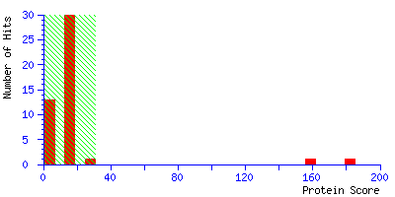 | tr|A9PGU7|A9PGU7_POPTR | Uncharacterized protein | C | 182 | Populus trichocarpa | 9% | 4 | 6.3/52 | R.WGGLVTDMSDDQQDISR.G (44)  R.WGGLVTDMSDDQQDISR.G (49)  K.SFQCELVFAK.M (23)  K.YLSEASLGEANQDSIDR.G (110) | PREDICTED: ribulose bisphosphate carboxylase/oxygenase activase, chloroplastic isoform X1 | Populus euphratica | 100/97/0.0 | F | O
16 | 284 | ↑1.76/0.017 | 235 | ↑0.96/0.159 | 6.2/50 | 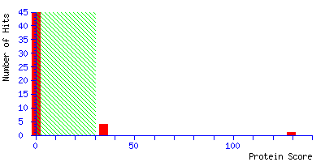 | tr|A9PGW0|A9PGW0_POPTR | Fructose-bisphosphate aldolase, chloroplastic | C | 129 | Populus trichocarpa | 16% | 4 | 7.6/43 | R.LASIGLENTEANR.Q (38)  K.GLVPLAGSNDESWCQGLDGLASR.T (23)  R.TAAYYQQGAR.F (6)  K.TWGGRPENVNAAQEALLIR.A (121) | – |  |  | F | G
17 | 297 | ↓1.31/0.000 | 246 | ↓1.39/0.048 | 5.2/51 | 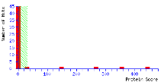 | RCA_MALDO | Uncharacterized protein | C | 444 | Populus trichocarpa | 16% | 5 | 6.3/52 | R.WGGLVTDMSDDQQDISR.G (114)  K.SFQCELVFAK.M (53)  R.VPIIVTGNDFSTLYAPLIR.D (127)  K.LVDTFPGQSIDFFGALR.A (114)  K.YLSEASLGEANQDSIDR.G (159) | PREDICTED: Ribulose bisphosphate carboxylase/oxygenase activase, chloroplastic isoform X1 | Populus euphratica | 100/98/0.0 | F | O
18 | 304 | ↓1.24/0.003 | 593 | ↓1e6/0.030 | 5.1/52 | 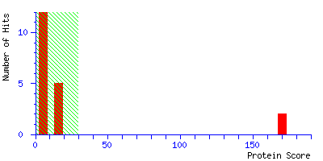 | RCAB_HORVU | Ribulose bisphosphate carboxylase/oxygenase activase B, chloroplastic | C | 170 | Hordeum vulgare | 10% | 3 | 7.6/47 | R.VPIIVTGNDFSTLYAPLIR.D (87)  K.FYWAPTR.E (20)  R.LVDTFPGQSIDFFGALR.A (63) | – |  |  | F | O
19 | 518 | ↑1.42/0.004 | 392 | ↑0.76/0.521 | 5.5/94 | 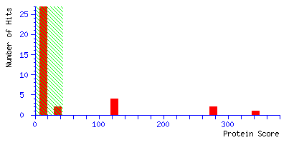 | gi|118487547 | Unknown | C | 343 | Populus trichocarpa | 14% | 4 | 6.3/52 | K.MCCLFINDLDAGAGR.L (64)  R.VPIIVTGNDFSTLYAPLIR.D (116)  K.LVDTFPGQSIDFFGALR.A (94)  K.YLSEASLGEANQDSIDR.G (69) | PREDICTED: ribulose bisphosphate carboxylase/oxygenase activase, chloroplastic isoform X1 | Populus euphratica | 100/97/0.0 | F | O
20 | 572 | ↑1.43/0.030 | – | – | 6.6/103 | 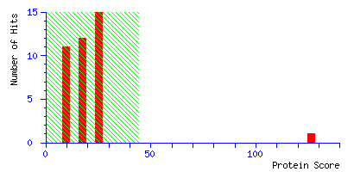 | gi|118487547 | Unknown | C | 126 | Populus trichocarpa | 5% | 2 | 6.3/52 | K.FYWAPTR.D (20)  K.YLSEASLGEANQDSIDR.G (106) | PREDICTED: ribulose bisphosphate carboxylase/oxygenase activase, chloroplastic isoform X1 | Populus euphratica | 100/97/0.0 | F | O
21 | 582 | ↑1.52/0.004 | 432 | ↑1.01/0.133 | 5.5/107 | 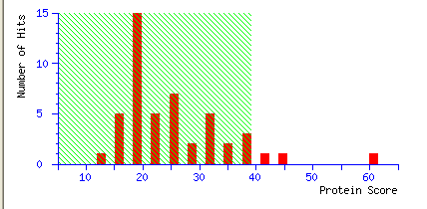 | TKTC_SOLTU | Transketolase, chloroplastic | C | 61 | Solanum tuberosum | 3% | 2 | 5.9/80 | K.NGNTGYDEIR.A (16)  K.ALPTYTPESPADATR.N (44) | – |  |  | F | G
Light dependent phase of photosynthesis (L)
22 | 11 | ↓1.34/0.005 | 9 | ↓1.04/0.141 | 4.8/25 | 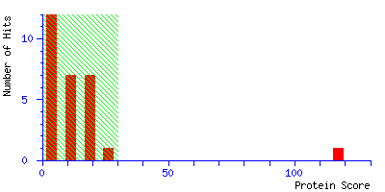 | tr|A9PGZ3|A9PGZ3_POPTR | Chlorophyll a-b binding protein CP26 | C | 117 | Populus trichocarpa | 10% | 3 | 4.0/31 | R.IFLPDGLLDR.S (27)  K.YQAFELIHAR.W (38)  K.DPDQAALLK.V (52) | – |  |  | L | S
23 | 51*** | ↑1.29/0.006 | 42 | ↓0.86/0.321 | 5.1/18 | 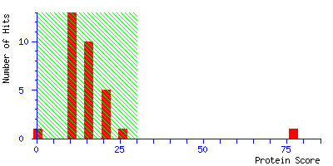 | tr|A9PEX3|A9PEX3_POPTR | Cytochrome b6-f complex iron-sulfur subunit, chloroplastic | C | 77 | Populus trichocarpa | 5% | 1 | 6.9/25 | K.VVFVPWVETDFR.T (77) | – |  |  | L | C
24 | 69 | ↑1.35/0.003 | 59 | ↑0.88/0.759 | 5.8/21 | 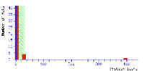 | tr|A9PHA9|A9PHA9_POPTR | O2 evolving complex 33kD family protein | C | 395 | Populus trichocarpa | 16% | 4 | 5.9/35 | K.RLTYDEIQSK.T (61)  K.NAPPEFQNTK.L (59)  K.DGIDYAAVTVQLPGGER.V (130)  R.GGSTGYDNAVALPAGGR.G (145) | – |  |  | L | G
25 | 70 | ↑1.55/0.000 | 60 | ↑1.82/0.030 | 6.4/21 | 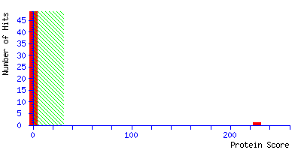 | tr|A9PHM0|A9PHM0_POPTR | Photosystem II oxygen-evolving complex protein 2 | C | 227 | Populus trichocarpa | 20% | 4 | 8.6/28 | K.EREFPGQVLR.Y (17)  R.YEDNFDATSNVSVMVIPTDK.K (107)  K.SITDYGSPEEFLSK.V (113)  K.QYFFLSVLTR.T (68) | – |  |  | L | S
26 | 83 | ↑1.69/0.000 | 74 | ↑1.25/0.010 | 6.4/22 | 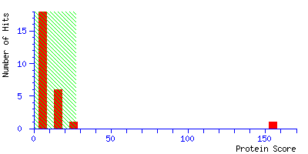 | PSBP_PEA | Oxygen-evolving enhancer protein 2, chloroplastic | C | 155 | Pisum sativum | 8% | 2 | 8.3/28 | R.EFPGQVLR.Y (36)  K.SITDYGSPEEFLSK.V (118) | – |  |  | L | S
27 | 148 | ↑1.52/0.000 | 129 | ↓1.02/0.105 | 5.2/28 | 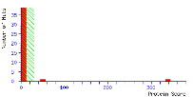 | PSBO_HELAN | Oxygen-evolving enhancer protein 1, chloroplastic | C | 338 | Helianthus annuus | 13% | 3 | 5.4/34 | K.RLTYDEIQSK.T (54)  K.DGIDYAAVTVQLPGGER.V (132)  R.GGSTGYDNAVALPAGGR.G (152) | – |  |  | L | S
28 | 187 | ↑1.33/0.036 | 161 | ↓0.98/0.262 | 6.4/34 | 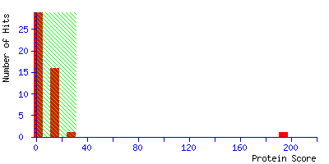 | tr|B9MXF5|B9MXF5_POPTR | Chain A family protein | C | 194 | – | 12% | 4 | 8.5/41 | R.GGSTGYDNAVALPAGGR.G (152)  R.LVYTNEQGEIVK.G (74)  K.DGIDWLEYK.R (40)  K.KAEQWNVEVY. (34) | PREDICTED: ferredoxin-NADP reductase. leaf isozyme, chloroplastic | Populus euphratica | 100/98/0.0 | L | P
29 | 230 | ↑1.35/0.014 | 196 | ↑0.83/0.449 | 6.5/43 | 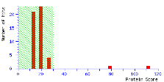 | P2SAF_ORYSJ | Photosystem II stability/assembly factor HCF136, chloroplastic | C | 112 | Oryza sativa subsp. japonica | 5% | 2 | 9.0/54 | R.SIPSAEDEDFNYR.F (69)  R.GFGILDVGYR.S (43) | – |  |  | L | S
30 | 255 | ↑1.37/0.033 | 210 | ↑0.75/0.499 | 5.4/47 | 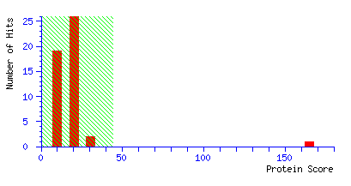 | gi|224096552 | predicted protein | C | 165 | Populus trichocarpa | 9% | 3 | 6,9/43 | R.SIPSAEDEDFNYR.F (87)  R.AAVQESVSATLNR.T (26)  K.GFVLGNDGVLLR.Y (52) | PREDICTED: photosystem II stability/assembly factor HCF136, chloroplastic | [Populus trichocarpa] | 100/100/0,0 | L | S
31 | 731 | ↑1.39/0.037 | – | – | 5.9/11 | 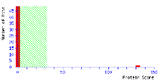 | tr|A9PHM0|A9PHM0_POPTR | Photosystem II oxygen-evolving complex protein 2 | C | 132 | Populus trichocarpa | 12% | 3 | 8.7/28 | K.SITDYGSPEEFLSK.V (95)  K.QYFFLSVLTR.T (48)  K.HQLITATVK.D (53) | – |  |  | L | S
Stress responce (S)
32 | 417 | ↑1.44/0.013 | 326 | ↑1.04/0.092 | 5.6/69 | 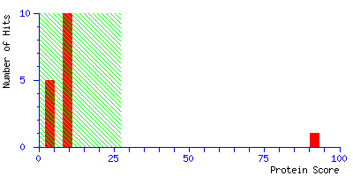 | HSP7N_ARATH | Heat shock 70 kDa protein 18 | - | 92 | Arabidopsis thaliana | 6% | 3 | 5.2/69 | R.VEIIANDQGNR.T (48)  K.NAVVTVPAYFNDSQR.Q (29)  K.DAGVIAGLNVLR.I (14) | – |  |  | S | 0
33 | 492 | ↑1.76/0.000 | 372 | ↓3.38/0.000 | 5.9/84 | 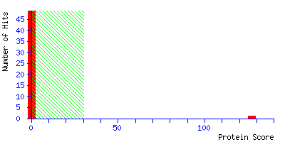 | tr|F8V189|F8V189_POPTR | Polyphenol oxidase | C | 127 | Populus trichocarpa | 6% | 3 | 6.0/65 | R.YYLYFYER.I (47)  R.DPIFFAHHGNIDR.L (25)  K.ADDAEFAGTFVNVPHNR.N (111) | – |  |  | S | S
34 | 548*** | ↑1.48/0.009 | 416 | ↑1.17/0.019 | 5.5/96 | 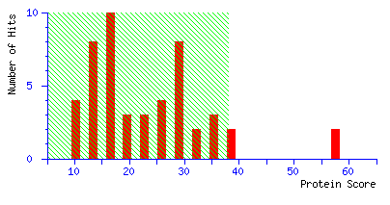 | DNAK_AGRVS | Chaperone protein DnaK | - | 58 | Populus trichocarpa | 2% | 1 | 4.9/69 | K.AVITVPAYFNDAQR.Q (58) | – |  |  | S | O
35 | 557 | ↑1.82/0.000 | 421 | ↑0.84/0.371 | 5.3/99 | 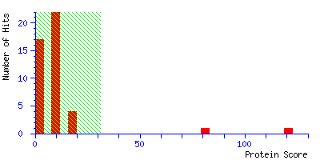 | tr|B9NBF4|B9NBF4_POPTR | Heat shock protein 70 cognate | - | 71 | Populus trichocarpa | 6% | 3 | 5.1/71 | R.VEIIANDQGNR.T (18)  K.NAVVTVPAYFNDSQR.Q (33)  K.STAGDTHLGGEDFDNR.M (70) | – |  |  | S | O
36 | 558 | ↑1.30/0.023 | 422 | ↑1.00/0.164 | 5.3/101 | 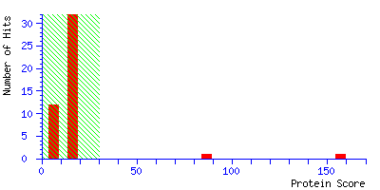 | tr|B9HMG2|B9HMG2_POPTR | Heat shock protein 70 | - | 157 | Populus trichocarpa | 7% | 4 | 5.1/72 | K.NAVVTVPAYFNDSQR.Q (19)  R.MVNHFVQEFK.R (24)  R.FEEMNMDLFR.K (41)  K.STVHDVVLVGGSTR.I (72) | – |  |  | S | O
37 | 640 | ↑1.36/0.010 | 468 | ↑1.28/0.026 | 5.6/131 | 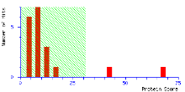 | CLPC2_ARATH | Chaperone protein ClpC2, chloroplastic | C | 68 | Arabidopsis thaliana | 2% | 2 | 6.0/106 | K.AIDLIDEAGSR.V (42)  K.EIELQVTER.F (28) | – |  |  | S | O
38 | 723 | ↑2.69/0.003 | 189 | ↓1.17/0.020 | 5.4/41 | 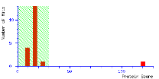 | tr|B9H105|B9H105_POPTR | Glyoxalase I homolog family protein | - | 120 | Populus trichocarpa | 6% | 2 | 5.2/33 | K.DPDGYAFELIQR.G (90)  1 R.KIDRPEYK.Y (30) | – |  |  | S | E
ROS scruvangers (R)
39 | 109 | ↑1.39/0.022 | 97 | ↑0.84/0.687 | 5.8/25 | 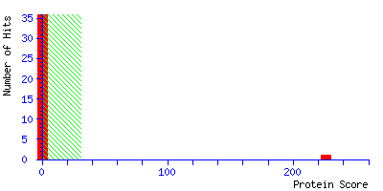 | tr|U5G0C8|U5G0C8_POPTR | Superoxide dismutase [Cu-Zn] (Fragment) | M | 226 | Populus trichocarpa | 9% | 3 | 8.2/31 | K.KLTHGAPEDEIR.H (104)  K.LTHGAPEDEIR.H (75)  K.GGHELSSTTGNAGGR.L (110) | – |  |  | R | P
40 | 740 | ↑1e6/0.000 | – | – | 4.8/21 | 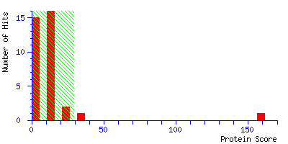 | BAS1_ORYSJ | 2-Cys peroxiredoxin BAS1 | C | 159 | Oryza sativa subsp. japonica | 9% | 2 | 5.7/28 | K.YPLISDVTK.S (64)  K.EGVIQHSTINNLAIGR.S (95) | – |  |  | R | O
Carbohydrate metabolism (C)
41 | 210 | ↑1.27/0.000 | 178 | ↓1.16/0.0372 | 5.6/38 | 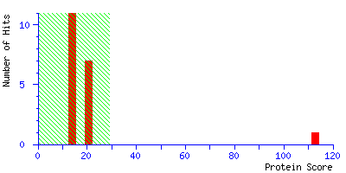 | tr|A9P8R3|A9P8R3_POPTR | Malate dehydrogenase, cytoplasmic | - | 113 | Beta vulgaris | 8% | 2 | 6.1/36 | K.LSSALSAASSACDHIR.D (78)  K.IVQGLSIDEFSR.K (35) | – |  |  | C | C
42 | 257 | ↑1.29/0.016 | 212 | ↑0.75/0.482 | 5.5/46 | 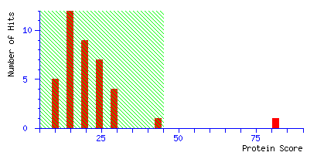 | gi|224120822 | Predicted protein | C | 81 | Populus trichocarpa | 5% | 2 | 6.0/36 | K.GVDIVVIPAGVPR.K (59)  K.LFGVTTLDVVR.A (22) | PREDICTED: nodule-enhanced malate dehydrogenase family protein | Populus trichocarpa | 96/99/0.0 | C | C
43 | 392 | ↑2.06/0.000 | 307 | ↓1.18/0.018 | 5.7/66 | 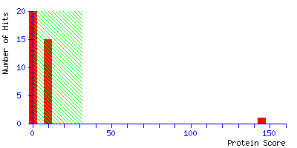 | tr|A9PF44|A9PF44_POPTR | Glucose-1-phosphate adenylyltransferase | C | 145 | Populus trichocarpa | 7% | 3 | 7.0/57 | K.FPGANDFGSEVIPGATSIGMR.V (71)  K.FPGANDFGSEVIPGATSIGMR.V (71)  K.IHHSVIGLR.S (21) | – |  |  | C | G
44 | 435** | ↑1.71/0.000 | 339 | ↑1.25/0.010 | 5.8/73 | 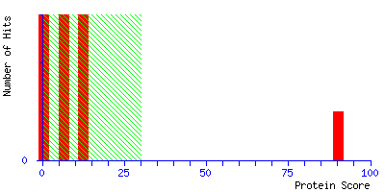 | UGPA_MUSAC | UTP-glucose-1-phosphate uridylyltransferase | - | 90 | Musa acuminata | 2% | 1 | 5.4/52 | R.FFDHAIGINVPR.S (90) | – |  |  | C | G
45 | 517 | ↑2.08/0.002 | 391 | ↑0.57/0.770 | 5.3/90 | 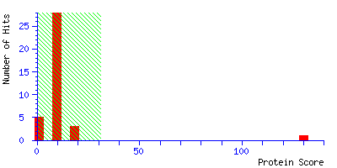 | tr|B9GEP0|B9GEP0_POPTR | Uncharacterized protein (Fragment) | - | 130 | Populus trichocarpa | 8% | 3 | 5.6/55 | R.GPSIWDTFTQDFPER.I (20)  K.FTGDGYDSGHFAPGR.C (70)  R.VEYHCTHLR.N (40) | PREDICTED: cyanogenic beta-glucosidase-like | Populus euphratica | 100/94/0.0 | C | G
46 | 536 | ↑1.38/0.005 | 406 | ↑0.91/0.221 | 5.8/93 | 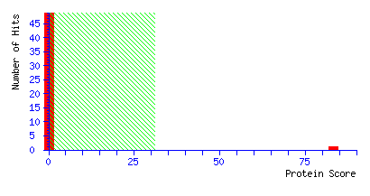 | PGMC_POPTN | Phosphoglucomutase, cytoplasmic | - | 83 | Populus tremula | 4% | 2 | 5.5/63 |  | – |  |  | C | G
Others (O)
47 | 267 | ↑1.59/0.005 | 220 | ↑0.79/0.633 | 5.7/48 | 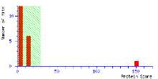 | GLNA1_LOTJA | Glutamine synthetase cytosolic isozyme | - | 150 | Lotus japonicus | 13% | 3 | 5.5/39 | K.WNYDGSSTGQAPGEDSEVILYPQAIFR.D (75)  R.DIVDAHYK.A (28)  K.EHIAAYGEGNER.R (47) | – |  |  | O | E
48 | 270 | ↑1.76/0.000 | 223 | ↑0.89/0.377 | 5.6/48 | 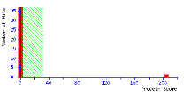 | tr|A9PF02|A9PF02_POPTR | Glutamine synthetase | C | 345 | Populus trichocarpa | 8% | 3 | 6.5/48 | K.IIAEYIWIGGSGLDLR.S (94)  K.EHIAAYGEGNER.R (19) | – |  |  | O | E
49 | 363* | ↑1.25/0.041 | 284 | ↑0.95/0.274 | 6.0/62 | 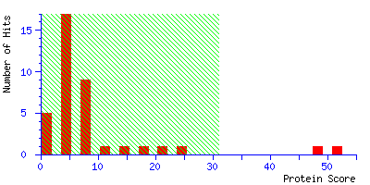 | tr|U7E1N4|U7E1N4_POPTR | S-adenosylmethionine synthase (Fragment) | - | 52 | Populus trichocarpa | 6% | 2 | 5.4/40 | K.TIFHLNPSGR.F (5)  R.FVIGGPHGDAGLTGR.K (46) | – |  |  | O | H
50 | 365 | ↑1.35/0.010 | 287 | ↑1.12/0.025 | 5.7/62 | 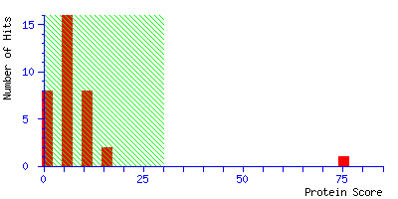 | METK_BRARP | S-adenosylmethionine synthase | - | 75 | Brassica rapa subsp. pekinensis | 6% | 2 | 5.7/44 | R.FVIGGPHGDAGLTGR.K (62)  K.TAAYGHFGR.D (13) | – |  |  | O | H
51 | 449 | ↑1.33/0.006 | 641 | ↓1e6/0.000 | 5.1/75 | 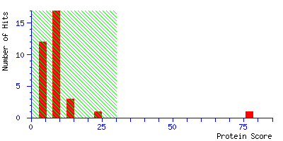 | TBB_HORVU | Tubulin beta chain | - | 77 | Hordeum vulgare | 8% | 4 | 4.5/51 | R.VNVYYNEASCGR.F (14)  K.IREEYPDR.M (18)  R.FPGQLNSDLR.K (23)  K.LAVNLIPFPR.L (25) | – |  |  | O | Z
52 | 470 | ↑1.38/0.039 | 361 | ↑0.86/0.888 | 5.8/81 | 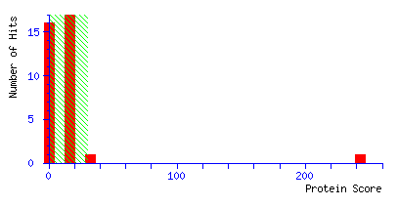 | tr|B9HBN0|B9HBN0_POPTR | Uncharacterized protein | C | 243 | Populus trichocarpa | 15% | 3 | 9.2/35 | K.IGGAEDVFVGDIR.E (78)  K.GRPEFYFEDGAFPEQVDWIGQK.N (66)  R.ELLVGKDDELLQTETR.T (99) | PREDICTED: uncharacterized protein At5g02240 | Populus euphratica | 100/93/0.0 | O | GM
53 | 720 | ↑2.36/0.000 | 115 | ↓0.85/0.490 | 5.6/27 | 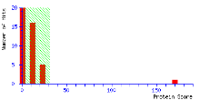 | tr|B9HBN0|B9HBN0_POPTR | Uncharacterized protein |  | 170 | Populus trichocarpa | 19% | 4 | 9.2/35 | K.IGGAEDVFVGDIR.E (52)  K.GRPEFYFEDGAFPEQVDWIGQK.N (74)  K.AFDLASKPEGTGTPANDFK.A (30)  K.ALFSQVTAR.F (15) | PREDICTED: Hypothetical protein CICLE_v10012166mg | Citrus clementina | 78/89/2E-156 | O | GM
54 | 748*** | ↑1e6/0.000 | – | – | 5.8/26 | 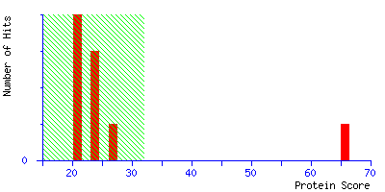 | tr|B9HBN0|B9HBN0_POPTR | Uncharacterized protein | C | 66 | Populus trichocarpa | 1% | 1 | 9.2/35 | K.IGGAEDVFVGDIR.E (66) | PREDICTED: uncharacterized protein At5g02240 | Populus euphratica | 100/99/0.0 | O | GM
Not identified
55 | 13 | ↑1.26/0.038 | 11 | ↑1.79/0.051 | 5.5/35 | NOT IDENTIFIED |  |  |  |  |  |  |  | –
56 | 262 | ↑1.50/0.002 | 216 | ↓0.99/0.128 | 5.8/48 | NOT IDENTIFIED
57 | 519 | ↑1.55/0.000 | 393 | ↑1.11/0.039 | 5.7/90 | NOT IDENTIFIED
58 | 520 | 1.73/0.002 | 394 | ↓0.94/0.317 | 5.7/90 | NOT IDENTIFIED
59 | 749 | ↑1e6/0.000 | 913 | ↑1e6/0.223 | 5.3/27 | NOT IDENTIFIED
60 | 763 | ↑1e6/0.000 | – | – | 5.7/36 | NOT IDENTIFIED
61 | 777 | ↑1e6/0.024 | – | – | 6.4/47 | NOT IDENTIFIED
62 | 916 | 1e6/0.002 | 81 | ↑1.79/0.010 | 4.9/23 | NOT IDENTIFIED
No. | Match ID ^{a)} | Ratio/ anova^{a)} | Match ID (Isolate H) ^{a)} | Ratio/ anova (Isolate H) ^{a)} | pI/ MW exp. ^{a)} | Graphical score distribution | Identification number | Identification |  | Score | Organism | Peptide Coverage | Peptide number | pI/ MW theor. | Peptides identified (Ions score) | Blast prediction ^{b)} | Blas- organism ^{b)} | Blat data ^{b)} | Functional group ^{c)}
Noninoculated vs inoculated with isolate L
Protein metabolism (P)
1 | 30 | ↓1.45/0.001 | 38 | ↓1.02/0.136 | 6.0/11 | 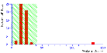 | IF5A1_NICPL | Eukaryotic translation initiation factor 5A-1 | - | 261 | Nicotiana plumbaginifolia | 19% | 2 | 5.7/18 | K.CHFVAIDIFTGK.K (30)  K.KLEDIVPSSHNCDVPHVNR.T (104) | - |  |  | P | J
2 | 151 | ↓1.54/0.011 | 195 | ↑1.02/0.085 | 6.2/22 | 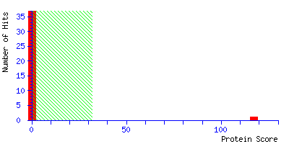 | tr|B9MU33|B9MU33_POPTR | 33 kDa ribonucleoprotein | C | 117 | Populus trichocarpa | 11% | 3 | 7.7/33 | R.EFFSTNCNPVSSR.V (87)  R.VVFDGPAGR.S (15)  R.SSGYGFVSFATR.E (58) | – |  |  | P | S
3 | 311*** | ↓1.63/0.021 | 399 | ↑1.32/0.024 | 5.7/54 | 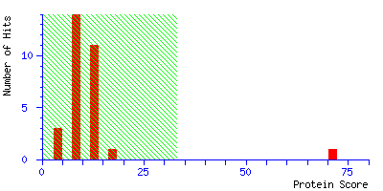 | PRS6A_BRACM | 26S protease regulatory subunit 6A homolog | - | 71 | Brassica campestris | 2% | 1 | 4.9/48 | R.KIEFPHPTEEAR.A (71) | – |  |  | P | O
4 | 343* | ↑1.48/0.002 | 441 | ↑0.86/0.287 | 6.6/58 | 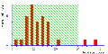 | RH52A_ORYSJ | DEAD-box ATP-dependent RNA helicase 52A | - | 38 | Oryza sativa subsp. japonica | 2% | 2 | 10.9/63 | K.VSLEAIKYLVMDEADR.M (38) | – |  |  | P | L
5 | 548 | ↓1e6/0.001 | 171 | ↑0.51/0.941 | 5.1/30 | 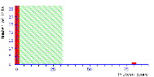 | tr|U5GDA1|U5GDA1_POPTR | Proteasome subunit alpha type | - | 80 | Populus trichocarpa | 15% | 3 | 5,7/27 | R.HITIFSPEGR.L (51)  K.ATEIEVGVVR.T (44)  R.VLSTEEIDEHLTAISERD.- (40) | - |  |  | P | O
6 | 599*** | ↓1e6/0.000 | 330 | ↓0.92/0.283 | 6.2/38 | 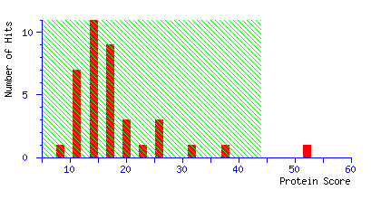 | gi|2462781 | Carbamoyl phosphate synthetase small subunit | C | 52 | Arabidopsis thaliana | 2% | 1 | 5.7/47 | K.FGHHGGNHPVR.N (52) | – |  |  | P | F
7 | 901 | ↑1e6/0.000 | – | – | 5.1/14 | 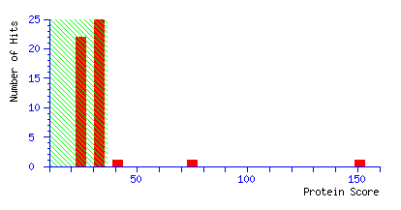 | tr|A9PB16|A9PB16_POPTR | Eukaryotic translation initiation factor 5A-2 | - | 151 | Populus trichocarpa | 18% | 4 | 5.6/18 | K.TYPQQAGTIR.K (50)  K.NGYIVIK.N (33)  R.LPTDDSLLTQIK.D (71)  R.LPTDDSLLTQIK.D (53) | – |  |  | P | J
Carbon fixation (F)
8 | 199 | ↓2.15/0.000 | 237 | ↓0.99/0.144 | 5.9/30 | 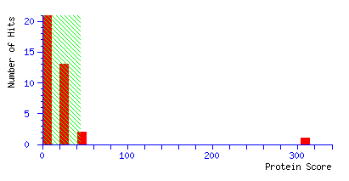 | gi|312281829 | Unnamed protein product | C | 309 | Thellungiella halophila | 11% | 3 | 6.5/43 | R.LASIGLENTEANR.Q (130)  K.GLVPLVGSNDESWCQGLDGLASR.T (125)  R.TAAYYQQGAR.F (54) | PREDICTED: probable fructose-bisphosphate aldolase 1, chloroplastic | Brassica oleracea var. oleracea | 100/96/0.0 | F | G
9 | 206 | ↓2.48/0.000 | 247 | ↓1.00/0.196 | 6.1/30 | 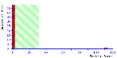 | tr|A9PGW0|A9PGW0_POPTR | Fructose-bisphosphate aldolase | C | 112 | Populus trichocarpa | 6% | 2 | 7.6/43 | R.LASIGLENTEANR.Q (68)  R.ATPEQVAEYTLK.L (74) | – |  |  | F | G
10 | 222 | ↓1.50/0.001 | 269 | ↓0.78/0.646 | 5.2/33 | 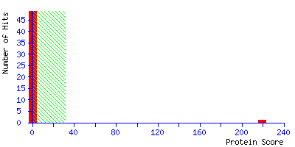 | tr|A9PF94|A9PF94_POPTR | Sedoheptulose-1 family protein | C | 220 | Populus trichocarpa | 10% | 4 | 5.8/43 | R.DQVAAAMGVYGPR.T (104)  R.DQVAAAMGVYGPR.T (58)  K.DYPGTHEFLLLDEGK.W (77)  R.YTGGMVPDVNQIIVK.E (72) | – |  |  | F | G
11 | 242 | ↓1.57/0.000 | 293 | ↓0.92/0.584 | 6.0/34 | 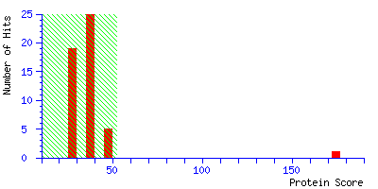 | gi|224109060 | PHOSPHOGLYCERATE KINASE 1 family protein | C | 175 | Populus trichocarpa | 6% | 2 | 8.3/50 | K.LVASLPDGGVLLLENVR.F (136)  K.ELPGVLALDEVER.V (39) | – |  |  | F | G
12 | 243 | ↓1.68/0.000 | 295 | ↓1.03/0.075 | 6.134 | 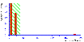 | PGKH_TOBAC | Phosphoglycerate kinase, chloroplastic | C | 182 | Nicotiana tabacum | 6% | 2 | 8.5/50 | K.LVASLPEGGVLLLENVR.F (100)  K.ELDYLVGAVSNPK.R (82) | – |  |  | F | G
13 | 246 | ↓1.39/0.048 | 297 | ↓1.31/0.000 | 5.3/35 | 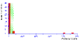 | tr|A9PGU7|A9PGU7_POPTR | Uncharacterized protein | C | 466 | Populus trichocarpa | 15% | 5 | 6.3/52 | R.WGGLVTDMSDDQQDISR.G (74)  K.SFQCELVFAK.M (52)  K.YLSEASLGEANQDSIDR.G (158)  R.GTFYGQAAQQVK.V (78)  K.VPVAEGCTDPNAANFDPTAR.S (107) | PREDICTED: ribulose bisphosphate carboxylase/oxygenase activase, chloroplastic isoform X1 | Populus euphratica | 100/97/0.0 | F | O
14 | 265 | ↓2.05/0.018 | 327 | ↓0.69/0.533 | 5.3/43 | 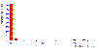 | tr|A9PGU7|A9PGU7_POPTR | Uncharacterized protein | C | 570 | Populus trichocarpa | 15% | 5 | 6.3/52 | R.WGGLVTDMSDDQQDISR.G (110)  K.SFQCELVFAK.M (60)  K.YLSEASLGEANQDSIDR.G (176)  R.GTFYGQAAQQVK.V (89)  K.VPVAEGCTDPNAANFDPTAR.S (138) | PREDICTED: ribulose bisphosphate carboxylase/oxygenase activase, chloroplastic isoform X1 | Populus euphratica | 100/97/0.0 | F | O
15 | 281 | ↓1.21/0.012 | 354 | ↓0.96/0.206 | 5.2/46 | 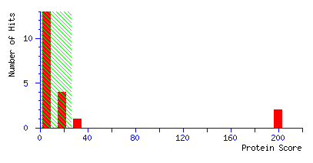 | RCAB_HORVU | Ribulose bisphosphate carboxylase/oxygenase activase B, chloroplastic | C | 200 | Hordeum vulgare | 8% | 2 | 7.6/47 | R.VPIIVTGNDFSTLYAPLIR.D (111)  R.LVDTFPGQSIDFFGALR.A (89) | – |  |  | F | O
16 | 318 | ↓1.35/0.004 | 409 | ↑0.72/0.990 | 5.8/55 | 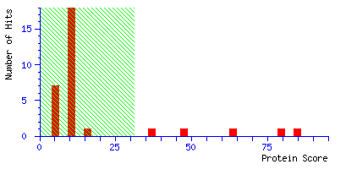 | RBL_ANTHE | Ribulose bisphosphate carboxylase large chain (Fragment) | C | 85 | Anthospermum herbaceum | 5% | 2 | 5.9/52 | K.TFQGPPHGIQVER.D (49)  R.DITLGFVDLLR.D (36) | – |  |  | F | C
17 | 374 | ↓3.38/0.000 | - | - | 5.9/64 | 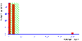 | tr|B9MZ75|B9MZ75_POPTR | RUBISCO SUBUNIT BINDING-protein ALPHA SUBUNIT | - | 199 | Populus trichocarpa | 9% | 5 | 5.2/62 | K.LADAVGLTLGPR.G (46)  R.NVVLDEFGSPK.V (45)  R.GYISPQFVTNPEK.L (38)  K.LICEFENAR.V (35)  K.ELSETDSVYDSEK.L (35) | – |  |  | F | O
18 | 385 | ↓1.44/0.019 | 507 | ↑0.60/0.646 | 4.9/65 | 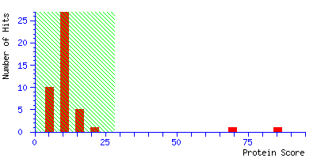 | RUBA_PEA | RuBisCO large subunit-binding protein subunit alpha, chloroplastic | C | 85 | Pisum sativum | 4% | 2 | 5.2/62 | K.LADAVGLTLGPR.G (56)  K.VGAATETELEDR.K (29) | – |  |  | F | O
19 | 494 | ↑1.43/0.034 | 681 | ↑0.95/0.915 | 5.9/114 | 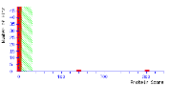 | tr|A9PFQ2|A9PFQ2_POPTR | Uncharacterized protein | C | 301 | Populus trichocarpa | 13% | 4 | 5.3/52 | K.SFQCELVFAK.M (51)  R.VPIIVTGNDFSTLYAPLIR.D (138)  K.LVDTFPGQSIDFFGALR.A (127)  K.VPIPEGCTDPNAANFDPTAR.S (75) | PREDICTED: ribulose bisphosphate carboxylase/oxygenase activase, chloroplastic-like isoform X1 | Populus euphratica | 100/97/0.0 | F | O
20 | 520 | ↓1.60/0.012 | 355 | ↑0.54/0.886 | 5.0/46 | 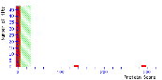 | tr|A9PFQ2|A9PFQ2_POPTR | Uncharacterized protein | C | 291 | Populus trichocarpa | 13% | 4 | 8.6/47 | K.SFQCELVFAK.M (32)  R.VPIIVTGNDFSTLYAPLIR.D (138)  K.LVDTFPGQSIDFFGALR.A (127)  K.VPIPEGCTDPNAANFDPTAR.S (85) | PREDICTED: ribulose bisphosphate carboxylase/oxygenase activase, chloroplastic-like isoform X1 | Populus euphratica | 100/97/0.0 | F | O
21 | 523 | ↓1e6/0.000 | 24 | ↑0.54/0.640 | 5.2/10 | 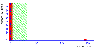 | tr|B9HY29|B9HY29_POPTR | Phosphoglycerate kinase, chloroplastic | C | 144 | Populus trichocarpa | 6% | 2 | 8.3/50 | K.LVASLPDGGVLLLENVR.F (136)  K.ELPGVLALDEVER.V (39) | – |  |  | F | G
22 | 572 | ↓1e6/0.002 | 240 | ↑1.05/0.084 | 5.7/30 | 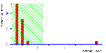 | ALFC1_ARATH | Probable fructose-bisphosphate aldolase 1. chloroplastic | C | 80 | Arabidopsis thaliana | 5% | 2 | 6.2/43 | K.SNIAEIPDLDDEYRK.V (60)  R.TAAYYQQGAR.F (20) | – |  |  | F | G
23 | 583 | ↓1e6/0.000 | 266 | ↑2.44/0.000 | 5.8/33 | 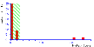 | RCAB_HORVU | Ribulose bisphosphate carboxylase/oxygenase activase B, chloroplastic | C | 236 | Hordeum vulgare | 8% | 2 | 7.6/47 | R.VPIIVTGNDFSTLYAPLIR.D (109)  R.LVDTFPGQSIDFFGALR.A (127) | – |  |  | F | O
24 | 585 | ↓1e6/0.002 | 273 | ↑0.59/0.651 | 5.2/34 | 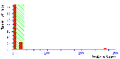 | tr|A9PF94|A9PF94_POPTR | Sedoheptulose-1 family protein | C | 269 | Populus trichocarpa | 10% | 4 | 5.8/43 | R.DQVAAAMGVYGPR.T (103)  R.DQVAAAMGVYGPR.T (49)  K.DYPGTHEFLLLDEGK.W (117)  K.GVFTNVISPSSK.A (49) | – |  |  | F | G
25 | 593 | ↓1e6/0.030 | 304 | ↓1.24/0.003 | 5.2/37 | 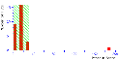 | tr|U5G4W8|U5G4W8_POPTR | Uncharacterized protein | S | 187 | Populus trichocarpa | 6% | 2 | 6.1/39 | K.FYWAPTR.D (32)  K.YLSEASLGEANQDSIDR.G (155) | PREDICTED: ribulose bisphosphate carboxylase/oxygenase activase, chloroplastic isoform X1 | Populus euphratica | 100/97/0.0 | F | O
26 | 606 | ↓1e6/0.000 | 350 | ↓0.83/0.383 | 4.9/42 | 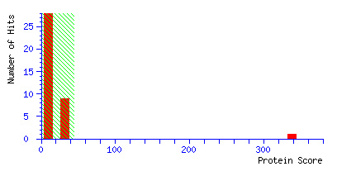 | gi|118487547 | Unknown | C | 338 | Populus trichocarpa | 9% | 3 | 6.3/52 | K.FYWAPTR.D (34)  K.YLSEASLGEANQDSIDR.G (148)  K.VPVAEGCTDPNAANFDPTAR.S (157) | PREDICTED: ribulose bisphosphate carboxylase/oxygenase activase, chloroplastic isoform X1 | Populus euphratica | 100/97/0.0 | F | O
27 | 806 | ↑2.4/0.023 | – | – | 5.7/58 | 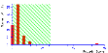 | tr|A0A0A0V020|A0A0A0V020_POPTR | Ribulose bisphosphate carboxylase large chain | C | 69 | Populus trichocarpa | 4% | 2 | 6.0/53 | K.TFQGPPHGIQVER.D (40)  R.DNGLLLHIHR.A (29) | – |  |  | F | C
Light dependent phase of photosynthesis (L)
28 | 39 | ↓1.42/0.007 | 48 | ↑1.02/0.083 | 5.4/12 | 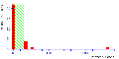 | UCRIA_PEA | Cytochrome b6-f complex iron-sulfur subunit | C | 162 | Populus trichocarpa | 17% | 3 | 6.5/25 | K.DALGNDIVVEQWLK.T (148)  K.FICPCHGSQYNDQGR.V (76)  K.VVFVPWVETDFR.T (97) |  |  |  | L | C
29 | 74 | ↑1.25/0.010 | 83 | ↑1.69/0.000 | 6.4/14 | 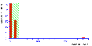 | tr|A9PHA9|A9PHA9_POPTR | O2 evolving complex 33kD family protein | C | 262 | Populus trichocarpa | 11% | 3 | 5.9/35 | K.RLTYDEIQSK.T (63)  K.NAPPEFQNTK.L (63)  R.GGSTGYDNAVALPAGGR.G (136) | – |  |  | L | G
30 | 82 | ↓5.10/0.002 | 91 | ↓0.93/0.178 | 4.8/14 | 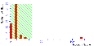 | tr|A9PE75|A9PE75_POPTR | Chlorophyll A-B binding family protein | C | 115 | Populus trichocarpa | 8% | 2 | 9.1/30 | K.AGLIPPETALPWFR.T (69)  K.QYFLGFEK.Y (46) | – |  |  | L | S
31 | 88 | ↓3.43/0.000 | 100 | ↓0.89/0.786 | 5.6/15 | 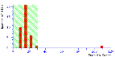 | tr|A9PE75|A9PE75_POPTR | Chlorophyll A-B binding family protein | C | 109 | Populus trichocarpa | 8% | 2 | 9.1/30 | K.AGLIPPETALPWFR.T (54)  K.QYFLGFEK.Y (55) | – |  |  | L | S
32 | 104 | ↓6.64/0.000 | 117 | ↓1.18/0.007 | 5.1/16 | 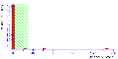 | tr|A9PEI5|A9PEI5_POPTR | Chlorophyll a-b binding protein 2 |  | 187 | Populus trichocarpa | 12% | 3 | 5.3/28 | K.TTKPVPSGSPWYGPDR.V (125)  R.WAMLGALGCVFPELLSR.N (92)  R.WAMLGALGCVFPELLSR.N (17) | – |  |  | L | J
33 | 522 | ↓1e6/0.000 | 21 | ↑0.75/0.467 | 5.0/13 | 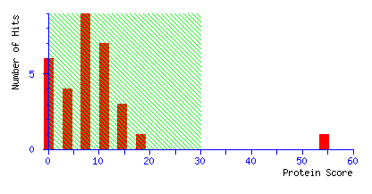 | tr|B9H7J7|B9H7J7_POPTR | Uncharacterized protein | M | 54 | Populus trichocarpa | 11% | 2 | 5.1/24 | R.EYGGQWLSSVTR.H (44)  R.LIGSDIEHYIR.K (10) | PREDICTED: NAD(P)H-quinone oxidoreductase subunit M, chloroplastic | Populus euphratica | 100/98/3E-110 | L | C
Stress response (S)
34 | 468 | ↑1.28/0.0261 | 640 | ↑1.36/0.010 | 5.6/74 | 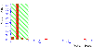 | tr|B9HMG7|B9HMG7_POPTR | Heat shock protein 70 cognate | - | 128 | Populus trichocarpa | 6% | 3 | 5.1/72 | R.TTPSYVAFTDTER.L (33)  K.NAVVTVPAYFNDSQR.Q (38)  K.STVHDAVLVGGSTR.I (57) | – |  |  | S | O
35 | 693 | ↓1e6/0.013 | 567 | ↓0.59/0.460 | 5.2/72 | 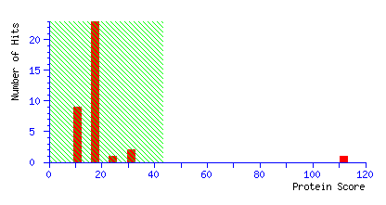 | gi|762844 | Hsp 70 | - | 112 | Solanum lycopersicum | 5% | 3 | 5.2/72 | R.VEIIANDQGNR.T (33)  K.NAVVTVPAYFNDSQR.Q (66)  K.FELTGIPPAPR.G (13) | – |  |  | S | O
ROS scruvangers (R)
36 | 28 | ↓1.82/0.003 | 33 | ↓0.88/0.764 | 5.7/10 | 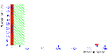 | tr|U5G0C8|U5G0C8_POPTR | Superoxide dismutase [Cu-Zn] (Fragment) | M | 219 | Populus trichocarpa | 9% | 3 | 8.2/31 | K.KLTHGAPEDEIR.H (82)  K.LTHGAPEDEIR.H (82)  K.GGHELSSTTGNAGGR.L (117) | - |  |  | R | P
37 | 65 | ↓2.26/0.003 | 74 | ↑0.72/0.731 | 5.1/14 | 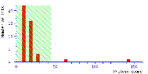 | gi|224091909 | 2-cys peroxiredoxin | C | 143 | Populus trichocarpa | 14% | 3 | 6.8/29 | K.YPLISDVTK.S (14)  K.SYGVLIPDQGVALR.G (22)  K.EGVIQHSTINNLAIGR.S (107)) | - |  |  | R | O
38 | 68 | ↓1.60/0.017 | 77 | ↑0.52/0.871 | 5.0/14 | 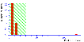 | BAS1_ORYSJ | 2-Cys peroxiredoxin BAS1, chloroplastic | C | 122 | Oryza sativa subsp. japonica | 9% | 2 | 5.7/28 | K.YPLISDVTK.S (14)  K.EGVIQHSTINNLAIGR.S (107) | – |  |  | R | O
39 | 70 | ↓3.17/0.002 | 79 | ↑0.78/0.602 | 4.8/14 | 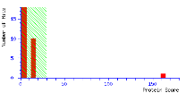 | tr|A9PAB9|A9PAB9_POPT | Putative uncharacterized protein | C | 162 | Populus trichocarpa | 11% | 2 | 6.8/29 | K.SYGVLIPDQGVALR.G (69)  K.EGVIQHSTINNLAIGR.S (92) | PREDICTED: peroxiredoxin family protein | Populus trichocarpa | 91/99/ 2e-169 | R | O
40 | 77 | ↓1.42/0.020 | 86 | ↑0.86/0.518 | 6.8/14 | 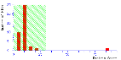 | tr|A9PHH6|A9PHH6_POPTR | Phi class glutathione transferase | - | 87 | Populus trichocarpa | 8% | 2 | 6.3/24 | K.DESITLFESR.A (73)  R.WWTEISNR.E (13) | – |  |  | R | O
41 | 110 | ↓2.00/0.000 | 126 | ↑1.04/0.132 | 5.9/17 | 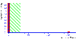 | tr|B9HQ83|B9HQ83_POPTR | Cytosolic ascorbate peroxidase family protein | - | 152 | Populus trichocarpa | 22% | 4 | 5.5/27 | R.LAWHSAGTFDVK.T (56)  R.EDKPEPPPEGR.L (51)  K.ALLSDPIFRPYVDK.Y (38)  K.YAADEDAFFADYSEAHLK.L (95) | – |  |  | R | P
Carbohydrate metabolism (C)
42 | 339** | ↑1.25/0.010 | 435 | ↑1.71/0.000 | 5.8/58 | 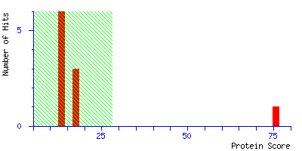 | UGPA_MUSAC | UTP-glucose-1-phosphate uridylyltransferase | - | 75 | Musa acuminata | 2% | 1 | 5.5/56 | R.KIEFPHPTEEAR.A (71) | – |  |  | C | G
Not identified
43 | 40 | ↓1.39/0.006 | 49 | ↑0.90/0.431 | 4.3/12 | NOT IDENTIFIED
44 | 60 | ↑.82/0.030 | 70 | ↑1.55/0.0001 | 6.4/21 | NOT IDENTIFIED
45 | 71 | 1.72/0.026 | 80 | ↑0.96/0.141 | 5.3/14 | NOT IDENTIFIED
46 | 78 | ↓1.98/0.049 | 87 | ↓0.55/0.965 | 6.2/14 | NOT IDENTIFIED
47 | 79 | ↓2.01/0.000 | 88 | ↑0.81/0.523 | 6.1/14 | NOT IDENTIFIED
48 | 81 | ↑1.79/0.010 | 916 | ↓1e6/0.002 | 5.0/14 | NOT IDENTIFIED
49 | 128 | ↓1.83/0.007 | 920 | ↓1e6/0.179 | 5.0/20 | NOT IDENTIFIED
50 | 308 | ↑1.40/0.013 | 725 | ↑1.91/0.000 | 6.6/51 | NOT IDENTIFIED
51 | 372 | ↑1.21/0.046 | 492 | ↑1.76/0.000 | 5.9/84 | NOT IDENTIFIED
52 | 461 | ↑2.6/0.002 | 622 | ↑0.29/0.876 | 5.3/101 | NOT IDENTIFIED
53 | 483 | ↑2.13/0.006 | 667 | ↑0.83/0.424 | 5.6/112 | NOT IDENTIFIED
54 | 531 | ↓1e6/0.000 | 92 | ↑0.16/0.769 | 5.3/14 | NOT IDENTIFIED
55 | 641 | ↓1e6/0.000 | 449 | ↑1.33/0.006 | 5.1/60 | NOT IDENTIFIED
56 | 682 | ↓1e6/0.000 | 545 | ↑0.80/0.410 | 5.3/72 | NOT IDENTIFIED

ª Data obtained from the proteomic analysis performed using Image Master Platinum 7.0 software. Values obtained for the ratio and ANOVA of the analysed spots and the corresponding spots from the second analysis (where possible).
^{b} Subcellular localization analysed with TargetP 1.1. software (http://www.cbs.dtu.dk/services/TargetP/).
^{c} Data obtained during the NCBI BlastP database search (http://blast.ncbi.nlm.nih.gov/Blast.cgi): Query coverage/Identity/E value.
^{d} Functional classification (based on the main function of the particular proteins): protein metabolism (P); carbon fixation (F); light-dependent phase of photosynthesis (L); stress response (S); ROS scavenging (R); carbohydrate metabolism (C); and others (O). This functional classification, which is more informative (than the classification based on COG; see below) for leaf proteome data, was used for preparation of Fig. S2-2.
^{e} COG (Clusters of Orthologous Groups of proteins) classes. C, Energy production and conversion; E, Amino acid transport and metabolism; G, Carbohydrate transport and metabolism; H, Coenzyme transport and metabolism; J, Translation, ribosomal structure and biogenesis; K, Transcription; L, Replication, recombination and repair; M, Cell wall/membrane/envelope biogenesis; O, Posttranslational modification, protein turnover, chaperones; P, Inorganic ion transport and metabolism; S, Function unknown and Z, Cytoskeleton (prepared based on the EggNOG database http://eggnogdb.embl.de/#/app/home). A graphical presentation of the COG classification is also presented in Figure S2-3 (see below).
Bold: spots common to both analyses; *spots with more than one identified protein (excluded from further discussion); ** spots identified on the basis of one peptide, but cross-identified with the corresponding, common spot (bold; not excluded from further discussion); *** spots identified on the basis of one peptide (excluded from further discussion).

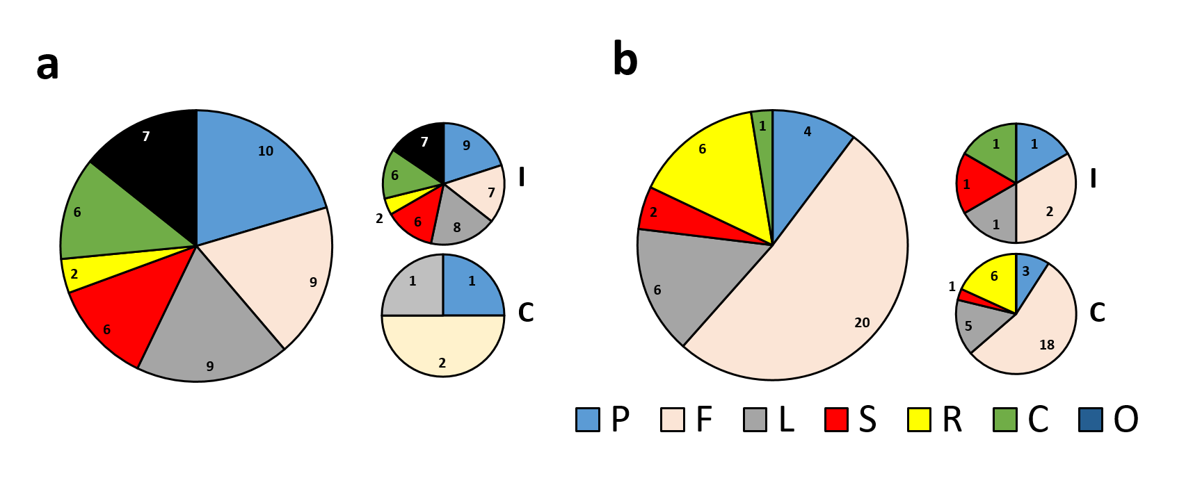
Fig. S2-2. Results of the functional classification of the identified proteins: protein metabolism (P); carbon fixation (F); the light-dependent phase of photosynthesis (L); the stress response (S); ROS scavenging (R); carbohydrate metabolism; (C) and others (O). Distribution of proteins belonging to different functional groups (large pie charts). Distribution of the proteins with higher abundances in the control and inoculated treatments (small pie charts) for all four treatments in the comparative IMP 7.0 analysis (‘I’: higher abundances in inoculated treatment; ‘C’ higher abundances in control treatment). The numbers of identified proteins are shown for all treatments. Comparative analysis of proteins isolated from control leaves and leaves of plants inoculated with isolates H (a) and L (b)

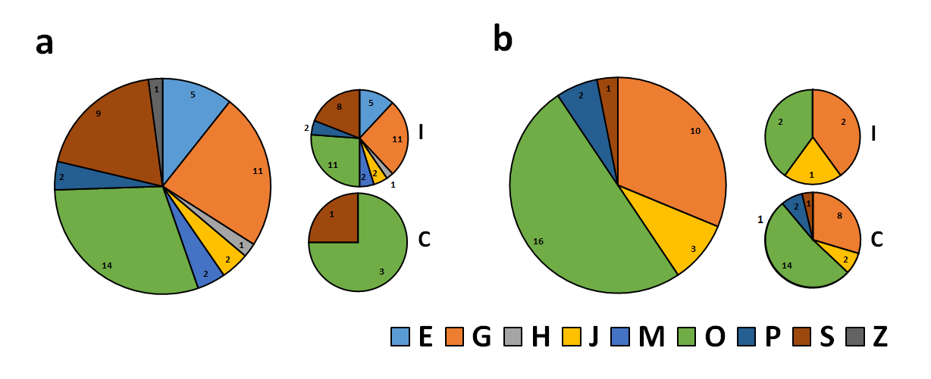
Fig. S2-3. Results of the functional classification of the identified proteins, according to COG classes. C, Energy production and conversion; E, Amino acid transport and metabolism; G, Carbohydrate transport and metabolism; H, Coenzyme transport and metabolism; J, Translation, ribosomal structure and biogenesis; K, Transcription; L, Replication, recombination and repair; M, Cell wall/membrane/envelope biogenesis; O, Posttranslational modification, protein turnover, chaperones; P, Inorganic ion transport and metabolism; S, Function unknown and Z, Cytoskeleton. Distribution of proteins belonging to different functional groups (large pie charts). Distribution of the more abundant proteins in the control and inoculated treatments (small pie charts) for all four treatments in the comparative IMP 7.0 analysis (‘I’: more in inoculated treatment; ‘C’ more in control treatment). The numbers of identified proteins are shown for all treatments. Comparative analysis of proteins isolated from control leaves and leaves of plants inoculated with isolates H (a) and L (b)

