Niche differentiation of Mucoromycotinian and Glomeromycotinian arbuscular mycorrhizal fungi along a 2-million-year soil chronosequence
Thomas M Mansfield^{1*}, Felipe E. Albornoz^{1,2,3}, Megan H. Ryan³, Gary D. Bending⁴ and Rachel J. Standish¹
¹Environmental and Conservation Sciences, Murdoch University, Murdoch, WA 6150, Australia.
² Commonwealth Scientific and Industrial Research Organisation, Land and Water, Wembley, WA, Australia
³UWA School of Agriculture and Environment, University of Western Australia, Crawley, WA 6009, Australia.
⁴School of Life Sciences, University of Warwick, Coventry, CV4 7AL, United Kingdom.
*Corresponding Author: Thomas Mansfield (Ph: +61 452 575 312; email: Thomas.Mansfield@murdoch.edu.au; postal address: 90 South Street, Murdoch University, Murdoch, WA, 6150, Australia)

Journal applying to: Mycorrhiza

Supplementary Figures
Figure S1. Four stages, in ascending chronosequence stage, of the Warren soil chronosequence in south-west Western Australia. This soil chronosequence is a sequence of dunes generated over 2-million years. Stage 1 (A) Meerup Leached over Calcerous Sands <6.5 ka. Stage 2 (B) Meerup Podzols over Calcerous Sands ~6.5 ka. Stage 3 (C) Meerup Podzols in Silicerous Sands 120-500 ka. Stage 4 (D) Cleave >2,000 ka. Dune classification follows Turner et al. (2018). These sites all follow the Warren Beach Road, south of the Warren River. Images: Ruipeng Yu.

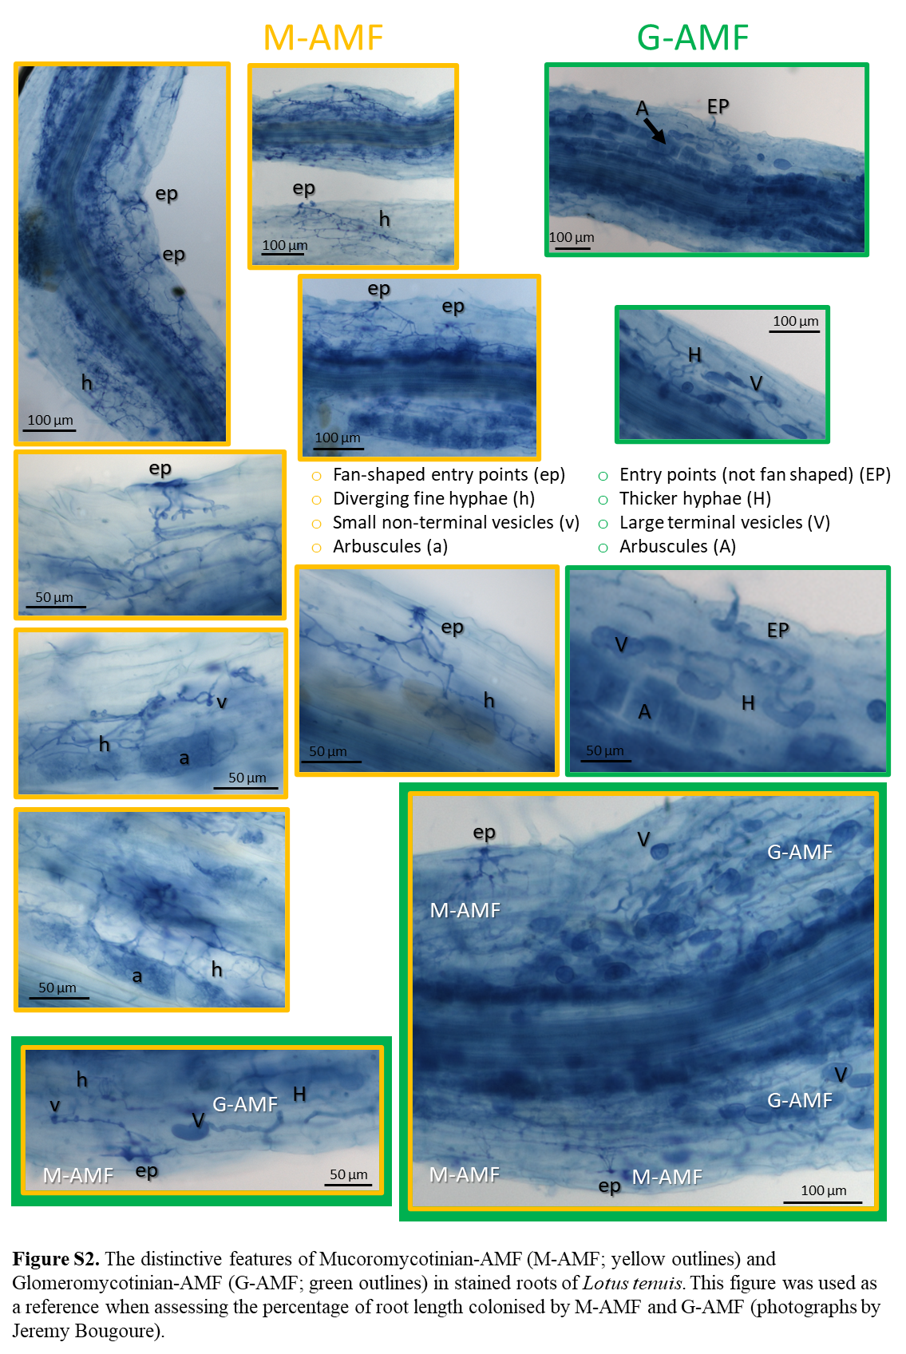
Figure S2. The distinctive features of Mucoromycotinian-AMF (M-AMF; yellow outlines) and Glomeromycotinian-AMF (G-AMF; green outlines) in stained roots of Lotus tenuis. This figure was used as a reference when assessing the percentage of root length colonised by M-AMF and G-AMF (photographs by Jeremy Bougoure).

