Supplementary Information (SI)
SI Table 1. Mineral nutrient concentrations and properties of the crushed glass mixture in the interstices between cone-tainers and soil within cone-tainers of each pot.
Soil characteristic* | Interstitial crushed glass mixture | Soil (within cone-tainers)
Phosphorus (μg g⁻¹) | 6.0 (Bray) | 10.2 (Olsen)
Potassium (μg g⁻¹) | 24.0 | 38
Nitrate (μg g⁻¹) | 0.7 | 9.4
Ammonium (μg g⁻¹) | 0.9 | 5.35
Magnesium (μg g⁻¹) | 39.0 | 147.9
Calcium (μg g⁻¹) | 323.0 | 2511.6
Sodium (μg g⁻¹) | 90.0 | 54.7
Manganese (μg g⁻¹) | 1.0 | 1.5
Iron (μg g⁻¹) | 5.0 | 153.8
pH | 7.9 | 7.6
Cation Exchange Capacity  (meq 100g⁻¹) | 1.0 | 14.22

SI Table 2. Samples size (N; total number of pots), mean shoot dry weight (DW), standard error (SE), coefficient of variation (C.V.), and the range of average plant sizes (Minimum and Maximum) per pot within the Watered, Intact CMNs treatment before and after omission of an outlier that affected normality of the residuals, which violated the two-factor ANOVA
 | N | Mean Shoot DW per pot | SE | C.V. | Minimum | Maximum
Before outlier omission | 10 | 0.0287 | 0.0033 | 35.75 | 0.0175 | 0.055
After outlier omission | 9 | 0.0258 | 0.0016 | 18.35 | 0.0175 | 0.034

SI Table 3. Statistical analysis results from tests for assumptions (Levene’s test and Shapiro-Wilk test) of a two-factor ANOVA, as well as Two-Factor ANOVA results before and after an outlier was removed from the Watered, Intact CMNs treatment
 | Test for Homogenous variance |  | Test for Normal Residuals |  | Two-Factor ANVOA
Data Management | Levene’s Test F | P | Shapiro-Wilk W | P | Factor | df | F | P
Before outlier omission | 1.10 | 0.3642 | 0.8734 | 0.0006 | CMNs | 1,33 | 6.84 | 0.0133
 |  |  |  |  | Water | 1,33 | 42.73 | <0.0001
 |  |  |  |  | CMNs x Water | 1,33 | 0.46 | 0.5001
After outlier omission | 2.23 | 0.1036 | 0.9813 | 0.7899 | CMNs | 1,32 | 7.23 | 0.0113
 |  |  |  |  | Water | 1,32 | 64.51 | <0.0001
 |  |  |  |  | CMNs x Water | 1,32 | 3.26 | 0.0806

SI Table 4. Principle components analysis (PCA) percentage of variance represented by the first axis, loadings on Axis 1 for the four PCA-summarized neighbor categories, and the correlation between Axis 1 and target whole-plant dry weights prior to rotation of Axis 1 for treatments with drought or watered conditions and with severed or intact common mycorrhizal networks (CMNs). For all treatments, the first axis was the only significant axis in explaining the variance among neighboring plants
 | Proportion of variance (P*) | Pearson's correlation coefficient with Axis 1†, r
Treatment | Axis 1 | Largest neighbor | 2nd largest neighbor | 3rd largest neighbor | 4th largest neighbor | Targets
Intact CMNs, Watered | 80.5% | -0.921 | -0.946 | -0.904 | -0.744 | -0.517
Intact CMNs, Watered | (0.001)
Intact CMNs, Drought | 92.9% | -0.956 | -0.983 | -0.986 | -0.897 | -0.561
Intact CMNs, Drought | (0.001)
Severed CMNs, Watered | 68.0% | 0.802 | 0.108 | -0.975 | 0.953 | 0.007
Severed CMNs, Watered | (0.011)
Severed CMNs, Drought | 76.6% | -0.966 | -0.971 | -0.5 | -0.529 | -0.101
Severed CMNs, Drought | (0.005)

SI Table 5. Two-way ANOVA results (degrees of freedom, F-statistics, and associated P values) for the main effect of watering conditions, CMN treatments (intact or severed), and their interaction on shoot mineral nutrient concentrations of pooled samples based upon shoot dry weights of Andropogon gerardii seedlings
 | Treatment |  | Value |  |  | Main Effect Water |  | Main Effect CMNs |  | Water x CMNs
Nutrient (unit) | Watering Condition | CMNs | Mean | SD | df | F | P | F | P | F | P
P (%) | Watered | Intact | 0.190 | 0.041 | 1,33 | 0.00 | 0.967 | 3.12 | 0.086 | 1.50 | 0.230
P (%) | Watered | Severed | 0.165 | 0.022
P (%) | Drought | Intact | 0.176 | 0.043
P (%) | Drought | Severed | 0.146 | 0.033
K (%) | Watered | Intact | 0.960 | 0.233 | 1,33 | 0.78 | 0.384 | 2.09 | 0.158 | 0.04 | 0.853
K (%) | Watered | Severed | 1.140 | 0.187
K (%) | Drought | Intact | 1.014 | 0.161
K (%) | Drought | Severed | 1.057 | 0.164
Ca (%) | Watered | Intact | 0.882 | 0.215 | 1,33 | 5.13 | 0.030 | 2.57 | 0.118 | 2.74 | 0.108
Ca (%) | Watered | Severed | 1.170 | 0.277
Ca (%) | Drought | Intact | 0.928 | 0.173
Ca (%) | Drought | Severed | 0.878 | 0.134
Mg (%) | Watered | Intact | 0.323 | 0.046 | 1,33 | 0.04 | 0.835 | 0.05 | 0.819 | 0.00 | 0.976
Mg (%) | Watered | Severed | 0.323 | 0.042
Mg (%) | Drought | Intact | 0.326 | 0.038
Mg (%) | Drought | Severed | 0.319 | 0.040
S* (%) | Watered | Intact | 0.171^{AB} | 0.036 | 1,32 | 15.66 | 0.004 | 2.19 | 0.149 | 5.47 | 0.026
S* (%) | Watered | Severed | 0.251^{A} | 0.023
S* (%) | Drought | Intact | 0.191^{B} | 0.026
S* (%) | Drought | Severed | 0.159^{C} | 0.020
Cu* (ppm) | Watered | Intact | 21.2 | 4.12 | 1,31 | 2.10 | 0.157 | 2.40 | 0.132 | 0.00 | 0.960
Cu* (ppm) | Watered | Severed | 25.9 | 2.97
Cu* (ppm) | Drought | Intact | 23.3 | 3.58
Cu* (ppm) | Drought | Severed | 23.4 | 2.66
Fe* (ppm) | Watered | Intact | 913^{C} | 417 | 1,33 | 24.59 | <0.0001 | 37.18 | <0.0001 | 12.71 | 0.001
Fe* (ppm) | Watered | Severed | 5532^{A} | 2505
Fe* (ppm) | Drought | Intact | 1134^{BC} | 472
Fe* (ppm) | Drought | Severed | 1420^{B} | 718
Mn* (ppm) | Watered | Intact | 20.5 | 9.4 | 1,33 | 40.84 | <0.0001 | 0.32 | 0.574 | 3.17 | 0.084
Mn* (ppm) | Watered | Severed | 63.4 | 15.8
Mn* (ppm) | Drought | Intact | 54.0 | 27.7
Mn* (ppm) | Drought | Severed | 14.0 | 11.9
Zn* (ppm) | Watered | Intact | 56.3^{B} | 16.6 | 1,32 | 1.83 | 0.186 | 4.36 | 0.045 | 6.49 | 0.016
Zn* (ppm) | Watered | Severed | 48.1^{B} | 3.8
Zn* (ppm) | Drought | Intact | 119.6^{A} | 82.2
Zn* (ppm) | Drought | Severed | 61.8^{B} | 22.7
* indicates data were transformed (as described in Statistical Methods) prior to analysis
SI Table 6. Two-way Repeated Measures ANOVA results (degrees of freedom, F-statistics, and associated P values) for the main effects of CMNs (intact or severed CMNs) and watering treatments (watered or drought) and their interaction on the rate of drying (change in % substrate moisture per day) of cone-tainer soil and interstitial substrate soil moisture over time
Substrate | Factor | Df | F | P
Cone-tainer soil | CMN | 1, 33 | 0.17 | 0.6869
Cone-tainer soil | Water | 1, 33 | 2.90 | 0.0978
Cone-tainer soil | CMN x Water | 1, 33 | 2.20 | 0.1477
Cone-tainer soil | Time | 17, 561 | 107.16 | < 0.00001*
Cone-tainer soil | CMN x Time | 17, 561 | 2.76 | 0.0104*
Cone-tainer soil | Water x Time | 17, 561 | 28.49 | < 0.00001*
Cone-tainer soil | CMN x Water x Time | 17, 561 | 3.77 | 0.0009*
Interstitial Substrate | CMN | 1, 33 | 0.75 | 0.3936
Interstitial Substrate | Water | 1, 33 | 6.73 | 0.0140
Interstitial Substrate | CMN x Water | 1, 33 | 0.54 | 0.4690
Interstitial Substrate | Time | 17, 561 | 253.01 | < 0.00001*
Interstitial Substrate | CMN x Time | 17, 561 | 1.81 | 0.0920*
Interstitial Substrate | Water x Time | 17, 561 | 19.68 | < 0.00001*
Interstitial Substrate | CMN x Water x Time | 17, 561 | 1.13 | 0.3481*

* indicates a Greenhouse-Geisser Corrected P-value for non-sphericity after a significant Mauchly’s Sphericity Assumption test (P<0.05).

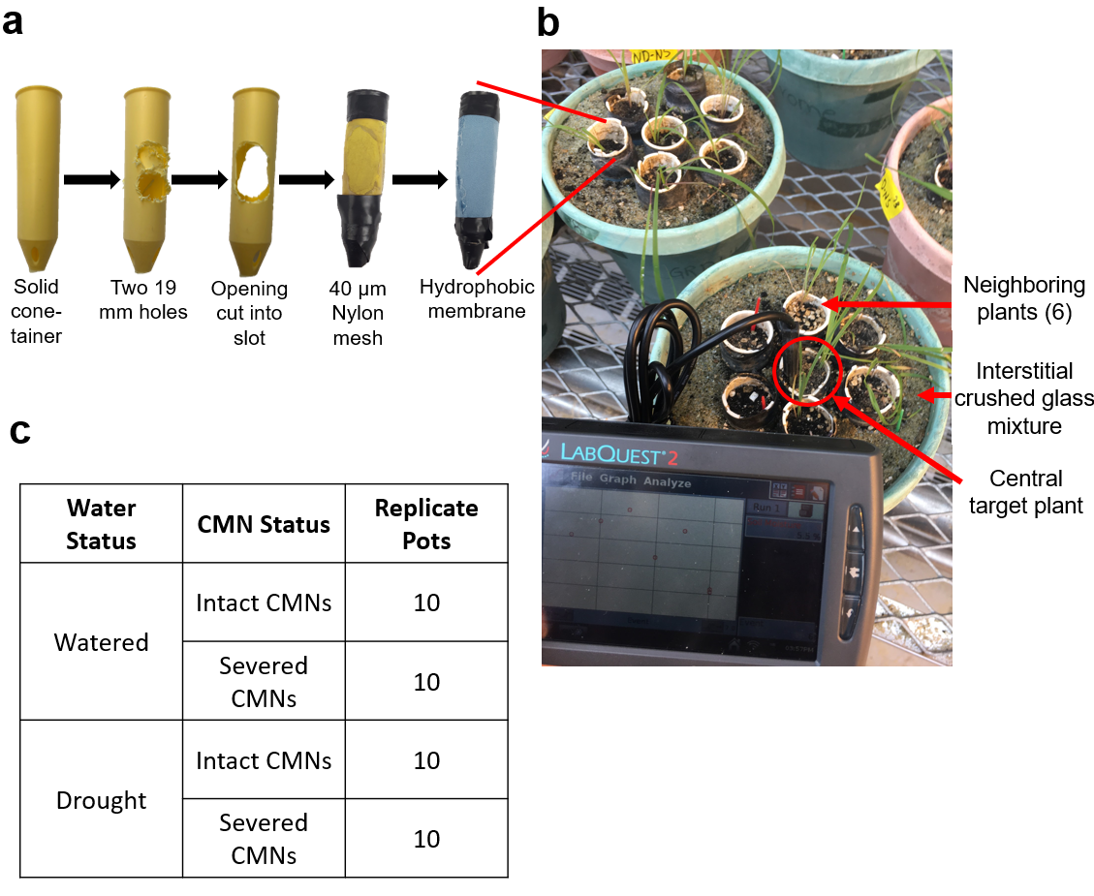
SI Figure 1: Experiment design of modified Ray Leach Cone-tainers ™ (a) as they were modified with openings, 40 µm nylon silk screen mesh, and a Gore-Tex ™ hydrophobic membrane. Individual Andropogon gerardii seedlings were grown in modified cone-tainers with nylon mesh and hydrophobic membranes that were placed into pots (b) in which a central target plant was surrounded by six equidistant neighboring. The interstices were filled with a 4:1 nutrient-poor fine crushed glass (20-40 grade, Harsco Corporation, Camp Hill, PA, USA) and glass bead (12-20 grade, Industrial Supply, Inc, Twin Falls, ID, USA) mixture. Modified cone-tainers were filled with a sandy soil mixture. Nutrient concentrations of media can be found in SI Table 1. The photo (b) additionally depicts the frequent soil moisture measurements that were conducted with using a LabQuest 2 Vernier Data Logger and soil moisture probe (Beaverton, OR, USA) on both the interstitial crushed glass mixture and soil within cone-tainers. If the values fell below our target range, water was added to the pots by hand. (c) The experiment was a factorial experiment in which watering was manipulated to be under well-watered (25-30% soil moisture) or drought (15-20% soil moisture) conditions and CMNs were kept either intact or severed through weekly rotation of cone-tainers.

