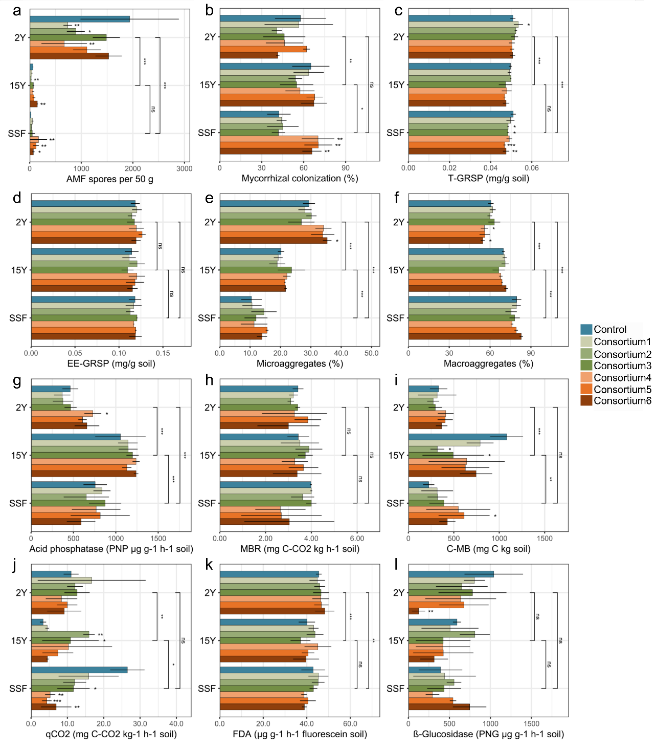

Fig. S1. Soil and AM parameters post-greenhouse experiment. Parameters assessed include (A) a percentage of soil macroaggregates, (B) total glomalin-related soil protein (T-GRSP), (C) acid phosphatase activity measured as p-nitrophenyl phosphate (PNP), (D) metabolic quotient (qCO₂), (E) soil microbial biomass carbon (C-MB), (F) macroaggregates, (G) macroaggregates, (H) microbial basal respiration (MBR), (I) soil microbial biomass carbon (C-MB), (J) metabolic quotient (qCO₂), (K) fluorescein diacetate hydrolysis (FDA), and (L) β-glucosidase activity measured as p-nitrophenol. Comparisons were made between control samples and various treatments: AM consortium1 (family Acaulosporaceae), AM consortium2 (family Gigasporaceae), AM consortium3 (families Acaulosporaceae and Gigasporaceae), AM consortium4 (AM fungal richness, n=4), AM consortium5 (AM fungal richness, n=8), and AM consortium6 (AM fungal richness, n=16), within each site: 2 years post-reforestation (2Y), 15 years post-reforestation (15Y), and a secondary succession forest (SSF) as a reference site. Statistical significance between treatments and sites was assessed using ANOVA, with significance levels denoted by asterisks (* p < 0.05; ** p < 0.01; *** p < 0.001). Vertical bars represent contrasts between sites (Two-way ANOVA- Contrast analysis), and standard errors are depicted as black lines.
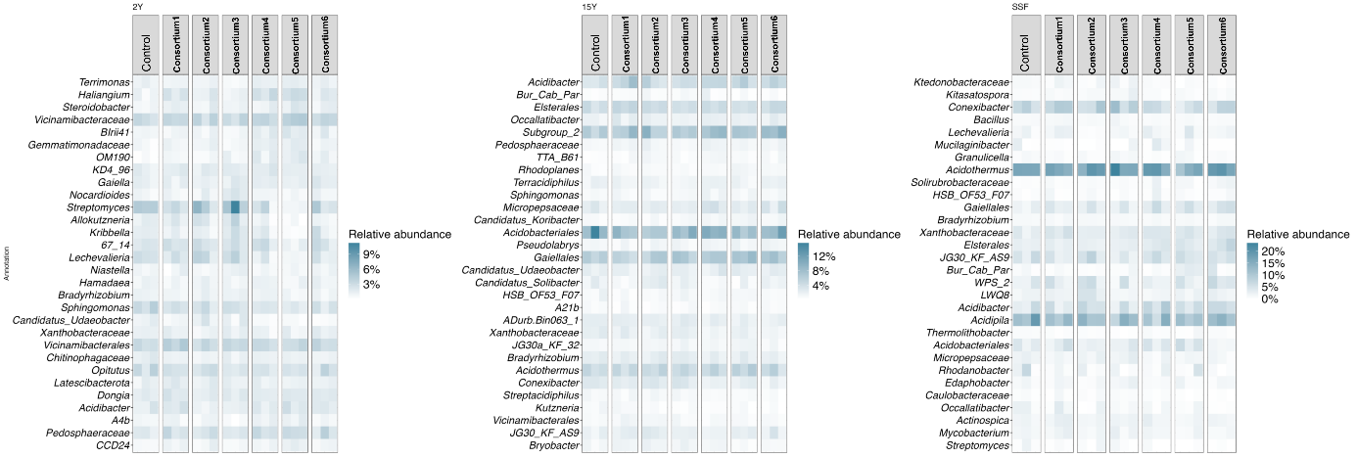
Fig. S2. Thirty most abundant taxa based on 16S rRNA gene amplicon sequencing in different treatments, AM consortium1 (Acaulosporaceae), AM consortium2 (Gigasporaceae), AM consortium3 (Acaulosporaceae and Gigasporaceae), AM consortium4 (AM fungal richness, n=4), AM consortium5 (AM fungal richness, n=8), and AM consortium6 (AM fungal richness, n=16), within each site, short-term recovery (2Y), long-term recovery (15Y), and a secondary succession forest (SSF)

