Supplementary material 1 Crown defoliation classes used in this study
Defoliation Class | Leaf loss | Degree of defoliation
0 | 0-10% | None
1 | 11-30% | Slight
2 | 31-60% | Moderate
3 | > 60% < 100% | Severe
4 | 100% | Dead

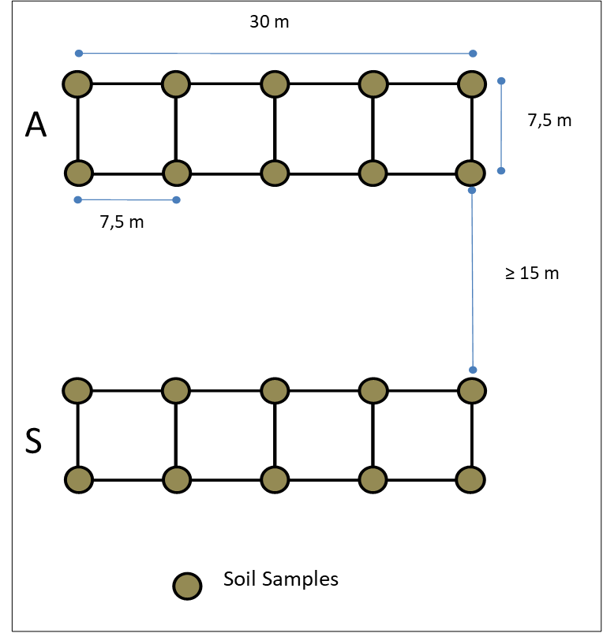
Supplementary material 2 Sampling method scheme (A=autumn; S=spring)

Supplementary material 3 Results of three-way ANOVA testing the effects and interactions of lithological substrate, management type, and sampling season on species richness (S), Shannon diversity index (H), and evenness (J) of ectomycorrhizal communities. Significant results (p<0.05) are reported in bold
Species Richness
 | Df | Sum Sq | Mean Sq | F-value | P-value
Substrate | 2 | 42.7 | 21.34 | 5.521 | 0.004865
Management | 2 | 57.0 | 28.484 | 7.367 | 0.000889
Season | 1 | 230.5 | 230.54 | 59.633 | 1.54e-12
Substrate x Management | 4 | 347.7 | 86.93 | 22.486 | 1.52e-14
Substrate x Season | 2 | 27.3 | 13.63 | 3.526 | 0.031902
Management x Season | 2 | 19.1 | 9.55 | 2.471 | 0.087985
Substrate x Management x Season | 4 | 125.2 | 31.31 | 8.099 | 6.16e-06
Residuals | 149 | 576.0 | 3.87
Shannon Index
Substrate | 2 | 0.771 | 0.386 | 1.896 | 0.15384
Management | 2 | 4.412 | 2.206 | 10.843 | 4.01e-05
Season | 1 | 12.267 | 12.267 | 60.290 | 1.22e-12
Substrate x Management | 4 | 13.652 | 3.413 | 16.774 | 2.26e-11
Substrate x Season | 2 | 0.382 | 0.191 | 0.940 | 0.39295
Management x Season | 2 | 0.797 | 0.398 | 1.958 | 0.14471
Substrate x Management x Season | 4 | 3.762 | 0.940 | 4.622 | 0.00152
Residuals | 149 | 30.317 | 0.203
Evenness
Substrate | 2 | 0.0118 | 0.00589 | 0.597 | 0.552057
Management | 2 | 0.0392 | 0.01962 | 1.988 | 0.141030
Season | 1 | 0.0026 | 0.00257 | 0.261 | 0.610524
Substrate x Management | 4 | 0.1315 | 0.03288 | 3.332 | 0.012351
Substrate x Season | 2 | 0.0550 | 0.02749 | 2.786 | 0.065342
Management x Season | 2 | 0.0583 | 0.02916 | 2.956 | 0.055519
Substrate x Management x Season | 4 | 0.2265 | 0.05662 | 5.738 | 0.000275
Residuals | 131 | 1.2926 | 0.00987

Supplementary material 4 Resuts of ISA
Group | Number of species | Species | P-Value | Significance
basaltic_ploughed_autumn | 1 | Hymenogaster sp.1 | 0.041 | *
granitic_ploughed_autumn | - | - | - | -
trachytic_ploughed_autumn | 1 | Sebacinales | 0.002 | **
basaltic_natural_autumn | 2 | Russula violacea  Laccaria bicolor | 0.041–0.050 | *
granitic_natural_autumn | 2 | Hygrophorus sp.1  Tomentella sp.21 | 0.001–0.050 | ***, *
trachytic_natural_autumn | 2 | Inocybe sp.6  Hebeloma parvicystidiatum | 0.004–0.048 | **, *
basaltic_grazed_autumn | 3 | Inocybe sp.16,  Cortinariaceae sp.6  Inocybe sp.3 | 0.001–0.020 | ***,**, *
granitic_grazed_autumn | 2 | Russula sp.13  Russula graveolescens | 0.025–0.046 | *
trachytic_grazed_ autumn | - | - | - | -
basaltic_ploughed_spring | 3 | Inocybe sp.12  Russulaceae sp.1  Inosperma lanatodiscum | 0.008–0.030 | **, *
granitic_ploughed_spring | 5 | Ceratobasidium sp.5  Ceratobasidium sp.1  Lactarius subumbonatus,  Cantharellales  Trechisporales sp. | 0.001–0.050 | ***, *
trachytic_ploughed_spring | 5 | Cortinarius sp.1  Thelephoraceae sp.6  Russula odorata  Tomentella badia  Entoloma leucocarpum | 0.002–0.044 | **, *
basaltic_natural_spring | 4 | Russula sp.3  Cortinarius sp.3  Tomentella sp.27  Pachyphlodes nemoralis | 0.001–0.004 | ***,**
granitic_natural_spring | 6 | Tomentella sp.75  Clavulina sp.  Tomentella sp.18  Inocybe geophylla  Tomentella sp.19  Boletus aereus | 0.001–0.048 | ***, **,*
trachytic_natural_spring | 5 | Russula sp.11  Tomentela sp.98  Inocybe sp.14  Tricholomataceae  Lactarius acerrimus | 0.001–0.006 | ***, **
basaltic_grazed_spring | 11 | Inocybe transitoria  Inocybe pseudorubens  Thelephora sp.  Inocybe lutescens  Butyriboletus fechtneri  Tomentella sp.4  Xerocomellus porosporus  Thelephorales  Amanita rubescens  Russula sp.2  Cortinarius gallurae | 0.001–0.048 | ***, **, *
granitic_grazed_spring | 1 | Cenococcum geophilum | 0.001 | ***
trachytic_grazed_spring | 2 | Cortinariaceae sp.2  Laccaria sp. | 0.0 | *

