SUPPLEMENTAL DIGITAL CONTENT 8: Forest plots for ESI vs. (non-)epidural placebo for back pain
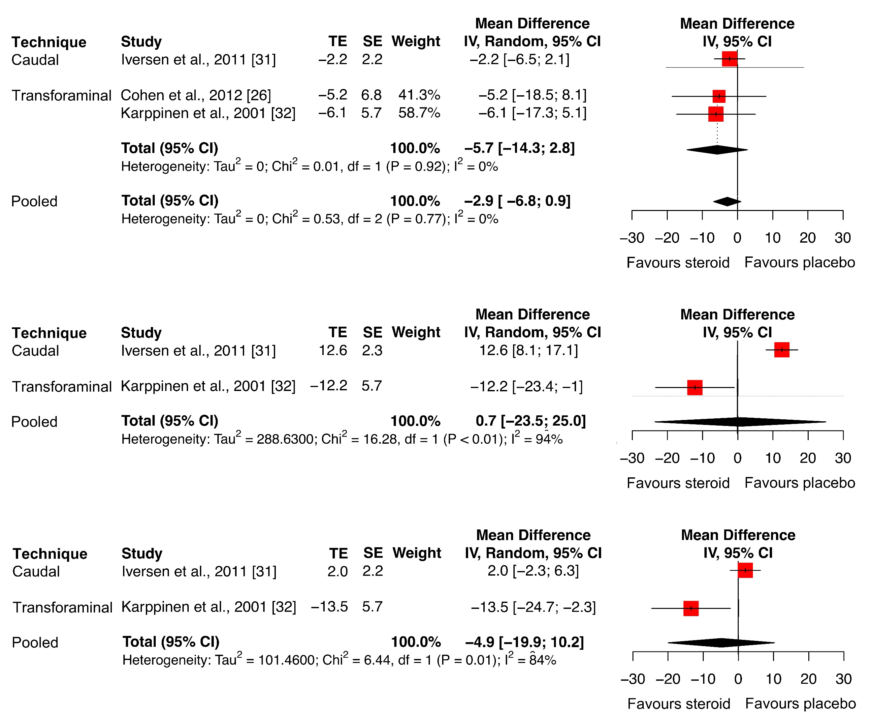
SDC 9.1: Forest plots for effect on back pain for studies with epidural placebo. Upper plot refers to 6-week effect, middle plot to 3-month effect and bottom plot to 6-month. A negative value for treatment effect (TE) or overall treatment effect (Total) indicates favour for steroid; a positive value indicates favour for epidural placebo.

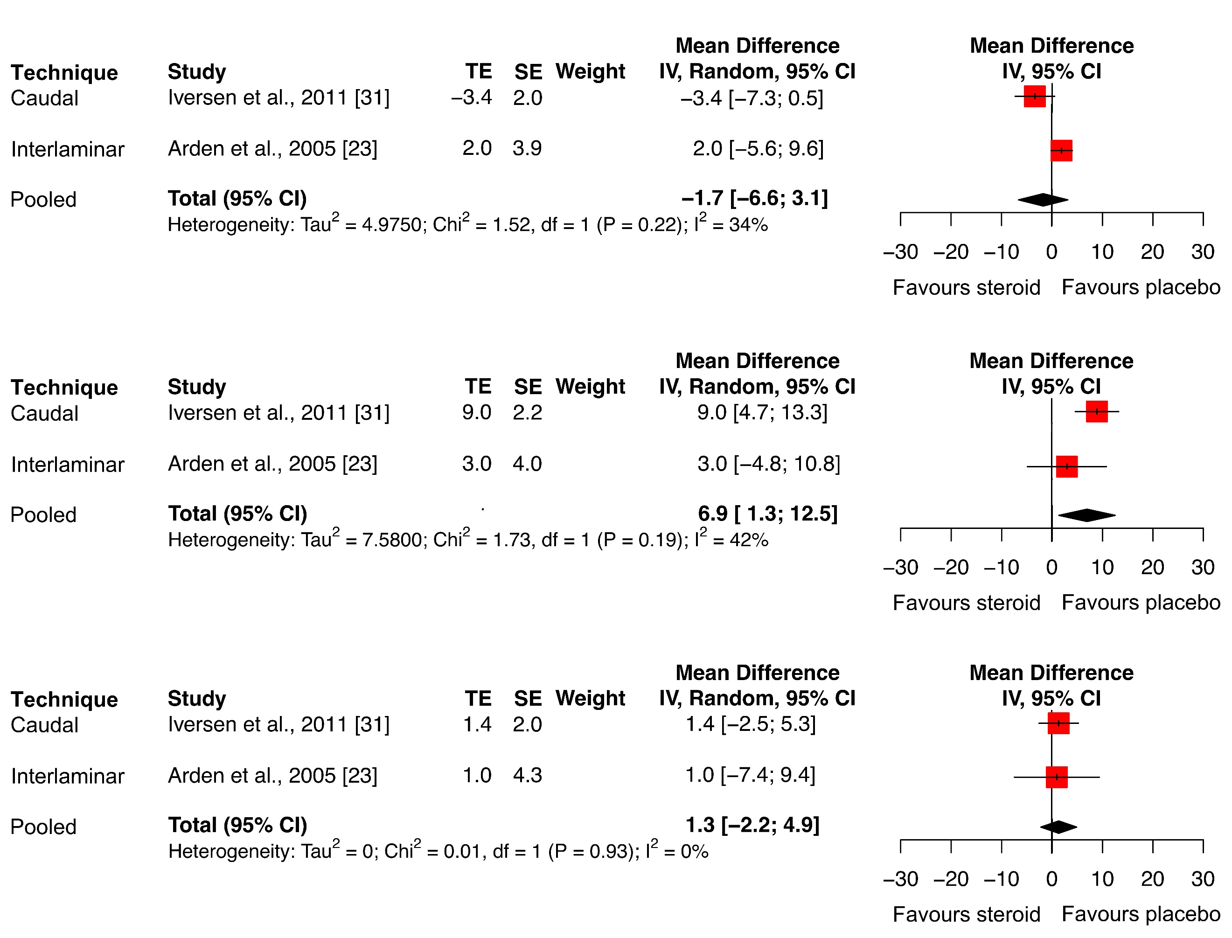

SDC 9.2: Forest plots for effect on back pain for studies with non-epidural placebo. Upper plot refers to 6-week effect, middle plot to 3-month effect and bottom plot to 6-month effect. A negative value for treatment effect (TE) or overall treatment effect (Total) indicates favour for steroid; a positive value indicates favour for non-epidural placebo.

