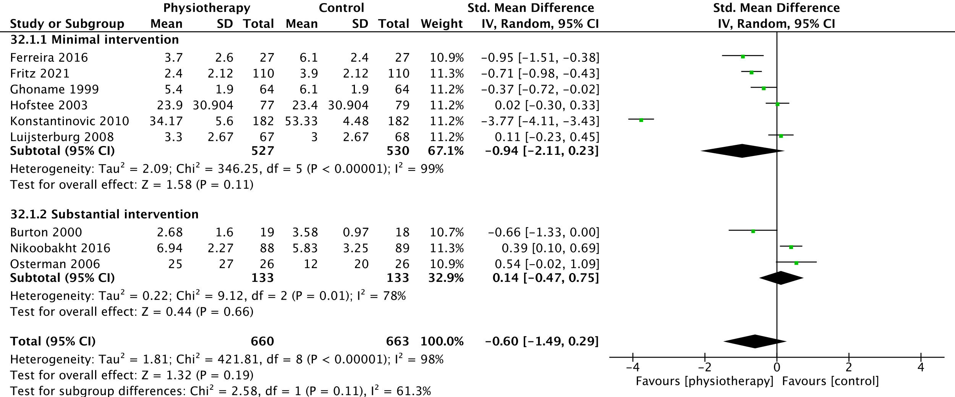
Supplemental Figure 1. Forest plot for primary outcome pain, short term, sensitivity analysis

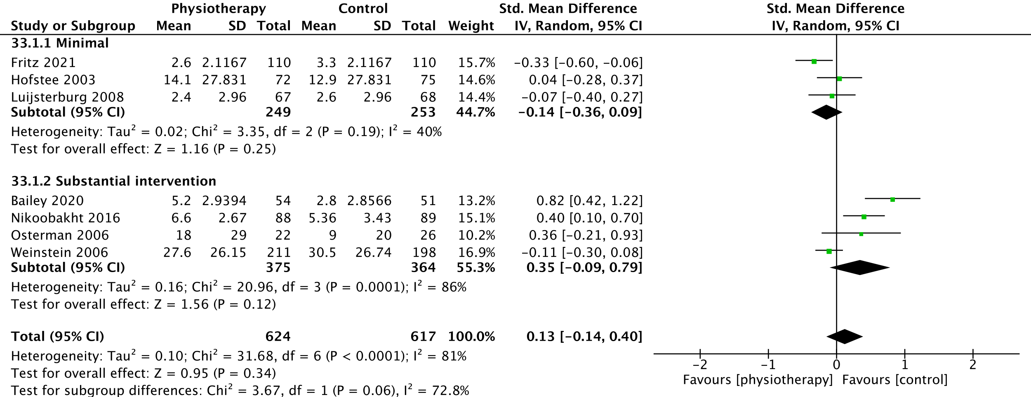
Supplemental Figure 2: Forest plot for primary outcome pain, medium term, sensitivity analysis

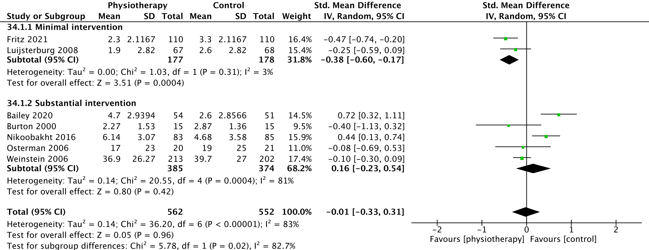
Supplemental Figure 3: Forest plot for primary outcome pain, long term, sensitivity analysis

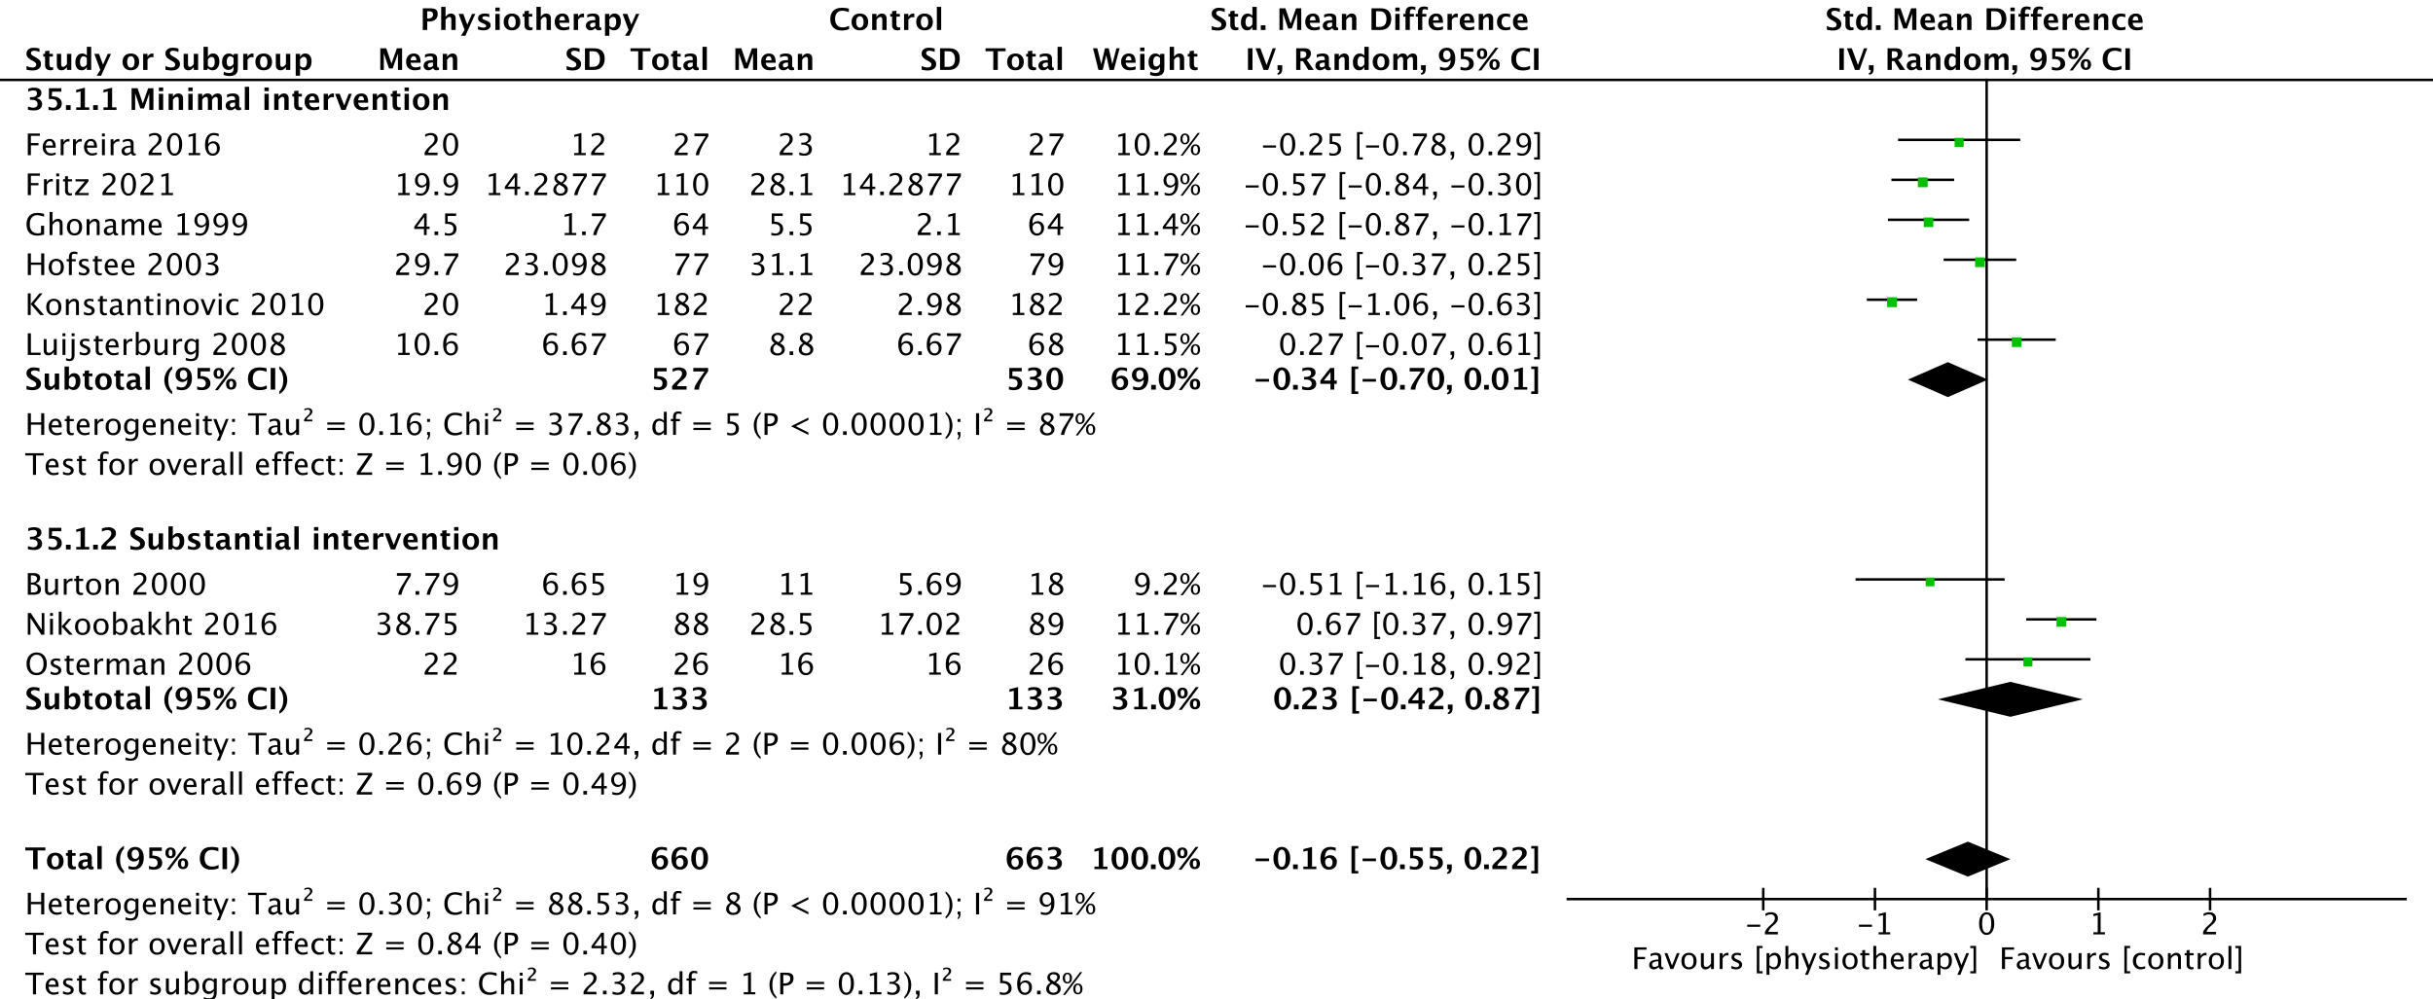Supplemental Figure 4. Forest plot for primary outcome disability, short term, sensitivity analysis

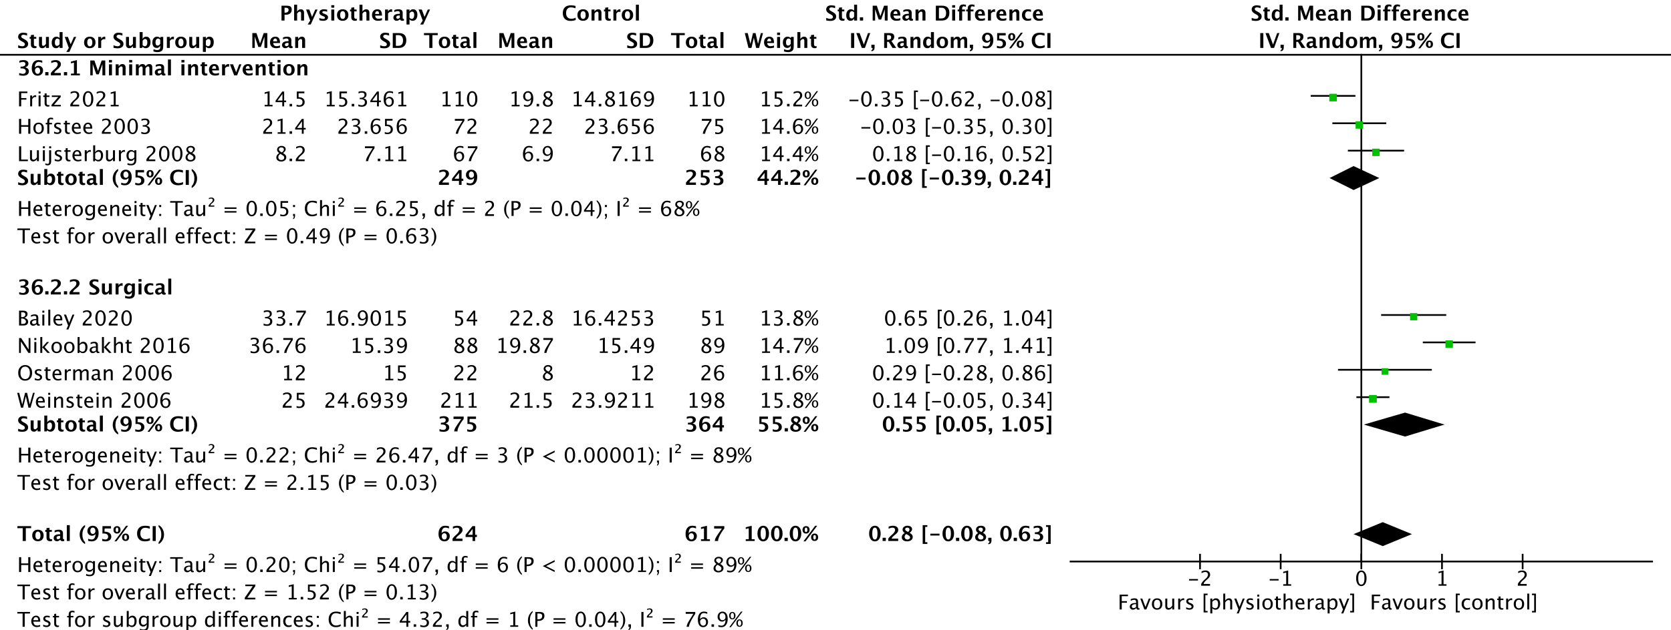
Supplemental Figure 5: Forest plot for primary outcome disability, medium term, sensitivity analysis

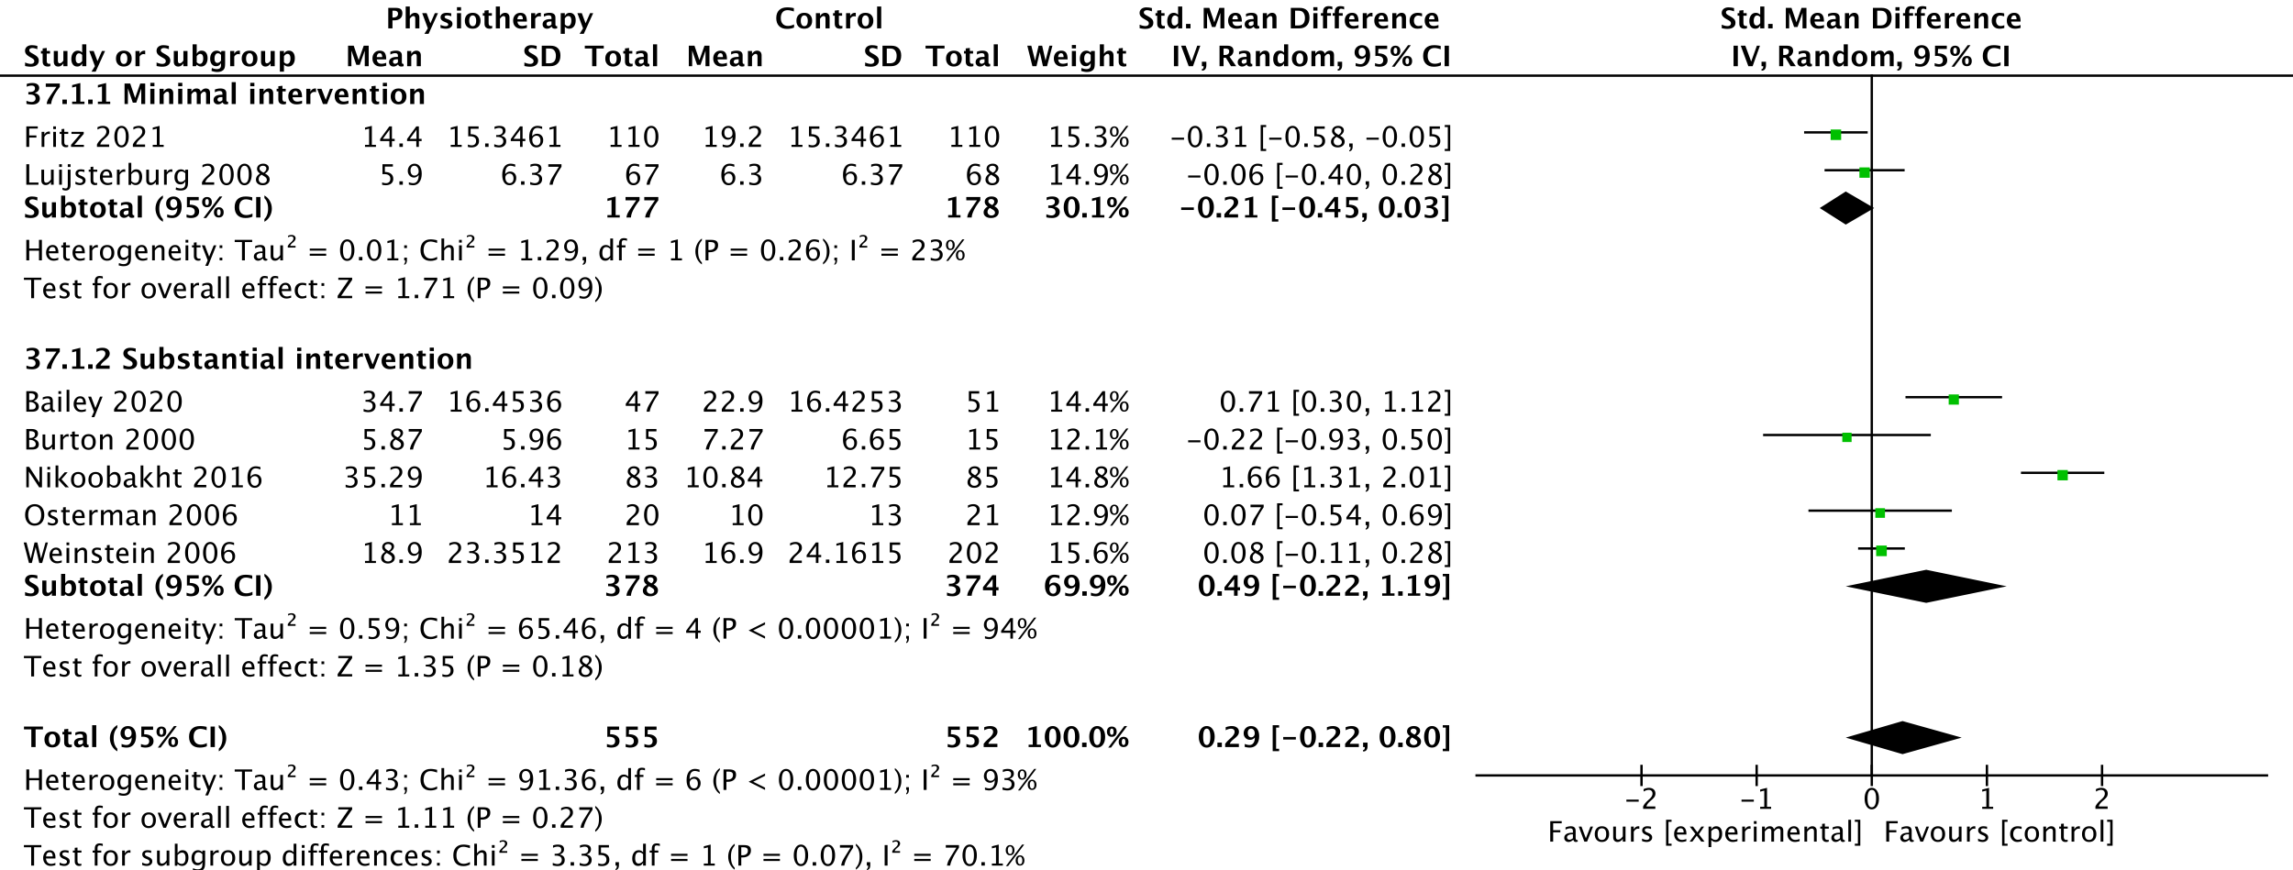
Supplemental Figure 6: Forest plot for primary outcome disability, long term, sensitivity analysis

