“Imagine you are suffering from lower back pain. It started 3 days ago. You think the pain was set off by lifting some boxes, but you are not sure. You have no leg pain. The pain is in your lower back as shown by the red rectangle on the body chart below.
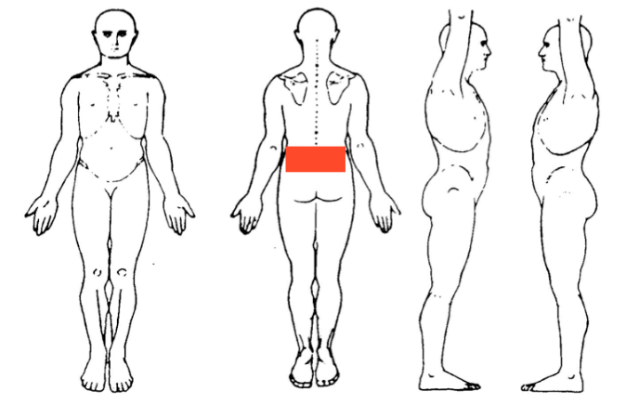

Over the past few days, you find it hard to move your back normally. For example, it is very hard to bend and twist. You have used heat and over the counter pain-relievers.

You visit your health care provider (e.g. doctor, physiotherapist, chiropractor, osteopath) as you still have pain. Your health care provider asks you questions about your back pain, and some health questions to rule out any worrying causes.Your health care provider does a detailed physical examination. It involves: looking at your lower back, touching and pressing different parts of your lower back to check for problems, and asking you to move your lower back in different directions, bend over, and walk around

AFTER THIS, YOUR HEALTH CARE PROVIDER TELLS YOU:”

Randomisation

- "YOU HAVE A DISC BULGE" "Discs are the soft cushions of tissue between the bones in your spine. They are shock absorbers for your spine. They are tough on the outside, and soft on the inside. A bulge is when the soft part pushes out of its normal position.”

- YOU HAVE DEGENERATION OF THE SPINE"
"As you get older, joints and cartilage in your spine can break down and lose their water content. Degeneration is a kind of wear and tear of the spine.”

- "YOU HAVE ARTHRITIS OF THE SPINE"
"Your spine is made up of different bones, joints, and the discs in between. Discs are like the cushions of the spine. As you get older, bones, joints and discs wear out, break down and can get inflamed, which leads to pain.”

- "YOU HAVE A LUMBAR SPRAIN" "Lots of soft tissues such as muscles, ligaments and tendons support the spine. You have pulled or torn one of these soft tissues.”

- "YOU HAVE NON-SPECIFIC LOW BACK PAIN" "You have tension, soreness, stiffness in the back, but I’m not able to say for sure which structure in your back the pain is coming from.”

- "YOU HAVE AN EPISODE OF LOW BACK PAIN"

