Fig S1 Forest plot for subgroup analysis of sex

Fig S2 Forest plot for subgroup analysis of indication

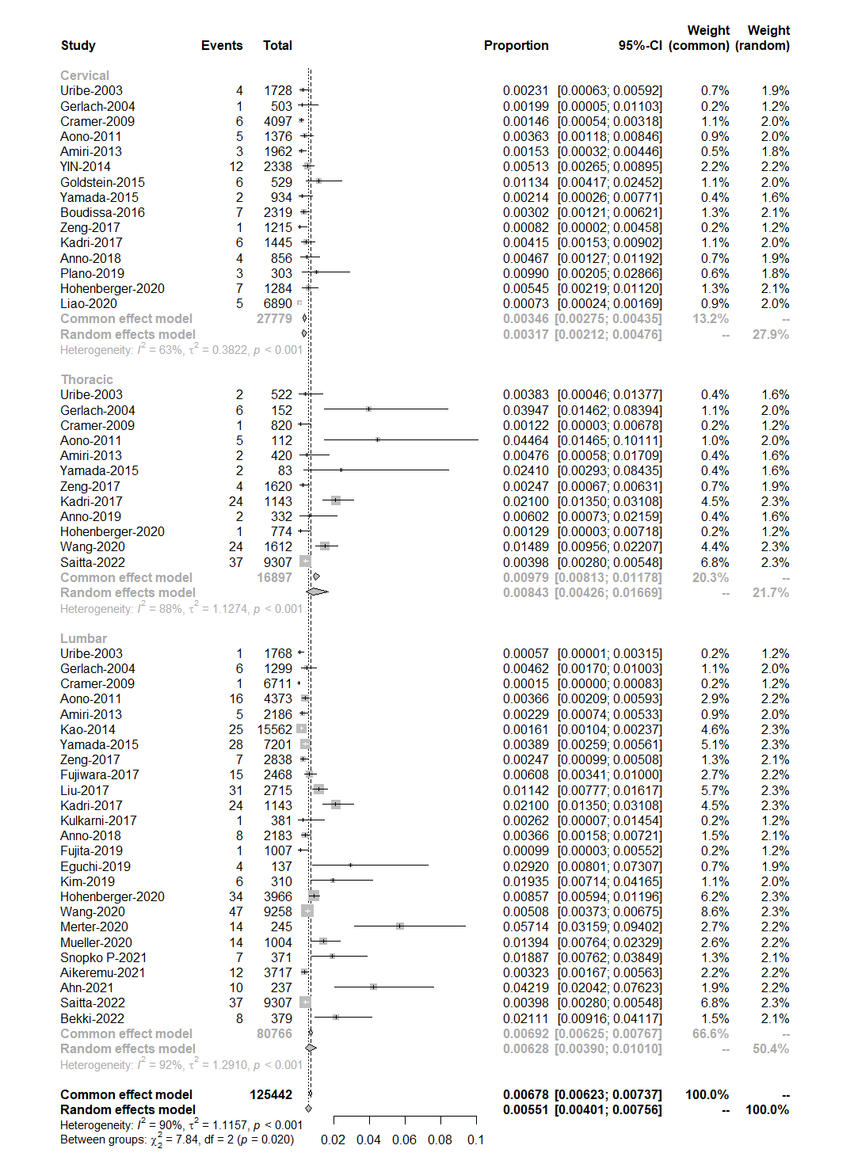
Fig S3 Forest plot for subgroup analysis of surgical site

Fig S4 Forest plot for subgroup analysis of approach

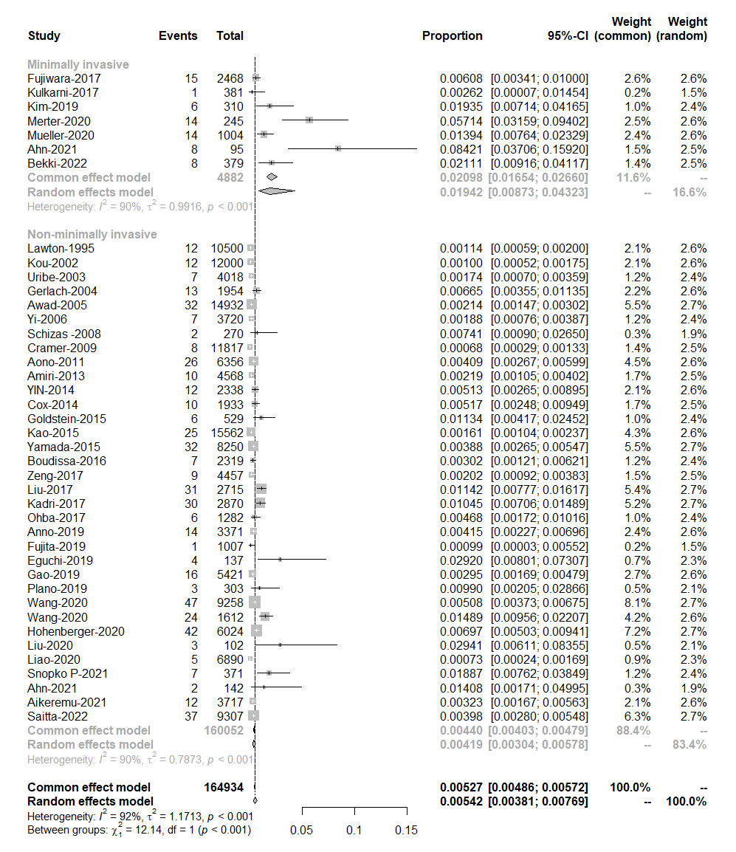
Fig S5 Forest plot for subgroup analysis of minimally invasive surgery
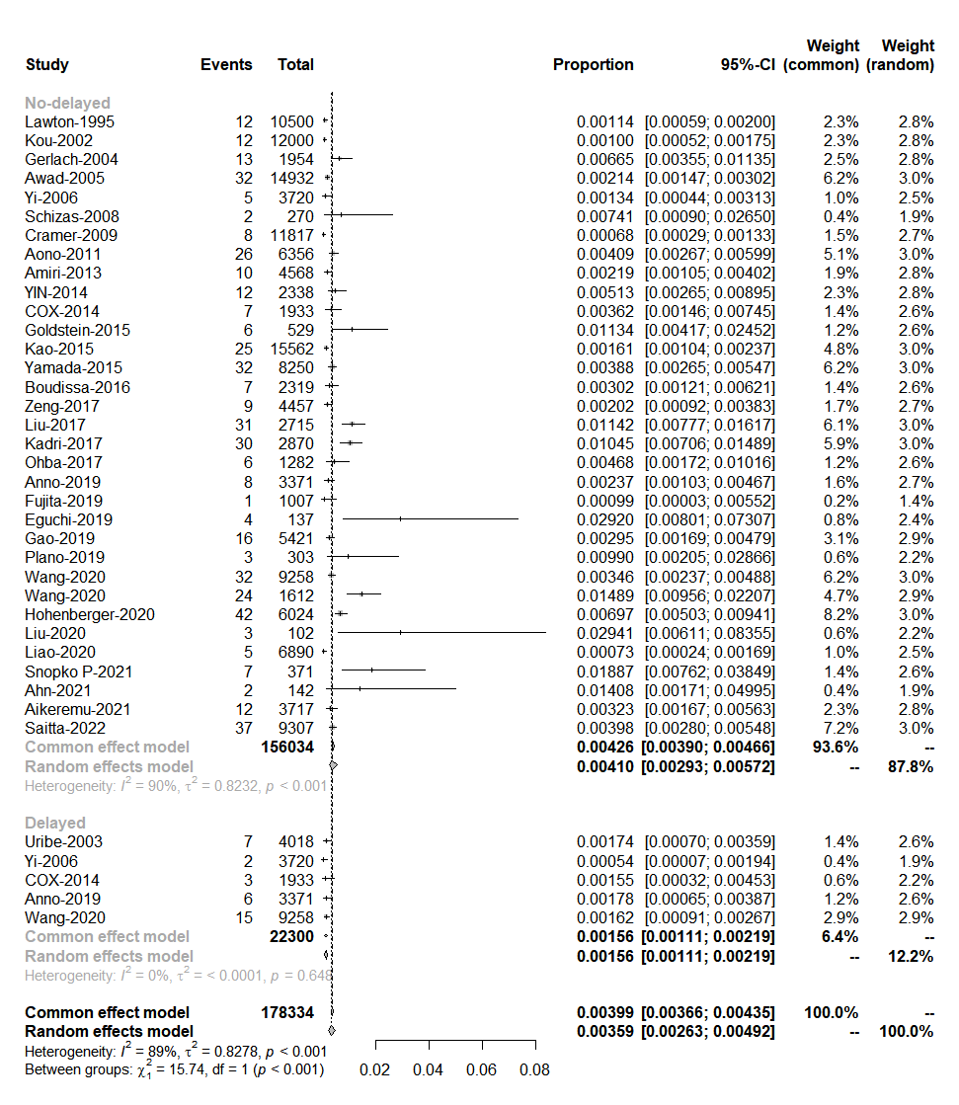
Fig S6 Forest plot for subgroup analysis of delayed onset

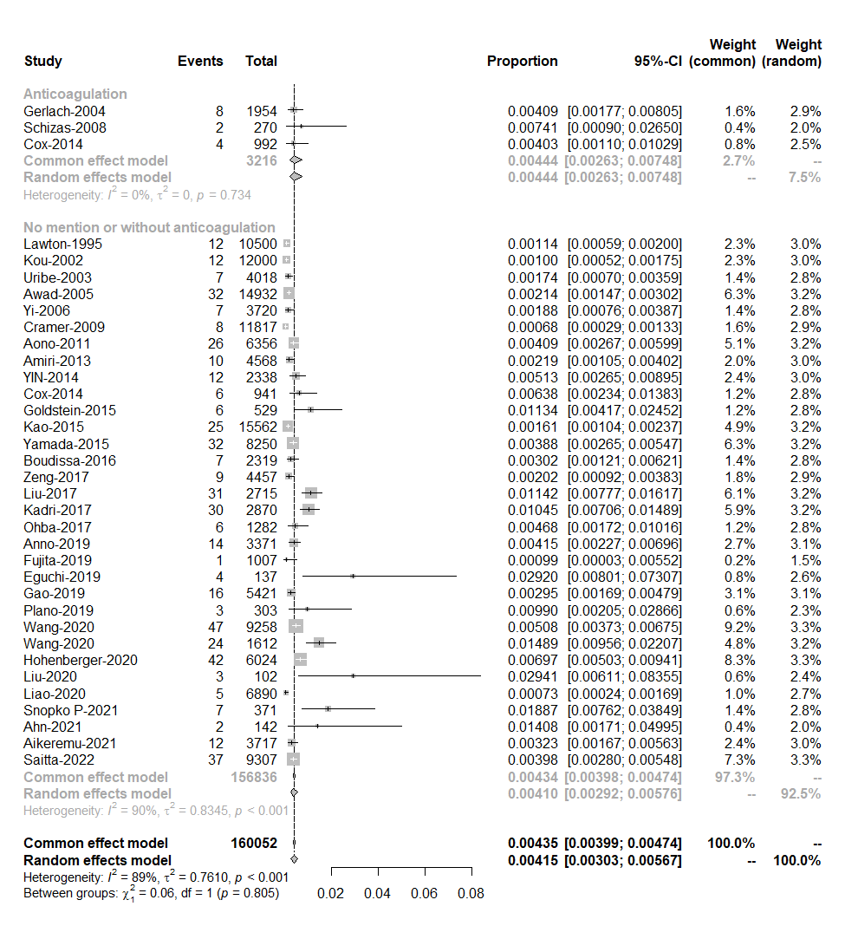
Fig S7 Forest plot for subgroup analysis of perioperative anticoagulation

