Supplemental File 1
Table of contents

sTable 1. Description of NORDSTEN-DS index trial, target trial, and target trial emulation using LSOS observational data 2
sFigure 1. Preoperative (left) and 3-years postoperative (right) standing lateral radiographic images of a lumbar spine with fusion surgery (above) and with decompression alone (below) 6
sTable 2. Baseline patient characteristics of all patients who underwent surgery within 6 months after baseline (n=258), and those with incomplete 3-year primary outcome follow-up data (n=43) 7
sFigure 2. Distribution of propensity scores before (top) and after (bottom) inverse probability weighting 10
sTable 3. Primary and secondary raw outcomes and adjusted mean differences after inverse probability weighting 11
sTable 4. Exploratory description of adverse events—patients with complications or revisions 12
sTable 5. Primary outcomes among patients who underwent surgery within 6 months after baseline (n=258) after multiple imputation by chained equations—sensitivity analysis 13

sTable 1. Description of NORDSTEN-DS index trial, target trial, and target trial emulation using LSOS observational data
Protocol Component | NORDSTEN-DS—Index Randomized Trial | Target Trial | Target Trial Emulation Using LSOS data
Eligibility criteria | Patients between 18 and 80 years of age in the Norwegian context  Neurogenic claudication or radicular radiating pain in the lower limbs that had not responded to at least 3 months of conservative care  Included: over 18 years of age; understand Norwegian language, spoken and in writing; have a degenerative lumbar spondylolisthesis, with a slip >=3 mm, verified on standing plain x-rays in lateral view; have a spinal stenosis in the level of spondylolisthesis, shown on MRI; have clinical symptoms of spinal stenosis as neurogenic claudication or radiating pain into the lower limbs, not responding to at least 3 months of qualified conservative treatment; have ODI score 25 points or more; able to give informed consent and to respond to the questionnaires  Patients referred to orthopedic and neurosurgical clinics  Provided informed consent  Excluded: not willing to give written informed consent; participating in another trial; ASA>3; not able to comply (psychosocially, mentally, and physically) fully with the protocol (treatment, follow-up or study procedures); have cauda equina syndrome (bowel or bladder dysfunction) or fixed complete motor deficit; have a slip >= 3 mm in more than one level ; have an isthmic defect in pars interarticularis; have a fracture or former fusion of the thoracolumbar region; have had previous surgery in the level of spondylolisthesis; have a lumbosacral scoliosis more than 20 degrees verified on AP-view; have distinct symptoms in one or both legs due to other diseases, e.g. polyneuropathy,  vascular claudication or osteoarthritis; have radicular pain due to a MRI verified foraminal stenosis in the slipped level, with deformation of the nerve root because of a bony narrowing in the vertical direction | Same as NORDSTEN-DS except:  Aged 50 years or more—no age upper limit  Unilateral or bilateral neurogenic claudication  MRI verified diagnosis of spinal stenosis  Swiss context—able to complete questionnaires in German  Expected life expectancy of more than a year—clinical judgement  DS—confirmed by conventional MRI  No age upper limit  Excluded: cauda equina syndrome; current fracture, infection or significant deformity (>15 degrees of lumbar scoliosis); current enrolment in another spine related treatment study; clinically relevant peripheral arterial disease (confirmed by vascular specialist in patients without palpable pulses in the lower limb) | Same as target trial
Treatment strategies | Decompression alone—posterior decompression that preserved the midline structures (supraspinous-interspinous ligament complex)  Decompression with instrumented fusion—optional technique for posterior decompression (with or without preservation of midline structures), followed by implantation of pedicle screws with rods and bone grafting across the level of spondylolisthesis, with optional use of an intervertebral fusion device | Same as NORDSTEN-DS | Same as target trial
Treatment assignment | Individuals randomized to a surgical intervention | Individuals would be randomized to a surgical intervention and would be unblinded to intervention assignment | Individuals treated based on the inverse of their probability of receiving decompression plus fusion within levels of the following baseline covariates: age, sex, body mass index (BMI), months since onset of current complaints, compromise of the foraminal zone (left and right), smoking status, educational level, back pain, gluteal pain, thigh pain, lower leg pain, presence of spinal instability (operationalized as facet degeneration with effusion of > 2 mm), spondylolisthesis severity (Meyerding grading system), number of vertebral levels operated, number of vertebral levels with spondylolisthesis (Meyerding I or more), diabetes, civil risk (operationalized as either living alone, or living in a nursing or residential home and being single, divorced, or widowed), anxiety (Hospital Anxiety and Depression Scale [HADS] anxiety subscale), depression (HADS Depression subscale), and EQ-5D-3L scores (German and French).
Outcomes | Primary:  Disability, ODI  Secondary:  EQ-5D-3L | Same as NORDSTEN-DS except:  EQ-5D-3L as primary outcome  ODI not included as an outcome | Same as target trial
Follow-up | 2 years | 3 years | Same as target trial
Causal contrast | Modified Intention-to-Treat (participants who received trial treatment in accordance with randomization assignment and had available data after randomization)—non-inferiority design  Per-protocol effect | Intention-to-treat effect  Per-protocol effect | Observational analogue of the per-protocol effect
Statistical analysis | Intervention differences were assessed by comparing the percentage of patients with a reduction of 30% or more in the ODI  Percentage of patients with a clinically important improvement from inclusion to 2 years after surgery as assessed by the EQ-5D-3L score  Linear mixed models (fixed effect for treatment, time, interaction between treatment and time, and trial center; time modeled as piecewise linear with a knot at 3 months; random intercept at the patient level) for repeated measures of EQ-5D-3L  Mean differences (with 95% confidence intervals) in change | Standardized and adjusted mean differences (with 95% confidence intervals) in EQ-5D-3L at 1-, 2-, and 3-year follow-up  Inverse-probability weighted ordinary least square regression models | Same per-protocol analysis as target trial
Abbreviations: AP, Anterior Posterior; ASA, American Society of Anesthesiologists physical status classification system; DS, degenerative spondylolisthesis; EQ-5D-3L, EuroQol Health-Related Quality of Life 5-Dimension 3-Level questionnaire summary index; LSOS, Lumbar Stenosis Outcome Stucy; mm, millimeters; MRI, magnetic resonance imaging; NORDSTEN-DS, Norwegian Degenerative Spondylolisthesis and Spinal Stenosis trial; ODI, Oswestry Disability Index

sFigure 1. Preoperative (left) and 3-years postoperative (right) standing lateral radiographic images of a lumbar spine with fusion surgery (above) and with decompression alone (below)
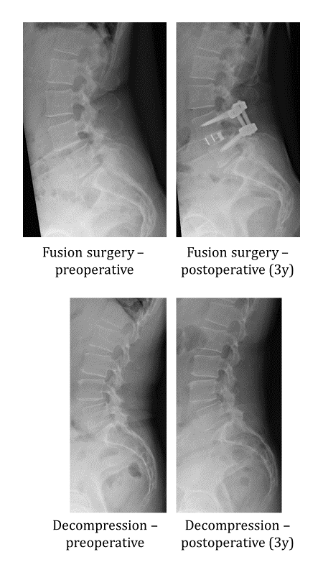

sTable 2. Baseline patient characteristics of all patients who underwent surgery within 6 months after baseline (n=258), and those with incomplete 3-year primary outcome follow-up data (n=43)
 | Patients who underwent surgery within 6 mo  (n = 258) |  |  | Patients with incomplete 3-year primary outcome follow-up data (n = 43)
 | Decompression alone  (n = 184) | Decompression plus fusion  (n = 74) | p | Decompression alone  (n = 31) | Decompression plus fusion  (n = 12) | p
Characteristics
Age, mean (SD) | 74.9 (7.9) | 69.4 (7.2) | <0.001 | 76.3 (8.68) | 69.1 (7.3) | 0.02
Female, No. (%) | 109 (59.2) | 37 (50.0) | 0.22 | 18 (58.1) | 6 (50.0) | 0.89
BMI, mean (SD) | 27.2 (4.9) | 27.5 (4.2) | 0.69 | 27.35 (5.6) | 27.88 (3.5) | 0.77
Level of education, No. (%) |  |  | 0.16 |  |  | 0.71
Compulsory educationª | 59 (32.1) | 16 (21.6) |  | 12 (38.7) | 5 (41.7)
High School/ Vocational School/ Apprenticeship | 104 (56.5) | 45 (60.8) |  | 14 (45.2) | 4 (33.3)
Higher education/ University | 21 (11.4) | 13 (17.6) |  | 5 (16.1) | 3 (25.0)
Smoker, No. (%) | 27 (14.7) | 13 (17.6) | 0.24 | 1 (3.2) | 2 (16.7) | 0.38
NA | 0 (0.0) | 1 (1.4) |  | 0 (0.0) | 0 (0.0)
Diabetes, No. (%) | 27 (14.7) | 4 (5.4) | 0.06 | 5 (16.1) | 1 (8.3) | 0.86
Civil risk, No. (%)^{b} | 80 (43.5) | 17 (23.0) | 0.003 | 15 (48.4) | 3 (25.0) | 0.29
Back pain, No. (%) | 157 (85.3) | 65 (87.8) | 0.74 | 30 (96.8) | 10 (83.3) | 0.38
Gluteal pain, No. (%) | 146 (79.3) | 54 (73.0) | 0.35 | 24 (77.4) | 6 (50.0) | 0.17
Thigh pain, No. (%) | 152 (82.6) | 57 (77.0) | 0.43 | 28 (90.3) | 6 (50.0) | 0.01
NA | 1 (0.5) | 0 (0.0)
Lower leg pain, No. (%) | 135 (73.4) | 57 (77.0) | 0.65 | 27 (87.1) | 9 (75.0) | 0.62
Months since onset of complaints, No. (%) |  |  | 0.13 |  |  | 0.83
< 3 mo | 14 (7.6) | 4 (5.4) |  | 2 (6.5) | 0 (0.0)
3 to 6 mo | 35 (19.0) | 6 (8.1) |  | 8 (25.8) | 3 (25.0)
6 to 12 mo | 23 (12.5) | 15 (20.3) |  | 4 (12.9) | 2 (16.7)
> 12 mo | 111 (60.3) | 49 (66.2) |  | 17 (54.8) | 7 (58.3)
NA | 1 (0.5) | 0 (0.0)
Compromise of the right foraminal zone, No. (%) |  |  | 0.16 |  |  | 0.35
None | 0 (0.0) | 1 (1.4)
Mild | 15 (8.2) | 7 (9.5) |  | 4 (12.9) | 1 (8.3)
Moderate | 99 (53.8) | 31 (41.9) |  | 14 (45.2) | 3 (25.0)
Severe | 70 (38.0) | 35 (47.3) |  | 13 (41.9) | 8 (66.7)
Compromise of the left foraminal zone, No. (%) |  |  | 0.82 |  |  | 0.30
None | 0 (0.0) | 0 (0.0)
Mild | 23 (12.5) | 9 (12.2) |  | 5 (16.1) | 0 (0.0)
Moderate | 99 (53.8) | 37 (50.0) |  | 17 (54.8) | 7 (58.3)
Severe | 62 (33.7) | 28 (37.8) |  | 9 (29.0) | 5 (41.7)
Instability, No. (%)^{c} | 128 (69.6) | 52 (70.3) | 1.00 | 21 (67.7) | 8 (66.7) | 1.00
Meyerding severity, No. (%)^{d} |  |  | <0.001 |  |  | 1.00
Grade I | 168 (91.3) | 49 (66.2) |  | 26 (83.9) | 10 (83.3)
Grade II | 16 (8.7) | 24 (32.4) |  | 5 (16.1) | 2 (16.7)
Grade III | 0 (0.0) | 1 (1.4) |  | 0 (0.0) | 0 (0.0)
Meyerding levels, No. (%) |  |  | 0.01 |  |  | 0.09
1 | 59 (32.1) | 39 (52.7) |  | 22 (71.0) | 8 (66.7)
2 | 83 (45.1) | 24 (32.4) |  | 6 (19.4) | 2 (16.7)
3 | 35 (19.0) | 7 (9.5) |  | 0 (0.0) | 2 (16.7)
4 | 7 (3.8) | 3 (4.1) |  | 3 (9.7) | 0 (0.0)
5 | 0 (0.0) | 1 (1.4) |  | 0 (0.0) | 0 (0.0)
Decompressed levels, No. (%) |  |  | 0.01 |  |  | 0.32
1 | 59 (32.1) | 39 (52.7) |  | 10 (32.3) | 4 (33.3)
2 | 83 (45.1) | 24 (32.4) |  | 12 (38.7) | 7 (58.3)
3 | 35 (19.0) | 7 (9.5) |  | 7 (22.6) | 0 (0.0)
4 | 7 (3.8) | 3 (4.1) |  | 2 (6.5) | 1 (8.3)
5 | 0 (0.0) | 1 (1.4)
HADS Anxiety, mean (SD) | 4.5 (3.6) | 5.1 (3.7) | 0.28 | 5.0 (3.2) | 2.7 (2.6) | 0.05
HADS Depression, mean (SD) | 5.1 (3.7) | 4.7 (2.9) | 0.35 | 6.4 (4.0) | 3.5 (2.4) | 0.03
EQ-5D-3L German, mean (SD)^{e} | 0.58 (0.29) | 0.63 (0.26) | 0.14 | 0.53 (0.28) | 0.65 (0.24) | 0.20
EQ-5D-3L French, mean (SD)^{e} | 0.47 (0.30) | 0.50 (0.25) | 0.46 | 0.38 (0.27) | 0.52 (0.21) | 0.12
NRS back/leg, mean (SD)^{f} | 6.63 (2.09) | 6.68 (1.67) | 0.83 | 7.23 (1.81) | 7.00 (1.41) | 0.69
SSM satisfaction, mean (SD)^{g} | 2.75 (0.71) | 2.68 (0.73) | 0.47 | 2.65 (0.69) | 2.48 (0.69) | 0.51
Physical therapy utilization, No. (%) | 99 (53.8) | 41 (55.4) | 0.44 | 16 (51.6) | 8 (66.7) | 0.56
NA | 4 (2.2) | 0 (0.0) |  | 1 (3.2) | 0 (0.0)
Oral analgesic use, No. (%) | 147 (79.9) | 60 (81.1) | 0.97 | 24 (77.4) | 9 (75.0) | 0.56
NA | 3 (1.6) | 1 (1.4) |  | 2 (6.5) | 0 (0.0)
Abbreviations: BMI, body mass index (weight in kilograms divided by height in meters squared); SSM, Spinal Stenosis Measure; NRS, Numeric Rating Scale; EQ-5D-3L, EuroQol Health-Related Quality of Life 5-Dimension 3-Level questionnaire summary index
ª A mandatory period of education imposed by the Swiss government, normally lasting up to 15 years of age.
^{b} Operationalized as 1) living alone or 2) being single, divorced, or widowed and living in a nursing or residential home
^{c} Operationalized as facet degeneration with effusion of 2 mm or more observed in conventional magnetic resonance imaging
^{d} Grade of degenerative spondylolisthesis severity—Grade I to III are determined based on the percentage of translation with respect to the superior endplate of the vertebra below (grade I: 0 to 25%, grade II: 26 to 50%, grade III: 51 to 75%)
^{e} Score ranges from −0.53 to 1.00—higher scores indicate better quality of life, with 1 indicating perfect health and scores below 0 indicating health states worse than death
^{f} Score ranges from 0 to 10; answer to the questions: “What has been the average intensity of your pain over the past seven days? How intense was your back or leg pain, during walking or activity?”
^{g} SSM scores range from 1 (most satisfied) to 4 (least satisfied) and are informed by the following questions: 1) “How satisfied are you with the overall results of your surgery/therapy?”, 2) “How satisfied are you with the decrease in pain after surgery/therapy?”, 3) “How satisfied are you with your walking ability after surgery/therapy?”, 4) “How satisfied are you with your ability to perform household chores, yard work, and activities at work?”, 5) “How satisfied are you with your strength in your thighs, legs and feet?” and 6) “How satisfied are you with your sense of balance or stability in your feet?”

sFigure 2. Distribution of propensity scores before (top) and after (bottom) inverse probability weighting
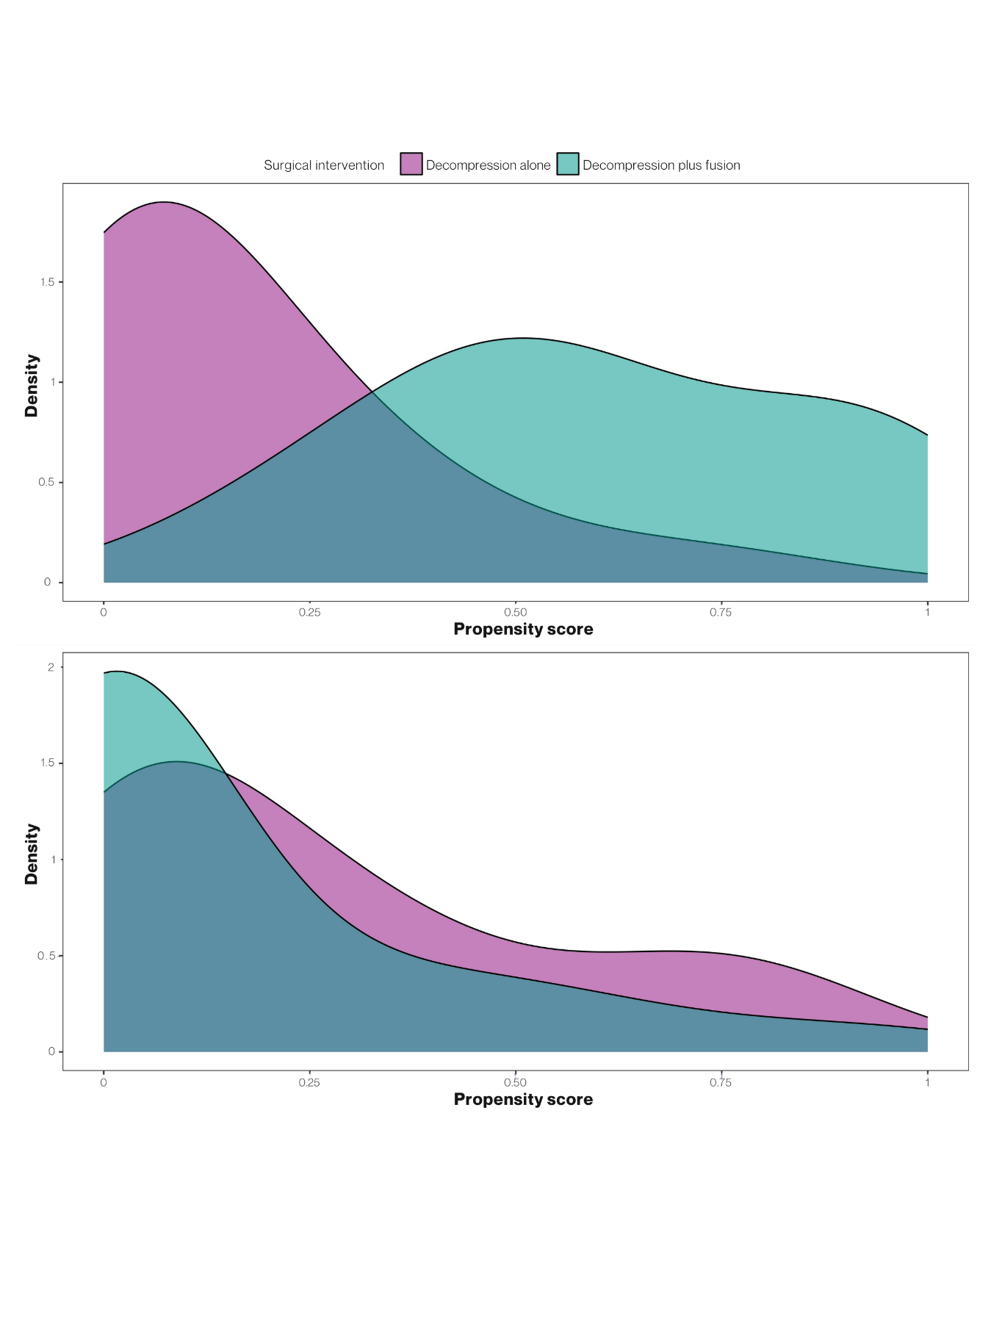

sTable 3. Primary and secondary raw outcomes and adjusted mean differences after inverse probability weighting
 | Raw (unweighted) outcomes |  | Weighted outcomes
Outcome,  Follow-up | Decompression alone  (n = 153) | Decompression plus fusion  (n = 62) | Adjusted mean difference (95% CI)ª | P value
Primary outcomes
EQ-5D-3L, Germanª
1 yr, mean (SD) | 0.83 (0.19) | 0.90 (0.14) | 0.06 (0.00 to 0.12) | 0.05
2 yrs, mean (SD) | 0.85 (0.16) | 0.88 (0.13) | 0.02 (-0.03 to 0.07) | 0.52
3 yrs, mean (SD) | 0.84 (0.18) | 0.88 (0.16) | 0.01 (-0.04 to 0.07) | 0.66
EQ-5D-3L, Frenchª
1 yr, mean (SD) | 0.75 (0.25) | 0.84 (0.22) | 0.07 (0.00 to 0.15) | 0.07
2 yrs, mean (SD) | 0.76 (0.26) | 0.81 (0.22) | 0.03 (-0.05 to 0.11) | 0.52
3 yrs, mean (SD) | 0.74 (0.28) | 0.83 (0.21) | 0.05 (-0.04 to 0.13) | 0.26
Secondary outcomes
NRS back/leg
1 yr, mean (SD) | 3.20 (2.57) | 2.03 (2.18) | -0.97 (-1.79 to -0.14) | 0.02*
2 yrs, mean (SD) | 3.20 (2.71) | 2.27 (1.96) | -0.60 (-1.44 to 0.24) | 0.16
3 yrs, mean (SD) | 3.16 (2.57) | 2.46 (2.20) | -0.48 (-1.29 to 0.34) | 0.25
SSM satisfaction
1 yr, mean (SD) | 1.81 (0.75) | 1.55 (0.67) | -0.27 (-0.51 to -0.04) | 0.02*
2 yrs, mean (SD) | 1.86 (0.82) | 1.64 (0.70) | -0.17 (-0.42 to 0.09) | 0.19
3 yrs, mean (SD) | 1.85 (0.84) | 1.60 (0.61) | -0.16 (-0.41 to 0.09) | 0.21
Abbreviations: EQ-5D-3L, EuroQol Health-Related Quality of Life 5-Dimension 3-Level questionnaire summary index; NRS, Numeric Rating Scale; SSM, Spinal Stenosis Measure; yr, year
ª β coefficients from weighted ordinary least squares models. Decompression plus fusion indicator was the independent variable
*p <0.05

sTable 4. Exploratory description of adverse events—patients with complications or revisions
 | Decompression plus fusion  (n = 153) | Decompression alone  (n = 62)
Complications—intra-operative
Bleeding, No. (%) | 2 (1) | 0 (0)
Dural tear, No. (%) | 9 (6) | 3 (5)
Complications—post-operative
Revision due to a complication*, No. (%) | 4 (3) | 3 (5)
Wound infection, No. (%) | 1 (1) | 1 (2)
Revisions
Due to restenosis, No. (%) | 17 (11) | 3 (5)
Due to infection, No. (%) | 0 (0) | 0 (0)
With fusion, No. (%) | 12 (8) | 7 (11)
Due to epidural bleeding, No. (%) | 2 (1) | 0 (0)
*Mostly within 3 months after initial surgery; Complications include revision due to wound infection, hematoma evacuation, wound revision, and dural leakage revision

sTable 5. Primary outcomes among patients who underwent surgery within 6 months after baseline (n=258) after multiple imputation by chained equations—sensitivity analysis
Outcome,  Follow-up | Standardized mean difference (95% CI)ª | P value
Primary outcomes
EQ-5D-3L, Germanª
1 yr | 0.30 (0.02 to 0.58) | 0.04*
2 yrs | 0.11 (-0.17 to 0.38) | 0.44
3 yrs | 0.21 (-0.08 to 0.50) | 0.15
EQ-5D-3L, Frenchª
1 yr | 0.30 (0.02 to 0.58) | 0.03*
2 yrs | 0.17 (-0.11 to 0.45) | 0.23
3 yrs | 0.30 (0.01 to 0.58) | 0.04*
Abbreviations: EQ-5D-3L, EuroQol Health-Related Quality of Life 5-Dimension 3-Level questionnaire summary index; yr, year
ª β coefficients from weighted linear models. All continuous outcomes were scaled and centered prior to being introduced in the model as dependent variables. Decompression plus fusion indicator was the independent variable
*p <0.05

