Supplementary Materials

mNGS technique was used to analyze the microbiome structure of intervertebral disc tissue in 99 patients with degenerative disc disease
Hao Liu^{1,3}, Yanchi Gan³, Bowen He⁵, Huiwen Liu³, Hang Zhuo³, Jingjing Tang², Bin Xie⁴, Gengyang Shen^{2,4}, Hui Ren^{2,4}, Xiaobing Jiang^{2,4}

- Department of Spinal Surgery, The First Affiliated Hospital of Guangzhou University of Chinese Medicine, 16 Jichang Road, Baiyun District, Guangzhou City, Guangdong Province, China
- Department of Spinal Surgery, The Second Affiliated Hospital of Guangzhou Medical University, 250 Changgang East Road, Haizhu District, Guangzhou City, Guangdong Province, China
- Guangzhou University of Chinese Medicine, 12 Jichang Road, Baiyun District, Guangzhou City, Guangdong Province, China
- Guangzhou Medical University, 1 Xinzao Road, Panyu District, Guangzhou City, Guangdong Province, China
- Department of Spinal Surgery, Gaoming District Peopel’s Hospital of Foshan City, 1 Kangning Road, Gaoming District, Foshan City, Guangdong Province, China

Hao Liu, Yanchi Gan, Bowen He have contributed equally to this work and therefore share first authorship.
Correspondence: Gengyang Shen, 15920198161@163.com; Hui Ren, renhuispine@sina.com; Xiaobing Jiang, spinedrjxb@sina.com;

The Supplementary Material for this manuscript includes the following:

Fig. S1
Fig. S2
Fig. S3
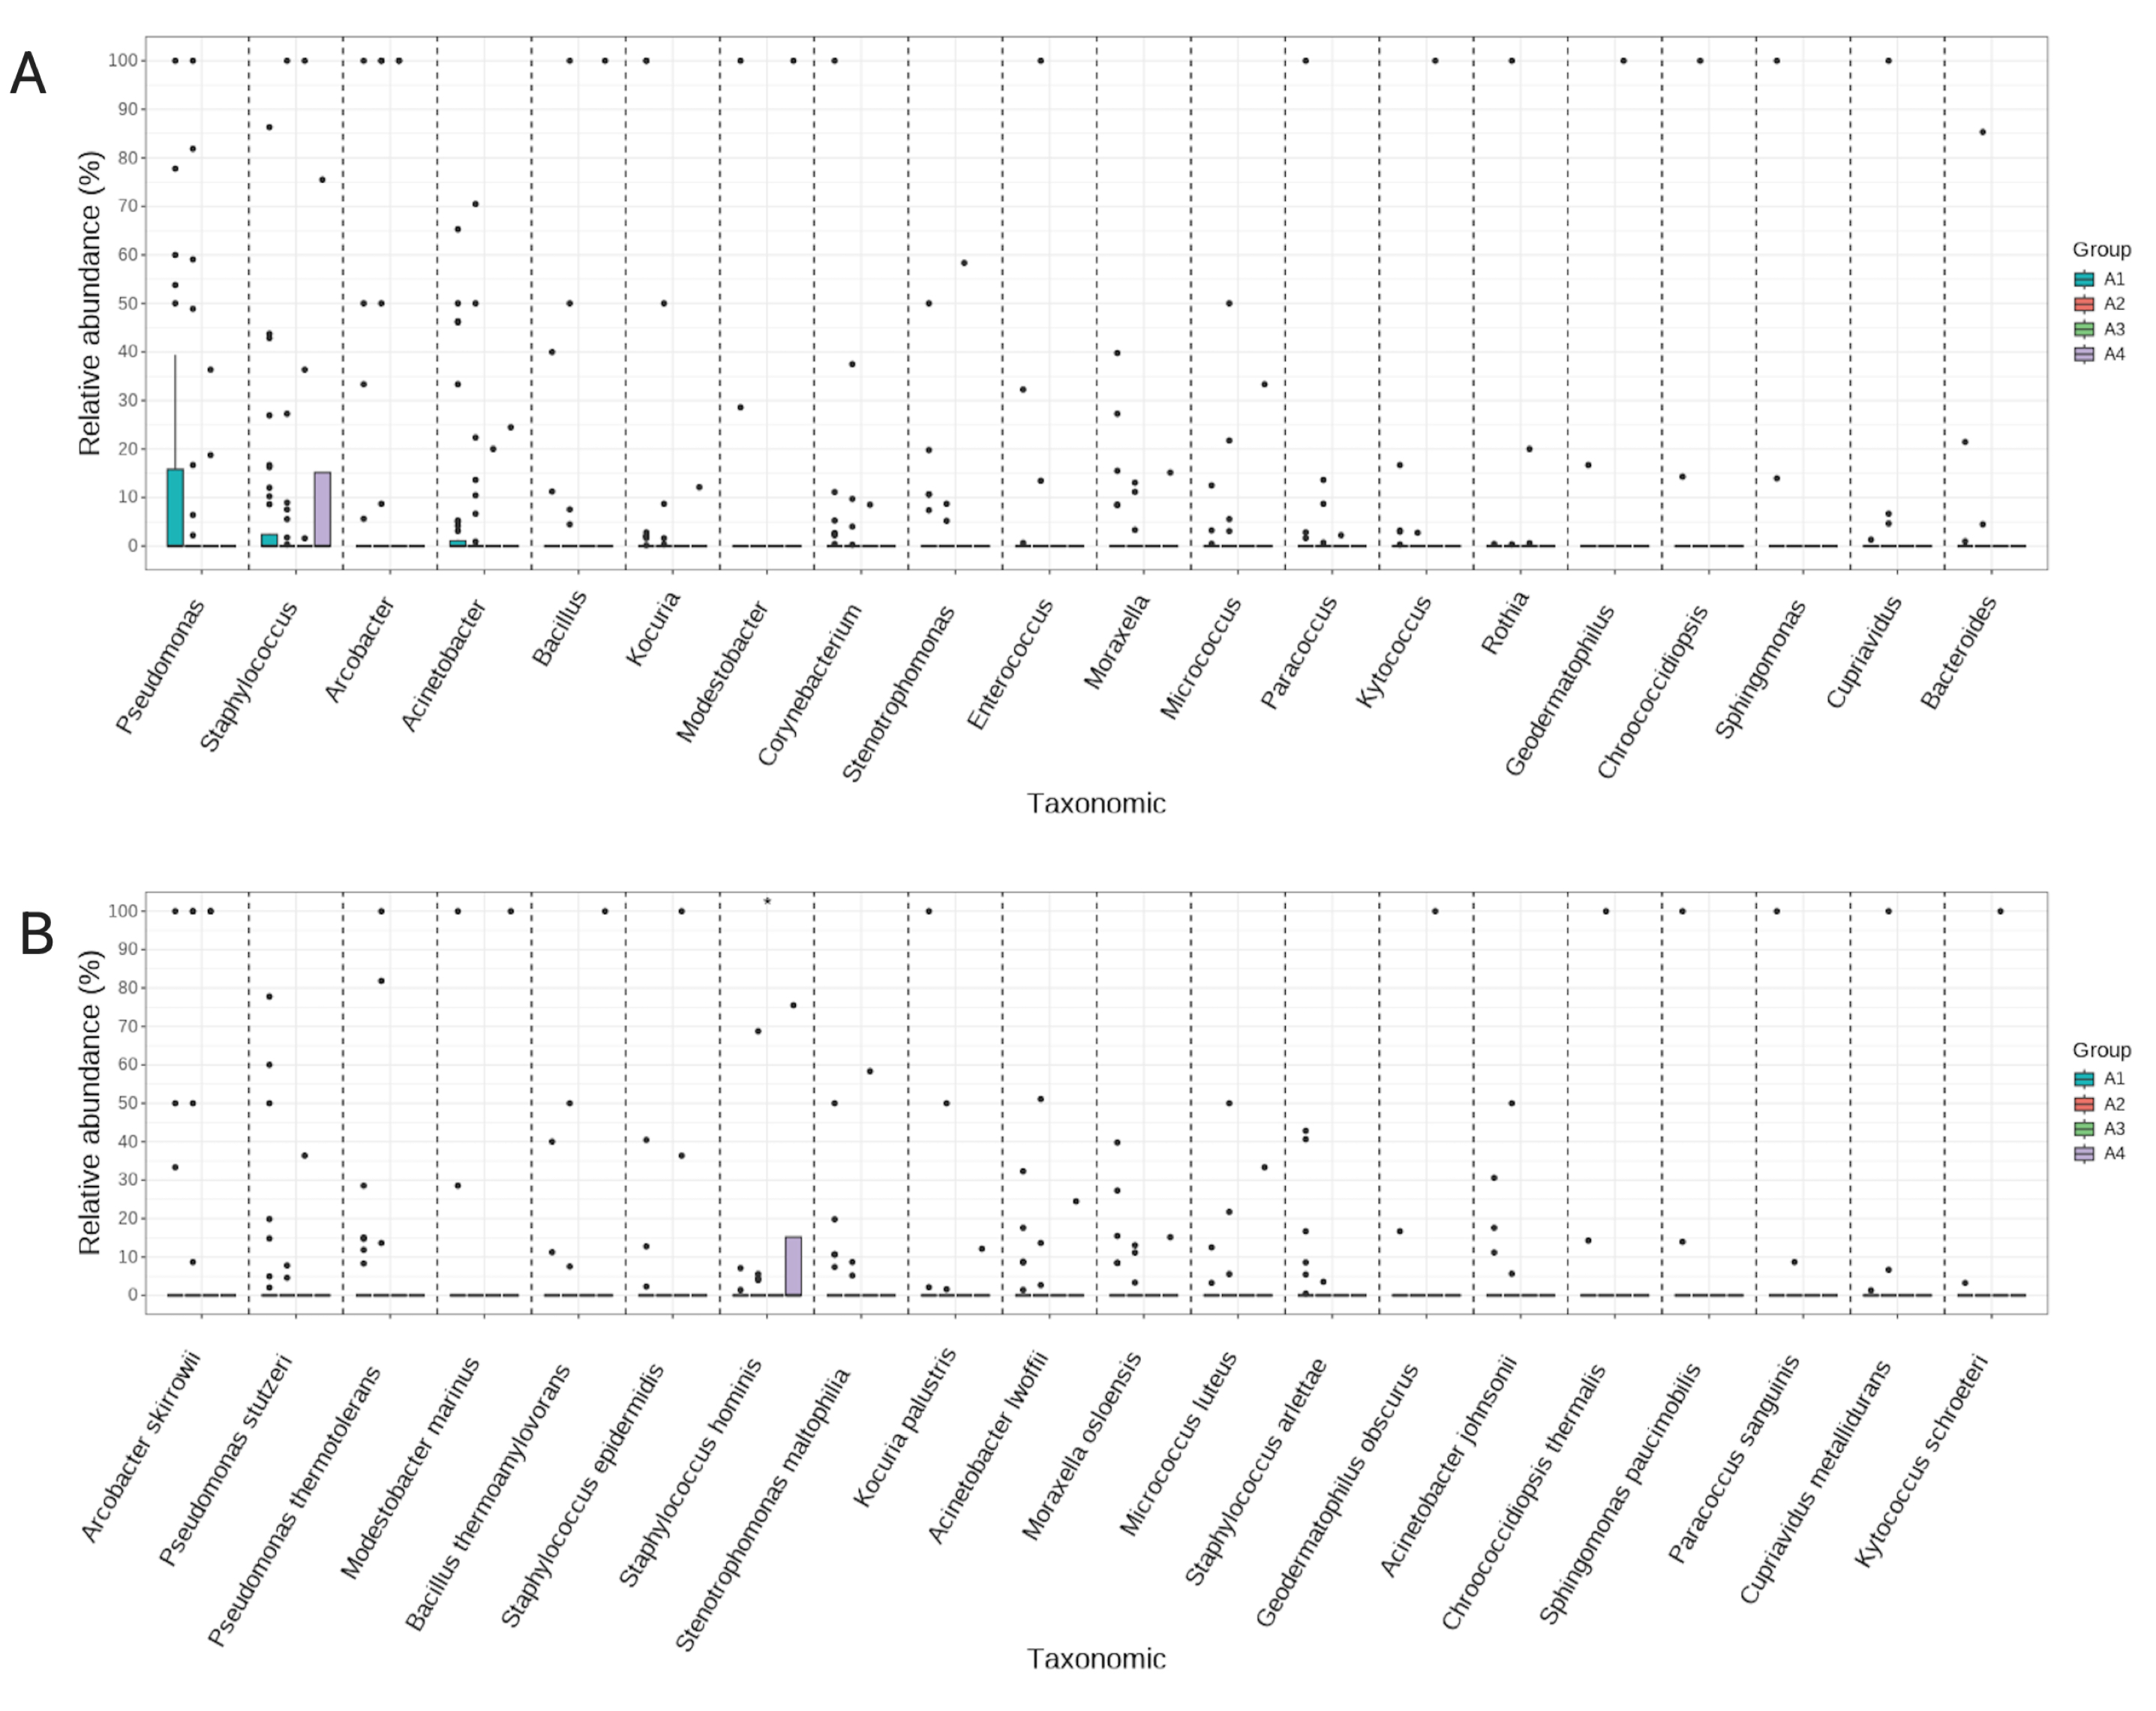
Fig. S1 a Analysis of species differences at genus level. b Species level species difference analysis

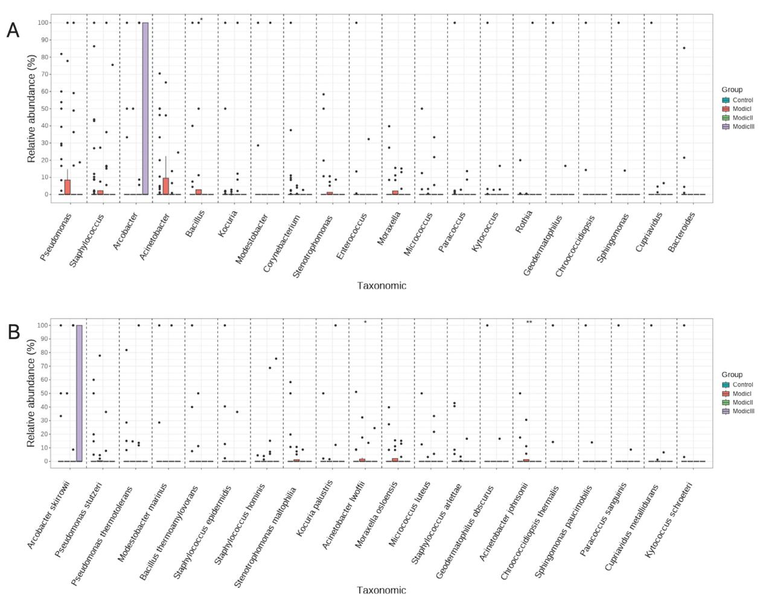
Fig. S2 a Analysis of species differences at genus level. b Species level species difference analysis

Fig. S3 a Analysis of species differences at genus level. b Species level species difference analysis

