Supplementary Data
S1. Height loss and biomechanical data
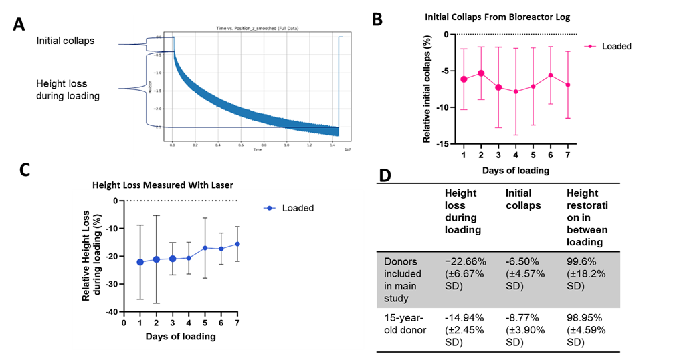
Supplementary Figure 1a: Height loss during loading and initial collapse from bioreactor log (A, B, D). Relative height loss during loading measured with laser (C).

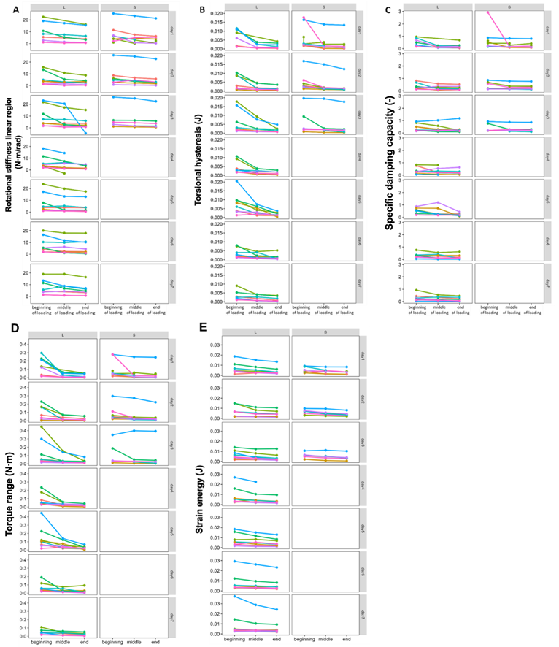
Supplementary Figure 1b: Biomechanical data graphs (z-axis) showing (A) Rotational stiffness linear region, (B) Torsional hysteresis, (C) Specific damping capacity, (D) Torque range, (E) Strain energy. Donors are shown individually. Additionally, the 15-year-old donor is shown in blue.

S2. Region specific changes in cell viability
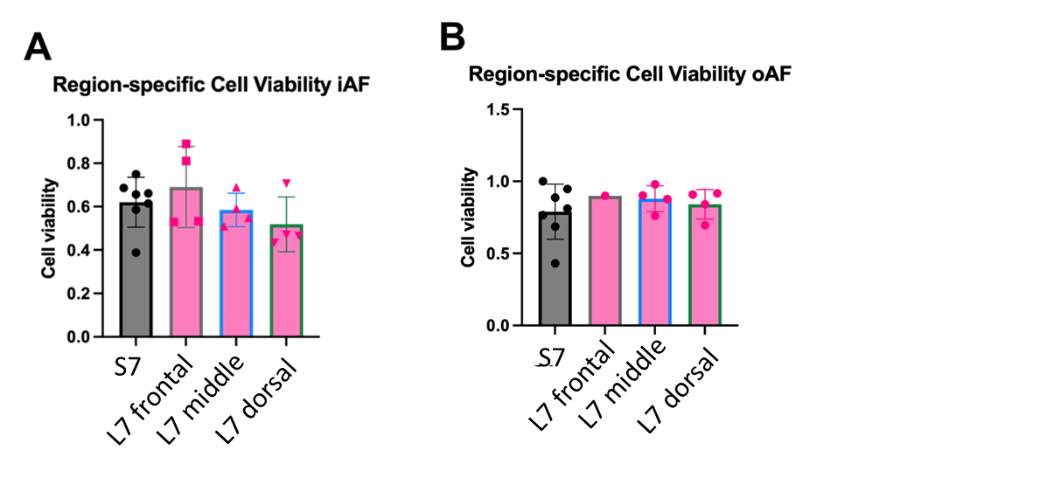
Supplementary Figure 2. Region-specific cell viability after 7 days of loading or free-swelling. Two-way ANOVA revealed no significant differences between groups (p > 0.2). Sample size: N = 7 for S7, N = 4 for all L7, except L7 frontal oAF (N = 1). The frontal region represents the compressed side, the dorsal region the tensile side, and the middle region corresponds to AF tissue located between the compressed and tensile sides.

S3. Structural changes (Safranin O/Fast Green scored images)

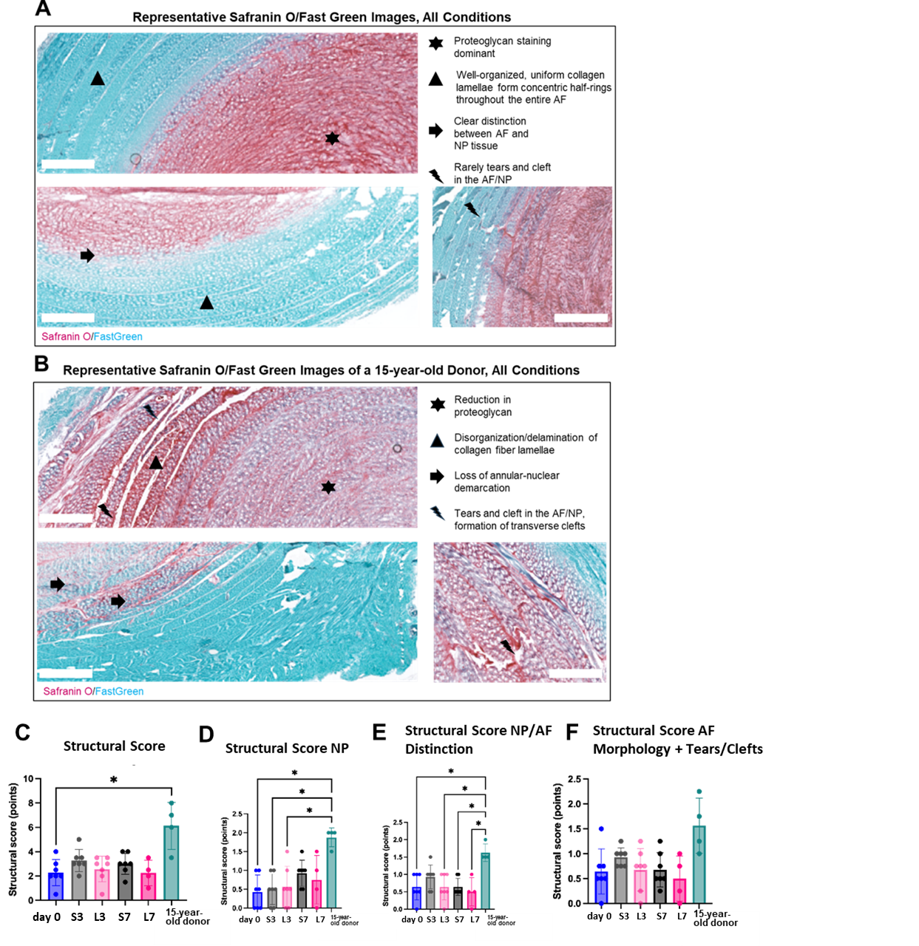
Supplementary Figure 3. Representative Safranin O/Fast Green–stained sections of intervertebral discs (IVDs) from study donors across all experimental groups (A) and from a 15-year-old donor (B). The latter was excluded from the main study and is shown solely as an example of advanced disc degeneration. Scale bar = 1000 µm. (C–F) Quantitative histological scoring results: (C) mean structural score, (D) NP structural score, (E) NP/AF distinction score, and (F) AF morphology score, including tears and clefts. Each point represents the mean of scores assigned by two blinded observers; mean ± SD are indicated. Statistical analysis was performed using the Kruskal–Wallis test. Sample size was n = 7 for all groups except L7 (n = 4); for the 15-year-old donor, n = 4 (day 0, S3, L3, S7 pooled).
S4. Collagen hybridizing peptide (CHP)
Collagen hybridizing peptide (CHP) staining methods
CHP staining was adapted from Dhiman et al.[27]. Briefly, unfixed cryosections were blocked in PBS containing 1% bovine serum albumin (BSA) and 5% goat serum, followed by incubation with Cy3-conjugated CHP (R-CHP; 3Helix, USA) at 10 μM, prepared by 5 min heat denaturation and 1 min rapid quenching. After washing, sections were mounted with anti-fade medium containing DAPI (EverBrite™ Hardset Mounting Medium with DAPI; Biotium, USA). Positive controls were prepared by incubating a pre-heated slide (75 °C, 30 min) with heated CHP, while negative controls used a non-heated slide with non-heated CHP (Supplementary Figure 4). On each slide, one section was stained with CHP and one section with scrambled CHP (3Helix, USA) as an additional negative control. Only a selection of slides was stained, and imaging was performed using a confocal microscope at 5x magnification (excitation ~550 nm, emission ~570 nm). To quantify Cy3 signal, mean fluorescence intensity analysis was performed on two regions of interest (ROIs) per section (size: 2000µmx2000µm) for Cy3-CHP-stained samples, as well as one ROI per section stained with the scrambled control, using ImageJ Fiji (1.53q NIH, USA). The positive control exhibited a mean fluorescence intensity of 16.5%. To determine whether an ROI showed specific fluorescence signal, a positivity threshold was set at the mean fluorescence intensity of the scrambled control ROIs plus two standard deviations (Mean + 2xSD), resulting in a threshold of 1.30%. ROIs with mean intensity values exceeding this threshold were considered positive for signal. The negative control showed mean fluorescence intensities below this threshold.
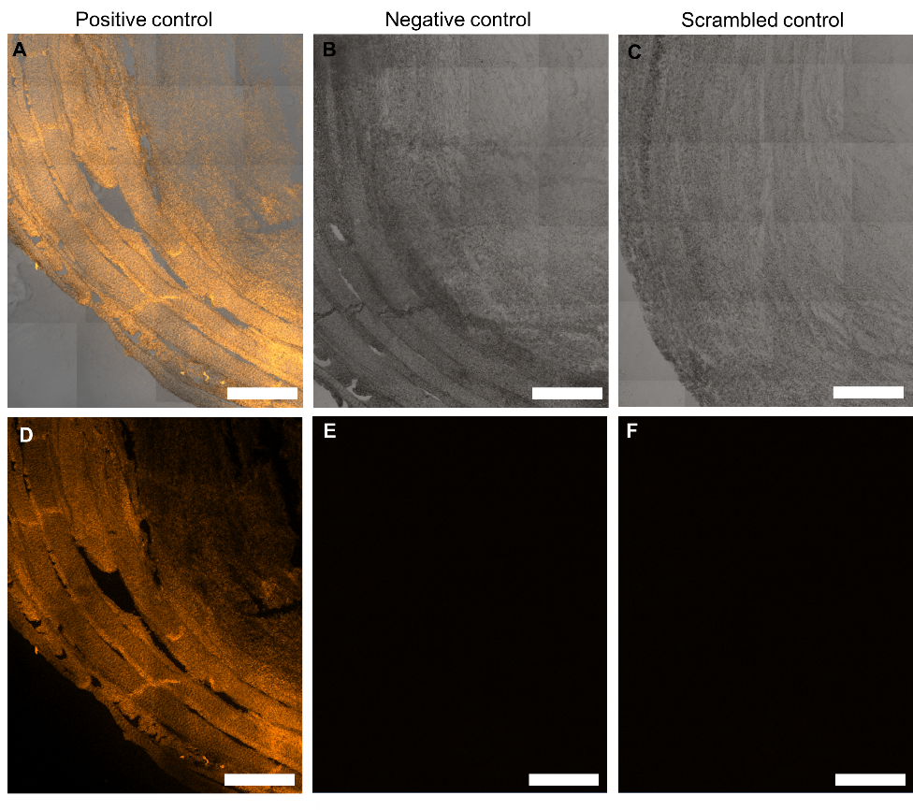
Supplementary Figure 4. Positive control (A, D) and a negative control (B, E) for CHP. The positive control was performed using a pre-heated slide (30 min at 75 °C) incubated with heated CHP, while a negative control used a non-heated slide incubated with non-heated CHP. Additionally, each slide contained a scrambled CHP control (C, F). Scale bar = 2000 μm

CHP staining results
CHP staining revealed fluorescence signal above the defined positivity threshold (1.30%) in all experimental samples, confirming the presence of denatured collagen across conditions (Supplementary Figure 5). Fluorescence intensity was quantified as a percentage of the maximum signal intensity (based on 16-bit image depth). Although no statistically significant differences were detected between groups (n = 4), a trend toward increased fluorescence intensity was observed in the loaded samples compared to both the free-swelling condition and baseline. For reference, two sections (day 0 and S7) from the 15-year-old donor, not included in the main cohort, are shown. This donor exhibited higher CHP fluorescence intensity in both baseline and free-swelling conditions compared to the primary study samples.
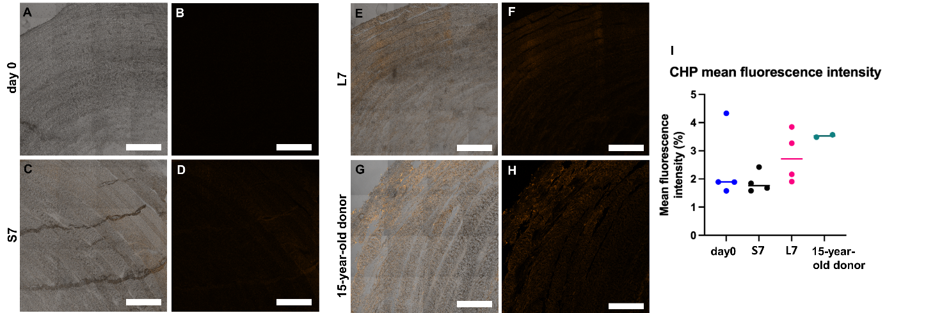

Supplementary Figure 5. CHP staining in IVD sections. (A, B) Representative images of a day 0 IVD section. (A) Brightfield and fluorescence overlay. (B) Fluorescence channel alone showing almost no signal. (C, D) Representative images of a 7-day free-swelling IVD section (group S7). (C) Overlay image. (D) Fluorescence channel showing weak CHP signal. (E, F) Representative images of a 7-day loaded IVD section (group L7). (E) Overlay image. (F) Fluorescence channel showing increased CHP signal compared to free swelling. (G, H) Representative images of a section from a 15-year-old donor IVD (excluded from the main study). (G) Overlay image. (H) Fluorescence channel showing clear CHP signal. Scale bars = 2000 μm. (I) Quantification of CHP fluorescence intensity across groups. Increased CHP binding was observed in IVDs cultured under loading compared to free-swelling controls (ns.). Data are shown as individual values with mean ± SEM. Statistical analysis: mixed-effects model.

27. Dhiman, M.S., et al., Collagen integrity of the annulus fibrosus in degenerative disc disease individuals quantified with collagen hybridizing peptide. JOR Spine, 2024. 7(3): p. e1359.

