Appendix IV Dynamic stabilization exercises
Exercise | Description | Figure
a- Basic marching with abdominal bracing | Patient placed in a hook laying position. Once the patient is able to start a firm bracing contraction and uses their fingers to provide feedback and ensure that the contraction is solid. Next, a controlled marching movement is initiated by raising one leg at a time while maintaining the brace contraction. The first leg must remain on the mat until the second leg begins to lift. | 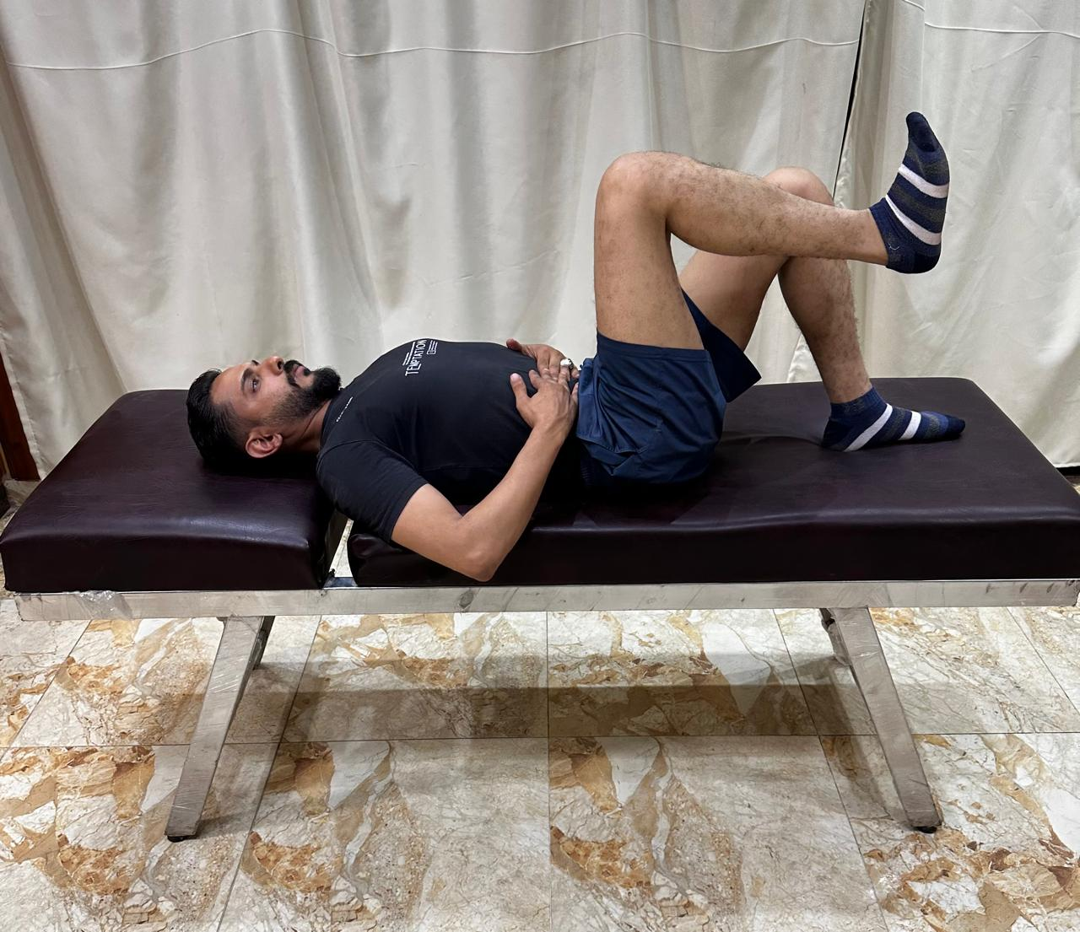
b- Brace with 90-90 hold. | The patient was positioned in a hook-lying position. Following the activation of abdominal bracing, one lower limb was lifted to form a 90-degree angle at the hip and knee joints. While maintaining a neutral pelvic alignment, the second leg was then raised to achieve the same position. Throughout the procedure, the therapist monitored for signs of lumbar spine deviation, anterior pelvic tilt, or pelvic rotation. | 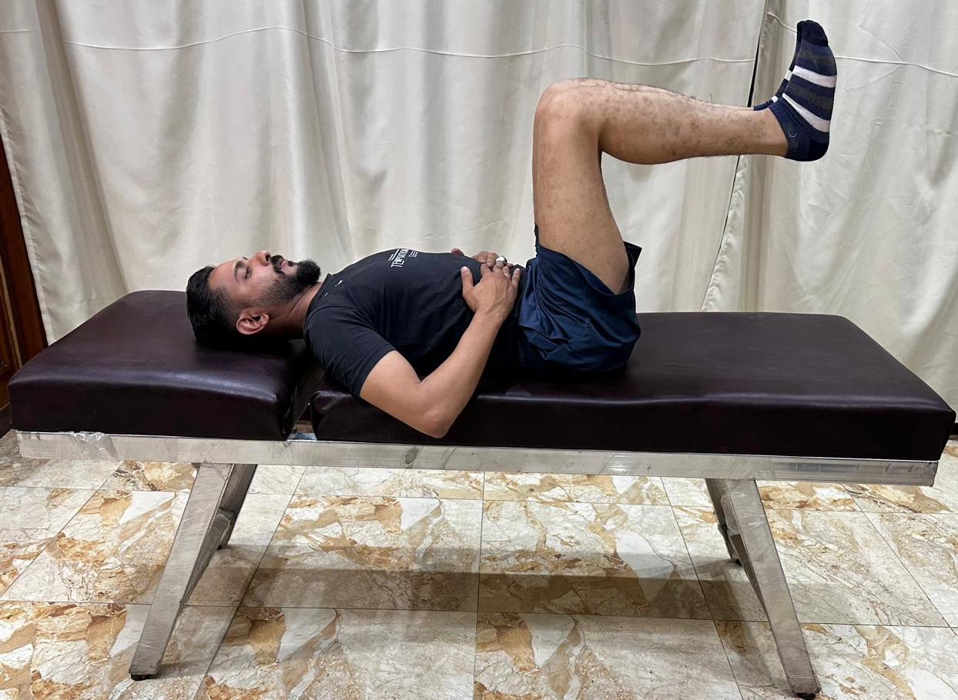
c- Alternate leg press. | In the 90-90 position as before, patient performs the alternate leg press | 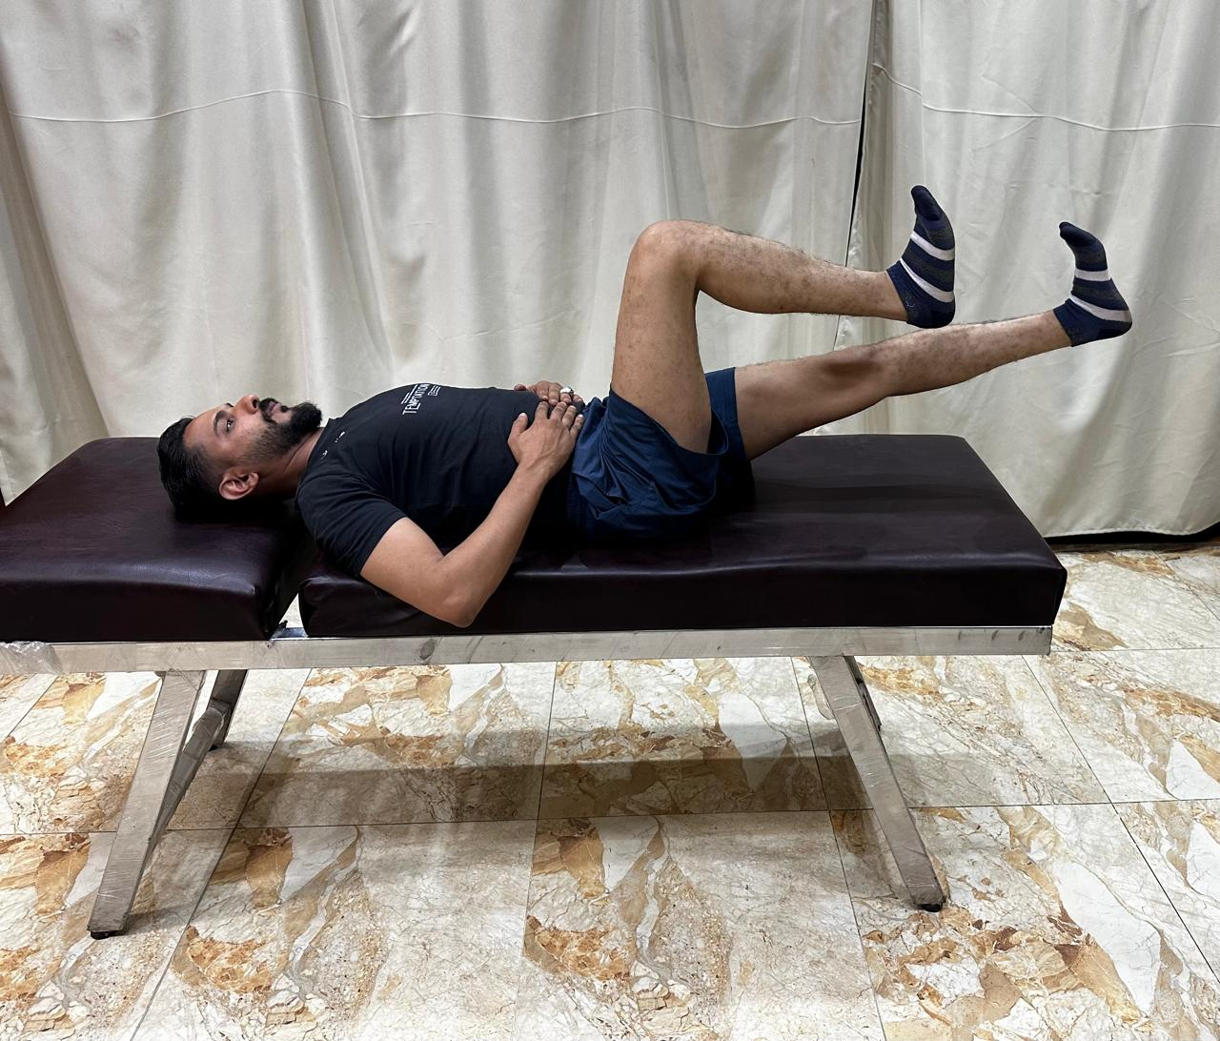
d- Non compressive bridging. | From this posture, patient was guided to gently elevate the pelvis off the mat while maintaining control. With each lifting of the bottom, the patient squeezed the gluteus very strongly to focus the contraction on the hips | 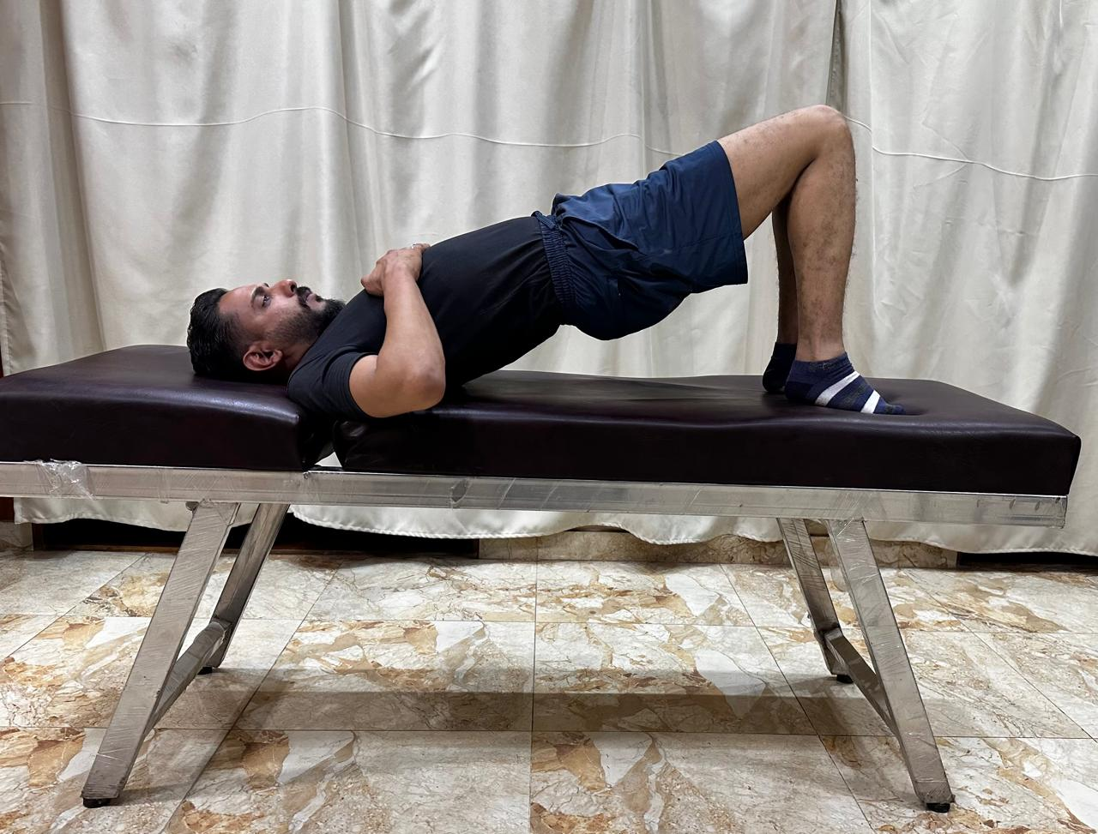
e-Bridging with adduction. | With the patient lying in a hook lying position, he was instructed to simultaneously adduct the knees (Squeezing the ball) and elevate the pelvis off the surface. This exercise was designed to activate both the hip adductors and gluteal muscles while promoting lumbopelvic stability. | 